CRoW Appendix 4 (140_10_SD02)  CRoW Act 2000: Natural Resources Wales application for permission - Formal Notice |  | 
Natural Resources Wales Formal Notice.
Requirements of Section 28I of the Wildlife & Countryside Act 1981 as amended by the Countryside and Rights of Way Act (CRoW) 2000.
Duty in relation to granting any consent, licence or permit for activities likely to damage Sites of Special Scientific Interest (SSSI).
Guide to filling in this form for Natural Resources Wales staff:
To be completed by Permitting Officers for any applications for a permission which the Natural Resources Wales has considered under S28G duties to protect and enhance SSSIs. This applies to all proposed permissions within a SSSI, and to operations outside the SSSI boundary which are likely to damage its special features.
Refer to OI 140_10 ‘Applying the Countryside and Rights of Way (CRoW) Act 2000 to applications for permits with potential for impact on Sites of Special Scientific Interest (SSSI)’, including the flowchart in Appendix 2.
Pink italic text – drafting notes, to be deleted before completion/consultation.
Blue text – examples, to be replaced with permission-specific information.
Ensure you have completed all sections.
- Natural Resources Wales area/region/NPS hub: | North
- Name of SSSI: | Morfa Uchaf, Dyffryn Conwy, Ceunant Dulyn and Aber Afon Conwy SSSIs
- Type of permission: | Landspreading Deployment under SR2010No4 Mobile plant permit
- Date for Natural Resources Wales permit determination: | 27/11/2023
- Predicted 28 day date for response from NRW conservation/ecology (under S28 I(4)): | n/a
- Natural Resources Wales reference no: | PAN-023343
- National grid reference: | 1 1 276950 , 370710  2 2 277070 , 370650  3 3 276950 , 370540  4 4 277020 , 370390  5 5 276910 , 370350  6 6 276790 , 370470  7 7 276800 , 370330  8 8 276890 , 370160  9 9 276990 , 370130  10 10 276780 , 370200  11 11 276780 , 369970  12 12 277080 , 369920  13 13 277120 , 369710  14 15 276780 , 368730  15 16 277060 , 368650  16 21 278060 , 373060  17 22 278130 , 373290  18 23 278230 , 373070  19 7078 276800 , 370780  20 7058 276835 , 370586  Storage:  1 277010, 370097  2 276732, 3 68739  3 278290, 372979  4 278266, 373053
- Description of proposal: | A land spreading application to spread a total of 7 waste streams for the waste codes 19 09 02 at Farchwel Farm. Wastes are to be spread on grass fields. The application rate ranges from 250- 35 tonnes per ha, with a total tonnage to spread 12,325 tonnes. The water treatment sludges consist of both stackable solids and non-stackable liquids. The waste is a source of essential elements N, P, K, macronutrients Mg, Ca, S and provide trace amounts of micronutrients. Wastes are beneficially used to replace a proportion of the bagged mineral fertiliser used by farmers.  The waste will be spread over 49.6 ha hectares of land within the listed fields at Farchwel Farm The stackable wastes will be stored in temporary field heaps. The non-stackable liquids may be stored in a temporary storage tank or spread on delivery.  The stackable wastes will be spread via low trajectory rear discharge spreader. The non-stackable wastes will be spread via a dribble bar or low tractor splash plate which are appropriate application method for the waste types.  Targeted periods of spreading on grass fields include early spring (late February – April), after cutting of silage(May 3 through to June), and prior to grazing through summer and autumn (July through until September).  No more than 50t/ha will be spread on a field in any 3-week period in accordance with CoGAP, and no more than 250t/ha will be spread within any 12-month period.  Spreading activities will also comply with The Water Resources (Control of Agricultural Pollution) (Wales) Regulations 2021 and CoGAP.  For aluminium flocculated sludges there will be no applications on fields that are < pH 6.0. This applies to waste streams DCWW Alaw, Cefni and Cwellyn. This mitigates the risk of Al becoming mobile in the soil.
- Is the proposed activity within (wholly or partially) the SSSI boundary? | NO  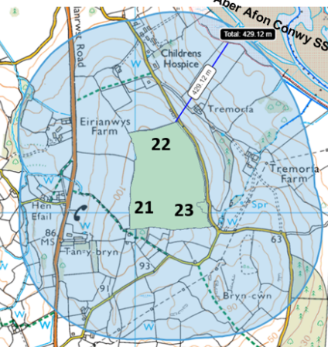  Fields 22 is located within 500 metres of the Aber Afon Conwy SSSI (429 metres). There is no impact pathway from landspreading these wastes to the SSSI due to the proximity the fields are from the SSSI.  Fields 8, 9, 11, 12 and 13 are located within 500 metres of the  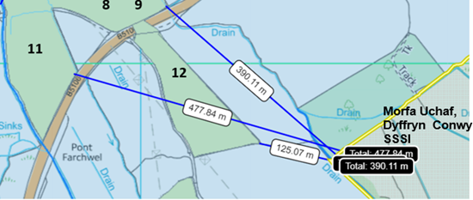  Morfa Uchaf, Dyffryn Conwy SSSI. Field 9 contains land drains that are hydrologically connected to the SSSI over a distance of 428 metres. Field 9 contains a 10 metre no spread buffer zone to mitigate the risk of nutrients and/ or PTES from entering the land drain.  Field 13 is located 108 metres from the Morfa Uchaf, Dyffryn Conwy SSSI. The Field borders the Afon Roe and is hydrologically connected to the SSSI over a distance of 126 metres. Field 13 a 10 metre no spread buffer zone to mitigate the risk of nutrients and/ or PTES from entering the Afon Roe.  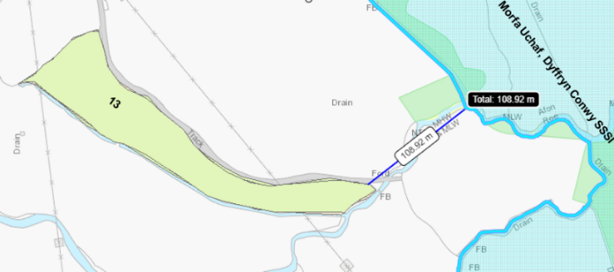  Field 15 is located 60 metres from the Afon Dulyn and Ceunant Dulyn SSSI. There is an 10 metre no spread buffer zone around the border of field 15 to prevent runoff of wastes reaching the site. There is no impact pathway for the wastes to reach the river. Field 16 borders the  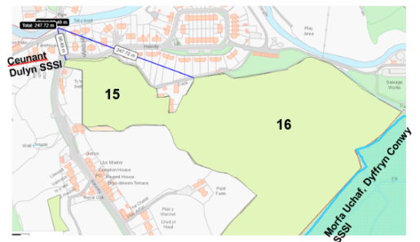  Morfa Uchaf, Dyffryn Conwy SSSI. There is a 100 metre no spread buffer zone to mitigate the risk of nutrients and/or PTES from entering the SSSI.
- Has there been any pre-application discussion or correspondence with NRW conservation/ecology | NO
- What aspect(s) of the proposed permission may damage the features which are of special interest for the SSSI?
The following ‘Operations Requiring Consent’ (or other activities associated with the permission) that may cause damage) are relevant to the proposed permission.

Aber Afon Conwy SSSI

5. Application of fertilisers and lime.
7. Dumping, spreading, or discharging of any materials.
22. Storage of materials.
26. Use of vehicles or craft which are likely to damage the features of special interest.

Ceunant Dulyn SSSI

5. Application of fertilisers and lime.

Morfa Uchaf, Dyffryn Conwy SSSI

5. Application of manure, fertilisers, and lime.
7. Dumping, spreading, or discharging of any materials.

The following SSSI features, and mechanisms of impact have been considered to assess the likelihood of damage:

Aber Afon Conwy SSSI

- All intertidal habitats and species groups.
- Nationally important bivalve ‘piddock’ habitats.
- Terrestrial invertebrate (belted beauty moth).
- Saltmarsh habitat
- Salmon
- Curlew
- Redshank
- Oystercatcher

Ceunant Dulyn SSSI

- Mixed semi-natural broad-leaved woodland with rich ground flora within a moist gorge.
- Small areas of acid grassland.

Morfa Uchaf, Dyffryn Conwy SSSI

- A mosaic of salt marsh and freshwater marsh vegetation communities

Impacts

There is no mechanisms of impact for the Aber Afon Conwy SSSI due to the closest field (22) located
429 metres from the SSSI. Therefore, has not been considered further in this appendix 4.

Field 9 is the closest field located to the Morfa Uchaf, Dyffryn Conwy SSSI .Field 9 contains land drains that are hydrologically connected to the SSSI over a distance of 428 metres. Field 9 contains a 10 metre no spread buffer zone to mitigate the risk of nutrients and/ or PTES from entering the land drain. Therefore, detriment to the SSSI site has been mitigated.

Field 13 is located 108 metres from the Morfa Uchaf, Dyffryn Conwy SSSI. The Field borders the Afon Roe and is hydrologically connected to the SSSI over a distance of 126 metres. Field 13 a 10 metre no spread buffer zone to mitigate the risk of nutrients and/ or PTES from entering the Afon Roe. Therefore, detriment to the SSSI site has been mitigated.

Field 16 borders the Morfa Uchaf, Dyffryn Conwy SSSI. There is a 100 metre no spread buffer zone to mitigate the risk of nutrients and/or PTES from entering the SSSI.

Field 15 is located 60 metres from the Afon Dulyn and Ceunant Dulyn SSSI. There is an 10 metre no spread buffer zone around the border of field 15 to prevent runoff of wastes reaching the site. There is no impact pathway for the wastes to reach the river/SSSI. Field 16 borders the Morfa Uchaf, Dyffryn Conwy SSSI. There is a 100 metre no spread buffer zone to mitigate the risk of nutrients and/or PTES from entering the SSSI.

- Decision
- The proposed permission is not likely to damage any of the flora, fauna or geological or physiological features which are of special interest.

Ceunant Dulyn SSSI

- Field 15 is located 60 metres from the Afon Dulyn and Ceunant Dulyn SSSI. There is an 10 metre no spread buffer zone around the border of field 15 to prevent runoff of wastes reaching the site. There is no impact pathway for the wastes to reach the river/SSSI.

Morfa Uchaf, Dyffryn Conwy SSSI

- Field 16 that’s borders the Morfa Uchaf, Dyffryn Conwy SSSI contains a 100 metre no spread buffer zone to mitigate the risk of nutrients and/or PTES from entering the SSSI.

- The land drains present in Field 9 contains land drains that are hydrologically connected to the SSSI over a distance of 428 metres contains a 10 metre no spread buffer zone to mitigate the risk of nutrients and/ or PTES from entering the land drain. In compliance with SR2010no4. Therefore, detriment to the SSSI site has been mitigated.

- Field 13 is located 108 metres from the Morfa Uchaf, Dyffryn Conwy SSSI. The Field borders the Afon Roe and is hydrologically connected to the SSSI over a distance of 126 metres. Field 13 a 10 metre no spread buffer zone to mitigate the risk of nutrients and/ or PTES from entering the Afon Roe. Therefore, detriment to the SSSI site has been mitigated.

Morfa Uchaf, Dryffin Conwy, Ceunant Dulyn SSSI

- Field 16 borders the Morfa Uchaf, Dyffryn Conwy SSSI. There is a 100 metre no spread buffer zone to mitigate the risk of nutrients and/or PTES from entering the SSSI.

- The watercourse in field 16 will also have 50m non-spread buffer zone.

General mitigation

- No more than 50t/ha will be spread on a field in any 3-week period in accordance with CoGAP, and no more than 250t/ha will be spread within any 12-month period.

- Replacement spreading machinery will be available to prevent waste being retained in faulty machinery. Hire vehicles will be used if required. All machinery will be fully serviced.
- There will be a sufficient number of trained staff available to ensure that the operation continues throughout operational hours (i.e., there will be sufficient cover for illness, holiday etc.).

- In adverse weather, storage is available until ground/weather conditions become favourable for land application.

- Spreading will only be undertaken when weather conditions are suitable within restrictions outlined in CoGAP and any relevant closed periods.

- Spreading will not be carried out in any areas of a field that will be sub-soiled.

- Machinery will be checked daily when in use, regularly serviced and spreading equipment calibrated.

- Machinery turns will not be executed in the buffer strips.

- Waste deliveries to field/stores will be supervised.

- All spillages will be reported immediately to NRW.

- The storage location is not within 10m of any ditch, watercourse, or footpath, not within an SPZ1, is at least 50m from any well spring or borehole, and 100m from SSSIs.

- Aluminium flocculated sludges there will be no applications on fields that are < pH 6.0. This applies to waste streams DCWW Alaw, Cefni and Cwellyn. This mitigates the risk of Al becoming mobile in the soil.

- Fields that are highly sloping have been buffered by no spread buffer zones to mitigate the risk of surface runoff leaving the field boundaries.

- Non stackable wastes will be spread via dribble bar. This application method is appropriate for the waste types and apply the wastes directly to the ground to reduce the risk of surface runoff.
- Stackable wastes will be spread via low tractor discharge spreader which is an approate application

- method for the waste,

- The water treatment sludges are being spread on fields well above a soil p.H of 6. Where the fields are between a soil p.H of 8-8.2. Therefore, the risk of Al becoming mobile is very unlikely.

- The operator will avoid the land spreading activity at sensitive times i.e., the breeding season.

- Spreading will only be undertaken when weather conditions are suitable within restrictions outlined in CoGAP.

- Machinery operations will take account of soil conditions, slopes etc.

- Liquid spreading machinery will be turned off and lifted away from soil prior to turning at the end of each run.

- Machinery will be checked daily when in use, regularly serviced and spreading equipment calibrated. Umbilical hoses will be regularly checked for damage to prevent leaks.

- Machinery turns will not be executed in the buffer strips.

- Waste deliveries to field/stores will be supervised.

Natural Resources Wales is minded to Issue the permission

- Name and job title of Natural Resources Wales officer: | Owen Clee  Permitting Officer
- Date form sent to NRW conservation/ecology | n/a
For Natural Resources Wales use only, once NRW conservation/ecology response received
- NRW conservation/ecology comment on assessment: | Please delete as appropriate:  i) NRW conservation/ecology advise the operation can go ahead  ii) NRW conservation/ecology advise the operation can go ahead with conditions  iii) NRW conservation/ecology advise against permitting the operation  Please ensure that the NRW conservation/ecology response is attached to this Formal Notice.
- Name and job title of NRW conservation/ecology officer:
- Date of receipt of NRW conservation/ecology response:

