PAN-023343 My Map Report:
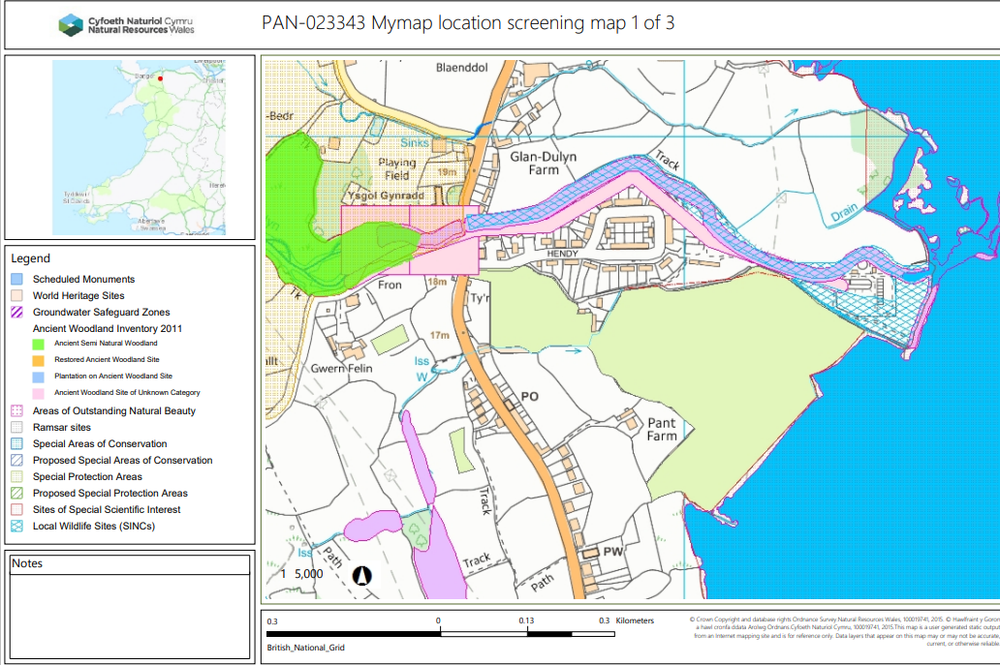

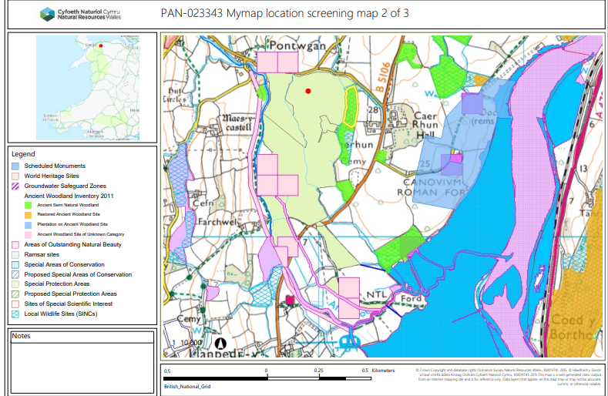

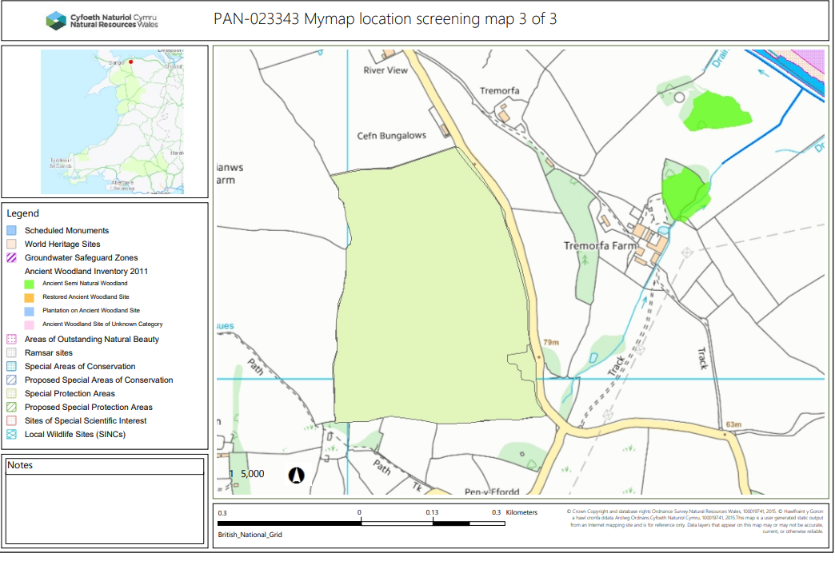

Detailed river network:

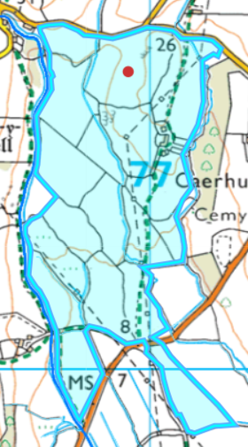
Fields 7078, 6, 7, 10 and 11 border the Afon Roe. There is a 10 metre no spread buffer zone in place to mitigate the risk of nutrients and/or PTES from entering the water course and complies with SR2010No 4.
Field 12 & 13 borders land drains/ water issue that has been buffered by 10 metres.
Fields 1, 2, 3, 4, 5, 6, 8,10, 11 border a water issue and have been buffered by 10 metres to mitigate the risk of nutrients and/or PTES from entering the water course and complies with SR2010No 4.

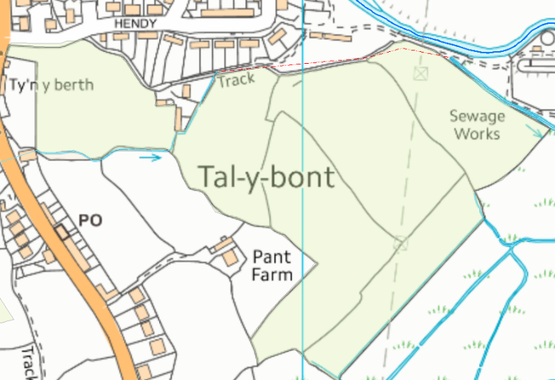
16
15
Fields 15 and 16 border a water issue and have been buffered by 10 metres to mitigate the risk of nutrients and/or PTES from entering the water course and complies with SR2010No 4.

Groundwater protection zones (source)
None in range.

Wells, springs or boreholes used for the supply of water for human consumption including from a private water supply or supplies
None in range.

any springs wells or boreholes not used to supply water for domestic or food production purposes within 50m

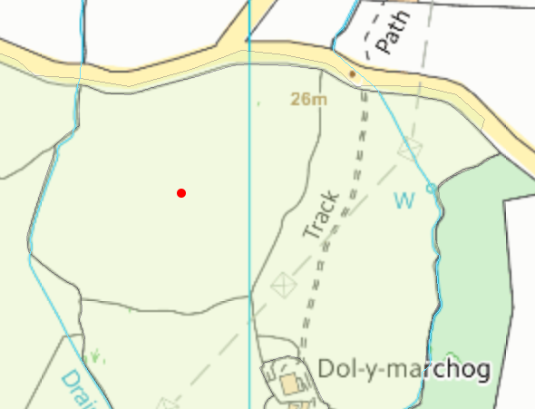

Field 2 contains a well and has been buffered by 50 metres from the request for information response.

2
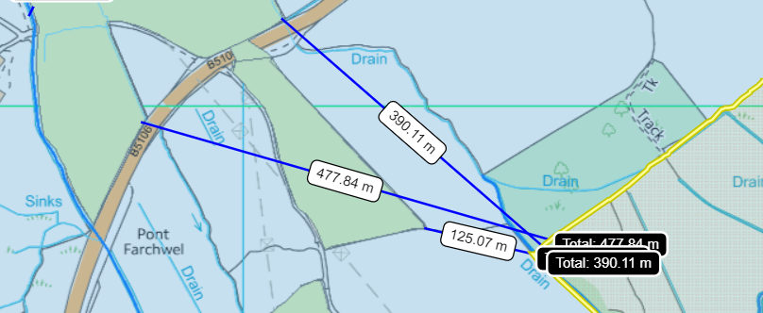
European designated sites- Natura 2000 (SPA, pSPA, SAC or cSAC) or Ramsar- or SSSI within 500m
8
9
12
11
Fields 8, 9, 11 and 12 are located within 500 metres of the Morfa Uchaf, Dyffryn Conwy SSSI.

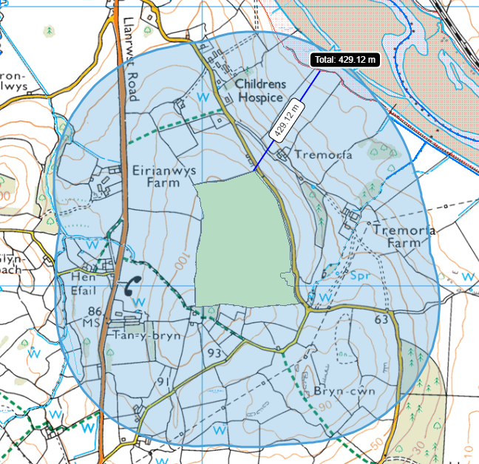
23
21
22
Field 23 is located within 500 meters of the Aber Afon Conwy SSSI.

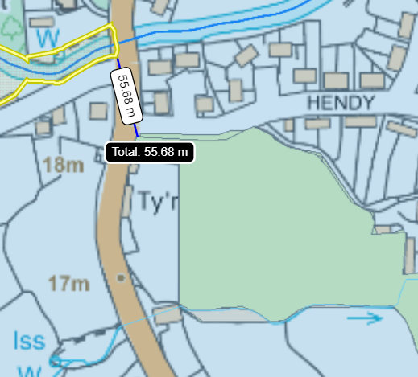
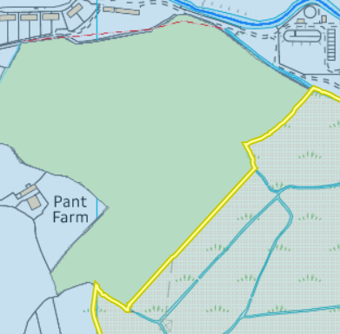
Field 16 borders the Morfa Uchaf, Dyffryn Conwy SSSI. There is a 100 metre no spread buffer zone in place to mitigate the risk of nutrients and/or PTEs from entering the SSSI.

16
15
Field 15 is located 56 metres from the Ceunant Dulyn SSSI. There is a 10 metre no spread buffer zone in place to mitigate the risk of nutrients and/or PTEs from entering the SSSI.

Other protected sites:
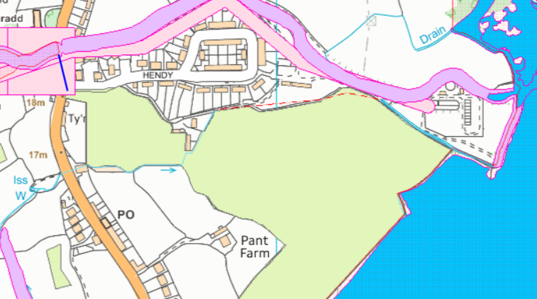
- Protected Species & Protected Habitats
Field 15 is located 56 metres from numerous protected species:
- Atlantic Salmon migratory route & Atlantic Salmon
- Brown Trout: Ferox, Trout. Sea Trout: Peal, Salmon Trout, Sewen, White Trout.
Due the proximity the spread field is from the protected species where there is no impact pathway it is unlikely detriment to these species will occur due the landspreading activity.
Field 16 borders a protected species (Coastal saltmarsh) there is an x metre no spread buffer zone in place to prevent nutrients and or PTEs from entering the protected salt marsh.

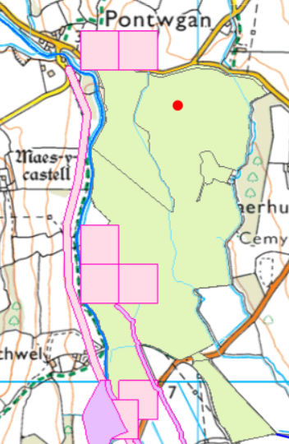
16
15
6
7058
7078
11
10
7
Fields 7078, 7058, 6, 7, 10 and 11 are located near to the protected species:
- Atlantic Salmon
- Brown Trout: Ferox, Trout. Sea Trout: Peal, Salmon Trout, Sewen, White Trout
These are aquatic species belonging to the Afon Roe and will not be present on the landspreading fields. There is an 10 metre no spread buffer zone in fields that border the Afon Roe to mitigate the risk detriment to these species from nutrients and/or PTEs.

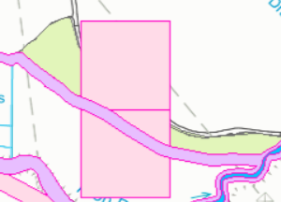
13
Field 13 is located near to the borders the protected species:
- Atlantic Salmon migratory route & Atlantic Salmon
- Brown Trout: Ferox, Trout. Sea Trout: Peal, Salmon Trout, Sewen, White Trout
These are aquatic species belonging to the Afon Roe and will not be present on the landspreading fields. There is an 10 metre no spread buffer zone to mitigate the risk detriment to these species from nutrients and/or PTEs.

- Scheduled Ancient Monument- None in range.

- Local Nature Reserve- None in range.

- National Nature Reserve- None in range.

- Ancient Woodlands-

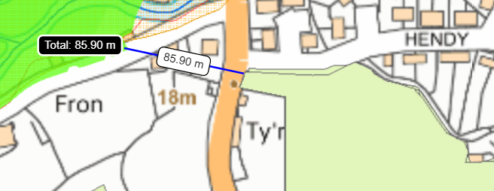

15

Field 15 is located 86 metres from an Ancient Semi Natural Woodland.

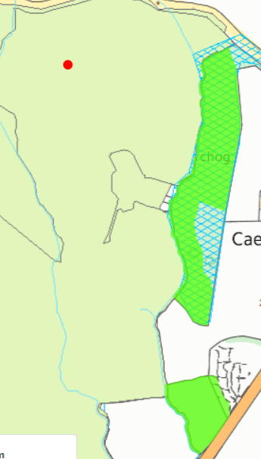
Fields 2 and 4 borders an Ancient Semi Natural Woodland. The site plan and SSRA has been updated in the request for information response. There is an 50 metre no spread buffer zone in place to prevent nutrients and/or PTES from entering the site.

4
2

- Local Wildlife Sites (SINC)-
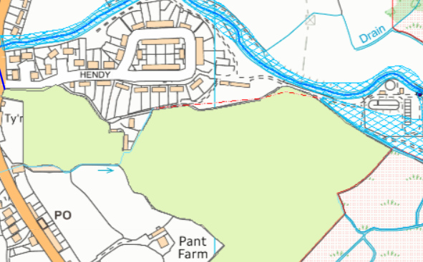
Field 16 borders the Afon Dulyn, Tal-y-Bont SINC site. There is an 10 metre no spread buffer zone in place in field 16 which borders the SINC site to prevent nutrients and/or PTES from entering the site.

16
15
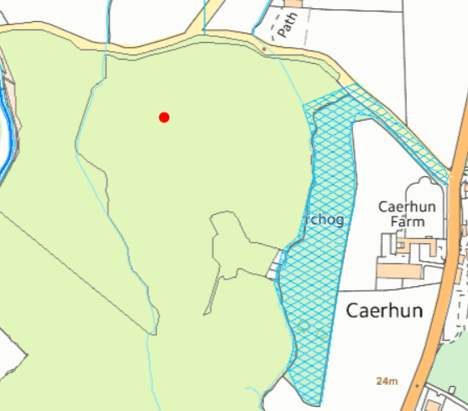
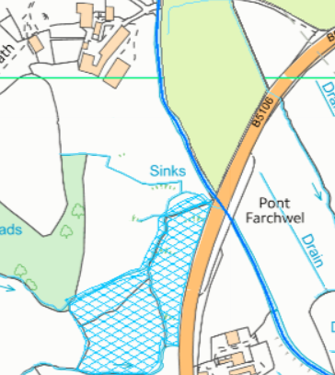
Field 2 borders the Coed Caerhun SINC. There is a 50 metre no spread buffer zone in place in fields 2 and 4 which borders the SINC site to prevent nutrients and/or PTES from entering the site.

Field 11 borders the Bryn Siriol Meadows. There is an 10 metre no spread buffer zone in place in field 16 which borders the SINC site to prevent nutrients and/or PTES from entering the site.

2
11

- National Park-
Field 15 is located 58 metres from the Snowdonia National Park . The site plan has been updated to show its location and the SSRA has been updated to consider this receptor in the request for information response. Field 15 contains a 10 metre no spread buffer zone in place to prevent nutrients and/or PTES from entering the site.

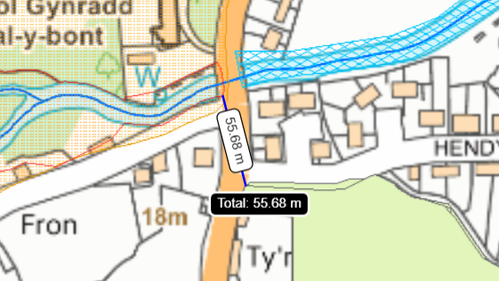
15
- Groundwater Safeguard Zone- none in range.

- World Heritage Sites – None in range.

- Hedges- n/a

- Ditches- see slope map below.

Slope Map 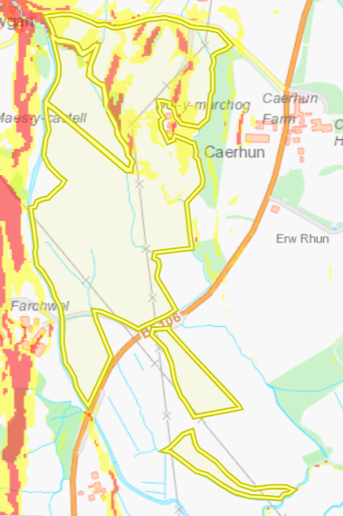
Fields 1, 2 and 3 contain small areas of land that are highly sloping (12º+). There is no spread buffer zone in place to mitigate the risk of surface runoff.
Fields 1, 2, 3 and 4 also contain moderately sloping land (7-12º). Although the slopes are contained to the fields.
The stackable sludges will be spread via rear discharge spreader. The non-stackable liquid sludges will be spread via dribble bar or low trajectory splash plate. Liquid wastes will be spread via umbilical cord using a dribble bar. The reason for the range in application methods is due to the liquid wastes having a variation in silt composition. Which may block the dribble bar therefore, making a low trajectory splash plate a more favourable choice when applying the water wastes. These are appropriate methods to spread the waste and the added justification has been accepted for a range in application methods for the liquid waste.
No more than 50t/ha will be spread on a field in any 3-week period to allow the soil to effectively uptake the wastes.

2
7078
4
3
1
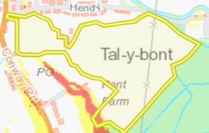
Field 16 contains a small area of land that is sloping at 12º +. There is no spread buffer zone in place to mitigate the risk of surface runoff.

16

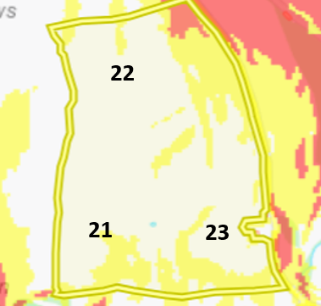
Field 22 contains a small area of land that is sloping at 12º +. There is no spread buffer zone in place to mitigate the risk of surface runoff.
Fields 21, 22 and contain moderately sloping land (7-12º). Although the slopes are contained to the fields.

