CRoW Appendix 4 (140_10_SD02)  CRoW Act 2000: Natural Resources Wales application for permission - Formal Notice |  | 
Natural Resources Wales Formal Notice.
Requirements of Section 28I of the Wildlife & Countryside Act 1981 as amended by the Countryside and Rights of Way Act (CRoW) 2000.
Duty in relation to granting any consent, licence or permit for activities likely to damage Sites of Special Scientific Interest (SSSI).
Guide to filling in this form for Natural Resources Wales staff:
To be completed by Permitting Officers for any applications for a permission which the Natural Resources Wales has considered under S28G duties to protect and enhance SSSIs. This applies to all proposed permissions within a SSSI, and to operations outside the SSSI boundary which are likely to damage its special features.
Refer to OI 140_10 ‘Applying the Countryside and Rights of Way (CRoW) Act 2000 to applications for permits with potential for impact on Sites of Special Scientific Interest (SSSI)’, including the flowchart in Appendix 2.
Pink italic text – drafting notes, to be deleted before completion/consultation.
Blue text – examples, to be replaced with permission-specific information.
Ensure you have completed all sections.
- Natural Resources Wales area/region/NPS hub: | PAN-023644
- Name of SSSI: | Afon Dyfrdwy (River Dee) (geological)
- Type of permission: | Landspreading deployment under standard rules permit SR2010 No4
- Date for Natural Resources Wales permit determination: | 07/12/2023
- Predicted 28 day date for response from NRW conservation/ecology (under S28 I(4)): | n/a
- Natural Resources Wales reference no: | PAN-023644
- National grid reference: | Farm location: SJ 41410 46192  Fields:  1 PL1 SJ 413641 458881  2 PL2 SJ 412291 458661  3 PL3 SJ 412521 460631  4 PL4 SJ 415011 460611  5 PL5 SJ 416331 460461  6 PL6 SJ 416871 462831 field removed from the deployment due to flooding risk.  7 PL7 SJ 415631 463881  Storage:  SJ 411761 459521  SJ 413221 459701  SJ 414651 462051  SJ 414701 462331  SJ 413471 462241
- Description of proposal: | A land spreading application to spread a total of 5 waste streams for the waste codes 02 02 04, 07 07 12, 02 03 05 & 02 07 05 at Dolennion Farm, Worthenbury. Wastes are to be spread on fields that contain spring wheat. The application rate ranges from 15-133 tonnes per ha, with a total tonnage to spread 3442.5 tonnes.  The waste will be spread over 16 ha hectares of land within the listed fields at Dolennion Farm. The wastes will be stored in an impermeable lagoon and field nurse tanks. The waste will be applied by sub soil injector or trailing shoe, these are both low emission spreading activities and place waste material directly on or below the soil surface reducing ammonia and odour emissions. 02 02 04 Waste  codes will only be sub soil injected.  The waste will be applied in made in one application prior to seedbed preparation in February to April 2024.  The wastes may be applied separately or in combination. If the wastes are applied in combination the total combined amount applied will be limited to the limiting factor of the waste streams. (lowest application rate).  The landspreading activity will comply with CoGAP and The Water Resources (Control of Agricultural Pollution) (Wales) Regulations 2021.  The Maelor waste stream has a high RAN content and will not be spread during closed period which dates have been outlined in the updated agricultural benefit statement.
- Is the proposed activity within (wholly or partially) the SSSI boundary? | NO  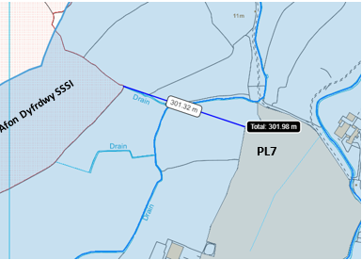  Field PL7 is located 302 meters from the Afon Dyfrdwy (River Dee) geological designation.  The landspreading fields are not located within 500 meters of the River Dee (SSSI) designated under aquatic features or otters. (see map below).  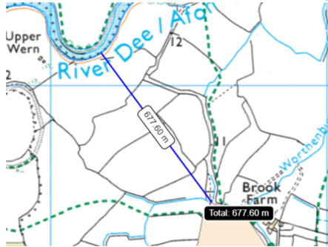
- Has there been any pre-application discussion or correspondence with NRW conservation/ecology | NO
- What aspect(s) of the proposed permission may damage the features which are of special interest for the SSSI?
The following ‘Operations Requiring Consent’ (or other activities associated with the permission) that may cause damage) are relevant to the proposed permission.

7. Dumping, spreading, or discharging of any materials.
22. Storage of materials.
26. Use of vehicles, vessels, or craft.

The following SSSI features, and mechanisms of impact have been considered to assess the likelihood of damage:

- Geology: Natural exposures of Upper Carboniferous rocks at Dee Bridge
- Geology: Fluvial landforms and processes related to the development of the River Dee near Rhewl, and between Holt and Worthenbury.
- Decision
i) The proposed permission is not likely to damage any of the flora, fauna or geological or physiological features which are of special interest.

- Field PL7 is located 302 meters from the geological designated SSSI. There is no impact pathways for the waste to travel to the SSSI to cause detriment.

- Field PL7 contains a no spread buffer zone for half the field located on a flood plain. To mitigate the risk of flood waters encroaching on the field and for nutrients to enter the SSSI.

- Field PL6 has been removed from the deployment application due to the field being located on a flood plain at high risk of flooding. This mitigates the risk of flood waters encroaching on the field and for nutrients to enter the SSSI.

- Field PL7 contains a water course that has been an implemented no spread buffer zone of 10 meters to mitigate the risk of nutrients from entering the water course. The no spread buffer zone complies with SR2010 No4.

- The fields in this deployment (fields PL1 to PL7) contain minimal sloping land. Which do not pose a surface runoff of risk.

- Wastes will be spread via trailing soil injection or trailing shoe. These application methods are appropriate for the waste types and apply the wastes directly to the ground or in the soil to reduce the risk of surface runoff and odour issues. EWC 02 02 04 wastes will only be applied via soil injection and complies with TGN 8.01.

- The wastes being spread consist of non-stackable sludges therefore there is no risk of dust generation from spreading the waste and for dust to reach the SSSI.

- The storage containers (lagoons and nurse tanks) are approperate methods of storing the waste. The lagoons are constructed with a metre thick clay layer to make them impermeable.

- Regular checks of watercourses in the area surrounding the spreading operations.

- To cover machinery breakdown, replacement machinery is available or can be hired from suppliers and mobile mechanics are available to attend sites. All machinery is regularly serviced.

- There is sufficient trained staff to maintain sickness and holiday cover.

- Spreading operations will not be carried out when there are adverse weather conditions that are likely to interfere with the opera5on. These conditions include heavy rain, or during periods of heavy snow or frozen ground as defined in the Code of Good Agricultural Practice (COGAP).

- The applicant has submitted a Site specific risk assessment that identified the nearby sensitive receptors and has detailed appropriate mitigation measures to prevent detriment to these areas.

Natural Resources Wales is minded to: Issue the permission

- Name and job title of Natural Resources Wales officer: | Owen Clee  Permitting Officer
- Date form sent to NRW conservation/ecology | n/a
For Natural Resources Wales use only, once NRW conservation/ecology response received
- NRW conservation/ecology comment on assessment: | Please delete as appropriate:  i) NRW conservation/ecology advise the operation can go ahead  ii) NRW conservation/ecology advise the operation can go ahead with conditions  iii) NRW conservation/ecology advise against permitting the operation  Please ensure that the NRW conservation/ecology response is attached to this Formal Notice.
- Name and job title of NRW conservation/ecology officer:
- Date of receipt of NRW conservation/ecology response:

