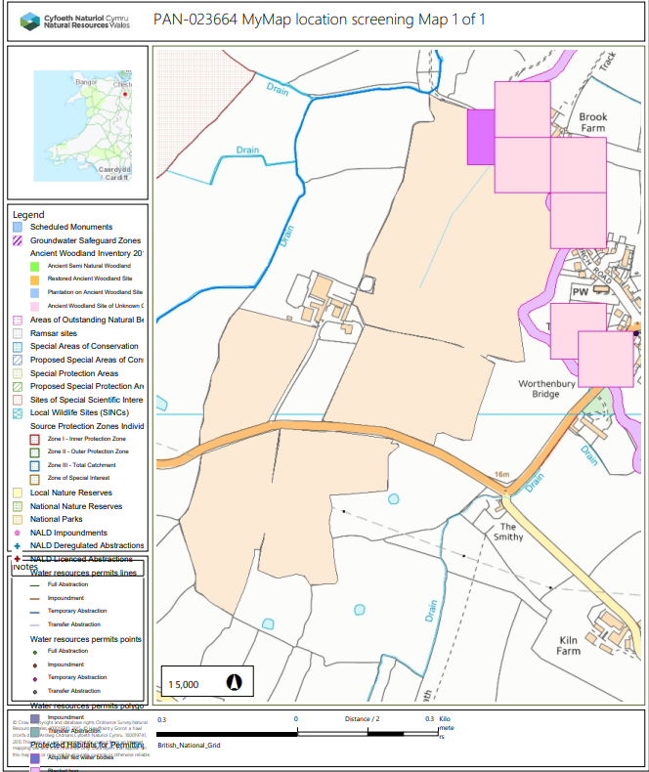
PAN-023644 My Map Report:

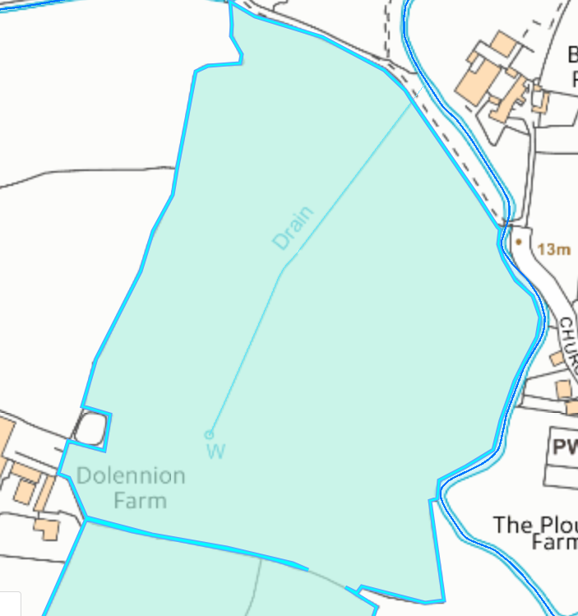
Detailed river network:
PL6 (removed from deployment).
PL7
The centre border of PL7 contain a land drain and a well and have been correctly buffered. (well 50 metres & land drain 10 metres).

Groundwater protection zones (source)
None in range.

Wells, springs or boreholes used for the supply of water for human consumption including from a private water supply or supplies
None in range.

Any springs wells or boreholes not used to supply water for domestic or food production purposes within 50m

None in range.

European designated sites- Natura 2000 (SPA, pSPA, SAC or cSAC) or Ramsar- or SSSI within 500m
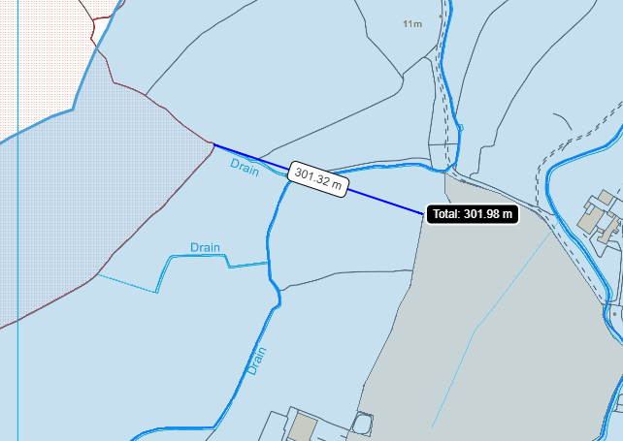
PL7 is the closest field located to the Afon Dyfrdwy SSSI at 303 metres. The land drains present in the SSSI flow down into the field boundary for PL7. Although the field is located downstream of the land drains over a distance of 326 metres. Field PL7 also contains an 10 metre no spread buffer zone along the land drain to mitigate the risk of nutrients from entering the land drain.

Afon Dyfrdwy SSSI

PL7

Other protected sites:
- Protected Species-
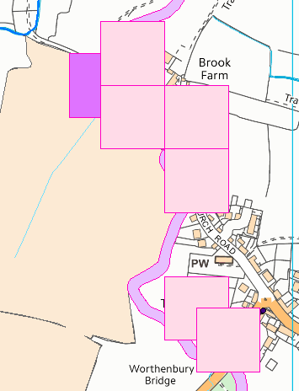
Field PL6 is located next to the Worthenbury Brook which contains the following protected species:
- Marine Lamprey & River Lamprey
- Silver Eel & Yellow Eel
- Atlantic Salmon migratory route & Atlantic Salmon
- Brown Trout: Ferox, Trout. Sea Trout: Peal, Salmon Trout, Sewen, White Trout.
- Bullhead (fish)
- Jawless fish (Agnatha)
- European Water Vole

- Protected Habitats- None in range.

- Scheduled Ancient Monument- None in range.

- Local Nature Reserve- None in range.

- National Nature Reserve- None in range.

- Ancient Woodlands-
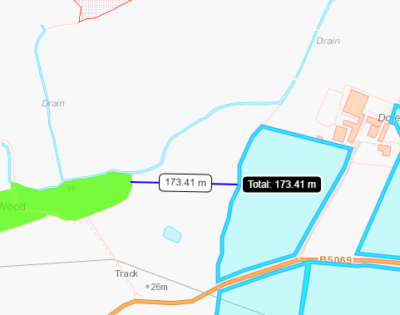
Field PL3 is located 173 metres from an Ancient Semi Natural Woodland.

PL3

- Local Wildlife Sites (SINC)- None in range.

- National Park- None in range.

- Groundwater Safeguard Zone- n/a

- ANOBs – None in range.

- Hedges- n/a

- Ditches- see slope map below.

- Local residents – The submitted site plan includes local residents and matches MyMap.

- Workplaces - The submitted site plan includes local residents and matches MyMap

- Recreational facilities - The submitted site plan and OMP includes the local church and matches Mymap.

Public rights of way -
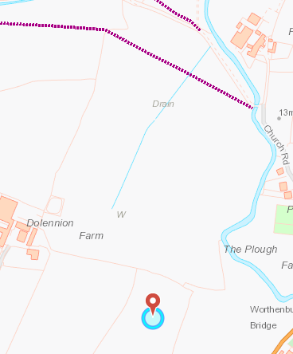
Field Removed from deployment
Field PL7 contain a public right of way, the field has a no spread buffer zone including where the public footpath is.
PL7
Slope Map
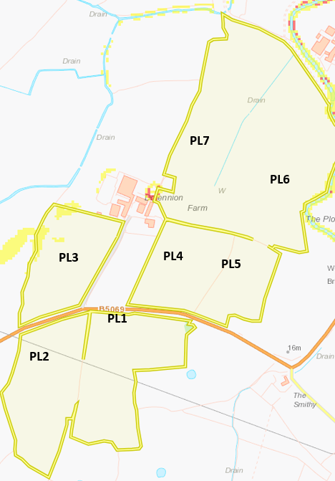
Field PL3 contains a small area of moderately sloping land (7-12º). The waste being spread is non stackable sludge, so the runoff risk is lower than liquids. The waste will also be spread via soil injection which reduces the risk of surface runoff.
The rest of the fields are located on flat to gently sloping land (0-7º) and do not pose a surface runoff risk.

Flood risk

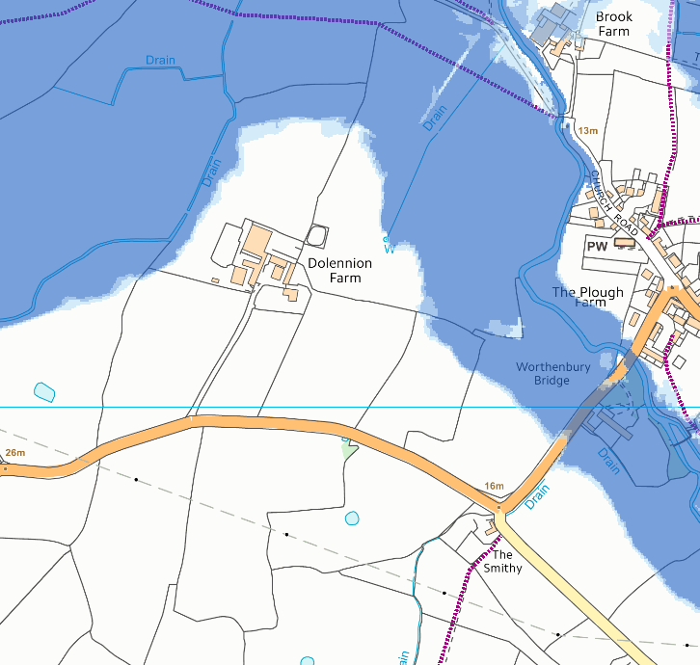
Fields PL5, PL6 and PL7 are on land that has a high risk of flooding from rivers (River Dee) and from smaller water courses ( high risk). The storage areas (lagoons and field nurse tanks) are not located in the areas that are prone to flooding.
CoGAP states that wastes should not be spread on fields likely to flood. As a result, in the request for information field PL6 will be asked to be removed from the deployment. Fields PL7, PL5 and PL3 will also need no spread buffer zones in place in areas where there is a high flood risk. The flood risk is due to the River dee which is designed as an SSSI and SAC. The applicant has stated weather conditions would be monitored but flooding is difficult to predict.

PL6
PL7
PL3
PL2
PL1
PL5
PL4

