 | ….  SAFE WORKING PROCEDURE | Document Number
 | ….  SAFE WORKING PROCEDURE | 01
 | Shear Maintenance (DECAP, Blade Change and Daily Maintenance Checks) | Review Period: 19.05.2022
 |  | Review Date Due: 19.05.2024
 |  | Owner: Scrap Yards UK

Revision History
Review Team  Date of Review | Name & Position | Name & Position | Name & Position | Name & Position
001

Rev Number | Reason for Revision | Revision Author | Reviewed By | Authorised By | Date

- Purpose and Scope
To provide instructions & guidance on the Shear Maintenance (including DECAP and Blade Change) (maintenance tasks, daily checks & greasing)
- Risk Assessment Reference
Area risk assessment
Generic activity risk assessment
Task risk assessment

- Glossary of Terms

PPE | Personal Protective Equipment
Shear Maintenance | DECAP, Blade Changes and Daily Maintenance checks

- Personal Protective Equipment and Tools required

PPE Required | Tools Required
- Overalls  - Welding Leathers  - Welding Gloves  - Safety Glasses  - Welding Masks  - Hard hat with chin strap  - Cut resistant gloves (WG0347- Kutlass PU500 Gloves)  - High visibility vest or jacket  - Ear plugs  - Steel toe & sole boots (UVEX U8415-2 BOOT QUATRO GORETEX  - Welding Boots  - Comply with CELSA UK Jewelry Policy 4C7130  - Dust masks | - Hand Tools  - Welding Equipment  - Burning Equipment  - Grinders  - Grease Gun  - DECAP Locks

- Preconditions

1 or more trained competent person for the task. Workers must familiarized with the working area and the conditions of the yards, Workers must have a Work Permit to carry out any work within the yard (RAPNET) also presented the Celsa RA for the present task as well as present their own, DECAP in place before any work is carried out, All Hazards, near misses and accidents must be reported immediately the Yard Manager.
Satisfy the Preconditions
No | Check | Tick
1. | Hot works permit to be issued and R.A.M.S checked
2. | Clear communication between Yard Manager
3. | DECAP in place on machine
4. | PPE for Daily maintenance and PPE for Hot works
5 | Sufficient lighting and Good housekeeping in working area
6 | Radios

- Significant Hazards & Precautions

Hazard | Risk  Precautions
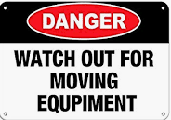 | MAN MACHINE INTERACTION  Beacons, claxons & cameras fitted in machinery  Blind spot training for floor worker  Radio communication to be maintained between floor worker machine operators at all times during operation  'Stop! Thumbs up' rule to apply to floor worker and plant operators  All plant operators to be trained and competent  High Vis clothing
 | Injury from moving machinery  Isolate the shear before carrying out any work.
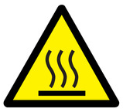 | Burns from hot steel  Wear welding gloves, jacket (closed, collar up, arms covered), and face visor
  Manual handling | Manual Handling of Equipment and Maintenance parts  Persons Manual Handling trained and competent of lifting and carrying any equipment and parts for maintenance tasks.
H.A.V.S | All persons should have undertaken H.A.V.S training  Persons will be using Pneumatic tools.
Abrasive Wheels | All persons should have undertaken Abrasive wheel training  Persons will be using disc cutter/grinder
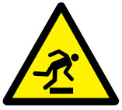 | Slips, trips and falls
- Noise from machines and movement of scrap
- Dust
- Vibrations

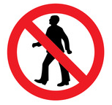 | No pedestrian access to operational areas
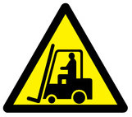 | Fork lift trucks and tele handler operating
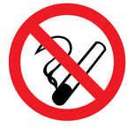 | No smoking anywhere on Celsa sites

- Step by Step Procedure
Step | Description | Done?
1 | Step 1  On arrival to the Yard all contractors report to site office for induction/sign in.  - work permit to be issued by Site Manager before any work is carried out  - Celsa site manager to show contractors where to isolate (DECAP) shear.  - Make sure all contractors are wearing all the correct PPE before entering the yard.  - Celsa staff to make sure contractors have all the correct equipment/parts for the job.  - Escort contractors to the working area  Make sure working area is clear of debris and the positioning of contractors vans/equipment is positioned correctly so there is no interference with anything else in yard.  .
2 | Step 2  Setting up working area and platform for accessing Shear.  2.1 Celsa staff to make sure everything in the working area which can be removed (blast walls) moved to a different location.  2.2 Celsa staff to attach the working platform (Blade changing platform) using Tele handler to the front of the shear for access and working platform.  2.3 Contractor to assemble there tools ready for work.  Make sure access ladder to the platform is secure correctly  Verb, pictures optional, brief and to the point, command not a story.

- Appendices
…..

