 | SAFE WORKING PROCEDURE | Document Number
 | SAFE WORKING PROCEDURE | CRUK-SWP-CRM-004
 | Grab attachment inspection and maintenance. | Review Period:  2 Years
 | Grab attachment inspection and maintenance. | Review Date Due:  June 2025
 | Grab attachment inspection and maintenance. | Owner:  Maintenance Manager

Revision History
Review Team  Date of Review | Name & Position | Name & Position | Name & Position | Name & Position

Rev Number | Reason for Revision | Revision Author | Reviewed By | Authorised By | Date
00 | Draft for implementation | C Griffiths

- Purpose and Scope
The purpose of this safe working procedure is to define the method for the inspection and general maintenance on a grab attachment to a 360° Material Handler. It applies to all locations, managers and operators where Celsa Recycling UK have the operating responsibility of the material handlers on site.

- Risk Assessment Reference
Area Risk Assessment: CRUK-CCH-ARA-001-00
CUK-GRA-004-04 General lifting operations
CUK-GRA 011-03 Operating mobile plant
CUK-GRA-013 Traffic movements

Glossary of Terms

PPE | Personal Protective Equipment
Grab | Claw attachment for 360° material handler

- Personal Protective Equipment and Tools required

PPE Required | Tools Required
Minimum Site PPE Applies  - Hard Hat with Chin Strap  - Safety Glasses  - Coveralls  - Safety Boots  - Gloves  Hard hat, gloves and safety glasses can be removed within the confines of the cab, but must be worn at all times outside the cab. | - 360° Material Handler  - Grease gun  - Rags

- Preconditions

Satisfy the Preconditions
No | Check | Tick
1. | Daily check to have been completed and machine in a serviceable condition
2. | Licensed operator only to operate equipment.
3. | Machine is located in Safe location outside of yard operating area.

- step by Step Procedure
Step | Description
1   | Step 1: Drive machine to maintenance area of yard  - Maneuver machine to maintenance area of yard.  - Park machine.  - Switch off engine.  - Open grab tines and place on the ground in a safe area  - Remove keys from machine.  Collision hazard, check parking area is clear of pedestrians and obstacles before maneuvering in to the maintenance area.
2  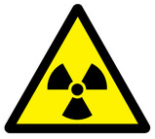  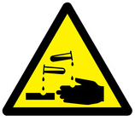  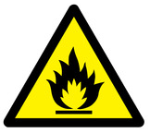 | Step 2: Visual inspection of the material handler grab attachment  - Turn off machine, remove keys and exit the cab  - Visually inspect each tine and hydraulic cylinder for any defects or fluid leaks.  - Grease each tine in-line with the OEM manual  - Inspect tips for wear and replace in-line with OEM manual  - Re-enter cab and start machine  - Operate grab open and closed to ensure operation is acceptable  - Hand machine over back into operations.  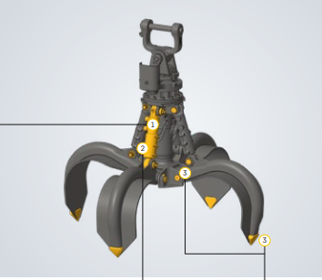  Hazardous materials –Oil, Grease, Fuel.  END OF PROCEDURE

