 | ….  SAFE WORKING PROCEDURE | Document Number
 | ….  SAFE WORKING PROCEDURE | CRUK-TRA-CRM-014
 | Shear Maintenance (COPEX blade change) | Review Period: 02.03.2023
 | Shear Maintenance (COPEX blade change) | Review Date Due: 02.03.2024
 | Shear Maintenance (COPEX blade change) | Owner: Scrap Yards UK

Revision History
Review Team  Date of Review | Name & Position | Name & Position | Name & Position | Name & Position
001 | Andreu Dorca  Scrap yards manager | Michael Kethro  Safety officer | Ryan Connick  Scrap yard operations manager

Rev Number | Reason for Revision | Revision Author | Reviewed By | Authorised By | Date
001 | Draft for implementation | C Griffiths |  |  | 02.02.2023

- Purpose and Scope
The purpose of this SWP is guidance on the safe working practices for changing the blades on a Copex shear baler.
- Risk Assessment Reference
CUK-GR-008-03 Manual handing
CUK-GR-014-03 Working at height
CRUK-M-RA-002-10 Lifting operations using manual hoists (Blade changes)
CRUK-M-RA-002-06 Access and egress

- Glossary of Terms

PPE | Personal Protective Equipment
Shear Maintenance | DECAP, Blade Changes and Daily Maintenance checks

- Personal Protective Equipment and Tools required

PPE Required | Tools Required
- Overalls  - Welding Leathers  - Welding Gloves  - Safety Glasses  - Welding Masks  - Hard hat with chin strap  - Cut resistant gloves (WG0347- Kutlass PU500 Gloves)  - High visibility vest or jacket  - Ear plugs  - Steel toe & sole boots (UVEX U8415-2 BOOT QUATRO GORETEX  - Welding Boots  - Comply with CELSA UK Jewelry Policy 4C7130  - Dust masks | - Hand Tools  - Grease Gun

- Preconditions

1 or more trained competent person for the task. Workers must be familiarized with the working area, and the conditions of the yards, Workers must have a Work Permit to carry out any work within the yard (RAPNET), All Hazards, near misses and accidents must be reported immediately the Yard Manager.
Satisfy the Preconditions
No | Check | Tick
1. | permit to be issued and R.A.M.S checked
2. | Shear work platform in place
3. | PPE for Daily maintenance
4. | Sufficient lighting and Good housekeeping in working area
5
6

- Significant Hazards & Precautions

Hazard | Risk  Precautions
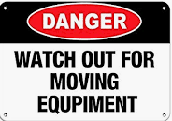 | MAN MACHINE INTERACTION  Moving Plant in yard.
 | Injury from moving machinery  Isolate the shear before carrying out any work.
  Manual handling | Manual Handling of Equipment and Maintenance parts  Persons Manual Handling trained and competent of lifting and carrying any equipment and parts for maintenance tasks.
H.A.V.S | All persons should have undertaken H.A.V.S training  Persons will be using Pneumatic tools.
Abrasive Wheels | All persons should have undertaken Abrasive wheel training  Persons will be using disc cutter/grinder
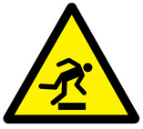 | Slips, trips and falls
- Noise from machines and movement of scrap
- Dust
- Vibrations

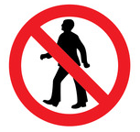 | No pedestrian access to operational areas
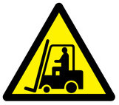 | Fork lift trucks and tele handler operating
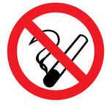 | No smoking anywhere on Celsa sites

- Step by Step Procedure
Step | Description | Done?
1 | Step 1 Pre-work conditions  On arrival to the yard all contractors report to site office for induction/sign in.  - Work permit to be issued by Site Manager before any work is carried out  - Decap of machine is not possible, hydraulic circuit must be depressurized and  Machine setting mode selected.  - Make sure all contractors are wearing all the correct PPE before entering the yard.  - Celsa staff to make sure contractors have all the correct equipment/parts for the job.  - Escort contractors to the working area  Make sure working area is clear of debris and the positioning of contractors vans/equipment is positioned correctly so there is no interference with anything else in yard.  .
2     | Step 2 preparing the work area.  Setting up working area and platform for accessing Shear.  2.1 Celsa staff to make sure the working area is cleared, blast walls moved, scrap removed,area cordoned off and any other operations in the area are aware of the work being carried out.  2.2 Celsa staff to attach the working platform (Blade changing platform) using Tele handler to the front of the shear for access and working platform.  2.3 Celsa staff to remove the blast door from the front of the shear using the telehandler  Complete ladder checks and ensure ladder is attached to the platform securely  Warning! Risk of injury due to falling in the prepress box! Run the plant until empty, or remove the material with a crane before performing maintenance work or fault location in the prepress box. Use a safety ladder with non-slip rungs to climb into the prepress box. The ladder must be secured against tilting and slipping  Danger! Risk of fatal accident due to damaged blade changing platform or incorrect assembly! Before use, check the blade-changing platform for visible damage, such as deformation, cracks and corrosion. Check the mounting on the shears frame. Do not use the platform if it has any damage or cannot be installed securely. Secure the installed blade-changing platform with the locking bolts
3 | Step 3, Check the condition on the blade.  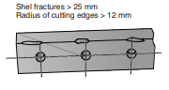  3.1 Check the blade cutting edge condition top and bottom.  3.2 Check from shell fractures > 25mm or are rounded >12mm radius  Excessive blade play with rounded and chipped or rounded cutting edges generate high traverse forces and can damage the blade seats, frames and blade slides/guide.
4 | Step 4, Mobile control unit operation, Blade changing mode.  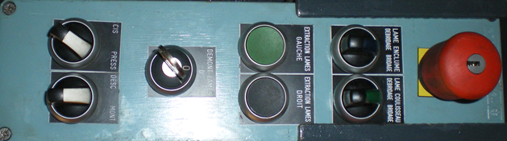  4.1. to make the blade replacement easier the shear press is equipped with a mobile control unit for driving the movements of the shear head.  4.2. This control unit is including movements up and down for the shear cylinders and hold-down, the extractors of the inferior shear frame blade and the hydraulic locking of the lower blade.  4.3. On the main cabinet, put switch with key « console blade desk » onto « 1 ». Remove the key and then activate it on the switch with key « BLADES CHANGING » of the blade removal control unit.Select the switch « shear blade change » on « 1 ».
4 Change the upper blades
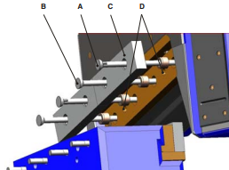

Danger! Risk of severe injury if blade falls down! Never remain under the blade during disassembly or assembly. To change the upper blade you need also a wooden plank, in addition to the tools required.

4.1 Disassemble the blade guard on the upper blade.
4.2 Unscrew the nuts of the blade-clamping device.
4.3 Remove one blade bolt A from the blade holder. Leave the second blade bolt B in place for safety reasons.
4.4 Insert a suitable round bar into the opening.
4.5 Place a wooden plank in the press box, onto which you can lower the upper blade.
4.6 Remove the second blade bolt B from the blade holder.
4.7 Loosen the upper blade C by striking a round bar, which is inserted through the drill hole D into the blade slide.
4.8 The blade is now resting on the round bar inserted from the front. Set the upper blade C down on the wooden planks.
4.9 Assemble the upper blade in reverse sequence to disassembly.

4   | 5. Change the lower blades.  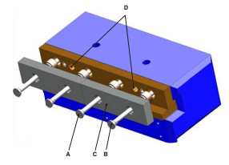  5.1 Unscrew the nuts of the blade-clamping device.  5.2 Remove one blade bolt A from the blade holder. Leave the second bolt B in place for safety reasons.  5.3Insert a suitable round bar into the opening. Remove the second blade bolt B from the blade holder.  5.4Loosen the lower blade C towards the front by striking a round bar. Remove the blade.  5.5. Assemble the lower blade in the reverse sequence.
5 | Check installation and re-instate shear into production.  5.1.Check blades are installed correctly, bolts tightened and locked.  5.2 Remove access platform  5.3 Remove decap.  5.4 start shear and move head up/down to ensure correct blade clearance.  5.5 hand over shear back to operation.
6 | End of procedure

- Appendices
…..

