Partial surrender notice with introductory note
The Environmental Permitting (England & Wales) Regulations 2016

SI Green UK Limited

Cwmrhydyceirw Quarry Landfill
Vicarage Road
Cwmrhydyceirw
Morriston
Swansea
SA6 6DR

Surrender application number
EPR/TP3835LV/S005

Permit number

EPR/TP3835LV

Cwmrhydyceirw Quarry Landfill

Permit number EPR/TP3835LV

Introductory note

This introductory note does not form a part of the notice

The following notice gives notice of the surrender in part of an environmental permit.

This partial surrender relates to the part of the total installation area on which the landfilling operations have not been carried out and on which they will not be carried out. The remaining area contains all the waste which has been deposited at the site and the infrastructure both existing and proposed which will be necessary for the continued management of surface water, groundwater and leachate.

The remaining part of the site is the subject of an application for closure. That application will be assessed on its own merits in due course.

Any changes made as a result of the partial surrender are set out in the schedules.

The status log of a permit sets out the permitting history, including any changes to the permit reference number.

Status log of the permit
Description | Date | Comments
Application TP3835LV (EP ref EA/EPR/TP3835LV/A001) | Duly made 15/02/2006
Response to requests for information | 16/08/2006 | Response 29/09/2006
Response to requests for information | 16/11/2006 | Response 14/12/2006
Response to requests for information | 18/12/2006 | Response 19/01/2007 & 26/01/2007
Response to requests for information | 13/02/2007 | Response 28/03/2007
Response to requests for information | 09/03/2007 | Response 23/04/2007
Response to requests for information | 18/07/2007 | Response 24/08/2007
Response to requests for information | 17/12/2007 | Response 22/02/2008
Response to requests for information | 09/04/2008 | Response 18/04/2008
Permit TP3835LV determined | Date of Issue 09/12/2008
Variation application EPR/TP3835LV/V002 | Duly made 27/10/2010
Request for further information | 10/11/2010 | 01/12/2010
Variation determined EPR/TP3835LV/V002 | 24/12/2010 | Varied permit issued.
Variation application EPR/TP3835LV/V003 | Duly made 28/08/2014 | Variation application to add a discharge to surface water
Additional information received | 17/12/2014 | Schedule 5 Notice response providing additional information required for modelling potential impact upon the Cwmrhydyceirw Stream.
Variation determined EPR/TP3835LV/V003 | 30/04/2015 | Varied permit issued.
Closure application PAN-004085 | 06/12/2018 | Received
Partial surrender application PAN-004216 | 17/12/2018 | Received
Closure application PAN-004085 and Partial Surrender application PAN-004216 | 19/07/2019 | Additional Information received
Variation EPR/TP3835LV/V004 | 16/10/2019 | Variation issued
Additional information received partial surrender application EPR/TP3835LV/S005 | 12/02/2020 | Updated proposed post partial surrender site plan
Additional information received partial surrender application EPR/TP3835LV/S005 | 12/06/2020 | Updated proposed post partial surrender site plan
Part surrender application EPR/TP3835LV/S005  determined | 23/06/2020 | Part surrender issued

End of introductory note

Notice of surrender
The Environmental Permitting (England and Wales) Regulations 2016

The Natural Resources Body for Wales (“Natural Resources Wales”) in exercise of its powers under regulation 25 of the Environmental Permitting (England and Wales) Regulations 2016 accepts the surrender in part of

Permit number

EPR/TP3835LV

issued to

SI Green UK Limited (“the operator”)

whose registered office is

c/o Harris Bassett

5 Llys Felin Newydd

Phoenix Way Enterprise Park

Swansea

West Glamorgan

SA7 9FG

company registration number 02777304

to operate a regulated facility at

Cwmrhydyceirw Quarry Landfill

Cwmrhydyceirw Quarry

Vicarage Road

Cwmrhydyceirw

Morriston

Swansea

SA6 6DR

to the extent set out in the schedules.

The notice shall take effect from 23/06/2020.

Signed | Date
Holly Noble | 23/06/2020

Authorised on behalf of Natural Resources Wales

Schedule 1 – conditions to be deleted

None.

Schedule 2 – conditions to be amended

The following conditions are amended as detailed, as a result of the application made by the operator.

Condition 2.2.1 shall now read as follows:

2.2.1 The activities shall not extend beyond the site, being the land shown edged in green on the site plan at schedule 2 to this permit.

Table S1.5 in Schedule 1 shall be amended and replaced in its entirety as follows:

Table S1.5 Annual waste input limits
Category | Limit Tonnes/ Year
Non-hazardous waste for disposal | 0
Inert waste for disposal | 0
Waste for recovery | 40,000

Schedule 3 – conditions to be added

None.

Schedule 4 – amended plan

The site plan in Schedule 2 of the permit is replaced with the following site plan.

Site plan

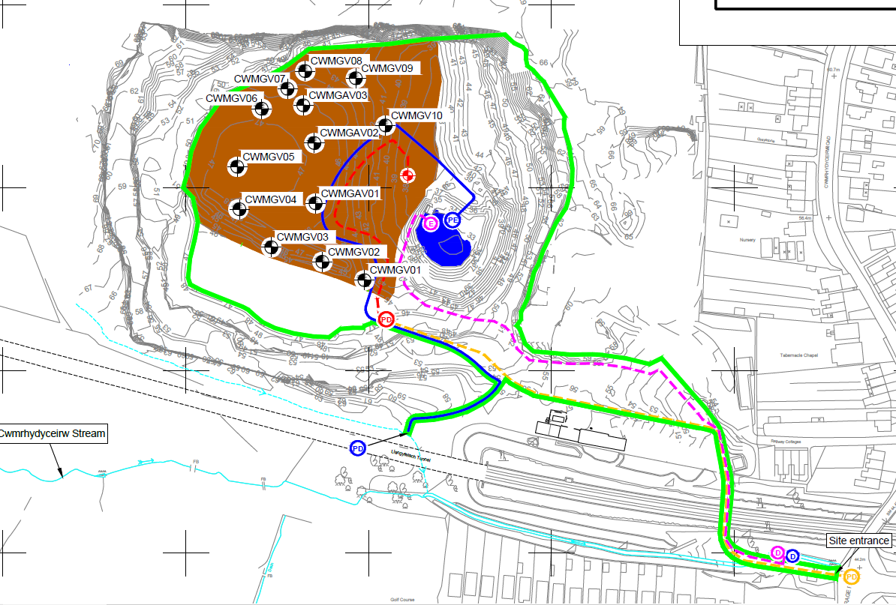

© Crown Copyright and database right 2020. Ordnance Survey licence number 100019741.

