Permit

The Environmental Permitting (England & Wales) Regulations 2016

TXO Systems Ltd

TXO Systems Ltd
Unit 3 to 5
Severn Cross Distribution Park
Newhouse Farm Industrial Estate
Mathern
Chepstow
NP16 6UP

Permit number

EPR/AB3297TQ

Permit
The Environmental Permitting (England and Wales) Regulations 2016
Permit number

EPR/AB3297TQ

The Natural Resources Body for Wales (“Natural Resources Wales”) authorises, under regulation 13 of the Environmental Permitting (England and Wales) Regulations 2016

TXO Systems Ltd (“the operator”),

whose registered office is

Finance & Administration Dept

Unit 3 Severn Cross Distribution Park

Newhouse Farm Ind Estate

Chepstow

Monmouthshire

NP16 6UP

company registration number 05479601

to operate waste operations at

TXO Systems Ltd

Unit 3 to 5

Severn Cross Distribution Park

Newhouse Farm Industrial Estate

Mathern

Chepstow

NP16 6UP

to the extent authorised by and subject to the conditions of this permit.

Under regulation 27(2) of the Regulations, standard rules SR2008 No23 are conditions of this permit.

Name | Date
Huw Davies | 09/01/2024

Authorised on behalf of Natural Resources Wales

Schedule 1 - Site plan

This is the plan referred to in the standard rules SR2008 No23

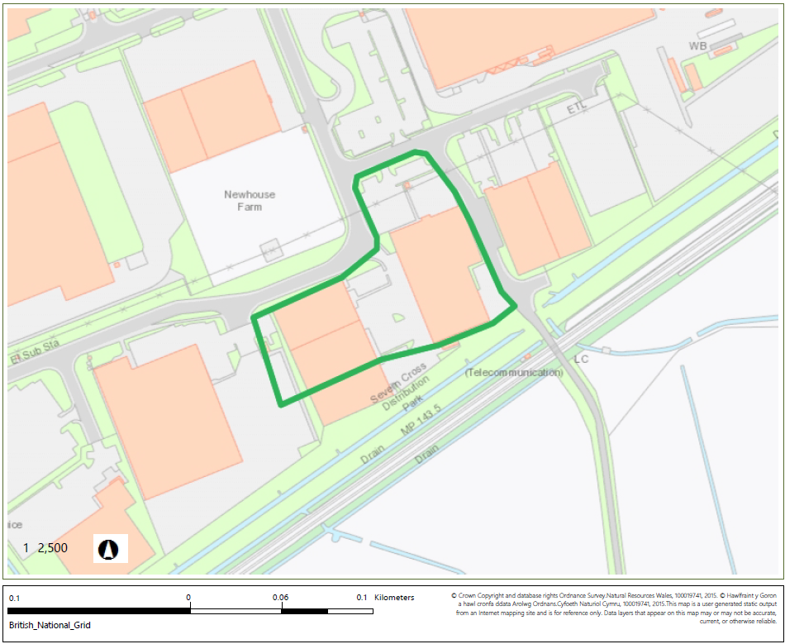

© Crown Copyright and database right 2023. Ordnance Survey licence number 100019741.

END OF PERMIT

