Record of a Habitats Regulations Assessment of a project
March 2016

OGN 200 Form 1
Document owner: Protected Sites Team, KSP

Version History:
Document Version | Date Published | Summary of Changes
1.0 | March 2016 | Document created
Review Date: February 2017

Record of a Habitats Regulations Assessment of a project

Contents

Section

1. Project details

- External applications to NRW

- Internal NRW projects

2. Determining whether HRA is required

3. Test of likely significant effect

- Screening of renewals

- Identifying likely significant effects

4. Appropriate assessment

- In the absence of additional conditions or restrictions

- Taking into account additional conditions or restrictions

5. In combination assessment

6. Conclusion

7. Record of consultation with protected sites advisors

8. Conservation Technical Specialist’s comments (to be completed only where HRA sign off and protected sites advice are done by the same team)

1. Project Details

1(b): Project details where NRW is the project proponent/instigator
NRW Project reference | RML2369
Activity proposed | Natural Resources Wales are developing a fish passage improvement scheme on the tidal section of  the River Afan in Port Talbot. The project is looking to improve passage over a weir structure, located at  NGR SS 75522 89195 that is impassable to fish at mid­low tide.  As part of the design of the project, a series of ground investigations work is being undertaken however, only the window samples located along the proposed fish pass alignment to confirm the stratigraphy, are subject to a marine license as these are located in the channel (below MHWS).  Please refer to the green labels on the map provided under the Location section below for the window sample locations.  The samples will be taken using a small window-sampling rig that will be pushed by hand to the sampling points at low-tide.
Statutory basis | Marine and Coastal Access Act 2009
Location | Newbridge, Port Talbot ­ Ground Investigation  - 51.588787, -3.7970934  - 51.588382, -3.7988530  - 51.587641, -3.7991125  - 51.587346, -3.7972098  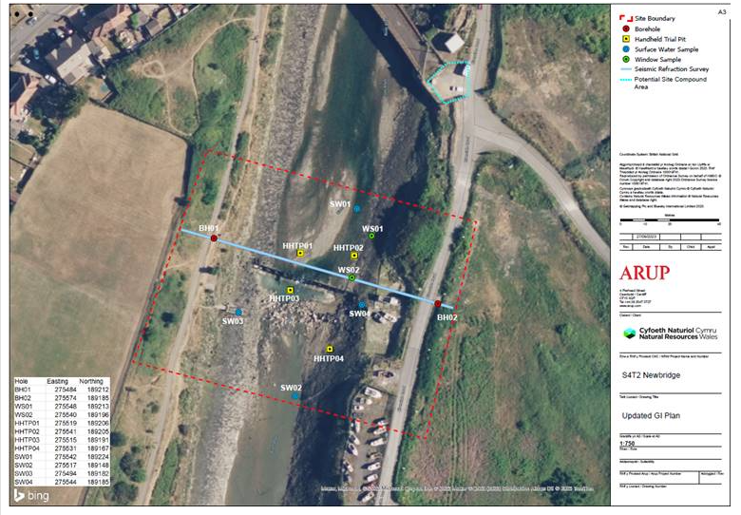
NRW team responsible for carrying out the project, and name of lead officer | Projects and Programme Delivery  Elinor Meloy
NRW team responsible for drafting this HRA report, and name of lead officer | Marine Licensing Team  Siân Marie Hughes
Project documents | RML2369 Application Form – dated 27.11.2023  RML2369 – 270923 Updated GI Plan.pdf  RML2369 – Confirmation of coordinates and predicted noise level – email dated 19.12.2023  RML2369 – Access routes.png  RML2369 – Ground Investigation Location Plan
Environmental Statement | N/A

2. Determining the need for a Habitats Regulations Assessment

2.1 Is the whole of the project directly connected with or necessary to the management of one or more Natura 2000 sites, for the purposes of conserving the habitats or species for which the Natura 2000 site(s) is/are designated? | NO
2.2 Is there a possibility that the project could affect a different Natura 2000 site to the one(s) the project is intended to conserve? | N/A
2.3 Is it necessary to carry out an HRA? | NO  The work site is not located within 5km of any designated sites. Due to the small scale and nature of the works, no detrimental impacts are expected.  The proposed window samples are considered low risk removal activity.

6. Conclusion

HRA is not required because the whole of the project is directly connected with or necessary to the management of one or more Natura 2000/Ramsar sites, for the purposes of conserving the habitats or species for which the site(s) is/are designated, and the project is not likely to have a significant effect on any other Natura 2000/Ramsar sites.
(As documented in section 2.1 and 2.2 of this form)

HRA is not required because there is no conceivable impact pathway to any Natura 2000/Ramsar site  (As documented in section 2.3 of this form) | X
This project is a renewal of a current permission which complies with NRW agreed criteria for ruling out significant effects of a renewal without conducting a project-specific LSE test. Therefore it is considered not likely to have a significant effect on any Natura 2000/Ramsar sites, either alone or in-combination with other plans and projects.
(As documented in section 3.1 of this form)

The project has been screened for likelihood of significant effects and, taking account of the advice received from protected sites advisors, is considered not likely to have a significant effect on any Natura 2000/Ramsar site
(As documented in section 3.2 of this form, or section 5 if applicable)

In light of the conclusions of an appropriate assessment, and taking account of the advice received from protected sites advisors, it has been established that the project will not adversely affect the integrity of any Natura 2000/Ramsar site, taking into account any conditions or restrictions as applicable, either alone or in-combination with other plans and projects.
(As documented in section 4 of this form, and section 5 if applicable)

In light of the conclusions of the appropriate assessment, it has not been ascertained that the project will not adversely affect the integrity of any Natura 2000/Ramsar site, as documented in section 4 of this form, and section 5 is applicable.

Approval for the project cannot be given unless either:
- the project specification, and/or the terms under which it might be approved, are modified so as to remove the risk of adverse effects, and a revised HRA report is prepared, or
- the project satisfies the requirements of Article 6(4) of the Habitats Directive, an Article 6(4) Statement of Case is prepared (OGN 200 Form 3) and submitted for consideration by the appropriate authority, normally Welsh Ministers

Signed: 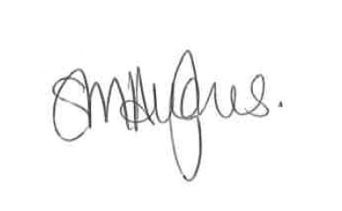

Name: Siân Marie Hughes

Position: Senior Marine Licensing Officer

Date: 12.01.2024

