PAN-022335 MyMap report

Application site plan
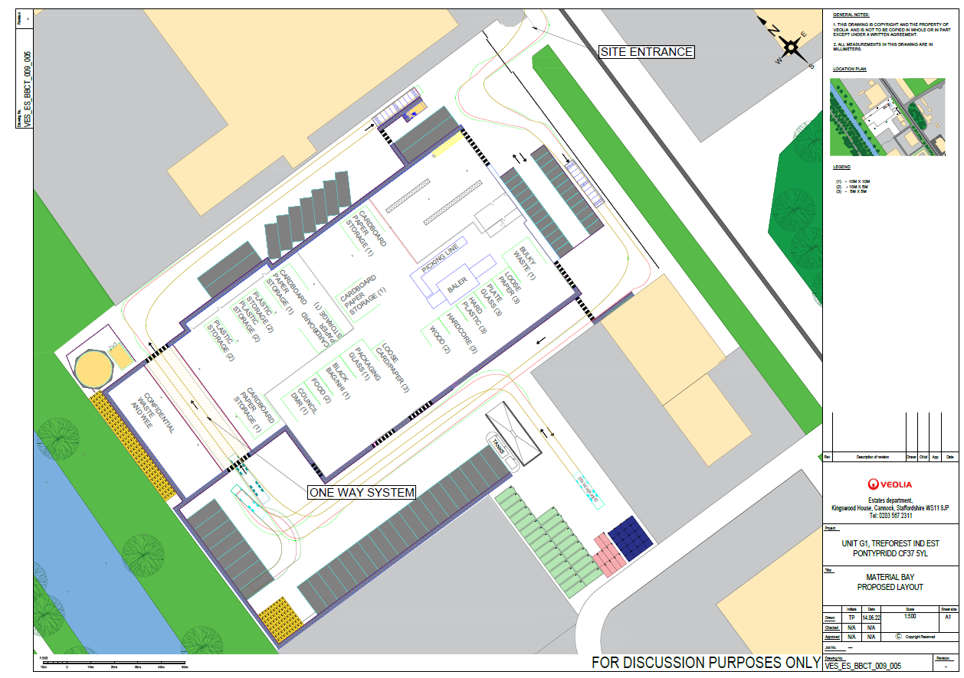
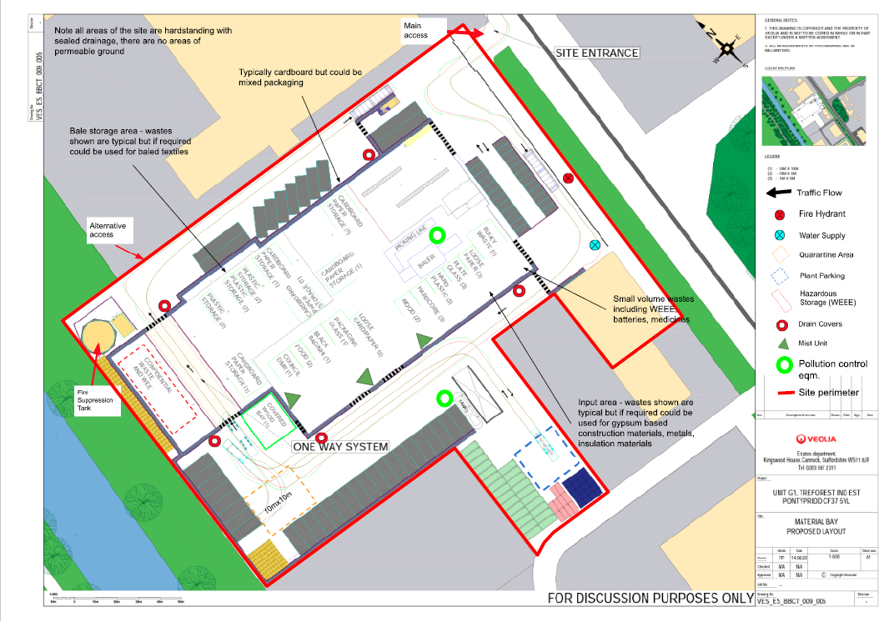
Proximity to Human Occupation
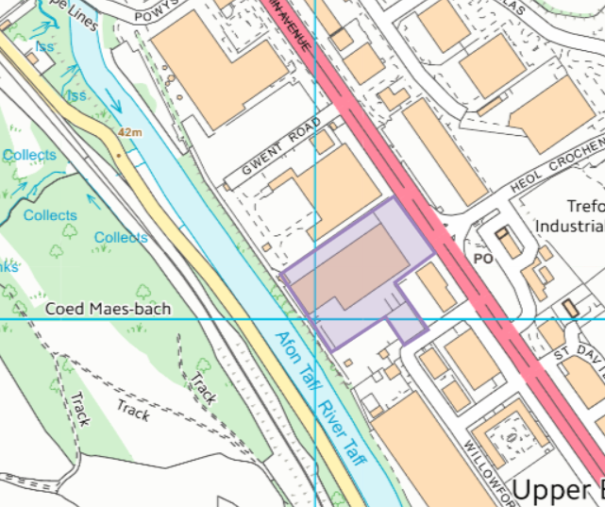

Assessment under wildlife, countryside or habitats legislation
- No SAC, SPA, Ramsar within 1km
- No SSSI within 2km. Gwaun Gledyr is just over 2km away from presumed site boundary

Groundwater/Aquifers
- Aquifer Designation (Superficial)
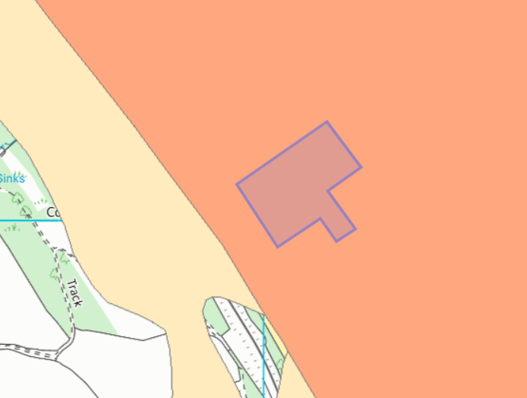
- Not within a GPZ

- Aquifer Designation (Bedrock)
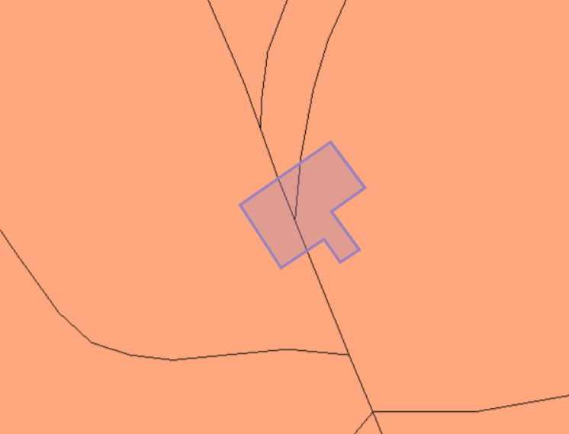
- Not within a GPZ

Sensitivity of surface water
Direct run-offs

Air Quality Management Zone
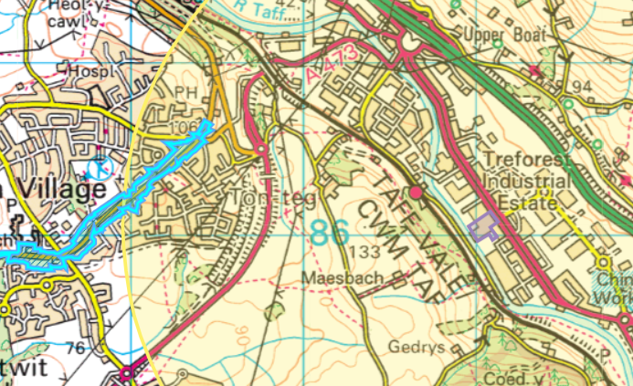
Tonteg-Church Village-Llantwit Fardre (A473) AQMA
- An area encompassing properties along both sides of the A473 through Tonteg, Church Village, Llantwit Fardre.
- POLLUTANTS- NO2
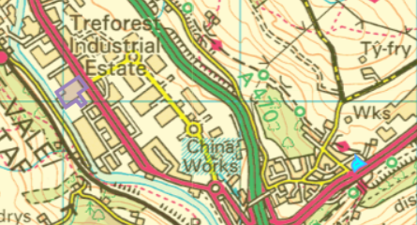
Nantgarw AQMA
- An area in Nantgarw encompassing the properties at Graig View along the western edge of the A468.
- POLLUTANTS- NO2
Flood Plain
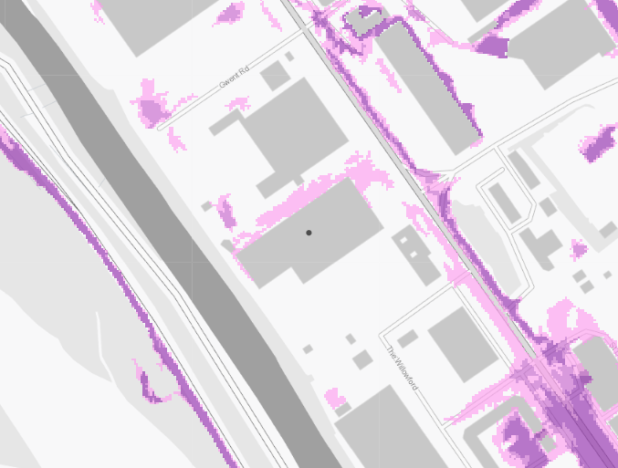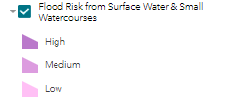
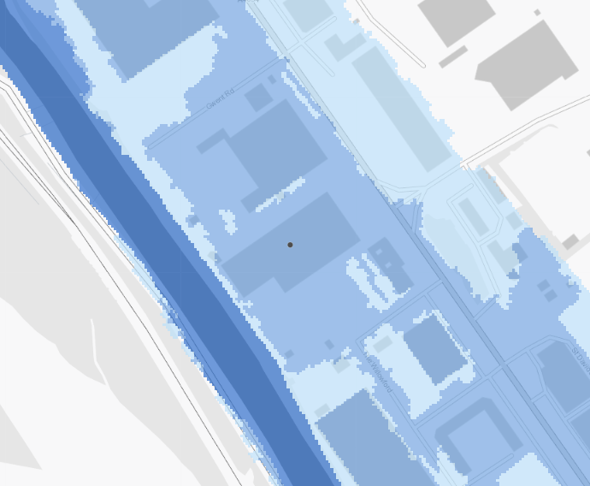

national parks
- None within 1km
areas of outstanding natural beauty (AONBs)
- None within 1km
marine conservation zones
- None within 1km

ancient woodlands
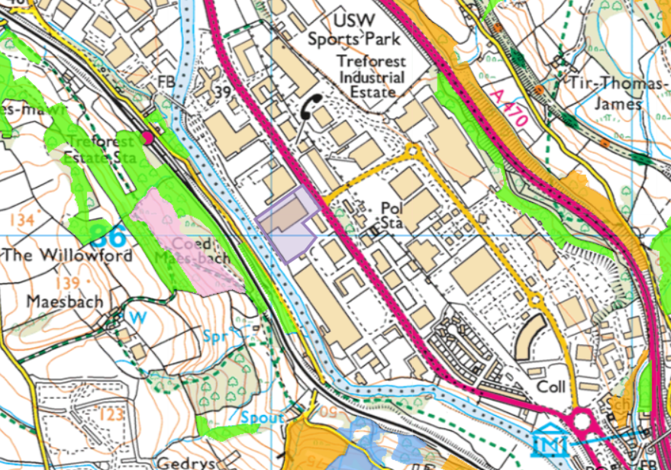

protected habitats/species and section 6/7 species
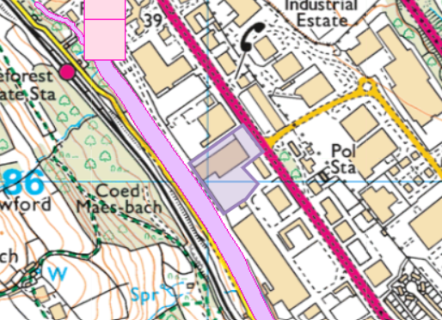
European Eel migratory route, Atlantic Salmon migratory route, Bullhead, European Eel
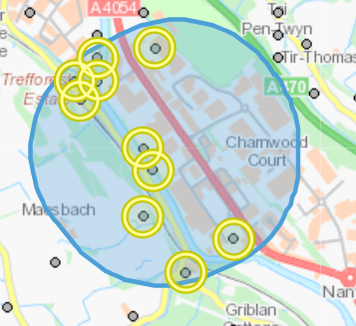
Birds- Black-headed Gull, Dunnock, Eurasian Bullfinch, European Herring Gull, House Sparrow, Kestrel, Marsh Tit, Song Thrush, Starling
Butterflies and Moths- Small Phoenix
Fish- Atlantic Salmon, Brown/Sea Trout, European Eel
Mammals- European Otter, Soprano Pipistrelle, West European Hedgehog

historic items (ancient monuments, historic sites etc.)
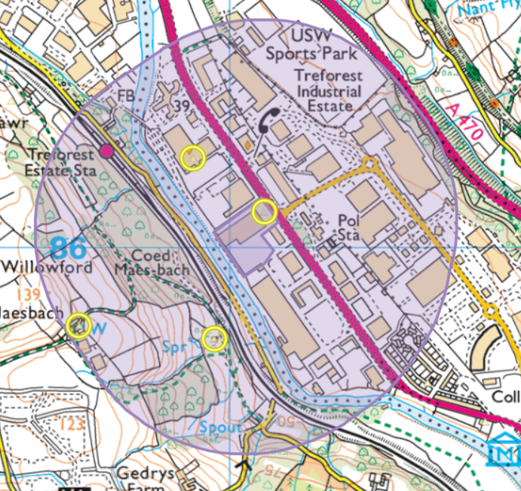
TREFOREST TRADING ESTATE; TREFOREST INDUSTRIAL ESTATE- Commercial- INDUSTRIAL ESTATE- Modern
MAES BACH-Domestic DWELLING Post Medieval
RHYD-YR-HELYG COLLIERY, TREFOREST- Industrial- COAL MINE- Post Medieval
TREFOREST TEXTILE PRINTERS-Industrial- PRINTING WORKS- Post Medieval
Listed building:
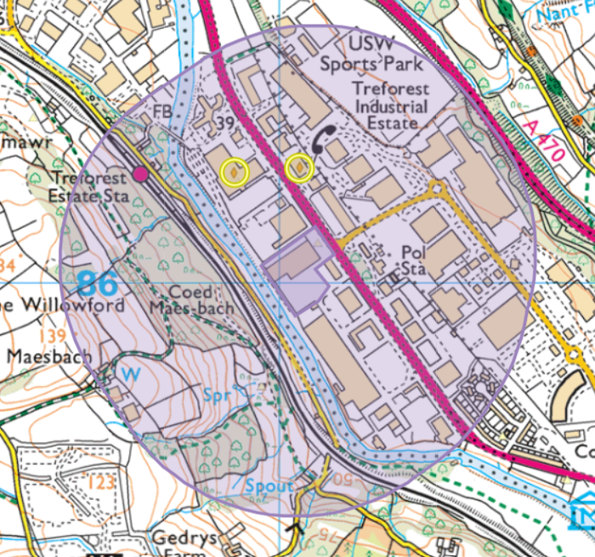
- Treforest Textile Printers
- Honeywell Power Tools Testing Division

local wildlife sites
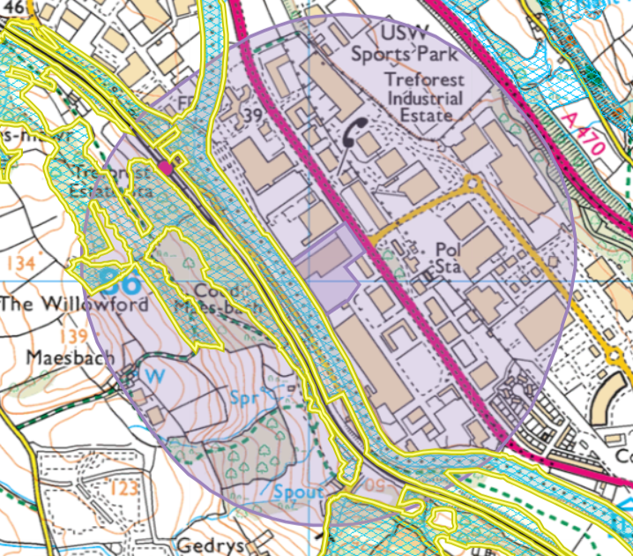
Taff and Rhondda Rivers
Coed y Gedrys & Garth-fawr
The Willowford

surface water courses (sinks/issues/springs/wells etc.)
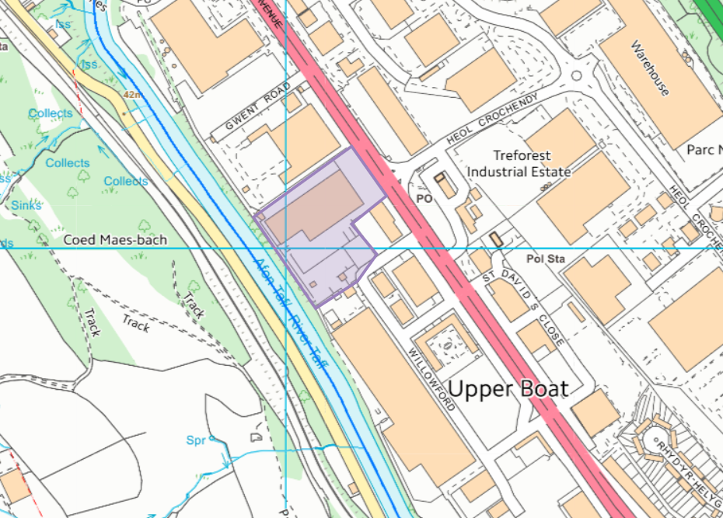
River Taff

