Ein cyf/Our ref: DMS BP0314801
Eich cyf/Your ref

Natural Resources Wales/Cyfoeth Naturiol Cymru
Maes Newydd
Llandarcy
Neath Port Talbot
SA10 6JQ.

Ebost/Email:
philip.morgan@cyfoethnaturiolcymru.gov.uk
philip.morgan@naturalresouceswales.gov.uk

Ffôn/Phone:
0300 065 4047
Sonia Hyland
Dyffryn Arms
Neath Road
Bryncoch
Neath
SA10 7YF

19 August 2019

Dear Sonia Hyland,

We have received a report of a strong odour of sewage located at the stream near to the Dyffryn Arms, Neath Road, Bryncoch.

Having checked our records we have identified that you have an exemption for the operation of a Sewage Package Treatment Plan at the Dyffryn Arms. We would like to ask that you check your Sewage Package Treatment Plant to ensure it is operating as designed.

I would like to bring to your attention that there are a number of conditions than need to be complied with, in order for this exemption to remain valid. Here is a summary of these conditions:-
- You may only discharge domestic sewage
- It must be properly treated
- You must operate and maintain your sewage treatment systemas recommended by the manufactureror by the guidance in the appropriate operating Code of Practice. This includes regular removal of excess sludge from the system.
- You must maintain the plant properly, using competent people
- You must dispose of any waste sludge removed from the sewage treatment system in an appriopriate controlled way using licenced and competent disposal contractors.

I would like to ask that you contact me to discuss these conditions to ensure you are compliant with these requirements.

Yours faithfully,
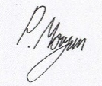

Philip Morgan
Uwch-swyddog Amgylchedd/Senior Environment Officer
Ffôn/Tel 03000 654047
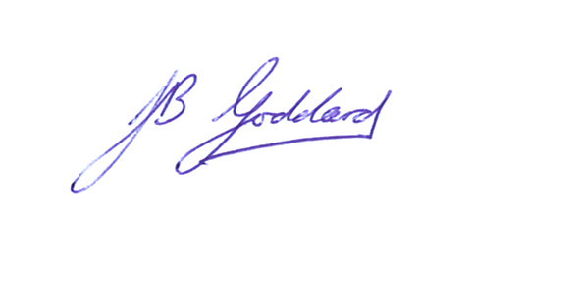
Ebost/Email philip.morgan@naturalresourceswales.gov.uk

