Mr Brian Sheppard  Glynclydach Hotel  Longford Road  Dyffryn  Neath  SA10 7AJ | Ein cyf/Our ref: BM0044301  Dyddiad/Date: 20 August 2019
WARNING LETTER

Dear Sir,

Environmental Permit: BM0044301 Discharge of effluent from sewage treatment works at Glynclydach Hotel

We believe that you have committed the following offence:

Offence: Contravention of Regulation 38 (1)(a) of the Environmental Permitting (England and Wales) Regulations 2016, by causing or knowingly permitting a water discharge activity, except under and to the extent authorised by an environmental permit.

Discharging effluent with a BOD of 144mg/l. and a suspended solids of 89 mg/l. which does not comply with condition 4 of environmental permit BM0044301.

Date: On or before 29 July 2019

We have issued this warning letter as a response to the above offence on this occasion. However, our decision could change if any further relevant information comes to light, including, but not restricted to, information that:

- you/the company has committed earlier offences.
- the environmental impacts of this offence are greater than we presently understand them.
- the offences are continuing or have been repeated.
- You/ the company has committed other offences of which we are presently unaware.

We will take this offence into account if we consider that you/the company are involved in any future offending.

This warning does not:
- prevent any other prosecuting authority taking action against you/the company; or
- affect our right to issue enforcement, clear-up or remediation notices, or seek recovery of costs or damages according to law.

Yours faithfully

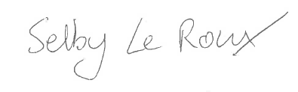

Selby Le Roux
Arweinydd Tîm/Team Leader
Tîm Amgylchedd / Environment team

Ffôn/Tel 03000 654041
Ebost/Email selby.leroux@cyfoethnaturiolcymru.gov.uk

