Natural Resources Wales Permitting decisions

Refusal of permit application PAN-020272

We have decided to refuse the permit application for Bala Camping and Caravanning Club Site operated by The Camping and Caravanning Club Ltd.

The applicant is Ms. Sabrina Voysey.

The facility location is Crynierth Caravan Park, Cefn Ddwysarn, Gwynedd, LL23 7LN.

The proposed discharge was for a new bespoke surface water discharge of 19.785 cubic metre a day of domestic sewage effluent. The effluent would originate from 25 tent pitches, 45 caravan/mobile home pitches, 1 site manager’s pitch, 1 assistant site manager pitch and 4 day staff. The treated sewage would be discharged directly into Afon Meloch which is part of the Dee River catchment. The caravan park was established in 1988 along with the existing septic tank and drainage field sewage treatment system. The applicant purchased the site in 2010 and is proposing a new package treatment plant to be installed. The model of the treatment plant was not provided in the application, though the applicant states that it will be either a WPL, HiPAF or SAF to be determined when the permit is issued to meet the required parameters. The existing system is looking to be replaced as it is reportedly requiring increased levels of maintenance and is nearing the end of its useful life. The septic tank and drainage field were in place upon purchase in 2010 and there is insufficient available land of suitable quality for a new drainage field. The applicant has expressed that they are not seeking to investigate the extent and efficacy of the current system with the incurred costs of surveying, when the option to discharge to the nearby watercourse exists.

We consider in reaching that decision we have taken into account all relevant considerations and legal requirements.

Purpose of this document

This decision document:
- explains how the application has been determined
- provides a record of the decision-making process
- shows how all relevant factors have been taken into account.

Unless the decision document specifies otherwise, we have accepted the applicant’s proposals.

Structure of this document

- Compliance Assessment of Welsh River SACs against Phosphorus targets
- Annex 1 the Key Issues and reasons for refusal

Compliance Assessment of Welsh River SACs against Phosphorus targets

In 2021 NRW published a report which shows that five (Dee, Cleddau, Teifi, Usk, Wye) of the nine Special Areas of Conservation (SAC) rivers in Wales are failing to meet the targets set out by the Joint Nature Conservation Committee (JNCC) in 2016 to protect the SAC’s (Natural Resources Wales / Update to phosphorus targets for water bodies in Special Area of Conservation (SAC) rivers in Wales ).

As a consequence, we updated our Planning Advice to Local Authorities in relation to developments in SAC catchment areas (Natural Resources Wales / Advice to planning authorities for planning applications affecting phosphorus sensitive river Special Areas of Conservation ) and also developed a permitting policy for new discharges that contain phosphates within these SAC catchments. Our permitting policy states that applications for these new discharges are to be refused on the basis that additional phosphorus loading to the catchment of a SAC river that is already failing its Conservation Objectives in relation to phosphorus, will further undermine those objectives and have an adverse effect on site integrity. Development within already failing SAC catchment may only proceed if they demonstrate no additional phosphorus loading i.e. the development is ‘Nutrient Neutral’ ( Natural Resources Wales / Principles of nutrient neutrality in relation to development or water discharge permit proposals ).

Annex 1: Key Issues and reasons for refusal

As the application involves a new discharge to surface water within one of the five failing catchments, we have decided to refuse the application PAN-020272 for an environmental permit for a water discharge activity received on 22/12/2022 for a new bespoke surface discharge for the site. The discharge would be via Package Treatment Plant directly into Afon Meloch at National Grid Reference (NGR) SH 96314 38933.

The impacted watercourse forms part of a designated site: River Dee and Bala Lake Catchment Special Area of Conservation (SAC)(UK0030252), designated under the Conservation of Habitats and Species Regulations 2017 and is further a Special Site of Scientific Interest (SSSI)(River Dee SSSI (2554)).

The decision to refuse the permit application is based on our assessment of the potential environmental impact on the SAC. It can be demonstrated that the proposed discharge would have an ‘Adverse Effect on Integrity’ (AEoI) of the designated site.

How we reached our decision

The River Dee and its tributaries, which includes the Afon Meloch, represents a large, linear ecosystem. It acts as an important wildlife corridor, an essential migration route and a key breeding area for many nationally and internationally important species. The River Dee and Bala Lake SAC (UK0030252) and River Dee SSSI are designated for the species, habitat types and general site characteristics listed below (Natural Resources Wales / Find protected areas of land and sea).

Table 1. River Dee and Bala Lake SAC (UK0030252) and River Dee designated species and habitats.
River Dee and Bala Lake SAC (UK0030252)
Watercourses of plain to montane levels with the Ranunculion fluitantis and Callitricho-Batrachion Vegetation
Atlantic salmon Salmo salar

Floating water-plantain Luronium natans

Sea lamprey Petromyzon marinus

Brook lamprey Lampetra planeri

River Lamprey Lampetra fluviatilis

Bullhead Cottus gobio

European otter Lutra lutra.

River Dee SSSI (2554)
Type VII Mesotrophic upland plateau rivers

Type VIII Moderate-gradient sand/shale rivers below uplands.

Type VI Middle reaches of upland rivers traversing more base rich strata.

Type II Clay rivers with diverse substrates and flow patterns.

Saltmarsh / freshwater transition habitats

A range of habitat types qualifying as a mixture

Slender hare’s-ear Bupleurum tenuissimum

Sea barley Hordeum marinum

Hard-grass Parapholis strigosa

Club tailed dragonfly Gomphus vulgatissimus

Scare yellow sally Isogenus nubecula

Yellow crucifer weevil Aulacobaris lepidii

Atlantic salmon Salmo salar

Sea lamprey Petromyzon marinus

Brook lamprey Lampetra planeri

River Lamprey Lampetra fluviatilis

Bullhead Cottus gobio

European otter Lutra

Holt to Worthenbury Section - geological/ Geomorphological SSSI

Rhewl Section
ecological/ Geomorphological SSSI
Dee Bridge - geological/ Geomorphological SSSI
Bala Lake Ramsar / Bala Lake SSSI
The lake and aquatic / emergent vegetation.

Lake fen /swamp incl. wet woodland.Tegid
Fish. Coregonus lavaretus Gwyniad.

Invertebrate. Myxas glutinosa Glutinous snail.
Nationally important species. Luronium natans

To determine whether the development may have an AEoI on the SAC, there is a need to demonstrate a pathway for additional phosphorus produced by the development to reach the SAC.

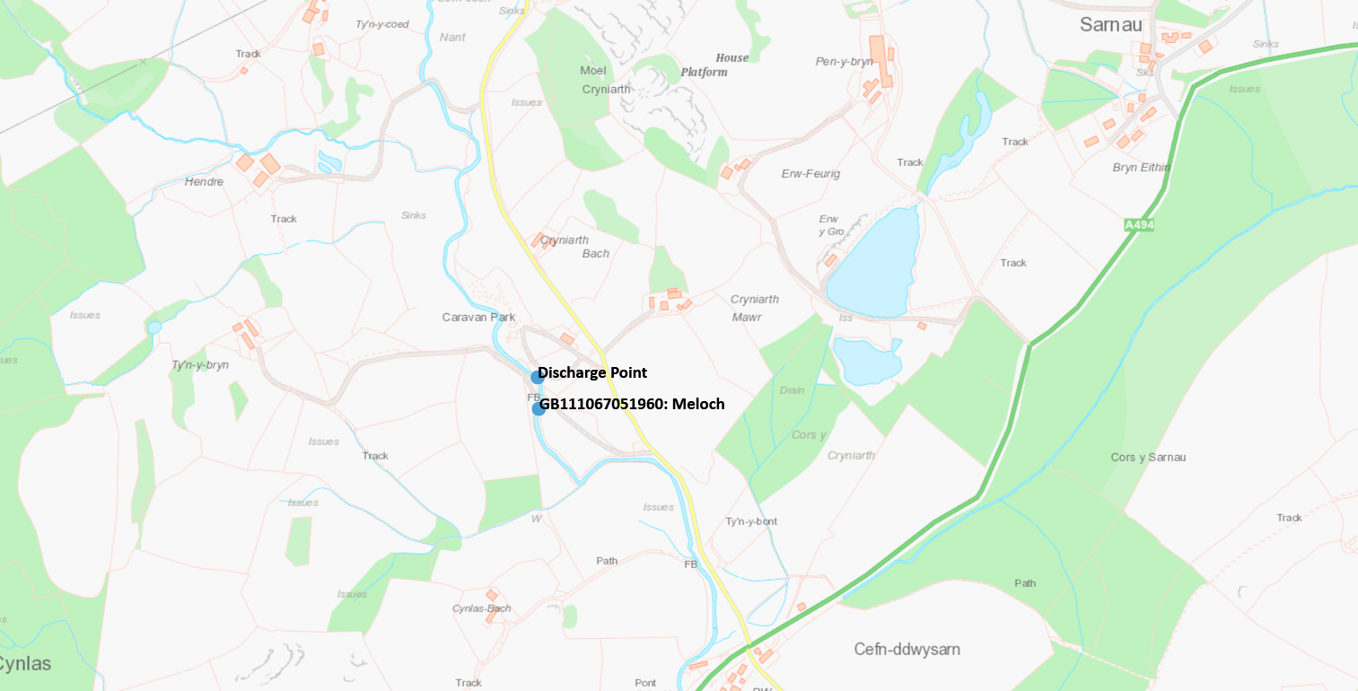
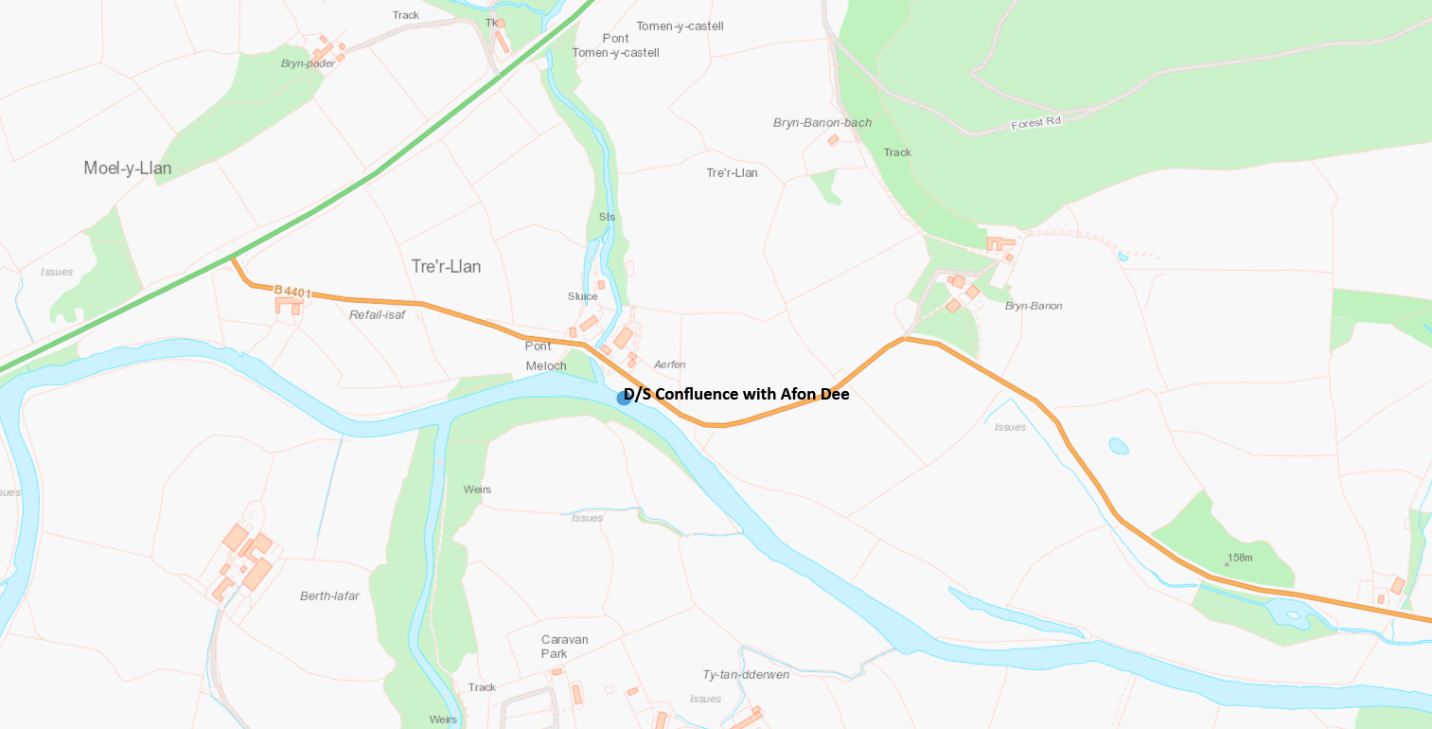

Figure 1: Map showing pathway between development and SAC

In order to inform the Habitats Regulations Assessment (HRA), discharge modelling was undertaken to assess the potential impact of the proposed discharge on the designated site. This was done using water quality dilution modelling using river quality planning software. The Core Management Plan for the SAC provides the water quality targets for each watercourse within the SAC network, with the proposed discharge going to; Afon Meloch water body WFD identification number GB111067051960. The achievement of these targets is a Conservation Objective of the Core Management Plan and include those species listed in the table above (Table 1). The phosphate target for the Afon Meloch is 0.01 mg/l. Internal consultation was also undertaken to assess the potential impact of the proposed discharge on the designated site. This was done by consulting technical specialists within the Environmental, Biodiversity and Conservation & Ecology who further provided their opinions on the application.

The discharge load of total phosphorus (TP) for the existing and proposed systems were calculated to estimate any potential impact from increased loading from the proposed development. Where possible, actual data was used in the calculations; if not available, the results of certified testing carried out by an independent testing provider on behalf of manufacturers was used. Where neither actual data nor certified testing data was available, referenced published data was used.

The calculations demonstrate an increase in the loading of TP into the environment post-development. There is no proposed mitigation solution to prevent additional phosphorus loading entering the environment. The pathway linking the discharge to the SAC means there is potential for AEoI of the designated site resulting from the additional loading of TP.

River modelling was undertaken to calculate the impact that the proposed discharge would have on the existing concentrations of ammonia, biochemical oxygen demand (BOD) and soluble reactive phosphorus (SRP) downstream of the proposed discharge point. Existing background concentrations for these parameters within the watercourse are listed in the WFD spreadsheet (‘2021_River-PhysChem_results_v6’). The table below illustrates the SAC Targets for these water quality parameters as set out within the Core Management Plan and the existing concentrations:

Table 4. SAC targets and existing concentrations.
Attributes | SAC Targets for Afon Meloch u/s River Dee (mg/l) | Existing concentrations Afon Meloch u/s River Dee  (mg/l)
Ammonia | 0.2 | 0.009383
BOD | 3 | 1.232414
Phosphate | 0.01 | 0.019726

Before any modelling was undertaken the above table demonstrates that the River Meloch u/s River Dee is already failing the target for SRP set in the Core Management Plan.

The data from the modelling shows that there will be a deterioration in the mean quality downstream of the proposed discharge point in River Meloch. This is based on a PTP with Phosphorus removal to 0.3mg/l Total Phosphorus (TP) as a mean. As a result, this would elevate the ‘Mean’ quality to 0.021025mg/l, a 0.001299 mg/l (or 6.59%)increase from the existing background conditions (noted in Table 4). As such, and with consideration of the implemented SAC target being 0.01mg/l, the results confirm a notable deterioration in water quality conditions, which would further increase during the growing season. Ultimately, a deterioration of the watercourse is in conflict with the SAC Core Management Plan targets (as per Appendix 2 of the Afon Dyfrdwy a Llyn Tegid SAC Core Management Plan).

Environmental Impact

Phosphorus is usually considered the “limiting nutrient” in freshwater aquatic ecosystems (National Aquatic Resource Surveys, 2017, Environmental Protection Agency USA) meaning that the available quantity of this nutrient controls the pace at which algae and aquatic plants are produced. In appropriate quantities, phosphorus can be used by vegetation and soil microbes for normal growth. However, in excess quantities, phosphorus can lead to water quality problems such as eutrophication and harmful algal growth. Some aquatic resources, such as wetlands, naturally serve as sinks for phosphorus found in sediments or dissolved in water. However, since phosphorus generally occurs in small quantities in the natural environment, even small increases can negatively affect water quality and biological condition.

NRW has an obligation to afford sufficient protection to species and habitats within sites designated under the Conservation of Habitats and Species Regulations (HSR).

Legislative Framework

Conservation of Habitats and Species Regulations 2017 + The Habitats Directive (92/43/EEC)
In 2019 the European Court of Justice ruled that for ‘designated sites’ where the conservation status is unfavourable then authorising activities that affect the ecological situation is “necessarily limited”. ‘Designated sites’ in this instance refers to Special Areas of Conservation (SAC), Ramsar, Special Protection Areas (SPA) and potential SPA sites. Additionally, the law stated that any developments in their respective catchments would have to demonstrate that there would be no likely significant effect (LSE) from the development on the downstream designated site.

Environmental Permitting (England and Wales) Regulations (EPR) 2016

Summary and Conclusion:
In summary, we have decided to refuse this application for the following reasons: -

We cannot conclude that the proposal, when considered alone, will not adversely affect the integrity of the SAC and its designating features. Total phosphate levels within the final effluent, taking into consideration the level of treatment, are not sufficient enough to prevent further deterioration of the SAC.

The applicant would therefore need to demonstrate that no phosphate could reach the SAC before we could consider granting a permit. It is the opinion of the Environment Team that an alternative course of action remains seeking a groundwater discharge. We sympathise with the applicant’s comments regarding available land constraints and would therefore recommend that an alternative means is sought, such as the acquisition of adjacent land parcels of suitably size to implement an infiltration system. Should the operator seek resubmission under groundwater discharge conditions, its location within a phosphorus sensitive SAC catchment would therefore require a quantitative groundwater risk assessment to show they demonstrate no hydrological connectivity with the SAC river (River Dee) and meet the requirement of nutrient neutrality. Our charges for permits under the Environmental Permitting Regulations are now reviewed on an annual basis and are normally implemented from 1st April subject to Welsh Government approval. Details of our current fees can be found on our website Natural Resources Wales / Our charging schemes.

Reference is made in this document to various EU directives, which as implemented in UK domestic legislation are still applicable.

