

 | Consent no | NRWWIA381
WATER INDUSTRY ACT 1991

SECTION 165 / 166

CONSENT TO DISCHARGE

TO: Dŵr Cymru Cyfyngedig
Linea
Fortran Road
St Mellons
Cardiff
CF3 0LT

The NATURAL RESOURCES BODY FOR WALES ("Natural Resources Wales") in pursuance of its powers under the Water Industry Act 1991 HEREBY CONSENTS to the making of a discharge as follows:

De-chlorinated water

FROM: talybont WTW, cwt, compartment 1, BRECON BEACONS, LD3 7YS
AT: NATIONAL GRID REFERENCE SO 10617 21065
TO: small brook leading to CAERFANELL RIVER
SUBJECT TO: the conditions set out in the following schedule:

De-chlorinated water Schedule No. NRWWIA381
This consent is issued on the 5th day of February 2024
This consent takes effect on the 9th day of February 2024
This consent shall cease to have effect on the 14th day of March 2024

Signed: Emma Jones

CONDITIONS OF CONSENT TO DISCHARGE
DE-CHLORINATED WATER (“the Discharge”)

NATURE OF THE DISCHARGE

1. The Discharge shall consist solely of de-chlorinated water

SOURCE OF THE DISCHARGE

- The Discharge shall be derived from Compartment 1, SRV, Talybont WTW

LOCATION OF DISCHARGE

3. The location of the Discharge shall be at NGR SO 10617 21065, marked ‘Discharge’ on the site plan in Annex 1.

SAMPLE POINT

4. A sample point shall be provided and maintained so that a representative sample of the Discharge may be obtained.

VOLUME

- The total volume of the Discharge shall not exceed 6,477 cubic metres.

- The total daily volume of the Discharge shall not exceed 1,850 cubic metres.

- The rate of the Discharge shall not exceed 21 litres per second.

COMPOSITION

8. The consent holder shall take all necessary steps to secure that any water discharged by it under this consent is as free as may be reasonably practicable from —
(a) mud and silt;
(b) solid, polluting, offensive or injurious substances;
and
(c) any substances prejudicial to fish or spawn, or to spawning beds or food of fish.

SCOURING

9. The rate of discharge shall be controlled to prevent any significant scouring of the bed or bankside of the receiving water.

FLOODING

10. The discharge shall not cause or significantly contribute to flooding in the downstream catchment.

PERIOD OF DISCHARGE

11. The Discharge shall only be made between 9th day of February 2024 and the 14th day of March 2024.

ANNEX 1- PLAN No. NRWWIA381

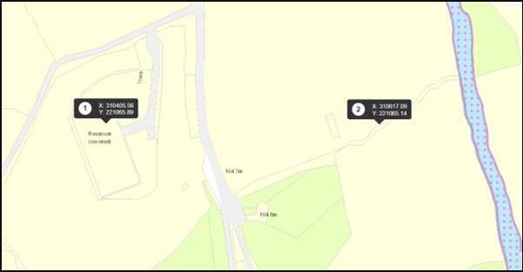

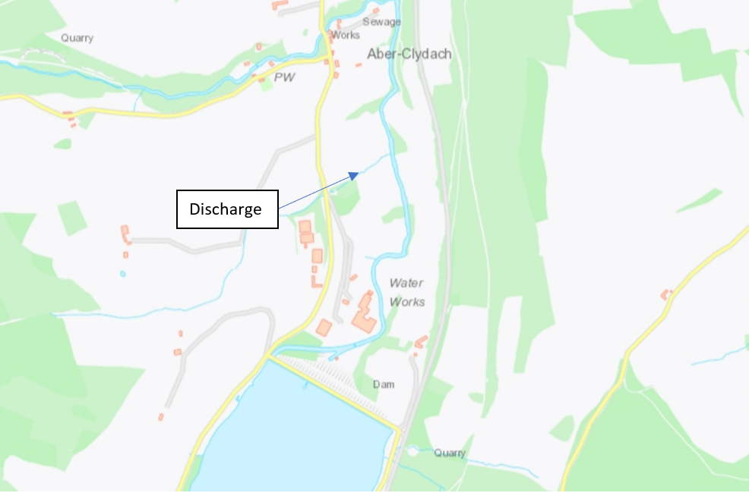

© Crown Copyright and database right 2024. Ordnance Survey licence number 100019741.

