PAN-023477 MyMap Report
Application map
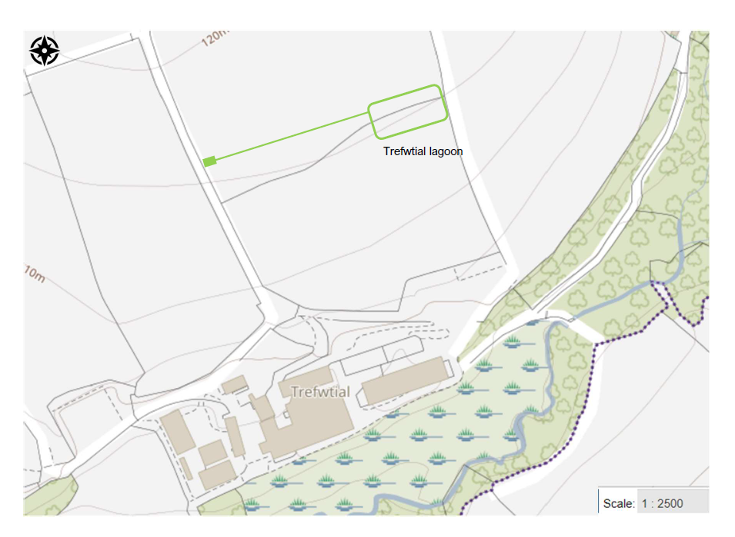
MyMap plot
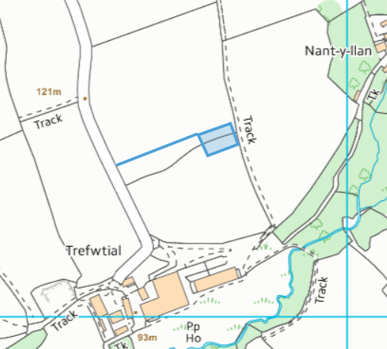

29/06/23 Google Earth
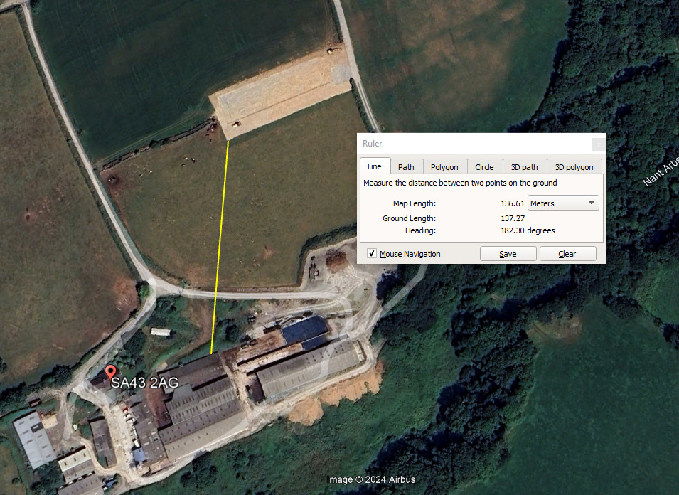
200 metres of a European Site (Special Areas of Conservation (SAC), Special Protection Area (SPA) or Ramsar) or a Site of Special Scientific Interest (SSSI);
- None

Within Groundwater Source Protection Zone 1;
- None

if a Source Protection Zone has not been defined then within 50 metres of any well spring or borehole used for the supply of water for human consumption. This should include private water supplies- Well, spring or borehole used for drinking water or domestic/ food production
- None

200 meters of any off-site building used by the public, including dwelling houses- Human occupation/building
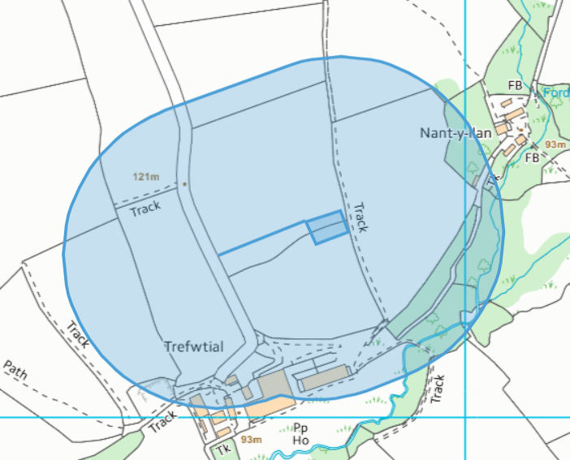
- Buildings for Trefwtial Farm and unknown building Nant-y-llan

