PAN-024179 MyMap Report
Pen Llyn a'r Sarnau / Lleyn Peninsula and the Sarnau SAC
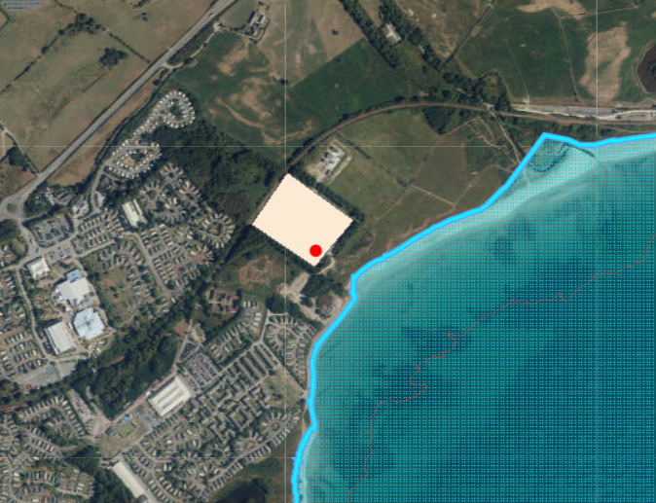

Glanllynnau a Glannau Pen-ychain i Gricieth SSSI
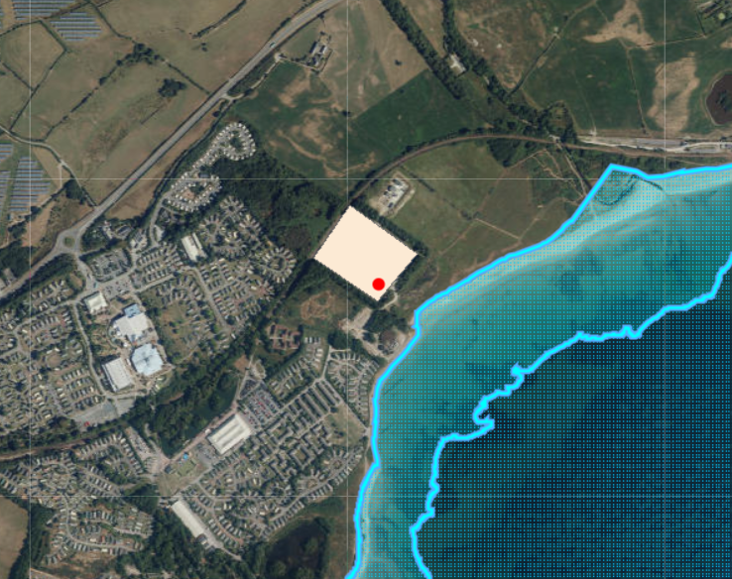

Ancient Woodland
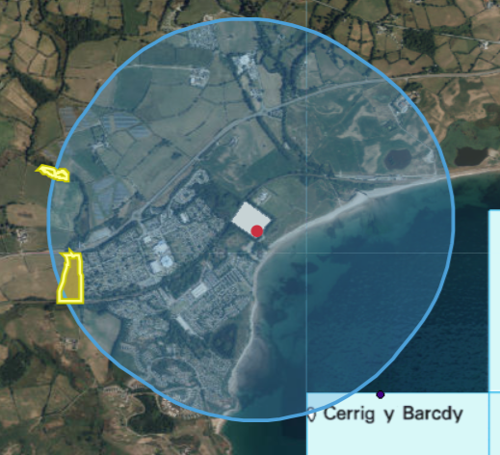

Local Wildlife Sites
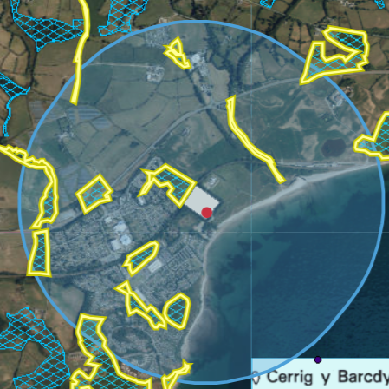
Bryntirion- Semi-improved neutral grassland; broadleaved woodland; scrub- SH445378
Llynnoedd Afonwen- Standing water; fen; marginal swamp- SH449373
Pen y Bryn- Scrub; acid grassland- SH435378
By Butlins- Marshy grassland- SH430369
Pont Llwyn-gwyn- Broadleaved woodland; marshy grassland- SH427368
Lon Drwsdeugoed- Hedgerow- SH429378
Butlins 2- Standing water; broadleaved woodland; coniferous woodland- SH434363
Porth Fechan coastal grassland- Coastal grassland- SH435357
Butlins 3- Basin mire; marshy grassland; acid grassland- SH431359
Butlins 1- Acid grassland; semi-improved neutral grassland- SH435370
Afon Wen- Running water; broadleaved woodland- SH439373

Flood risk
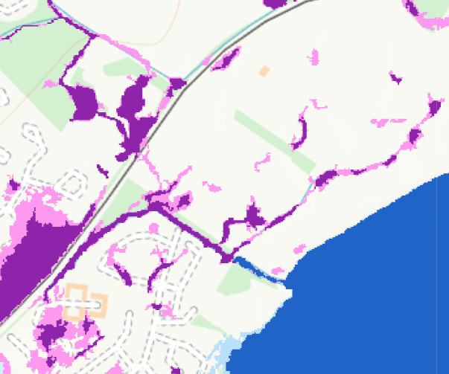

Section 7 species
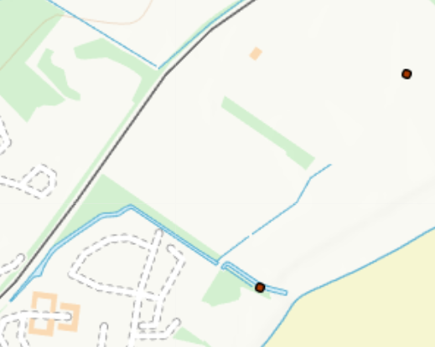
- European otter

Human receptors
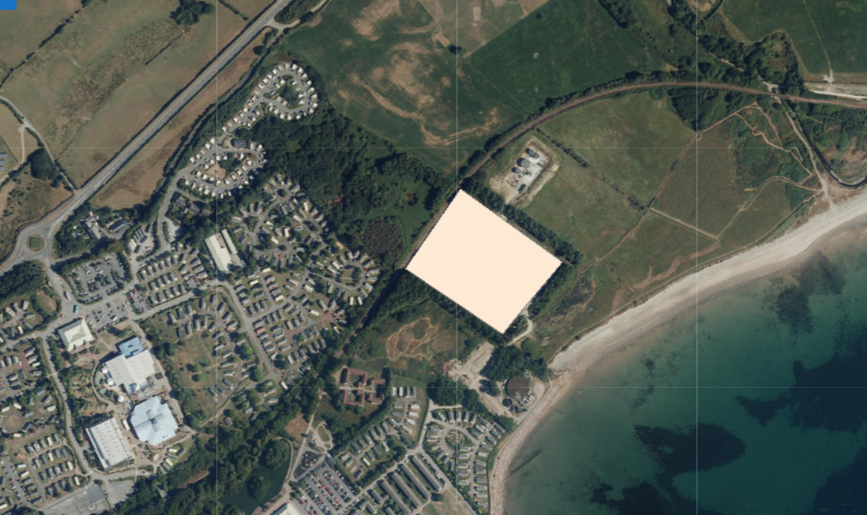
Caravan Park, Beach, Railway

