APPLICATION FOR A MARINE LICENCE FOR MARINE WORKS

Marine Works include, but are not limited to, coast defences, beneficial uses of dredged materials, subsea cables, pontoons, jetties, land reclamation, grab samples and outfall pipes under the Marine and Coastal Access Act 2009

Please read the notes carefully before completing the form.
- The Marine Licensing Team (MLT) administers Part 4 of the Marine and Coastal Access Act 2009 on behalf of the Licensing Authority, the Welsh Ministers.

- The completed application form must be accompanied by a location plan and, where appropriate, descriptive drawing(s) and any supporting environmental assessments. One completed hard copy of the application and supporting documents will always be required. Additional copies are required for consultation purposes.

  - For application and supporting documents less than 10MB we can accept an additional copy via email.
  - For applications larger than 10MB 16 additional copies in CD/DVD format will be required
  - When applications and supporting documents are hard copy only 16 copies will be required.

- Please submit applications to the Permit Receipt Centre via the details at the top of this form

- Please submit marine licence applications, including this form and all supporting documents, at least 4 months before the licence is required.

Some projects may raise matters that require a significantly longer time for consideration. These are most likely to be:

  - Projects that fall within The Marine Works (Environmental Impact Assessment) Regulations 2007 – as amended requiring an Environmental Statement
  - Large scale projects with substantial volumes of material being deposited or excavated.
  - Works requiring an Appropriate Assessment to be conducted under The Conservation of Habitats and Species Regulations 2017.

- Information should be provided about the anticipated duration of the entire project in respect of works below/seaward of Mean High Water Spring (MHWS). Where appropriate, planned phasing of the work for which consent is sought must be detailed. For projects lasting more than one calendar year, planned phasing details must be given for each 12-month period.

A licence fee is payable in respect of an application. Details of fees can be found on our web pages.

Please note applications will not be processed without the correct relevant fee or invoicing details.

- Payments can be made via Cheque, BACS or credit/debit card.
- Cheques should be crossed and made payable to Natural Resources Wales.
- For BACS payments ensure you provide the reference number (not remittance number)
- For credit/debit card payments please complete the CC1 form and submit with the application. The CC1 form can be found on our web pages.

Further information on payment methods can be found on our web pages.

- All activities need to comply with the Water Framework Directive (WFD). The framework and guidance can be found on the Natural Resources Wales website, http://naturalresources.wales. The results of your WFD assessment must be attached to your marine licence application.

- Please answer all questions. If any information is not available at the time of application please indicate in the relevant section, giving reasoning in a covering letter. Outstanding details must be submitted as soon as possible. Any delay in forwarding details is likely to result in delays in determining your application.
Your application may not be considered complete and therefore not processed until key information has been submitted. Your application may be returned if you fail to submit outstanding information within given timescales.

- Please note any licence may have conditions that must be discharged before works can commence. This will take additional time.
- If you have any queries with regards to completing this application, please contact the MLT: marinelicensing@naturalresourceswales.gov.uk

How your application will be processed by the MLT:

- Submit all application to the Permit Receipt Centre via the details at the top of this form.

- Checked and acknowledged by the MLT within 21 days of receipt of application and payment
- If the application is complete and no further information is needed at this time, your application will be placed in a work queue to be assigned a permitting officer.

- If the application is not complete, further information will be request and need to be provided before the application can be considered as complete
- Our 4 months service level for determining non-EIA applications will begin from the date the completed application is received (Please note some projects may take significantly longer than 4 months to determine due to their nature)

- EIA projects may take significantly longer due to their scale and complexity. Therefore, we encourage early engagement with the MLT
- Your application and supporting documents will be sent to for an initial consultation period of 28 days (42 days for EIA projects)
- For the majority of projects, a public notice must be advertised. Public consultation will be 28 days (49 days for EIA projects).
For EIA projects a second public notice will be required. The MLT will advise on how this should be done.
- Responses to consultation will be considered and additional information requested at this time, if necessary.
- A decision on your Marine Licence Application will be made.

All information submitted may be referred to within a licence, therefore all works must be in accordance with this information, unless otherwise agreed with NRW acting on behalf of the Licensing Authority during the determination process.

It is the responsibility of the applicant to obtain any other consents/authorisations that may be required.

Application Form Structure
- Project Description and Cost
- Applicant Details
- Details of Agent, Contractor, Vehicles and/or Vessels used to carry out works.
- Environmental Impact Assessment (EIA)
- Licensable Period
- Project Description
- Methods Statement
- Materials of Project
- Beach Replenishment, Land Reclamation or Salt Marsh Feeding
- Temporary Works
- Dredge and Disposal of Dredge Material
- Protected Sites
- Other Consents
- Statutory Powers
- Public Register
- Application Fee
- Declaration

Check List
Please ensure that you have included all the necessary information before you submit you application. If any of the below are not completed in the application form, the application is likely to be considered incomplete and may be returned to you.

Item | Yes (√)
The applicant is a legal entity? | Yes
The declaration is signed by the applicant? | Yes
Is the application fee correct? | Yes
Are the grid references/coordinates, correct? | Yes
Do the coordinates match map locations? | Yes
Have all the relevant supporting documents been submitted? | Yes
Has a clear methodology been provided in the application form? | Yes
Has Protected sites information been included? | Yes
Has a Water Framework Directive (WFD) assessment been submitted? | Yes
Are all the continuation sheets for application questions appended with correct corresponding numbers? | Yes

Should you have any queries regarding you application please contact the MLT via marinelicensing@naturalresourceswales.gov.uk
- Project Description and Cost

1 (a). Project Name
Menai Strait, Beach Road, Bangor, Sewage Pumping Station

1(b). Please provide a brief description of the proposed project, including location
Project location is on the outside perimeter of Welsh Water, Beach Road, Sewage Pumping Station (SPS). The address is: Beach Road, Garth, Upper Bangor, Gwynedd, LL57 1AT.
This project will reduce the number of foul sewage spills to the Menai Straits. The project forms part of the National Environmental Programme (NEP) to meet the Shellfish Water Directive of 10No. spills per annum for the Menai Strait.
The works entail, internal works at the SPS and installation of <30 meters of DN900 rising main above ground, around the side of the SPS. Pipes are supported by 5 or 6 no. RC concrete plinths.

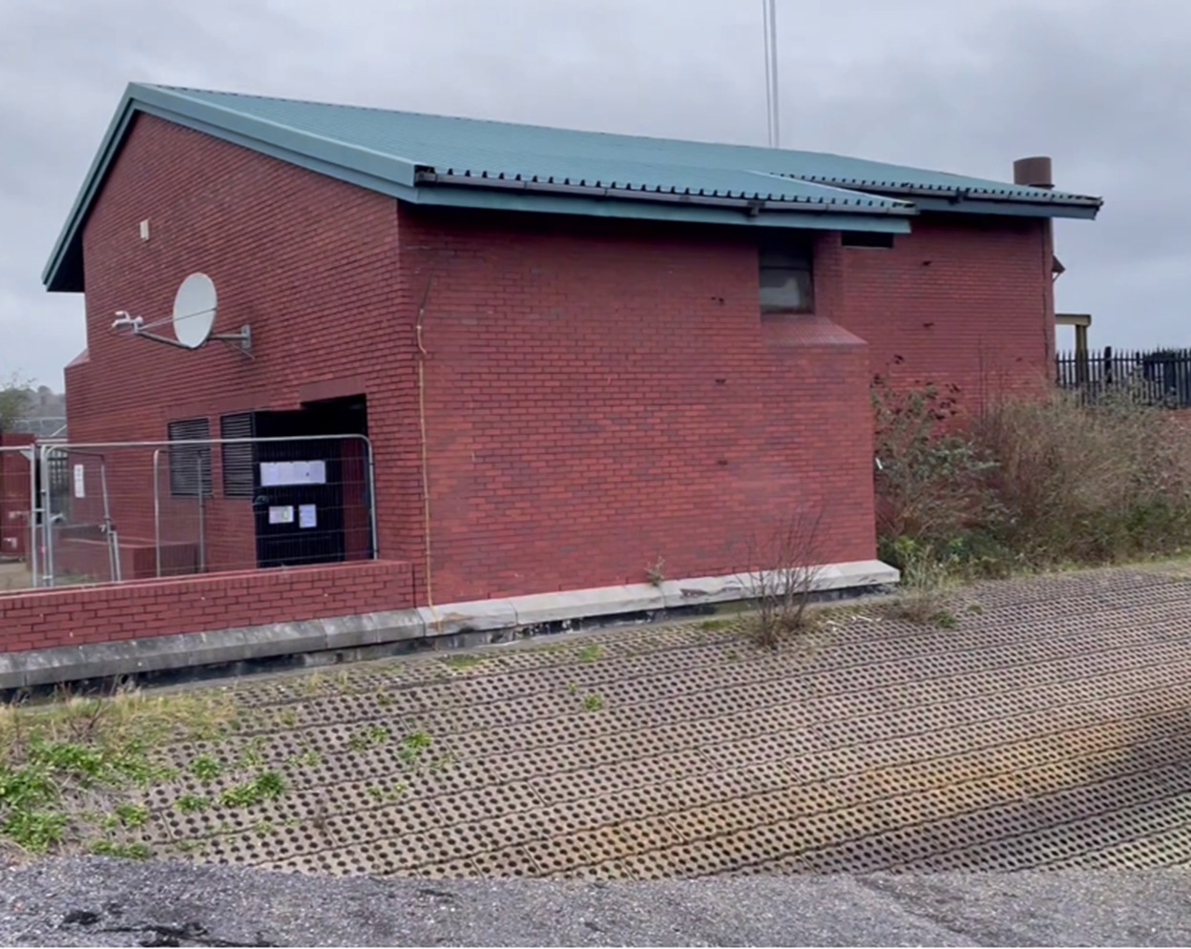

Using the photograph above a new 900mm diameter pipe will come from the back of the building (on the right of the photograph) and run along the upper section of the revetment adjacent to the building. It will connect to a new below ground pipe to the left of the photograph which is landward of the existing sea wall.

An elevation of the proposed works is shown below:
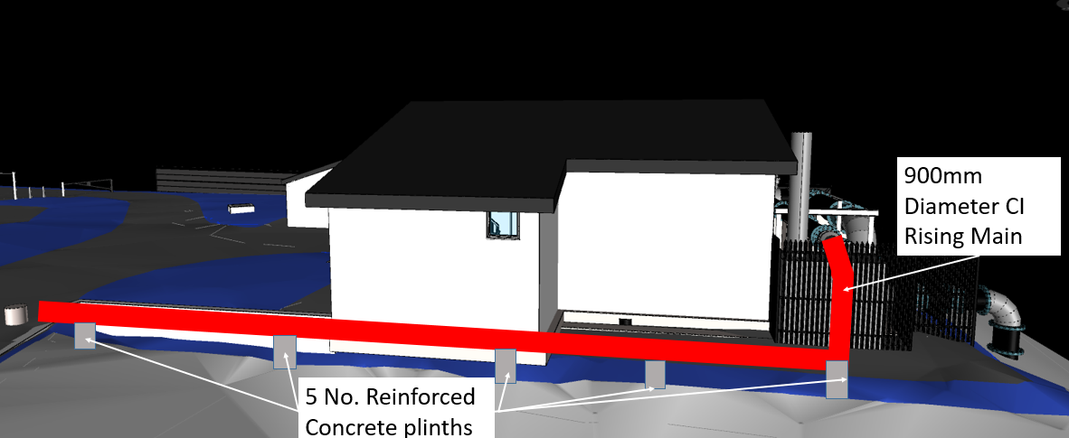

Estimated cost of the works that fall below seaward of MHWS including material and labour is £280,000.00.

1(c). Please provide an estimated gross cost of the project (Inc. materials and labour) for works that fall below/seaward of Mean High Water Springs (MHWS)

Applicant Details

To whom the licence will be issued. This must be a legal entity such as an individual, registered company/ charity or public body.
Mr
Peter Gale
Title Full Name

Company or Trading
Name
Eric Wright Water Ltd
01835168
Company Registration
Number (if applicable)
Peter Gale
Name of Contact or
individual (if different)
Senior Project Manager
Position in Company

Sceptre House Sceptre Way, Bamber Bridge, Preston, Lancashire, PR5 6AW
Address inc. postcode
(provide registered
Company address if
applicable)

Telephone Number
01772 698822 or 07970 483 828

pgale@ericwright.co.uk

Email Address

- Details of Agent, Contractor, Vehicles and/or Vessels used to carry out works.

3(a). Agent Details

This is who we will correspond with unless otherwise informed. If no agent, we will contact the applicant.

Title Full Name

Company or Trading Name

Company Registration
Number (if applicable)

Name of Contact or
individual (if different)

Position in Company

Address
(Inc. postcode)
Telephone Number

Email Address

3(b). Does the Applicant wish to be included in all correspondence? Yes ☒ No ☐

3(c). Contractor Details

In order for contractors to benefit from the licence permission, details must be provided.

Any details not provided with application must be confirmed before operations commence.

Contractor Company or Trading Name | Address
Eric Wright Water Ltd | Sceptre House Sceptre Way, Bamber Bridge, Preston, Lancashire, PR5 6AW

3(d). Will the works require the use of vessels? Yes ☐ No ☒

3(d) (i). Vessel Details (if applicable and available)

In order for contractors to benefit from the licence permission, details must be provided.

Any details not provided with application must be confirmed before operations commence.

Operator | Name of Vessel | Type of Vessel | Vessel Registration Number | Country of Registration

3(e). Will the works require the use of vehicle? Yes ☒No ☐

3(e) (i). Vehicle Details (if applicable and available) to be used below MHWS.

In order for contractors to benefit from the licence permission, details must be provided.

Any details not provided with application must be confirmed before operations commence.

Operator | Type/Description of Vehicle
Eric Wright Water Ltd | 21 tonne excavator
Eric Wright Water Ltd | 8 tonne excavator
Eric Wright Water Ltd | 13 tonne twin drum roller
Eric Wright Water Ltd | 6 tonne dumper
Contractor TBC | Sectional Flight Auger (SFA) piling
There will be temporary works within the MHWS which will involve putting in some temporary sheet piles. Once these are in, our works are protected from the MHWS. These sheets will be removed once the permanent works are complete.

3(f). If the contractor or vessels or vehicles are not known at the application stage, when do you expect to provide these details?

These details will need to be confirmed prior to the licence and operations commencement.
Any piling works would be sub-contracted out, but we do not know who this contractor will be at this stage. We would likely have this detail in the next 3-4 months, April/May. The piling contractor would be supervised by Eric Wright Water Ltd who would be doing all civil and mechanical works relating to this aspect of the scheme.

- Environmental Impact Assessment (EIA)
Certain projects, due to their scale, location and/or nature, may require an EIA under the Environmental Impact Assessment Directive (Directive 85/337/EEC – as amended). If a project qualifies under EIA, an Environmental Statement (ES) must be prepared and submitted with the application.
Projects that fall within Annex I of the Directive automatically require an EIA. Projects that fall within Annex II of the Directive are assessed on a case-by-case basis for the requirement for an EIA to be undertaken.

4(a). Do you consider the works to be under the Environmental Impact Assessment Directive (Directive 85/337/EEC – as amended)? Yes ☐No ☒

4(a) (i) If yes, which Annex does the proposal fall under? Annex I☐ Annex II☐

4(a) (ii) Which number(s) within the Annex does the proposal relate to?

4(b). Have you applied for a screening or scoping opinion from the MLT under the Marine Works (Environmental Impact Assessment) Regulations 2007 (as amended)? Yes ☐ No ☒

4(b) (i). If yes, please provide the reference number.

4(c). Has an Environmental Impact Assessment been undertaken? Yes ☐ No ☒

4(c)(i). If yes, has an Environmental Statement been submitted to support this Marine Licence application? Yes ☐ No ☒

4(d). If an Environmental Impact Assessment has been undertaken, but an ES has not been submitted, please provide an explanation.

Please continue on a separate sheet if necessary. Please tick if you have done this ☒

- Licensable Period

Determination of applications will be based on the works taking place during these dates. Please ensure you have included an adequate contingency period. If works are not completed by the Requested Licence Expiry Date you may be required to submit a new application. Including a contingency period within your original application does not impact on Licence Fee
30th May 2025
1st June 2024

Start Date Requested Licence Expiry Date

Please ensure you submit your application for a Marine Licence at least 4 months prior to the intended start date. Some projects, such as EIA projects, will take significantly longer to determine.

- Project Description

6(a). Please give a description of the proposed project.
This should include the purpose of the project, estimate timescales of construction and operation, and broken down by the phases of works, if applicable.
Details should include, but not be limited to, dimensions of project, quantity of material being deposited and removed.

This project will reduce the number of foul sewage spills to the Menai Straits from Bangor Sewage Pumping Station. The project forms part of the National Environmental Programme (NEP) to meet the Shellfish Water Directive of 10No. spills per annum for the Menai Strait. Eric Wright Ltd are delivering the works associated with the pumping station on behalf of Welsh Water.
The works entail 1) internal works at the SPS consisting of mechanical, electrical and civil and 2) for the purposes of the Marine Licence Application, installation of 24.5m or certainly less than 30 meters of DN900 rising main which runs above ground around the side of the SPS. Pipes are supported by 5 or 6 no. RC concrete plinths. The design for these is currently being undertaken. The above ground pipe will run alongside the existing building at the top of an existing revetment. On the photograph below the new pipe will come from the right-hand side at the rear of the building and will be aligned above ground, supported on new concrete plinths and will run inland along the side of the building.

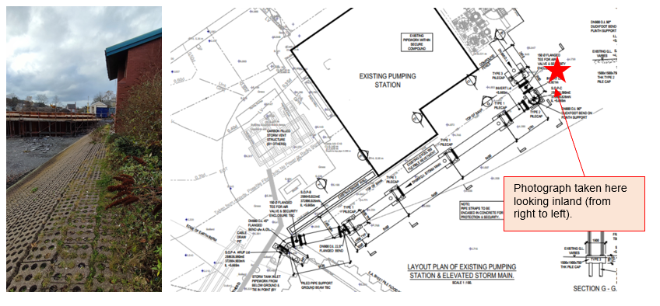

In order to construct the works noted above and as shown on the drawing we will need to create a temporary, level working area on top of the revetment shown. It is proposed that sheet piles will be driven along the foot of the revetment. This work will align with low tides times only and is expected to take no more than 20 working days. Once these sheets are installed the revetment side of these will be protected from the tide. A triangular void will have then been created at this point which will be filled with stone to form a level piling platform. A piling rig will track out from the land onto the new piling platform and will install the new piles that will be used to support the pipe. The pipe will then be installed. Upon completion of the pipe, the stone and the sheet piles at the foot of the revetment will be removed and the site will be left as it is today just with a new 900mm dia above ground pipe located as shown on the drawing.

Please continue on a separate sheet if necessary. Please tick if you have done this ☒

6(b). Please detail the location of the proposed construction project.
This should be either Ordnance Survey National Grid Reference (i.e. AB 12345 67890) or Latitude and Longitude in decimal degrees to 4 decimal places (i.e. Lat 52.1234 Long -4.1234), defining the extent of the project. Please specify which coordinate system has been used.

53.2342,-4.1191

Latitude Longitude

Please continue on a separate sheet if necessary. Please tick if you have done this ☒

6(c). The following must be provided with the completed application form:

- a suitably scaled extract of an Ordnance Survey Map or Admiralty Chart with location of project, complete with North Arrow and Scale

- construction plans and sectional drawings showing those proposed works below/seaward of MHWS, which should give details of the materials to be used (for beach replenishment the quantity, particle size and source of material to be deposited and deposit location is also required).

- a descriptive schematic drawing and suitably scaled location plan which show the full extent of the project clearly in relation to the surrounding area and features.

Please list below all supporting documents that have been submitted with this application, including suitable documents/maps/drawing titles and reference numbers
- Location plan
- General arrangement and elevation drawing
- EWW Environmental Management Plan
- WFD Scoping Template
- WFD Assessment
- Site check results
- EWG-E-MP-02 - Environmental Management Toolkit
- EWG-E-P-001 - Environmental Policy
- NOTE- RAMS are embedded within this application.

Please continue on a separate sheet if necessary. Please tick if you have done this ☐

The applicant should note that these drawings/plans may be copied to others as part of the MLT's consultation procedures. If they are subject to copyright, it is the responsibility of the applicant to obtain the necessary approvals to reproduce the documents and to submit up to 16 copies with the application.

- Methods Statement

7(a). Please provide a detailed method statement for the works
This must include methods for all works including temporary structures or deposits such as jetties, cofferdams, moorings or landing stages to be constructed seaward of MHWS.

Sheet piled cofferdam wall as sea defence and to retain structures

Temporary shoring will be required to facilitate the works relating to the construction of the Pipe and Pipe Support Plinths. All works will be designed and follow EWW Temporary Works Procedures. These preparation works proceed both piling and all other activities. Sheet piling is to be undertaken by competent contractor under the supervision of EWW management. A detailed description and RAMS of the agreed piling method will be provided and reviewed prior to works commencing. Measures will be in place to reduce any spoil or waste material spillage during construction and removal.

Ground preparations shall be undertaken as per Temporary works design to allow safe access and operation of heavy machinery and no activities are to be undertaken without the site engineer confirming all areas are signed off and permit to load has been issued by the Temporary Works Coordinator. All material such as sheet piles and other work-related material will be stored within a designated location. Exact location will be subject to site constraints.

Prior to start installation of sheet piles, the location and grid line will be marked out by the site engineer to control the straightness and verticality on the position. The sheet piles will be installed between two guides of I-beam and a short temporary sheet pile location as a guide to install the sheet pile. The temporary short sheet pile to be use as initial guide to commence installation. A vibro-hammer suspended with a crawler crane will vibrate the piles to the required depth. When sheet pile walls are installed, waler and ground anchor works will proceed. Movax piling head a drop hammer shall be available in case the piles refuse to penetrate ground to required depth.

Hold Point: A permit to dig shall be issued before any piling works take place. The process shall be repeated until all the piles have been driven in all areas any piles that are still too high, shall be cut off to the correct height using Oxy Propane cutting equipment.

Hold Point: A hot works permit shall be issued before any burning takes place following EWW procedures
Prior to works commencing, all relevant operatives will be briefed and POWRA completed.
After completion of installation, the movement of the sheet piles will be monitored regularly during the planned works. Removal shall be in reverse order.

Break out and re-instatement of Existing Embankment

Prior to break out of existing ramp area, working areas shall be assessed for the presence of uncharted buried services in accordance with the Permit to Dig procedure HSG47.CAT and Genny scanning as per excavation protocols when safe to do so.

Hold point: no excavation activities shall be undertaken without a valid Permit to Dig, as authorised by the Site Supervisor. Any exposed services once identified will need protection/support as agreed prior with site engineer.

Excavation/Break out shall be undertaken using an excavator and hydraulic pecker attachment as required to remove the existing embankment in areas as per the agreed design. Arising’s will be loaded directly into 6t dumper and removed to allocated/designated area.

Hold point: all plant and segregated work zone shall be controlled by a banksman, ensuring exclusion zones are set up based on red-amber-yellow basis using machine reach to reduce people-plant interface within identified machine tracking limits. Excavation to be controlled and inspected prior and during task or inclement weather by the Site Engineer. Traffic Management Plan will be under the control of a banksman at all times. Once all material has been removed and the required embankment profile has been achieved, the Site Engineer will then give written instruction to proceed with upcoming programmed works.

Barriers and control systems to be left in place for programmed sequenced works.

Reinstatement works shall be confirmed upon completion of permanent works design.

Installation of piling mat

In order to provide a suitable level access platform capable of supporting the piling rig, a piling platform will be constructed. This shall consist of imported granular 6N stone fill, installed and compacted in layers to the required dimensions and specifications as outlined in the Temporary Works Design.

All plant, equipment and materials required for the works shall be delivered to the area as outlined in EWW Traffic Management plan.

Hold point: Stone required to construct the piling platform and access ramp shall be offloaded in low-height stockpiles in areas of the worksite, ensuring these are in positions of safety.

Piling platform works are to be carried out within a segregated fenced area. The Site Engineer shall set out the dimensions of the proposed platform in accordance with the Temporary Works Design. This shall include clearly identifying the toe of platform and placing batter rails (or equivalent) for slope and ramps.

Hold point: the Site Engineer shall ensure that the toe and profile of the piling platform does not encroach on the fenced positions of safety. All plant operating shall maintain a minimum exclusion zone of 1m (except during compaction of stone) and utilise a Banksman to prevent collision/damage. Stone shall be loaded from stockpiles into the site dumper using an 8t excavator. This shall travel to the piling platform area as required under the direction of the Site Engineer and Banksman. Stone shall then be tipped off by the dumper and pushed out to the required layer thickness by an 8t excavator. Layer thicknesses are to be determined by the Site Engineer in accordance with the design specification and compaction plant used.

Once a sufficient area of the stone layer has been pushed out, this shall be compacted using a 13t twin drum roller or equivalent. The Site Engineer shall monitor the number of passes made and ensure this is in accordance with the designed quality procedure. Periodic compaction testing (i.e. sand replacement and/or nuclear density tests) and stiffness testing (i.e. plate bearing, CBR and/or lightweight deflectometer tests) shall be undertaken by a Sub-Contractor to ensure that the required properties are achieved throughout installation. Construction of the platform must be tapered towards the previously constructed access ramp.

Hold point: access ramp gradient should not exceed 1:10 for wheeled plant of 1:5 for tracked plant. The above process shall be repeated until the piling platform reaches the required height and dimensions, as controlled by the Site Engineer. The finished surface shall undergo final stiffness testing (i.e. plate bearing tests) to ensure this complies with the Temporary Works Design requirements. Edge protection and machine tracking limits in the form of red and white barriers and timber baulks shall be installed along the piling platform surface in accordance with the Temporary Works Design. Upon complete, the Site Engineer shall provide the TWC with quality check sheets.

Hold point: A Temporary Works Permit to Load shall be issued by the TWC before platform can be taken into use.

6 No piles (type TBC but likely to be 5 or 6 as per drawing)

Sectional Flight Auger (SFA) piling work shall be carried out along the high-level piling platform for the new above ground pipe concrete Support Plinths in accordance with the Permanent Works Design. This shall be undertaken by a competent piling Sub-Contractor in accordance with their RAMS. All works are to be planned and overseen by EWW (incl. managing safe digging procedures, lifting operations and permits).

Hold point: Piling Sub-Contractor RAMS shall be reviewed and approved by the EWW supervisor prior to starting work. The sequence of activities will incorporate Sub-Contractor proposals whilst ensuring all site hazards and adjacent activities are safely managed. All plant, equipment and materials required for the works shall be delivered to the area as outlined in EWW Traffic Management plan.

Hold point: pile cages shall be pre-assembled by the piling Sub-Contractor in advance of delivery and stockpiled in the safe working areas ready to be installation. All piling platform works are to be carried out within a segregated area. Piling rig to maintain a minimum exclusion zone of 1m when tracking (except for when manoeuvring onto the pile location) Rig to be setup with controls facing towards access ramp ensuring the machine is positioned between piling operator(s). Piling to be advanced to designed depth. Where early refusal occurs, drilling shall continue for up to 15mins. If no advancement in depth is made after this time, the pile shall be terminated and grouted. The pile locations shall be set out by the Site Engineer and the rig shall track to the first location.

Hold point: Safe digging procedures HSG47 shall be followed prior to starting piling, incl. review of buried services, trial holes and CAT scanning prior to issuing the Permit to Dig. Buried services information shall be maintained on site throughout the works. Piling work will start in accordance with Sub-Contractor RAMS.

Concrete shall be delivered to site and pumped to pile locations using a concrete pump positioned as near as possible to work area. This shall be in accordance with the Temporary Works Design and access agreements. Concrete will either be pumped directly to the rig or pumped to the tracked on-site agitator, where concrete can be kept workable until ready for pumping into piles. When the auger has achieved the correct depth, concrete shall be connected to the rig and pumped through the auger stem as withdrawn from the hole. Once concrete works are complete, the rebar cage shall be lifted and inserted into the pile.

Hold point: A Permit to Lift shall be issued for lifting the cages into the concrete. This sequence shall be repeated until all of piles in that location are finished. All construction waste must be continuously cleared using excavator and site dumpers.

Pile cropping/trimming is required to expose the reinforcement for incorporation into the new support plinths to ensure a sound concrete connection. Cropping/trimming should be carried out without resulting damage to the reinforcement, concrete, and instrumentation of the pile. Cropping/trimming will take place once the site engineer has marked around the circumference of the pile denoting the required cut-off level. Prior to cropping, cutlines will be placed using a grinder with dust suppression in place. The cropping will be undertaken utilising both an excavator with mechanical/hydraulic pile cropper and handheld breakers to break excess concrete to expose the reinforcement bars. Final chipping is to be carried out using a handheld electric concrete breaker that will enable finishing the pile top to the allowable tolerance from the design cut-off level and in preparation for the surface to receive pile integrity testing. Works area to be segregated and controlled by banksman as an exclusion zone with access only permitted to operatives involved directly with this task. Once completed the site engineer will inspect and agree that the next sequence of works can continue.

Construction of concrete support plinths for the pipe supports
Formwork materials shall be delivered to site compound (methodology to be confirmed). To ensure correct setting out and dims the site engineer will mark out area for construction of the support plinths Once area has been deemed ready the site engineer will give instruction for erection of formwork and steel reinforcement as per detail in AFC drawings. Formwork/Shuttering and steel fixing controls must be performed during assembly, erection, and final positioning of shutters for structural concrete activity with regular phased checks by site engineer. Contractor and onsite team shall strictly follow all design and Temporary Works design specifications. During and after the phased concrete pour, the formwork must remain stable (both vertically and laterally). Surface finishing should conform to the type specified in AFC drawing detail. Concrete formwork or shuttering should allow for appropriate placement and vibration. Formwork must be correctly secured to prevent mortar loss and concrete surface deformation. All works shall be undertaken from within the worksite compound, with all operations (excl. material and concrete deliveries) to be undertaken from within the segregated area.

Hold Point: Any required design changes must be discussed and authorised prior in writing by TWC, TWD and TWDC. No concrete to be poured until Temporary Works “permit to use” has been issued.

Dismantling/striking will be undertaken in reverse order. Before striking Formwork, the concrete will require to have reached minimum sufficient strength.

Hold point: all plant shall be controlled by a banksman, ensuring exclusion zones are set up based on red-amber-yellow basis using machine reach to reduce people-plant interface.

Rebar/Mesh will be manoeuvred and lifted into allocated positions for the support plinths utilising an 8tn excavator, lifting attachments and by hand. Materials shall be placed in designated locations to ensure a tidy works area is maintained without interference or trip hazards.

Using a mechanical bar bender and hand tools the pile cap rebar will be altered to the correct dimensions to allow the follow-on rebar fixing to be erected in position. Cutting/alterations of steelwork will be undertaken using a Petrol Disc Cutter, or a 5” grinder with steel cutting blades. Correct task specific PPE shall be worn when undertaking this work within a specified Hot works zone with all procedures and permits in place prior to commencing any Hot Works.

Hold Point: Designated Hot Work Area and Permit required prior to Hot Works commencing. Fire watch and brief required. Rebar/mesh shall be set out to suit foundation dimensions and tied into position by competent steel-fixers using stainless steel tying wire and hand tools. Where required, chairs shall be used to support steel top mats prior to concrete pours. A level tolerance of ±10mm shall be set out to achieve nominal 50mm cover as per AFC detail drawings/schedule.

When all elements are completed a Temporary Works “Permit to Use” shall be issued by the Temporary Works Coordinator to initiate concrete pour. The Formwork and all fixings/supports shall undergo inspections by the Temporary Works Supervisor throughout installation and use.

Prior to concrete deliveries Traffic Management will need to review and restrictions implemented for siting of Concrete pump wagon and management of Concrete deliveries.

Hold point: A Temporary Works “Permit to Use” shall be issued by the Temporary Works Coordinator once a signed sign off/inspection sheet has been received when Concrete pump wagon has completed set up and prior to pour. Communications with Public regarding road closure and Traffic Management. All Operatives involved in this task shall wear correct task specific PPE and ensure all areas that require protection are covered with plastic sheeting prior to commencing pour.

Hold Point: Site Engineer to check all areas that need protection are protected.
C40 / 50 concrete will be delivered via premix wagons unloaded to a mobile pump with flexible hoses to fill the formwork in phased sections as required. During the phased laying process the concrete should be poured into the formwork ensuring that it is spread evenly and that any air pockets are removed. Concrete will be vibrated using air or 110v powered “pokers” and level controlled by Auto / laser level. Regular inspections will be undertaken during concrete pours to ensure stability. Mortar loss indicates movement and should be highlighted immediately to the Contractors supervisor.

Hold Point: Site Engineer to undertake inspections during concrete pours to ensure stability.
Concrete cubes shall be taken at a rate of 6no. per 24m3 of concrete placed. Cubes shall be tested at 3, 7, 14 and 28 days (pair) with an additional spare. Dependant on weather conditions concrete should be protected from the elements using plastic sheeting, hessian cloth or frost blanket. When pour has been completed Concrete wagons and pump will wash out in pre agreed designated washout areas ensuring all public areas are kept clean throughout the operation.

When Formwork has been stripped after suitable curing time the Concrete shall be inspected by the Site Engineer for any required snagging. As required the concrete will be made good by bag rubbing or grout infill as appropriate.

Hold Point: Inspection to be carried Site Engineer and Contractors Supervisor to agree snagging items (Photographic report required) ITPs / QA records shall be completed during progress of works.

Demobilisation
Note once the pipe support plinths and the above ground pipe has been completed, all enabling works will be removed i.e. the piling platform and the piles used to support it etc. The site will be left as it was with the exception of the permanent works i.e. the pipe supports and the pipe.

Please continue on a separate sheet if necessary. Please tick if you have done this ☒

7(b). Do you intend to undertake activities that could generate underwater noise?

This includes piling, use of explosives, geophysical, acoustic deterrent devices and multibean echosounders. Yes ☐ No ☒

7(b) (i). If yes, what type(s) of activities will be undertaken?

7(b) (ii). If yes, approximately how many days will the activity be undertaken for?

If yes, you will be required to complete an additional form that will be provided.

7(c). Please state the measures to be taken to:
- Minimise risk to the marine environment.
Eric Wright Water Ltd have environmental procedures and working methods that includes topic specific legislative requirements, guidance documents, procedures, work.
instructions, checklists and best practice. The environmental procedures are used in partnership with our compliance team who audit sites and ensure the necessary procedures are in place. These works are within 30m of the sea wall / land. Our strategy will be to minimise all impact to the marine environment through our environmental procedures noted above. All activities that can be completed on the mainland will be i.e. re-fuelling, spill prevention, noise, vibration and dust mitigation measures will be considered, no waste or material other than permanent works will be left upon completion of the works. Please refer to the Environmental Management Toolkit attached to the application for detail of our standard procedures.

- Prevent undue interference to others.
These works are part of a bigger project being delivered by DCWW. DCWW have employed Alun Griffiths to construct a below ground tank within an adjacent football field. Any customer impact, vehicle movements etc associated with that project have agreements in place. The works being conducted by Eric Wright Water will adhere to all agreements made by DCWW whilst also following our own safe working procedures to maintain safe working areas with the public.

- Maintain navigational safety, including marking and lighting of works.
N/A - No work will be undertaken in navigation channels. All works will be within 30m of the land and adjacent to an existing sea revetment defence. The ariel views below (left) show the maximum working area and (right) shows the route of the new above ground pipe.

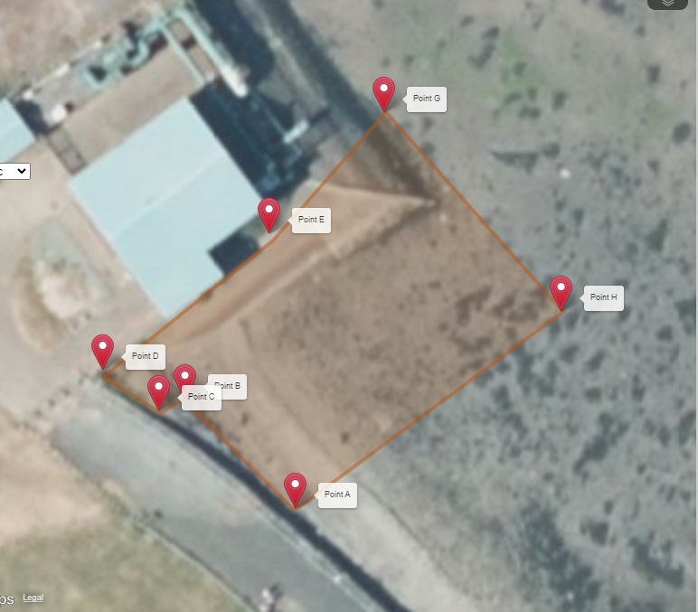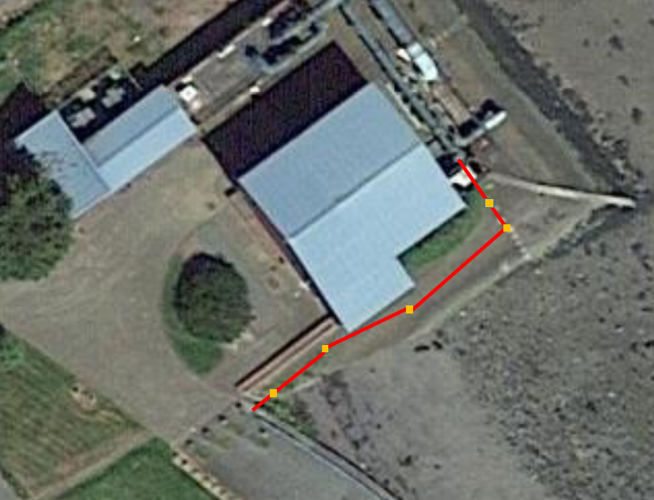
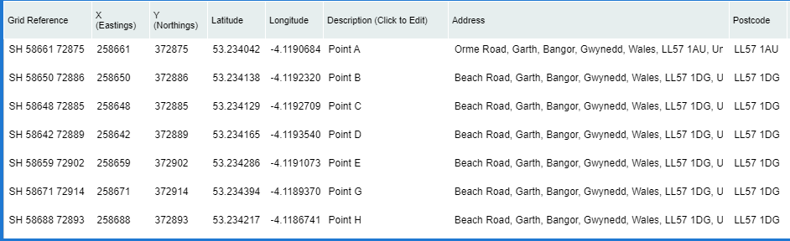

Please continue on a separate sheet if necessary. Please tick if you have done this ☒

- Materials of Project

8(a). Description of materials to be deposited seaward of MHWS (Please tick all that apply)
Timber ☐ Iron/Steel ☒ Concrete ☒ Biocides/other chemicals ☐
Silt ☐ Stone/Rock ☐ Gravel ☒ Plastic/Synthetics ☐
Sand ☐ Other ☐

If other, please provide a description of materials.
I have ticked all materials that will be used to construct the temporary works which will be removed upon completion of the permanent works (pipe supports and above ground 900mm dia pipe)

8(b). Delivery method of materials to site
If sea delivery, please include details of vessels to be used with a chart of proposed route and transhipment area. If vehicle delivery, please provide the proposed access route.
No materials will be delivered by sea.

Please continue on a separate sheet if necessary. Please tick if you have done this ☒

8(c). Will the works involve removals seaward of MHWS? Yes ☐ No ☒

8(c) (i). Description of materials to be removed seaward of MHWS (Please tick all that apply)
Timber ☐ Iron/Steel ☐ Concrete ☐ Biocides/other chemicals ☐
Silt ☐ Stone/Rock ☐ Gravel ☐ Plastic/Synthetics ☐
Sand ☐ Other ☐

8(c) (ii). Description of objects/materials to be removed seaward of MHWS.
Including quantities to be removed.

- Beach Replenishment, Land Reclamation or Salt Marsh Feeding
For works involving any of the above, please provide the following information.

9(a). Is the material to be deposited like for like to existing material? Yes ☐ No ☐

9(a)(i) If No for Beach Replenishment please provide justification why?
N/A

9(b). Description of material to be deposited.
Please provide the grading specification of materials to be used, if using a range of grain sizes please state the percentage by weight passing. If unsure, please refer to the Wentworth Scale

Please continue on a separate sheet if necessary. Please tick if you have done this ☐

9(c). Source of the material to be deposited.
Including dredged or land based stating the origin of material

9(d). Has the material been chemically analysed? Yes ☐ No ☐
If material has been analysed, we may request this information to determine the application.

9(d) (i) If yes, is the analysis data been included with the application? Yes ☐ No ☐

Temporary Works

10(a). Will there be any temporary deposits below MHWS? Yes ☒ No ☐
This includes construction materials, removed objects/material, jetties or cofferdams.
If yes, please continue with section 10.

10(b). Please provide the location of temporary deposits
Please include a map/chart displaying the location of temporary deposits, if necessary.
Please refer to method statement above, section 6 and our drawings attached to the application.

Using the photograph below as a guide. A row of sheet piles will be installed at the foot of the revetment, the top level of which will be the same as the building level. This triangular void that is then created will be infilled with stone to form a piling platform. The piling rig will track out on this flat surface from the land (no requirement for any machines, at this stage to be on the foreshore, seaward side of the sheets) and install 5 or 6 new piles which will be used to support the new DN900mm above ground pipe that comes from the rear of the SPS and will run towards the land close to the building. Upon completion of the pipe supports and the pipe, the stone infill will be removed and then the sheet piles along the foot of the revetment will be removed. The site will be left as it is today other than 5 or 6 new pipe supports and the above ground pipe adjacent to the building.

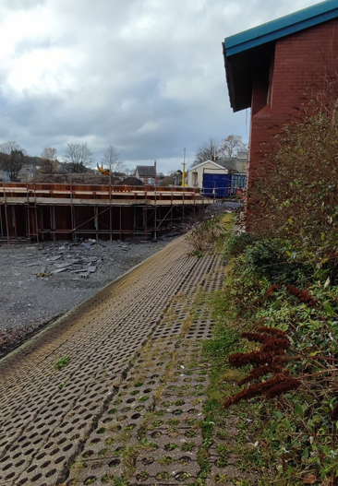

10(c). Description of temporary deposits
There will be sheet piles and stone infill between the piles and the building as noted above.

Please continue on a separate sheet if necessary. Please tick if you have done this ☒

- Dredge and Disposal of Dredge Material
If you are undertaking Dredge and Disposal activities, please also complete the Dredge and Disposal application form and submit together.

11(a). Do you intend to apply for a marine licence to dispose of dredged material to sea as part of the works in this application? Yes ☐ No ☒

- Protected Sites

Licensing Authorities have a duty to ensure that projects will not have significant adverse environmental impact, particularly on any designated European Site of Conservation Importance - Special Areas of Conservation (SAC) and Special Protection Areas (SPA), listed under the Habitats Directive (Council Directive 92/42/EEC on the conservation of natural habitats and of wild fauna and flora). In addition, it is Government Policy that Wetlands of International Importance (Ramsar sites) are also considered as European Sites. There is a duty to take reasonable steps to further the conservation and enhancement of nationally designated sites (Sites of Special Scientific Interest (SSSIs).

12(a). Have you had pre-application correspondence with NRW, its legacy bodies or Natural England? Yes ☒ No ☐

12(a)(i). If yes, please provide copies of correspondence with application and state which team(s) you have contacted?
We completed some Ground Investigation at the foot of the revetment to gain ground condition information to support the specification of the piles for the pipe support. This was a band 1 licence reference is RML2363.

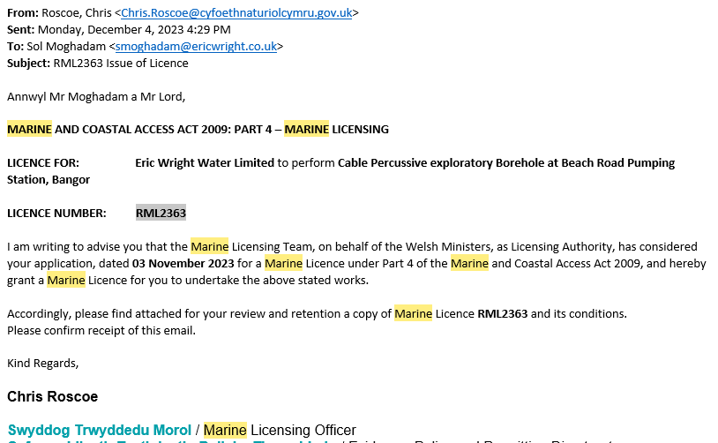

12(b). Is any part of the works located within or likely to affect a designated conservation site? (SAC, SPA, SSSI or Ramsar) Yes ☐ No ☒

12(b)(i). If yes, which designated site(s) may be affected?

12(c). Please provide a description of all mitigation measures proposed to avoid any impact on designated conservation sites.

Please continue on a separate sheet if necessary. Please tick if you have done this ☐

12(d). If the works are not located within or likely to affect a designated conservation site, please indicate the approximate distance to the nearest designated conservation site.
0.4km to a special protection area.

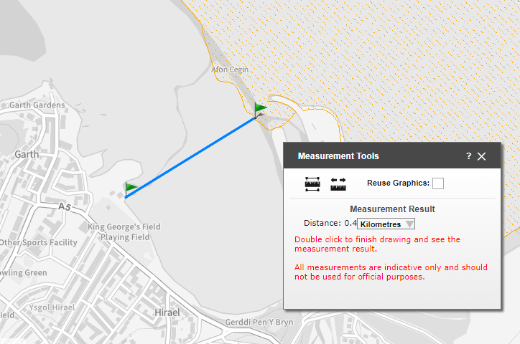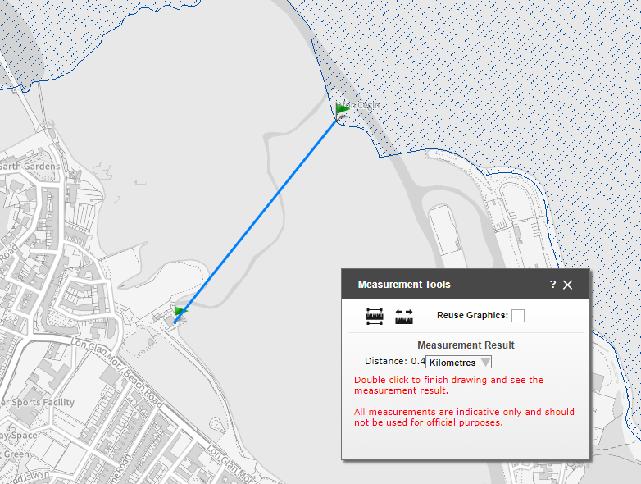

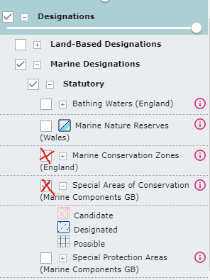

Please note that if the proposed works are in or within 2km of a European Site of Conservation Importance you will have to provide suitable mitigation measure to avoid any impact on designated conservation sites.

- Other Consents

Please detail all consents that you have applied for or received for these works.

Type of Consent | Applied for | To be applied for | Reference Number | Date of Issue and Expiry | Note
Planning Permission under Town and County Planning Act 1990 – From Local Planning Authority (LPA) | No | Likely, yes but also likely to be permitted development | TBC |  | Discussions on-going with the council but no formal application submitted at this time
Name and Address of LPA for location of works | Gwynedd Council Shirehall St, Caernarfon LL55 1SH
Landowners Consent such as The Crown Estate Consent | No | No as this is not Crown Estate Land |  |  | Land ownership details to be confirmed via local council soon. This is not shown as being owned by Crown Esates
Port Authority or Local Harbour permissions | No | TBC | N/A |  | Won’t be affected by works but curtesy contact will be made.
Other NRW consents such as Flood Defence or SSSI assent | No | No | N/A
Details of NRW consent | N/A to these works but there is a consent to discharge flows from the SPS down the long sea out fall. The consent number is CG0351702
Other consents such as Transport and Works Act Order, Section 36 Electricity Act, grant/loan sanction | No | No | N/A | N/A

Details of other consents

- Statutory Powers

14(a). Does the applicant have statutory powers to consent any aspect of the project?
E.g. coast protection authority, dredging powers, statutory undertakers Yes ☐ No ☒

14(a)(i). If yes, please give details and state the relevant legislation that gives these powers.

All works are on behalf of Dwr Cymru Welsh Water with the aim of the project to reduce the number of foul sewage spills to the Menai Straits in order to protect and improve the condition of the Marine Environment

- Public Register

Under The Marine Licensing (Register of Licensing Information) (Wales) Regulations 2011 and the Environmental Impact Assessment Directive (Directive 85/337/EEC – as amended), all information contained within or provided in support of this application will be placed on the Public Register unless NRW approve of the applicant’s reasons for withholding all or part.

15. Is there any information contained within or provided in support of this application that you consider should NOT be included on the Public Register on the grounds that its disclosure: No

15(a). Would be contrary to the interest of National Security? Yes ☐ No ☒

15(b). Would prejudice to an unreasonable degree you, or some other person’s commercial interest of those of a third party? Yes ☐ No ☒

If yes to either (a) or (b), please provide full justification as to why all or part of the information you have provided should be withheld.

Please continue on a separate sheet if necessary. Please tick if you have done this ☐

- Application Fee

16(a). What are the corresponding fee band for this application? Band 2 ☒ Band 3 ☐

16(b) Band 2 Only

Projects are charged at a fixed fee of £1920. The application will not be processed until the correct fee has been provided.

Please provide the method of payment

Method | Yes (√) | Reference Number
Cheque
BACS (not remittance no.) | Yes | Payment Date: 8/2/24  Reference: PRCAPPERICW003  Amount £1920
World Pay (phone or CC1)

Please attach CC1 Form with application. Can be found on our web pages.

16(c) Band 3 Application only

Band 3 applications are charged at on hourly rate of £120 and are invoiced in arrears. Please complete the details below which will be required for invoicing.

Customer Name

FAO

Purchase order number

Address for invoice

Telephone Number

Email Address

- Declaration

I declare that to the best of my knowledge and belief that the information given in this application form and supporting documentation is true.

WARNING: It is an offence under the Marine and Coastal Access Act 2009, under which this application is made, to fail to disclose information or to provide false or misleading information and can invalidate any licence granted.

Signature 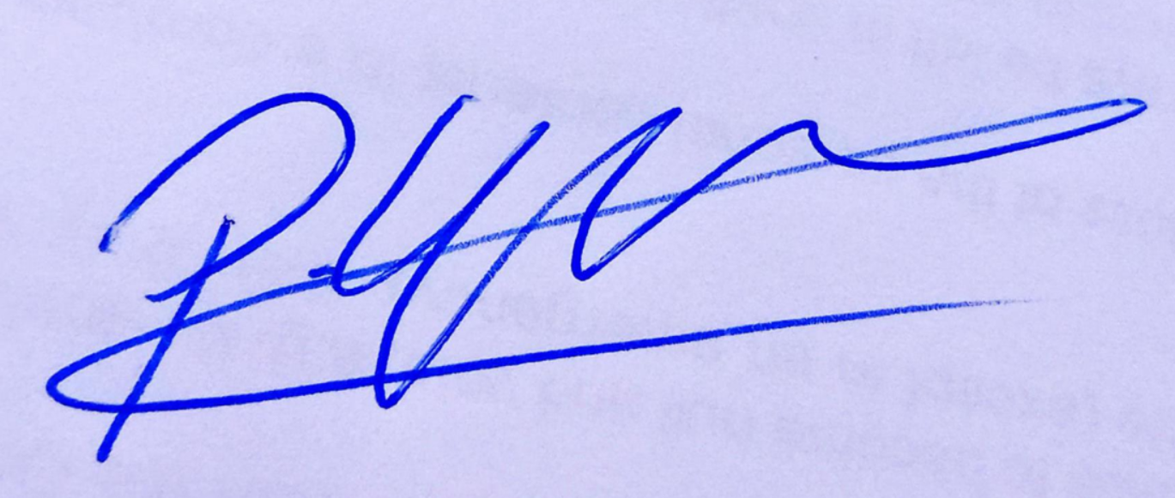 Date 07/02/24

Name (in capitals) Peter Gale

Position in Company Senior Project Manager

Applications cannot be processed unless signed by the Applicant (not agent), the applicant must have appropriate level of authority within the company.

Applications will not be processed unless signed.

