PAN-023606 MyMap Report
The activities shall not be carried out within 200 metres of a European Site and or a SSSI.
- Special Areas of Conservation (SAC)- none
- Special Protection Area (SPA)- none
- Ramsar- none
- Site of Special Scientific Interest (SSSI)- none
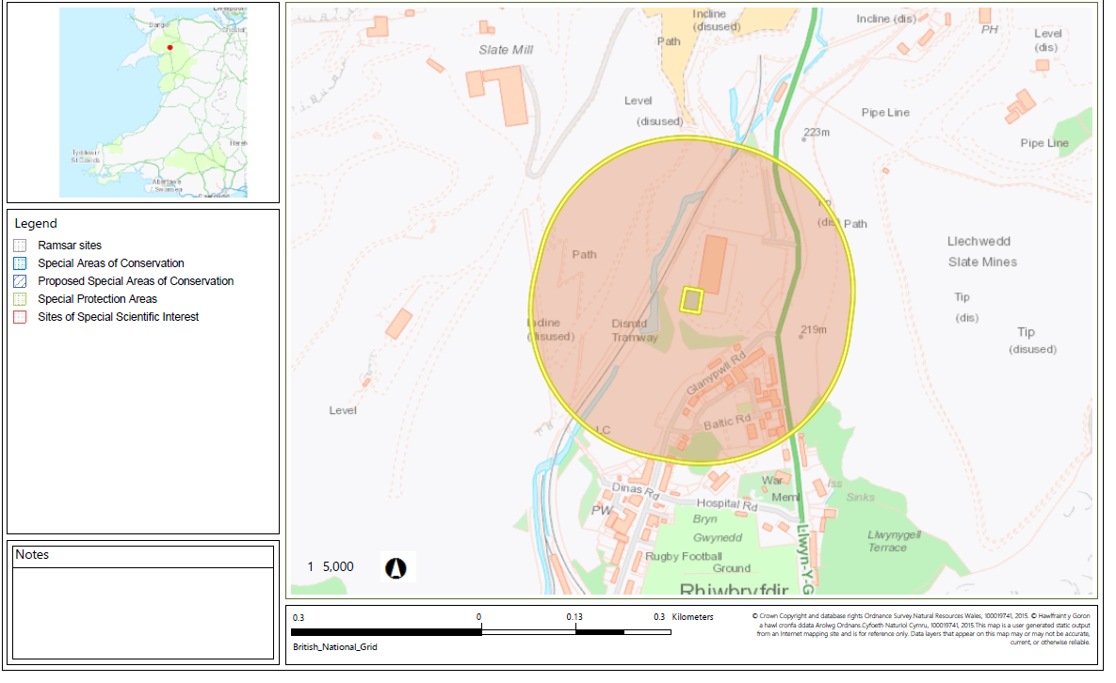

The activities shall not be carried out within Groundwater Source Protection Zone 1, or if a Source Protection Zone has not been defined then within 50m of any well spring or borehole used for the supply of water for human consumption. This must include private water supplies.
- Well used for drinking water- none
- Spring used for drinking water- none
- Borehole used for drinking water- none
- Groundwater Source Protection Zone 1- none
- Well used for domestic/ food production- none
- Spring used for domestic/ food production- none
- Borehole used for domestic/ food production- none


