This template is intended to be used in conjunction with a Band 1 Marine Licence application. Please complete each section below following the guidance provided (max 500 words per section). For any queries relating to this template please contact: marinelicensing@cyfoethnaturiolcymru.gov.uk

Summary
Please provide a brief summary of the application including location of the works (coordinates - lat/long, decimal degrees). For activities that cover a large area please provide coordinates of the approximate extent of works.

The application is to facilitate the maintenance of Puma Energy’s jetty located off Gelliswick Bay within the Milford Haven waterway.

The works will be centred on Ordnance Survey National Grid Reference SM 88634 04619. The works will be undertaken on discrete sections of the jetty structure (piles, beams and pipework) located above MHWS within the overall jetty boundary. The works will consist of the removal of discrete patches of surface corrosion (surface preparation) from steel structures located above MHWS and their subsequent repainting. Should there be a requirement to carry out repairs these will be completed prior to repainting.

Surface preparation will be carried out by hand and/or blasting from a temporary scaffold or floating barge.

Should mechanical repairs be required these will be undertaken from a temporary scaffold.

Painting using brush, roller or spray as appropriate will be carried out by hand from a floating barge or temporary scaffold.

Contact with the Port authority will be maintained throughout the works and specific RAMS will be provided on request.

Scope of works
Please provide a full description of all proposed works including:
- Sequence of works (mobilisation, marine works, site remediation (if required))
- Estimated timing of works (duration, working hours, day/night, plus contingency)
- Plant, machinery or vessel required
- Estimated quantities (removals, deposits, construction materials)

The scope of works will consist of both planned and reactive maintenance.

Planned Maintenance

Planned activities as part of the preventative maintenance programme are well defined and summarised below.

Jetty piles – Various locations

Using a floating barge complete with access hoist, gain access to upper sections of corroded piles above MHWS. Scope of works is to remove corrosion and repaint.

The work is planned to commence in late March 2024 and will take approximately 8 months to complete subject to weather.

A specialist diving contractor will carry out underwater inspection of a sample of piles from throughout the Jetty structure

The work is planned to commence in July 2024 and will take approximately 3 months to complete subject to weather.

Jetty Berth 2/3 Approach Road Berh 2/3 Tee Head and Mooring Dolphins Berths 1 and 2

Using temporary suspended scaffold gain access to structure and piping in the section of Approach road from approximately 800m out from the shore. Scope of works is to remove all corrosion and re-paint. Limited weld repairs are likely to be required which will be completed prior to repainting.

The work is planned to commence in late March 2024 and will take approximately 8 months to complete (subject to weather).

Reactive Maintenance

There may be occasions where access to discrete sections of the jetty above MHWS is required in order to complete unforeseen repairs. In these circumstances access would be by the most practical method available, e.g., work boat, floating barge or temporary suspended scaffold. Repair scopes are assumed to require the removal of corrosion, removal /repair of structure/piping and repainting to make good. This requirement could arise at any time during 2024

Access and working areas
Please provide details of access to the site and working areas. This should include:
- Attached map of the access/egress route and working areas (annotated aerial image and/or OS map)
- Predicted plant/vehicle movements
- Storage areas for plant, equipment and materials (if required)
- Risks to navigation

Access/egress for scaffold, materials and equipment will be by road via Puma Energy’s jetty which is located off South Hook Road, Gelliswick. Access to the jetty is controlled by 24/7 security. The frequency of vehicle movements is not predicted to be significantly greater than during normal operation.

Where a floating barge is to be used it will be moored in Milford Docks overnight and travel to/from Puma Energy’s jetty once each working day.

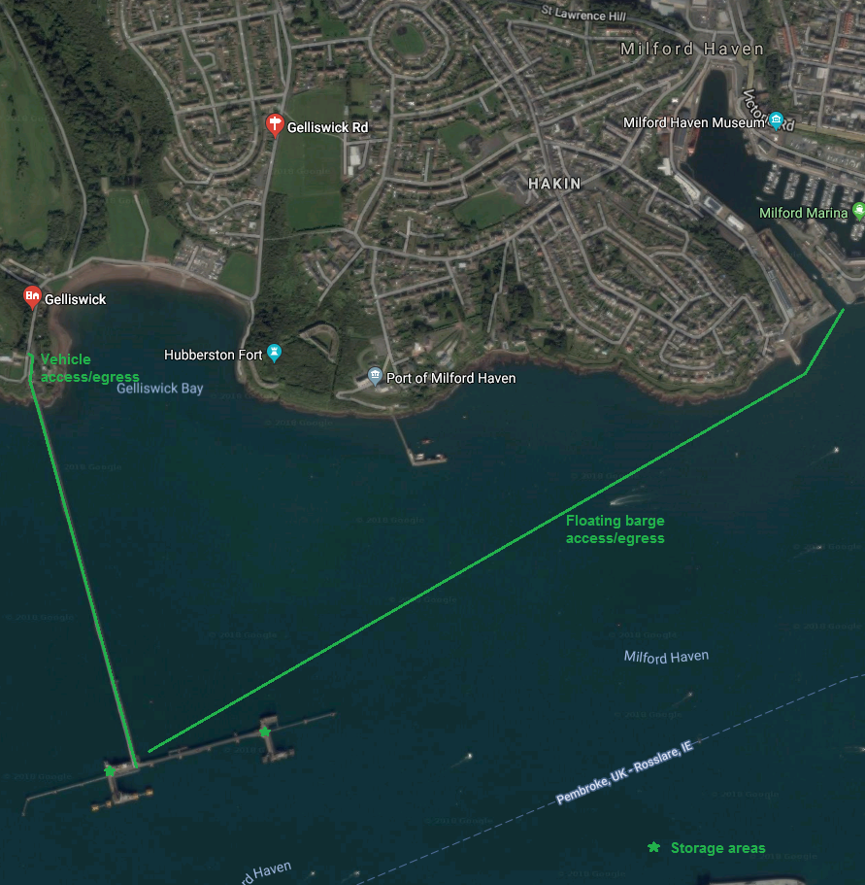

Environmental mitigation
Please list appropriate mitigation measures to minimise impacts on the marine environment these may include:
- Pollution prevention and control procedure (guidance available at: http://www.netregs.org.uk/media/1304/gpp-5-works-and-maintenance-in-or-near-water.pdf)
- Spill response kits
- Minimise plant traffic
- Designated access and egress routes
- Storage of materials (fuel, chemicals, construction waste)
- Biosecurity (guidance available at http://www.snh.gov.uk/docs/A1294630.pdf)
Note: To assist you, the following mitigation statements will be used as conditions within the licence. By signing this method statement, you will be agreeing to adhere to these restrictions. If you are unable to do this, the application will not qualify as Band 1.

- All equipment, temporary structures, access tracks, waste and/or debris associated with the works will be removed on completion of the works.

- Bunding, storage facilities and spill kits will be employed to contain and prevent the release of fuel, oils and chemicals associated with the plant, refuelling and construction equipment into the marine environment.

- Plant, vehicles and machinery will not be refuelled on the foreshore.

- Coatings and treatments will be suitable for use in the marine environment and are used in accordance with best environmental practice.

- All equipment, materials, machinery and PPE used will be in a clean condition prior to their arrival on site, and upon removal from site, to minimise risk of introducing non-native species into the marine environment.

- In the event of removal of any sensitive species or habitat designated by NRW under Schedule 7 of the Environment (Wales) Act 2016, no further removals will occur at that location or within 20m of that location.

Please list your bespoke mitigations here:

Where grit blasting of corrosion product (rust) is necessary, mitigations to prevent pollution of the marine environment will be as follows:
- If practical the work area will be fully enclosed and all blast materials will be collected and removed by sweeping during and upon completion of the works; or
- If not practical to fully enclose the work area, closed-cycle ‘induction’ blasting will be used thus allowing blast materials to be collected by vacuum and removed during the works.

The iron silicate blasting abrasive to be used is not classified as hazardous under the CLP Regulation (1272/2008/EC), is not persistent bioaccumulative and toxic (PBT) or very persistent and very bioaccumulative (vPvB) as defined in Annex XIII of the REACH Regulation, and is not included in the ECHA candidate list of substances of very high concern.
Due to the aggressive environment and difficulty of access to the jetty structure, a two-component, polyamide adduct cured epoxy paint will be used which will outlast and require less maintenance than water based paint.

Waste blast materials and paints will be brought ashore at either Puma Energy’s jetty or Milford Docks and transferred by a registered waste carrier to a suitably permitted disposal site.

Works will take place during daylight hours only and is not expected to cause undue interference to others.

Marking and lighting of works is not required.

Additional Information
Please list any additional information that may help with the application:
- Consents/permissions required
- List of plans or drawings attached to method statement
- Emergency procedures
- Contact details

- Customer details

Signature: Kevin Rees

Full name: Mr Kevin Rees

Organisation name (where appropriate): Puma Energy (UK) Limited

Contact email: kevin.rees@pumaterminals.com
Sarah Jones <Sarah.Jones@pumaterminals.com>

Contact phone number: KR – 01646 663372

