Permit
The Environmental Permitting (England & Wales) Regulations 2016

Pencefn Feeds Limited

Pencefn AD
Pencefn Drysgol
Dewi Road
Tregaron
Ceredigion
SY25 6JW

Permit number

EPR/BB3794CF

Permit
The Environmental Permitting (England and Wales) Regulations 2016

Permit number

EPR/BB3794CF

The Natural Resources Body for Wales (“Natural Resources Wales”) authorises, under regulation 13 of the Environmental Permitting (England and Wales) Regulations 2016

Pencefn Feeds Limited (“the operator”),

whose registered office is

Pencefn Drysgol

Tregaron

Ceredigion

Cymru

SY25 6NH

company registration number 04536928

to operate waste operations at

Pencefn AD

Pencefn Drysgol

Dewi Road

Tregaron

Ceredigion

SY25 6JW

to the extent authorised by and subject to the conditions of this permit.

Under regulation 27(2) of the Regulations, standard rules SR2018 No11 are conditions of this permit.

Name | Date
Huw Davies | 11/08/2020

Authorised on behalf of Natural Resources Wales

Schedule 1 - Site plan

This is the plan referred to in the standard rules SR2018 No11

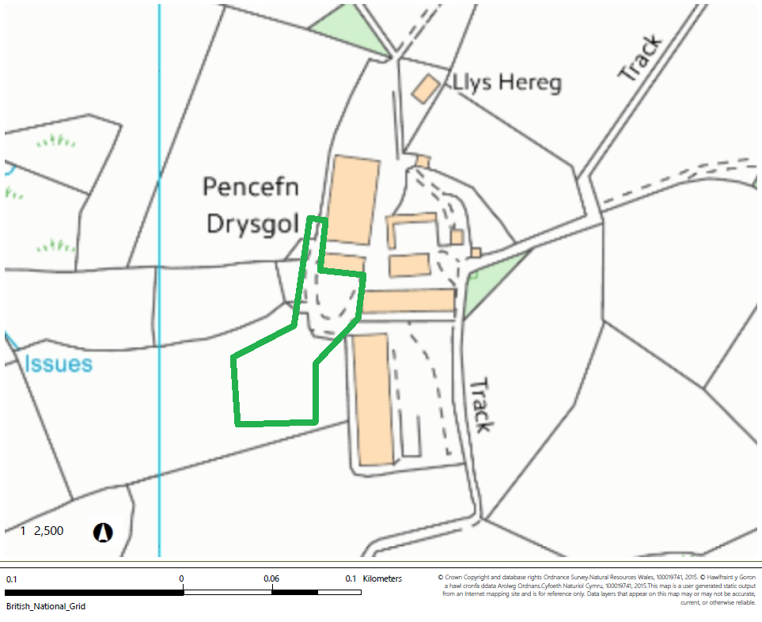

© Crown Copyright and database right 2020. Ordnance Survey licence number 100019741.

END OF PERMIT

