PAN-024237 My Map Report:
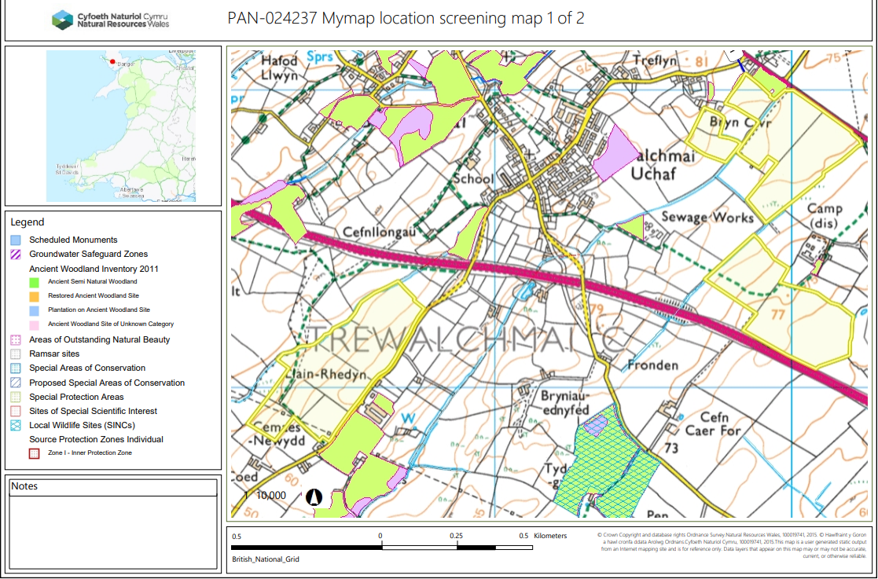
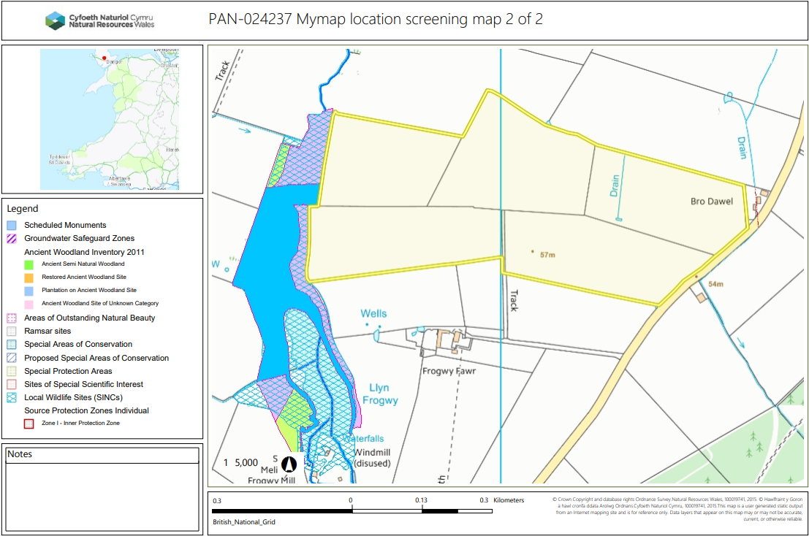
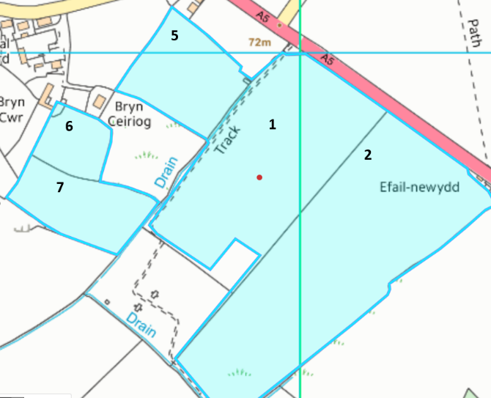
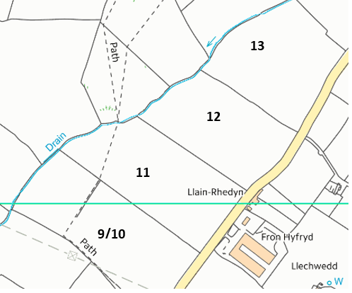
Detailed river network:
Fields 1, 2, 5 and 7 border land drains. There are 10 meter no spread buffer zones in place where the land drains intersect the field boundaries in accordance with the SRP. No action needed.
Fields 9/10, 11, 12 & 13 border surface waters/land drains which have been correctly buffered by 10 meters in accordance with the SRP.

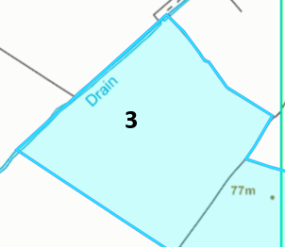
Fields 3 border surface waters/land drains which have been correctly buffered by 10 meters in accordance with the SRP.
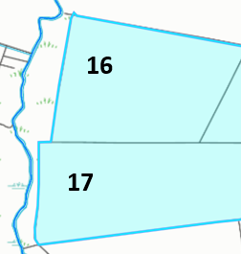
Fields 16 and 17 are located border surface waters/land drains which have been correctly buffered by 10 meters in accordance with the SRP.

Groundwater protection zones (source)
None in range.

Wells, springs or boreholes used for the supply of water for human consumption including from a private water supply or supplies
None in range.

any springs wells or boreholes not used to supply water for domestic or food production purposes within 50m

None in range.

European designated sites- Natura 2000 (SPA, pSPA, SAC or cSAC) or Ramsar- or SSSI within 500m
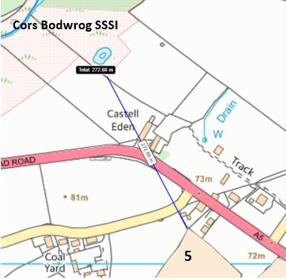
Field 5 is located 272 meters from Cors Bodwrog SSSI Field 5 is the closest field to the SSSI. There is no direct impact pathway to the site due to distance the closest field is from the SSSI. There are also physical barriers prevent the waste to enter the SSSI such as two main roads. The ground is also flat to gently sloping at 0-7º which means the waste will not drain into the SSSI.

Other protected sites:
- Protected Species- None in range.

- Protected Habitats-
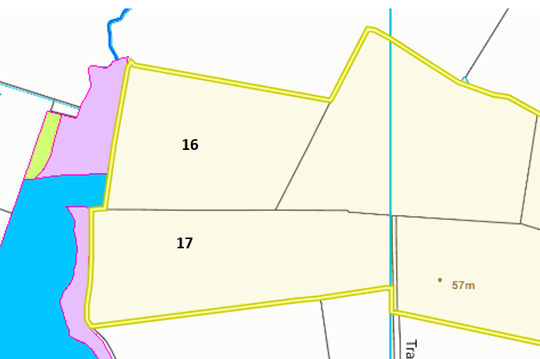
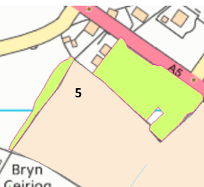
Field 5 borders a protected habitat: Lowland dry acid grassland and Lowland calcareous grassland. This has been referenced in the site plan. A 10 meter no spread buffer zone is also in place around the border of field 5 and the protected habitat. This will ensure no wastes enter the protected habitat.

Field 16 & 17 borders a protected habitat: Lowland dry acid grassland and Lowland calcareous grassland. A 10 meter no spread buffer zone is also in place around the border of the protected habitat. This will ensure no wastes enter the protected habitat.

- Scheduled Ancient Monument- None in range.

- Local Nature Reserve- None in range.

- National Nature Reserve- None in range.

- Ancient Woodlands- None in range.

- Local Wildlife Sites (SINC)-
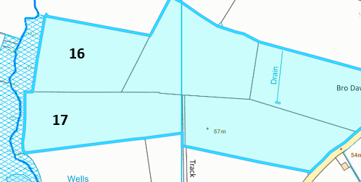

Field 16 & 17 borders a SINC site named: Llyn Frogwy. This has been displayed on the submitted site plan and risked assessed in the SSRA.

- National Park- None in range.

- Groundwater Safeguard Zone- None in range.

- Hedges- Nothing of concern.

- Ditches- see slope map below.

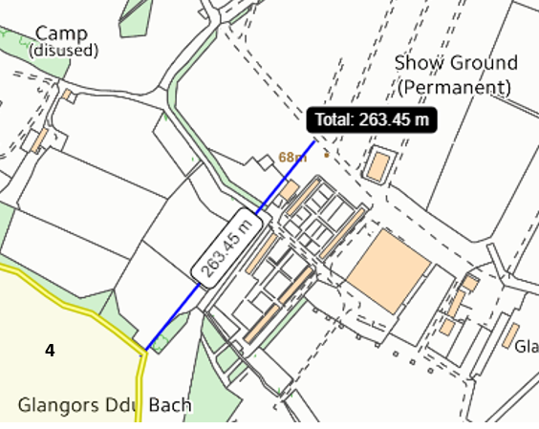
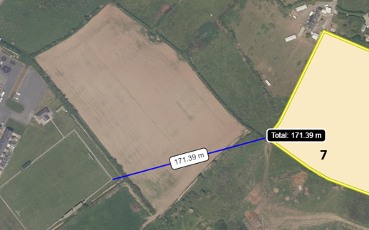
Field 7 is located 171 metres away from a playing field. This has been referenced as a potential sensitive receptor for odour in regard to spreading EWC 19 05 99 (Penhesgyn in Vessel Composting waste) in the submitted OMP.

Field 4 is located 263 metres from the Anglesey Agricultural Society show grounds. This has now been considered in the OMP from the request for information response.

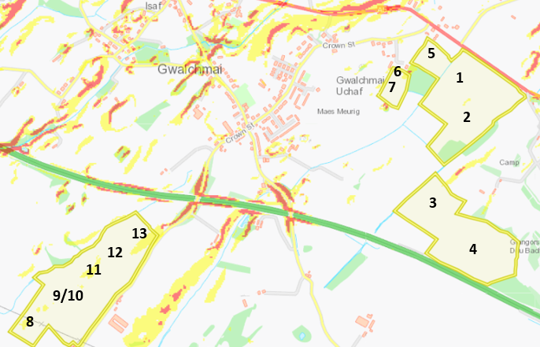
Slope Map

Fields 13 , 11 & 8 contain small areas of land that are moderately sloping at 7-12º. These areas are contained to the spreading fields with little risk of runoff outside the spreading area. The application method of applying the stackable sludge via rear discharge spreader, the liquid wastes via low trajectory splash plate, the Penhesgyn waste by soil injection are all appropriate methods of applying the wastes. . No more than 50t/ha will be spread on a field in any 3-week period to allow the soil to effectively absorb the wastes and mitigate runoff.
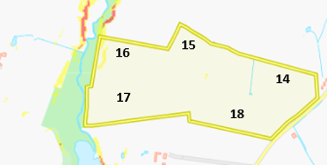
The rest of the fields in this deployment application contain flat to gently sloping areas of land (0-7º) which do not pose a runoff risk.

Flood risk from rivers ans seas
No flood risk for fields 1, 2, 3, 4, 5, 6, 7, 8, 9/10, 11, 12 and 13.
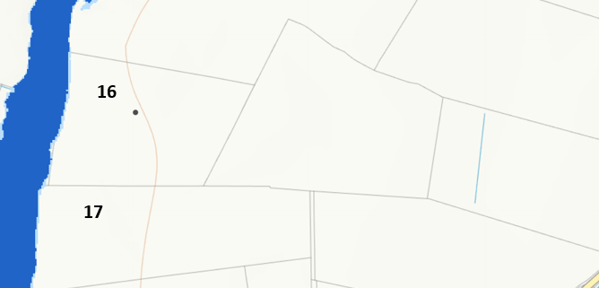

There is flood zone 3 risk for fields that border fields 16 and 17. A 10 meter no spread buffer zone is also in place around this area to mitigate the risk of flood waters encroaching onto the spreading fields.

