Permit
The Environmental Permitting (England & Wales) Regulations 2016

Mr. John Evans

J H Evans & Sons
Land at rear of Glanypwll Depot
Rhiwbryfdir
Blaenau Ffestiniog
LL41 3LN

Permit number

EPR/DB3192HS

Permit
The Environmental Permitting (England and Wales) Regulations 2016
Permit number

EPR/DB3192HS

The Natural Resources Body for Wales (“Natural Resources Wales”) authorises, under regulation 13 of the Environmental Permitting (England and Wales) Regulations 2016

Mr. John Evans (“the operator”),

of

108 Manod Road

Manod

Blaenau Ffestiniog

LL41 4AH

to operate waste operations at

J H Evans & Sons

Land at rear of Glanypwll Depot

Rhiwbryfdir

Blaenau Ffestiniog

LL41 3LN

to the extent authorised by and subject to the conditions of this permit.

Under regulation 27(2) of the Regulations, standard rules SR2011 No03 are conditions of this permit.

Name | Date
Huw Davies | 13/03/2024

Authorised on behalf of Natural Resources Wales

Schedule 1 - Site plan

This is the plan referred to in the standard rules SR2011 No03

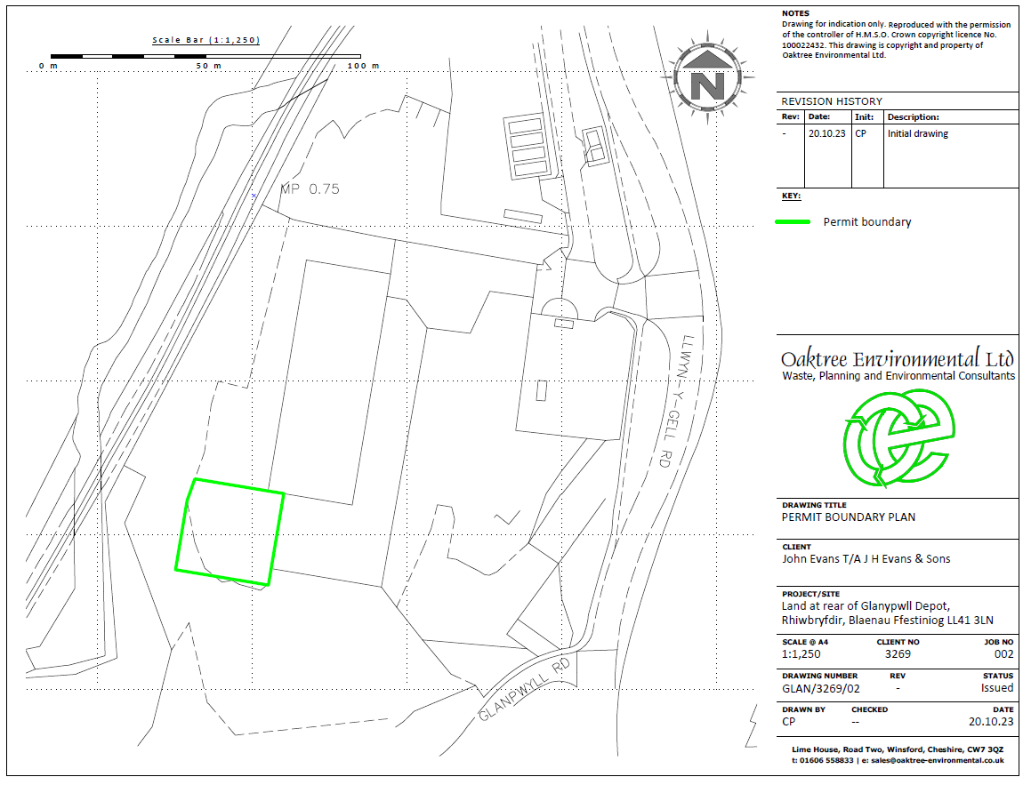

END OF PERMIT

