PAN-025050 My Map Report:

Application map
*NOTE. Site layout, pile sizes/locations, separation distances etc have not been assessed by the Permitting Officer as part of the application for this Standard Rules Permit.
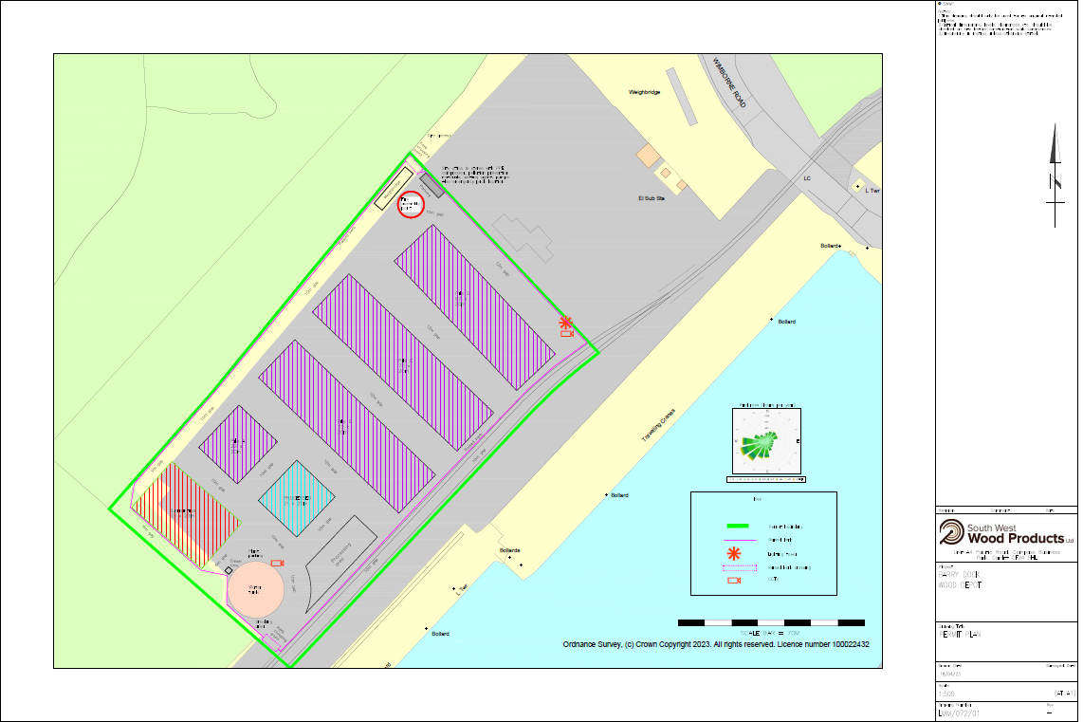
MyMap location
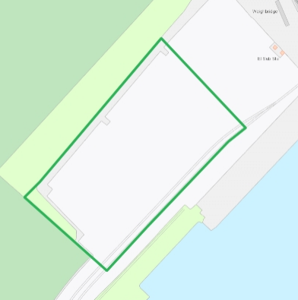
Detailed river network: 10m
None
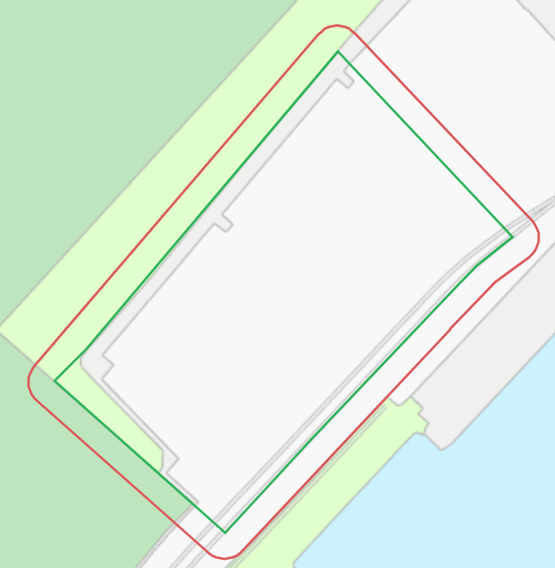
Any well, spring (or issue) or borehole used for the supply of water for human consumption including from a private water supply or supplies: 50m.
None
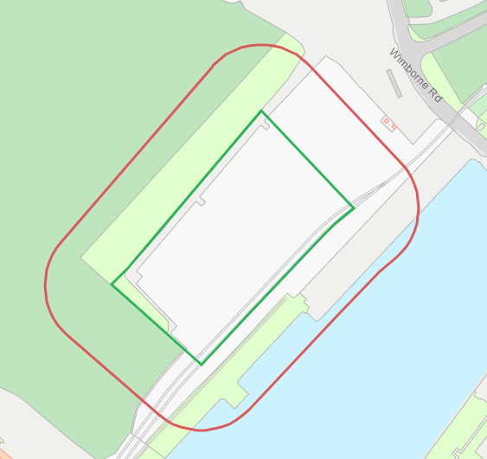
European designated sites- Natura 2000 (SPA, pSPA, SAC or cSAC) or Ramsar- or SSSI: 500m
None
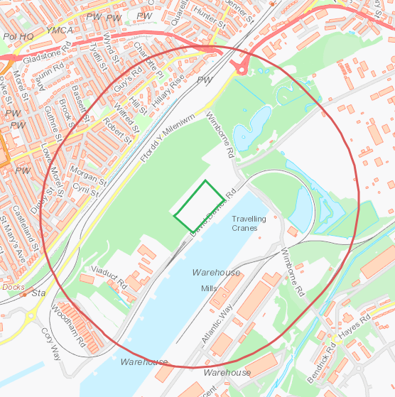
Other protected sites:
- Protected Species-50m
- Protected Habitats-50m
- Scheduled Ancient Monument- 50m
- Local Nature Reserve- 50m
- National Nature Reserve-50m
- Ancient Woodlands-50m
- Local Wildlife Sites (SINC)-50m

None
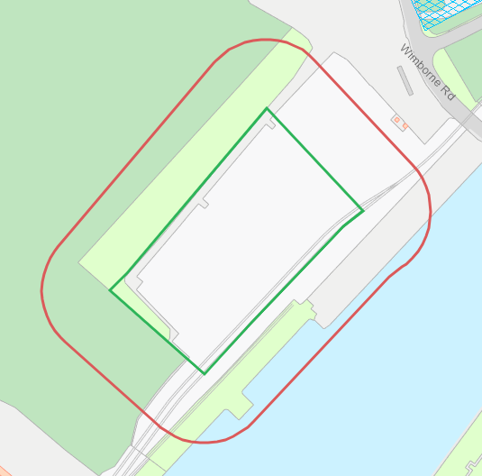

- Great crested newts-250m
None
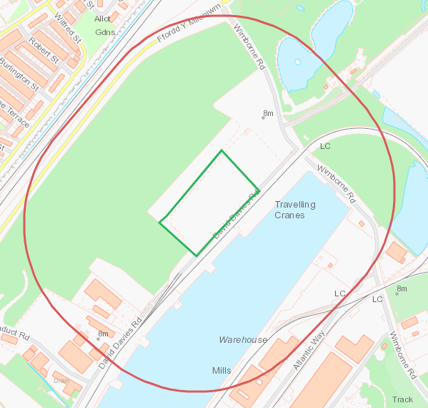
END

