PAN-024355 - My Map Report:
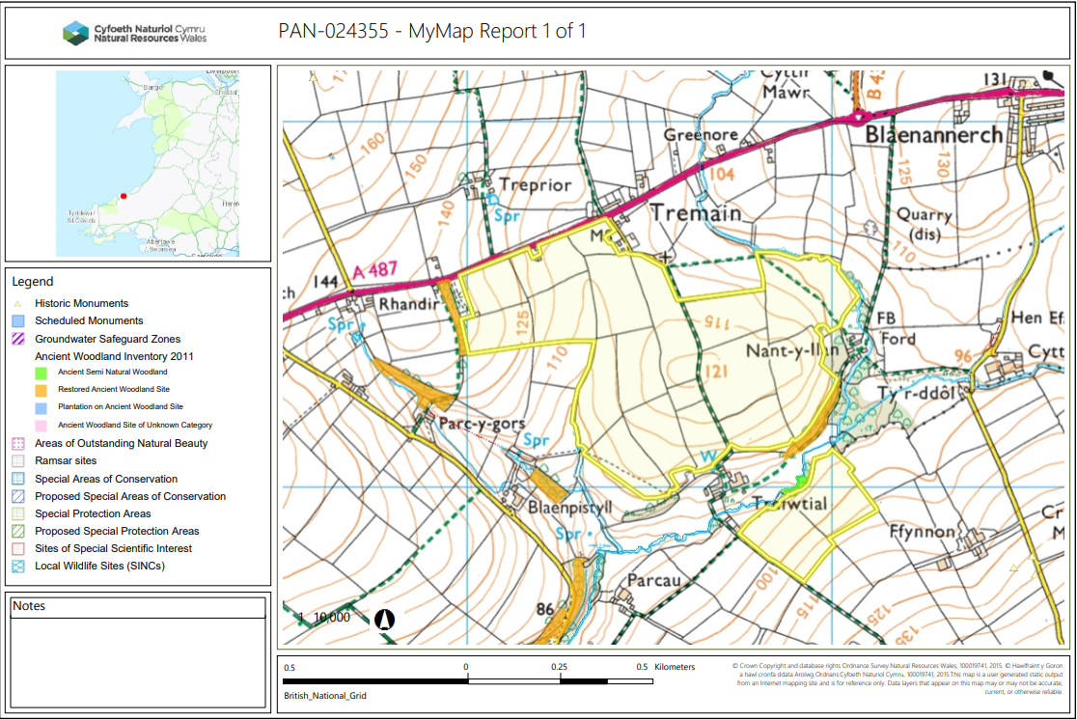
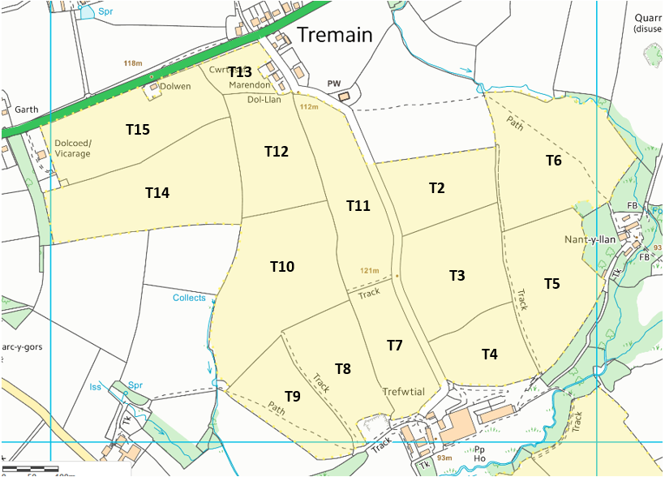
Detailed river network:
A river network runs around the field boundary of T6 and near to the boundary of the bottom of T5. Another water course also runs on the boundary of T10. Both rivers are clearly marked on the submitted site maps and 10 Meter no spread buffer zones have been implemented to account for any potential run off risk.
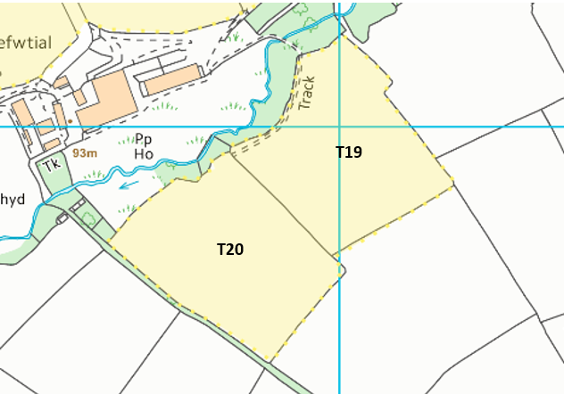
A river runs along the top end of both T20 and T19. The river itself is not in direct proximity to the field, however a 10m buffer zone has been implemented along the edges closest to the watercourse, mitigating any potential run off risk.
Groundwater protection zones (source)
None in range
Wells, springs or boreholes used for the supply of water for human consumption including from a private water supply or supplies
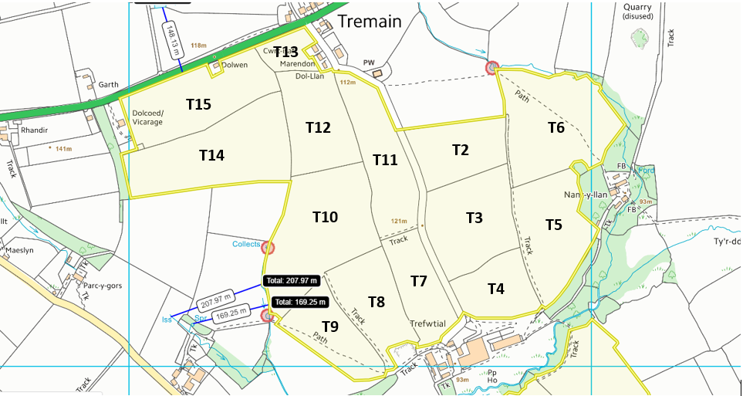

any springs wells or boreholes not used to supply water for domestic or food production purposes within 50m

None in range
European designated sites- Natura 2000 (SPA, pSPA, SAC or cSAC) or Ramsar- or SSSI within 500m

None in range
Other protected sites:
- Protected Species-

None in range

- Protected Habitats-
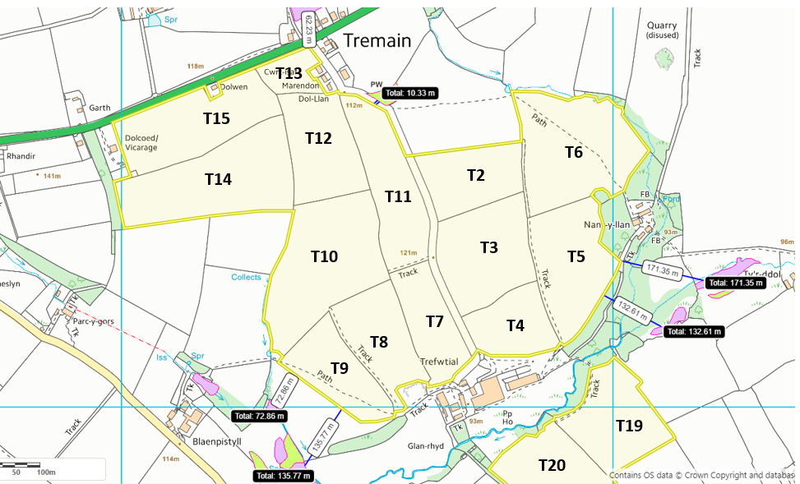
Field T11 is 10.33m from protected habitat: Lowland dry acid grassland. Ariel images suggest this area is now a agriculturally improved. Due to this and the section of road between the spreading fields and habitat, run off risk is low, no action required. Field T9 has a protected habitat 72.86m and 135.77m from its border: purple moor grass and rush as well as lowland dry acid grassland, lowland Calcareous grassland and purple moor grass and rush respectively. Due to the distance no impact pathway is perceived. Field T5 has an area of purple moor grass and rush 132.61m and 171.35m from its border. Due to the large no spread zone implemented on this border no impact pathway is perceived. Field T13 has a protected habitat of purple moor grass and rush 62.23m from it's border, no impact pathway perceived.

- Scheduled Ancient Monument

None in range

- Local Nature Reserve

None in range

- National Nature Reserve

None in range

- Ancient Woodlands

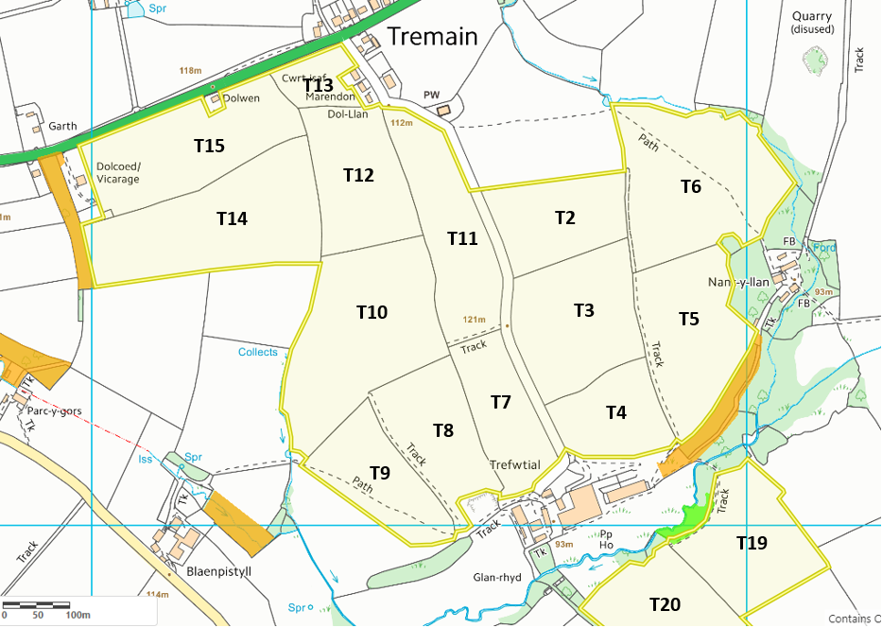

Ancient woodland areas border field T14, T5 and T19. There is no overlap into the field itself and 10m no spread buffer zones have been implemented at the field boundaries to mitigate any impact pathway. No action required.

- Local Wildlife Sites (SINC)
None in range
- National Park
None in range
- Groundwater Safeguard Zone
None in range
- ANOBs
None in range
- Heritage coast
None in range
- World Heritage Sites
None in range
- Hedges
- Ditches
None in range
- Local residents, Housing, schools, Workplaces, Recreational facilities
All neighbouring residential buildings, churches and places of work are effectively included on the submitted maps. An OMP plan has been submitted to reduce impacts to these neighbouring properties.

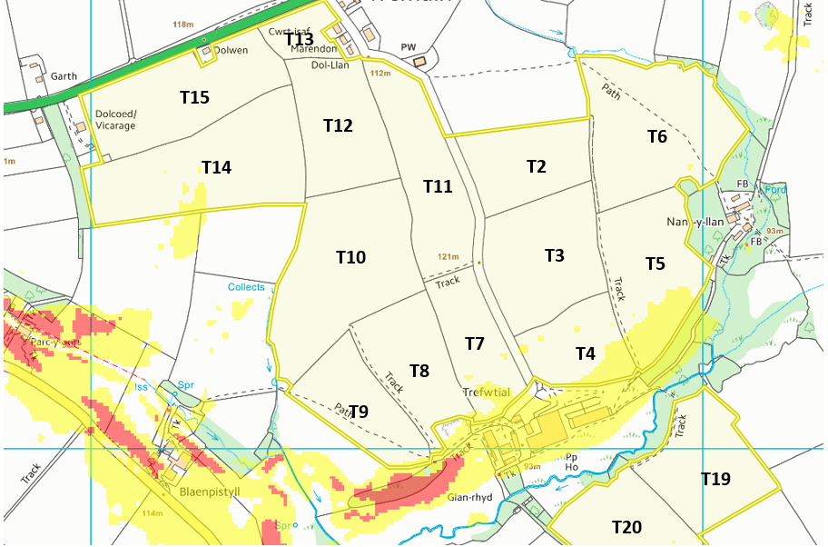
Slope Map

Field T5, T4, T7 and T14 contain areas of moderately sloping land (0-7º). The slope continues outside the boundary of the field. Bordering T5 and T14 as shown above there is an area of ancient woodland. T14 has a no spread buffer on the border closest to the woodland, although it’s size is not specified. Due to the physical form of the waste, application method and that the sloping is contained to the middle section of the field, no impact pathway is perceived. Field T5 has a 10m no spread buffer around it border, however the sloping runs directly into the woodland.

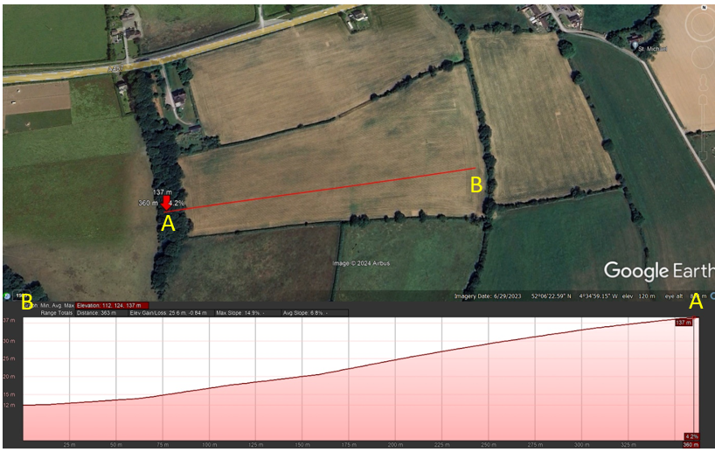
The terrain found in field T14 gently slopes downward from point A to point B. Point A denotes the highest elevation in the field with point B being the lower region. This gradual decline shows there would be a natural drainage in the field away from the ancient woodland at point A and as such no impact is determined on this sensitive receptor.
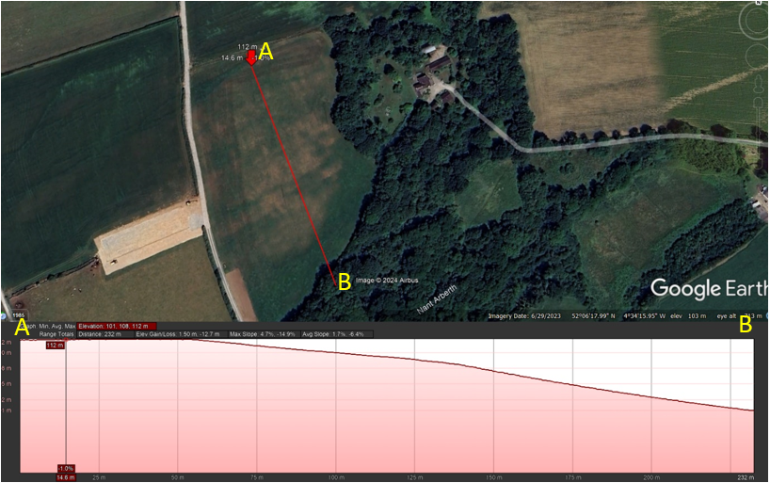
The terrain found in field T5 gently slopes downward from point A to point B. Point A denotes the highest elevation in the field with point B being the lower region. This gradual decline shows there would be a natural drainage into the ancient woodland that borders the southern section of the field. There is a 10m no spread buffer implemented here, this is not sufficient due to the slope, high iron concentration and application waste of the waste to be spread.
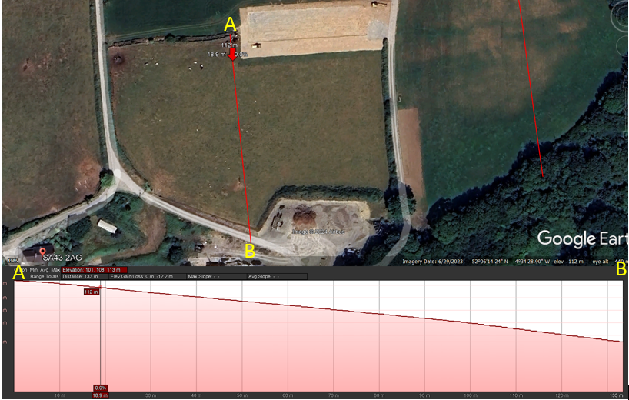
The terrain found in field T4 gently slopes downward from point A to point B. Point A denotes the highest elevation in the field with point B being the lower region. This gradual decline shows there would be a natural drainage into the road that borders the southern section of the field. There is no buffer zone present in this field.

Flood risk
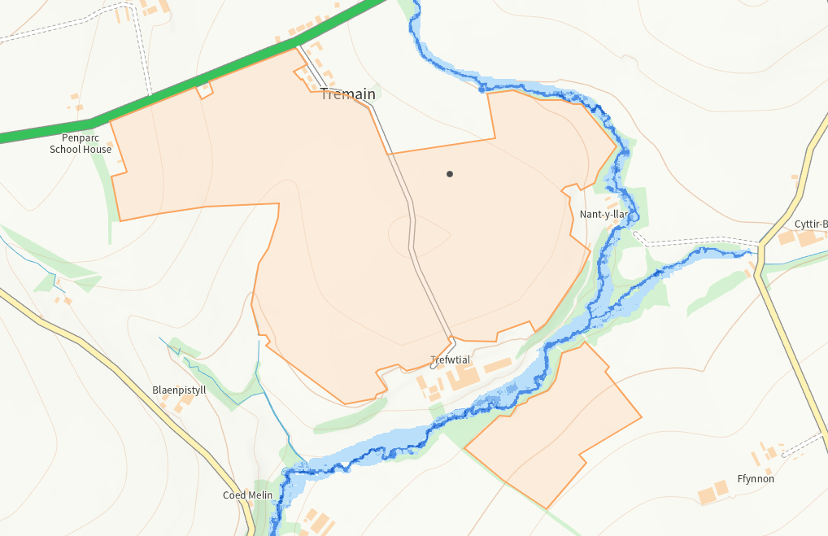
There is no flood risk across any of the fields. There is a low flood risk near the border of T6 however, this field is bordered by a 10m no spread zone. No action required.

