PAN-024720 MyMap report
https://mapsinternal.cyfoethnaturiolcymru.gov.uk/Html5Viewer2101/index.html?viewer=MyMap_Permitting.MyMapPermittingHTML5&project=1745cc2bebbd4f5aa5257d7af1b15496
Crug Farm (fields 8295, 1594, 2312, 3498, 4526, 5412, 5994, 7025)
surface water courses, well, spring (or issue) or borehole
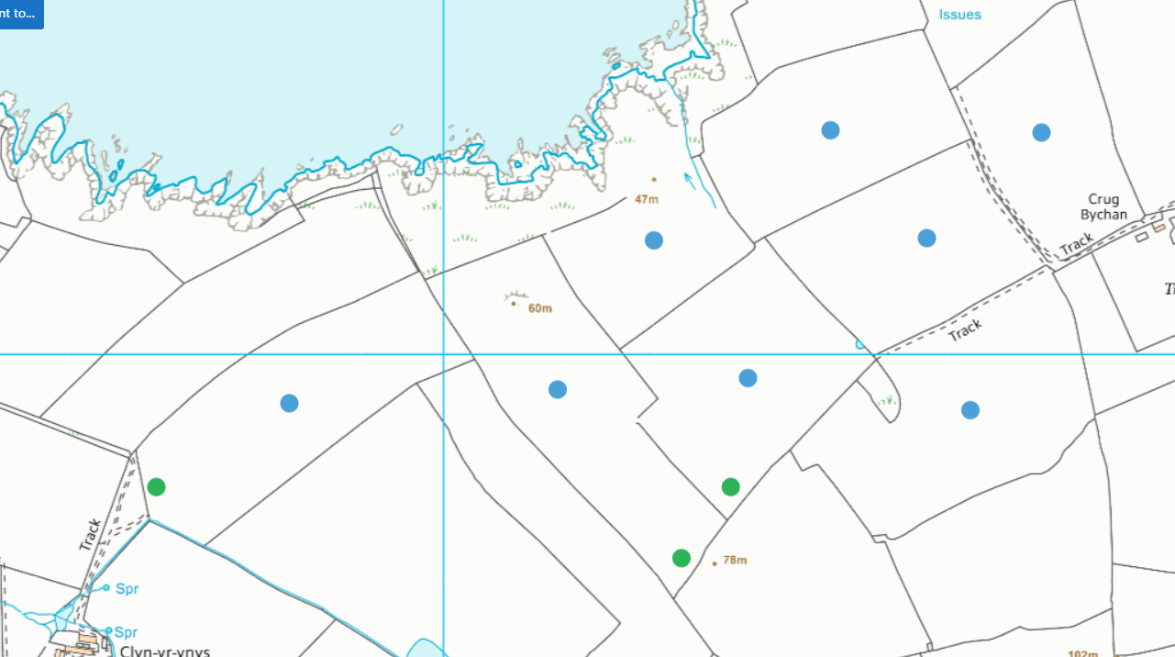
- All water courses buffered
- No springs, wells or boreholes
European designated sites- Natura 2000 (SPA, pSPA, SAC or cSAC) or Ramsar- or SSSI within 500m
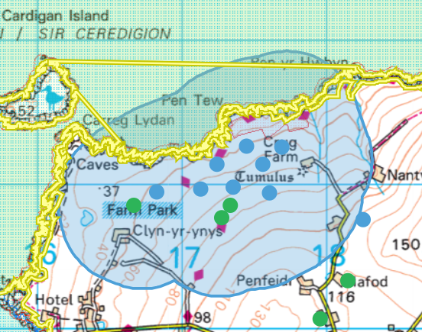
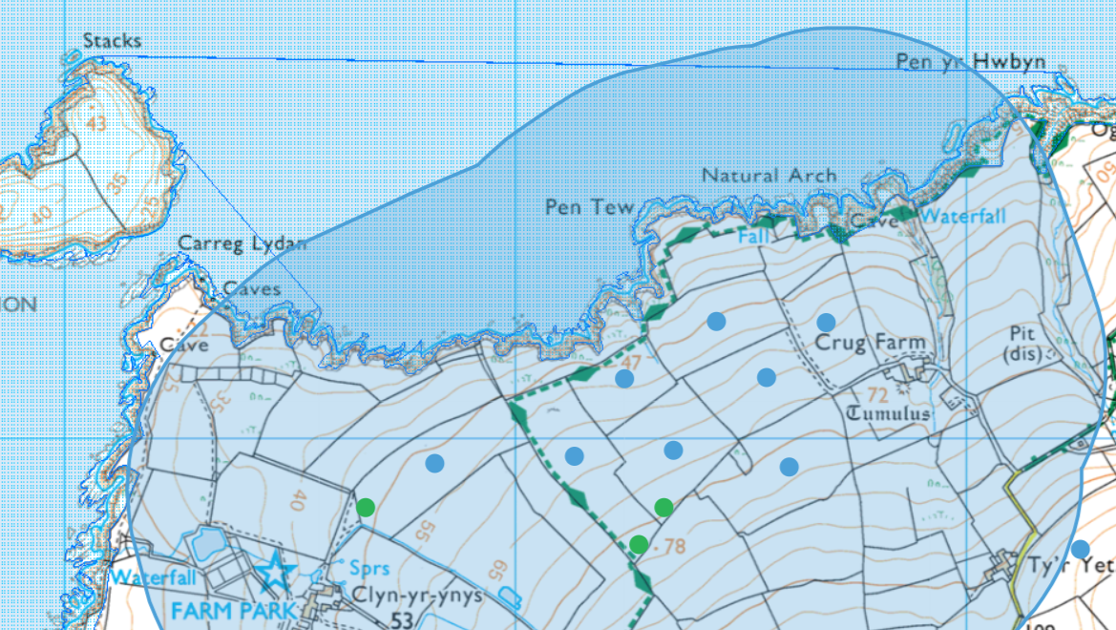
- Cardigan Bay / Bae Ceredigion SAC
- West Wales Marine / Gorllewin Cymru Forol SAC

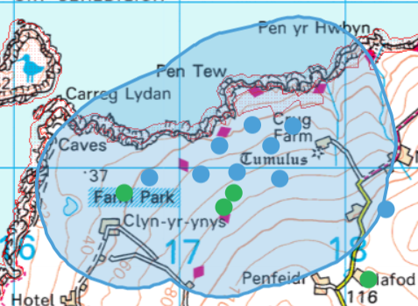
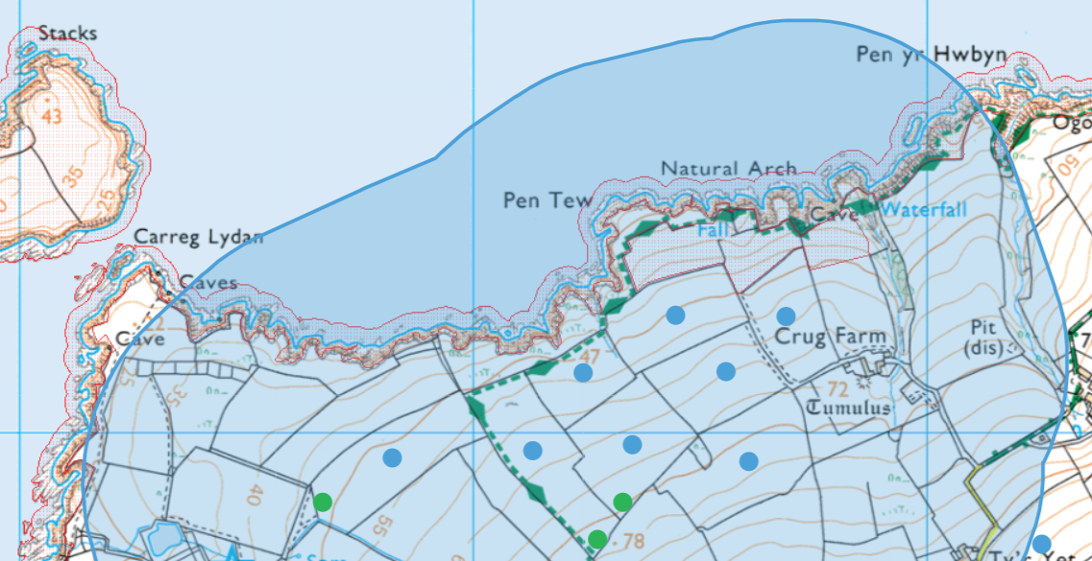
- Aberarth - Carreg Wylan SSSI
- Caeau Crug Bychan, Ty Gwyn a Llwyn Ysgaw SSSI

location of any public rights of way
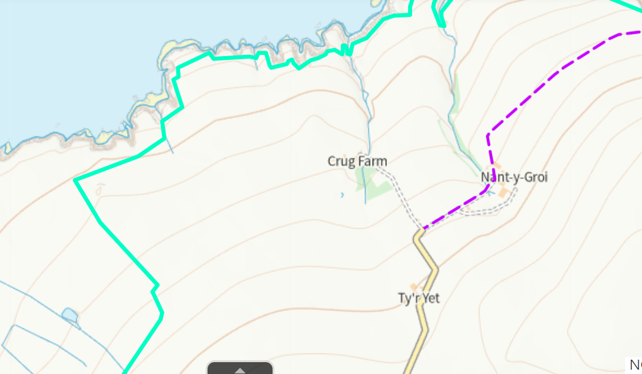
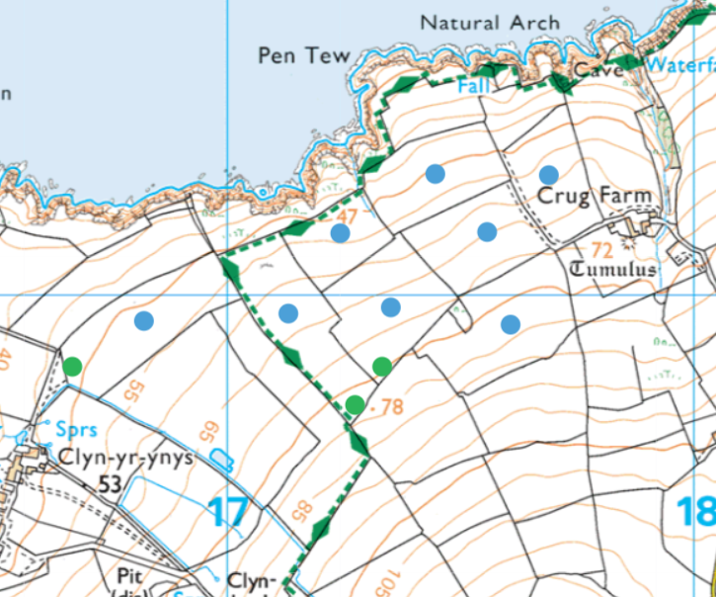
- On field edges- shown on map, included in ABS

Protected Habitats
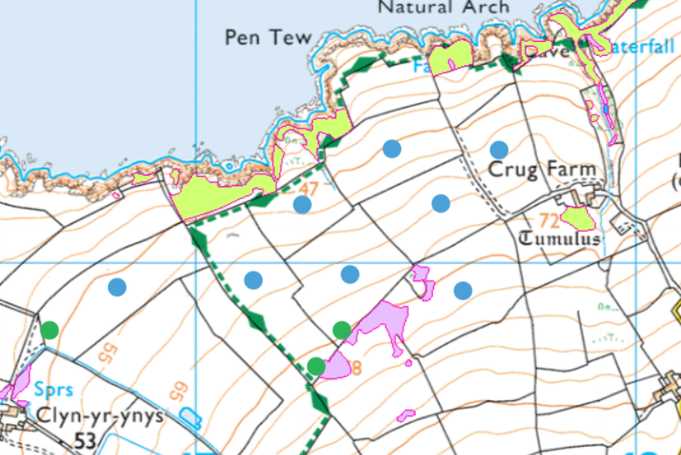
- Lowland dry acid grassland and Lowland calcareous grassland north of 1594 and 2312
- Purple moor grass and rush pastures south of 1594, 3498 and in 5994- on review of most recent google earth airol photos- these areas are not visibly different to the rest of the field- no action required:
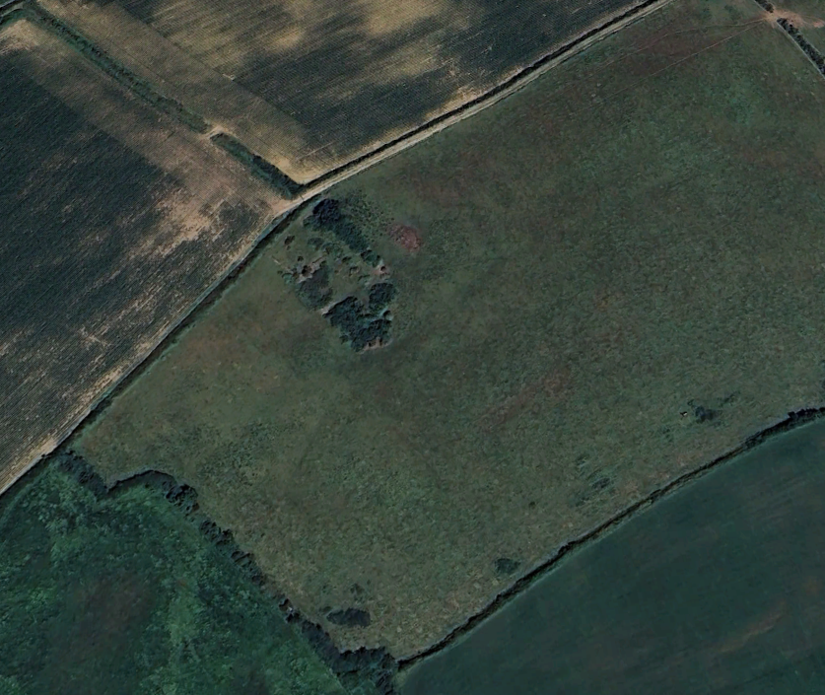
Section 7 species
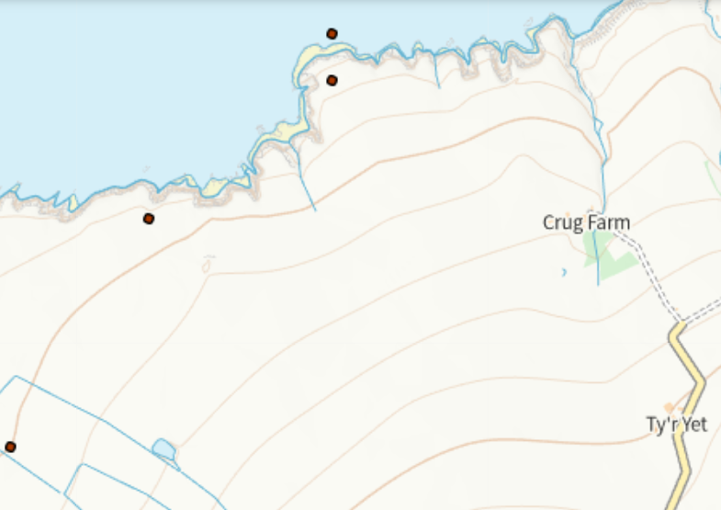
- Kestrel (west on land dot)
- Common Porpoise (in sea)
- Wall butterfly/moth (east on land dot)

Flood risk
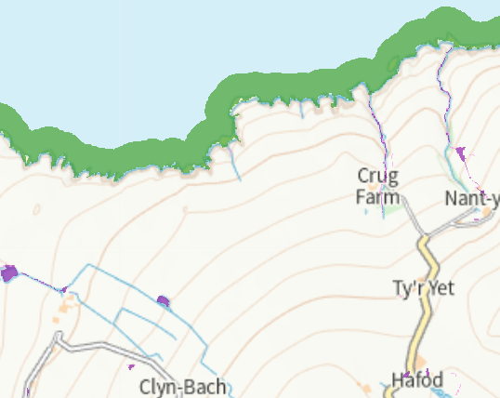
- None on spreading fields, all to the north at sea lever/under cliffs.

Slope
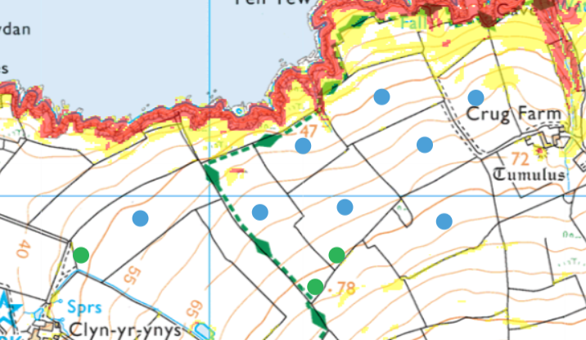
- Only area of red is already removed from spreading area
- Minimal areas of yellow in 7025

groundwater source protection zones- none
Groundwater Safeguard Zone- none
Scheduled Monument- none
Local Nature Reserve/National Nature Reserve/ National Park- none
Ancient Woodlands- none
Local Wildlife Sites (SINC)- none

Hafod field 2675
surface water courses, well, spring (or issue) or borehole
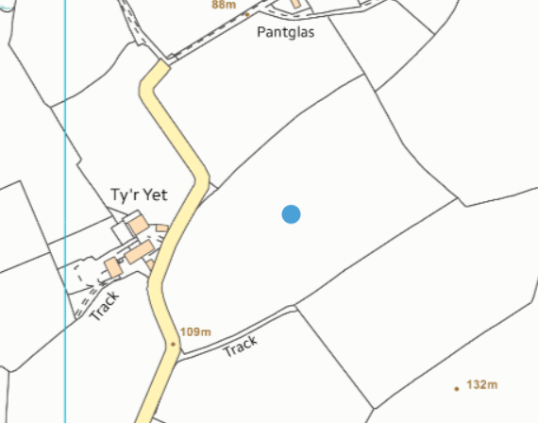
- none

Protected Habitats
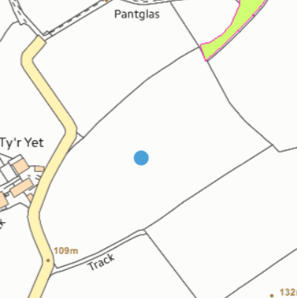
- Lowland dry acid grassland and Lowland calcareous grassland

Slope
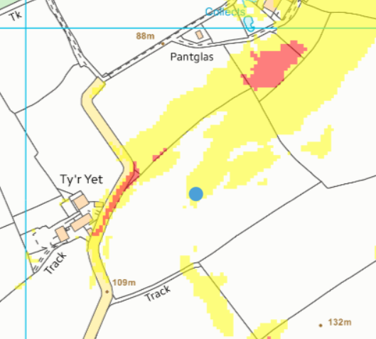
- Areas of yellow

groundwater source protection zones- none
European designated sites- Natura 2000 (SPA, pSPA, SAC or cSAC) or Ramsar- or SSSI within 500m- none
location of any public rights of way- none
Groundwater Safeguard Zone- none
Section 7 species- none
Scheduled Monument- none
Local Nature Reserve/National Nature Reserve/ National Park- none
Ancient Woodlands- none
Local Wildlife Sites (SINC) - none
Flood risk- none

CYY Heolgwyddil fields 1 and 2
surface water courses, well, spring (or issue) or borehole
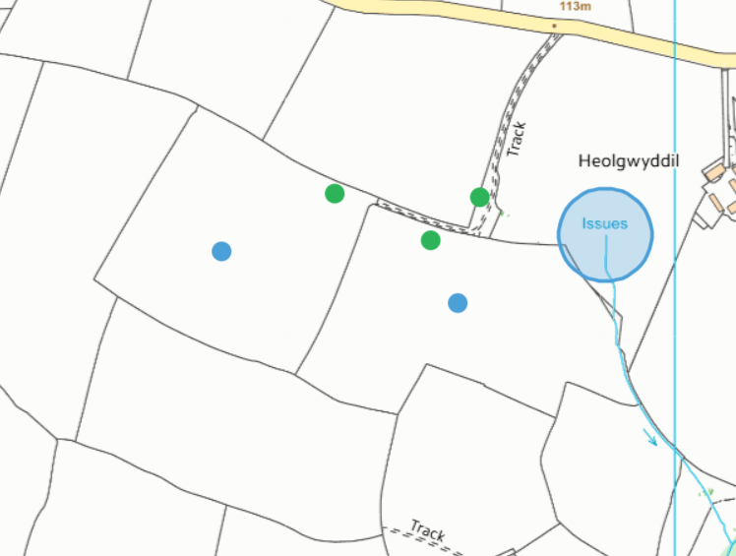
- Watercourse and issue- both buffered

location of any public rights of way
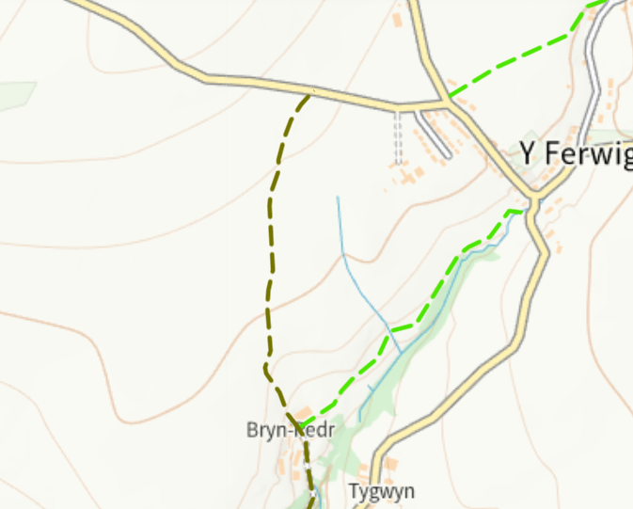
- Shown on map and buffered

Section 7 species
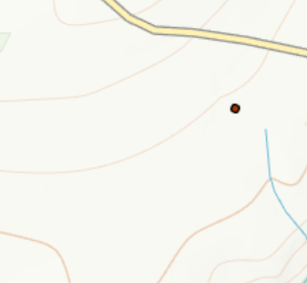
- Wall Butterfly/Moth

Flood risk
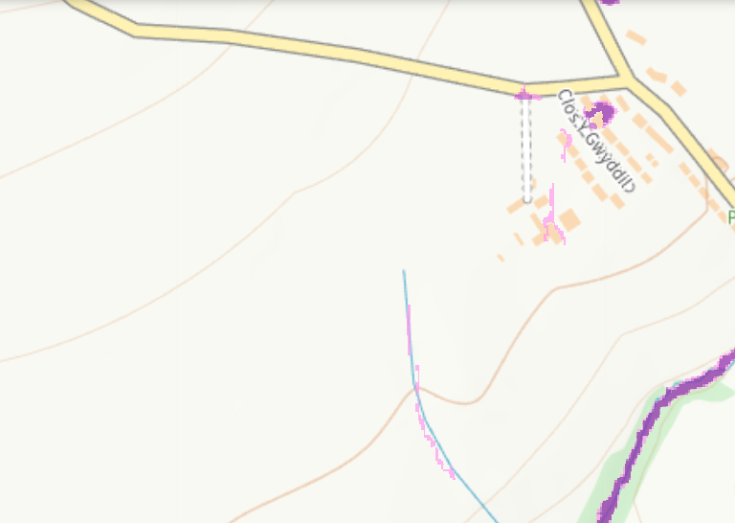
- None (watercourse following south away from field)

Slope
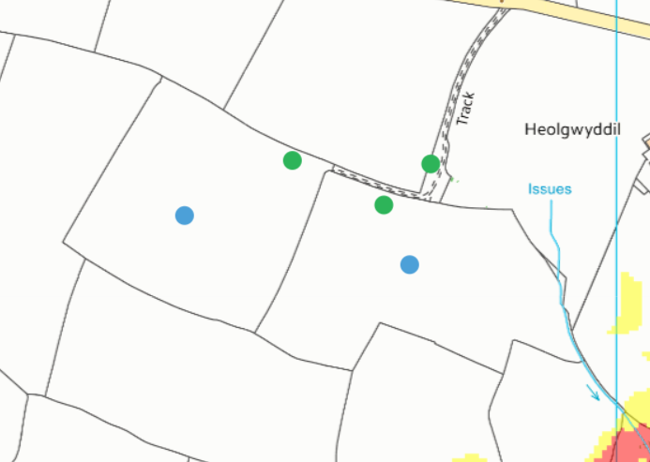
- none

groundwater source protection zones - none
European designated sites- Natura 2000 (SPA, pSPA, SAC or cSAC) or Ramsar- or SSSI within 500m- none
Groundwater Safeguard Zone- none
Protected Habitats- none
Scheduled Monument- none
Local Nature Reserve/National Nature Reserve/ National Park- none
Ancient Woodlands- none
Local Wildlife Sites (SINC)- none

Storage- SN1795650061- above ground storage tank and SN1814850320- nurse tank (at Hafod Farm)
surface water courses, well, spring (or issue) or borehole
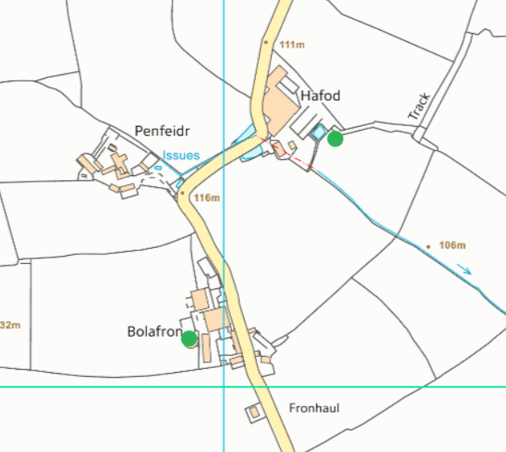
- pond/lagoon by nurse tank location- having reviewed the most recent google earth aerial photos- pond is no longer there- 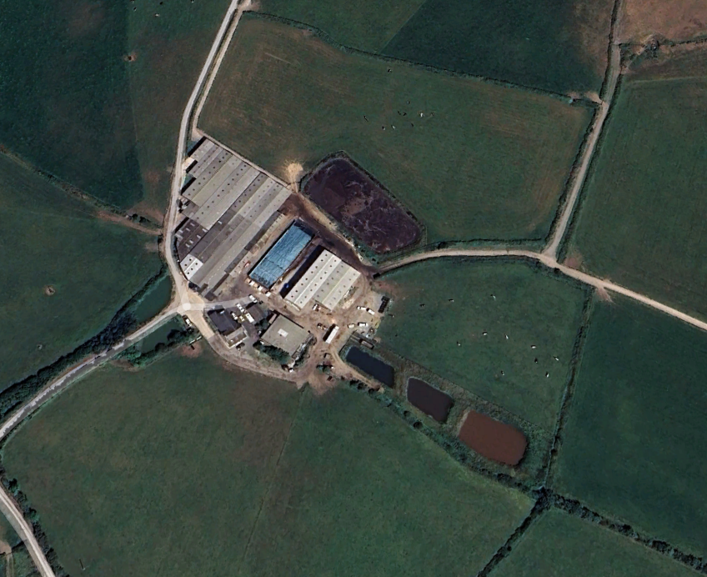
- no other watercourse etc within distances.
Flood risk
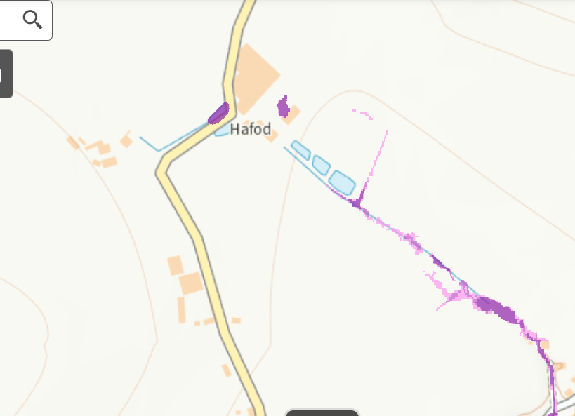
- none at storage locations

Slope
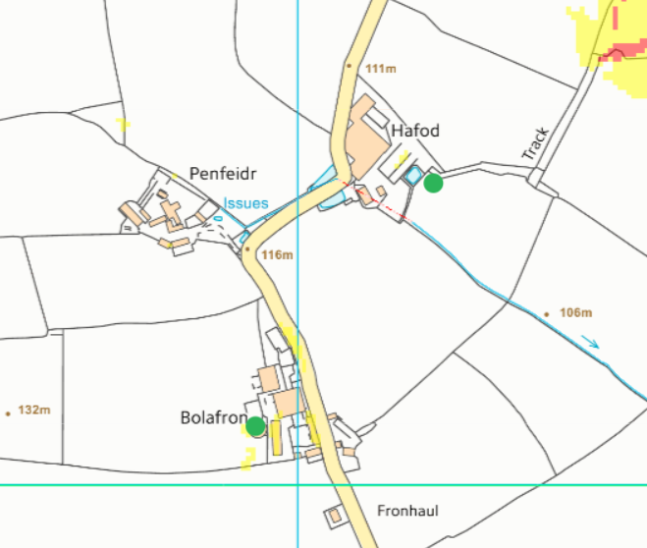
- none

groundwater source protection zones- none
European designated sites- Natura 2000 (SPA, pSPA, SAC or cSAC) or Ramsar- or SSSI within 500m- - none
location of any public rights of way- none
Groundwater Safeguard Zone- none
Protected Habitats- none
Section 7 species- none
Scheduled Monument- none
Local Nature Reserve/National Nature Reserve/ National Park- none
Ancient Woodlands- none
Local Wildlife Sites (SINC)- none

