CRoW Appendix 4 (140_10_SD02)  CRoW Act 2000: Natural Resources Wales application for permission - Formal Notice |  | 
Natural Resources Wales Formal Notice.
Requirements of Section 28I of the Wildlife & Countryside Act 1981 as amended by the Countryside and Rights of Way Act (CRoW) 2000.
Duty in relation to granting any consent, licence or permit for activities likely to damage Sites of Special Scientific Interest (SSSI).
- Natural Resources Wales area/region/NPS hub: | Mid
- Name of SSSI: | Aberarth - Carreg Wylan SSSI  Caeau Crug Bychan, Ty Gwyn a Llwyn Ysgaw SSSI
- Type of permission: | Landspreading of waste deployment under Standard rules mobile plant permit SR2010 No4
- Date for Natural Resources Wales permit determination: | 12/03/24
- Predicted 28 day date for response from NRW conservation/ecology (under S28 I(4)): | n/a saved for information only
- Natural Resources Wales reference no: | PAN-024720  EPR/AB3891CX
- National grid reference: | Fields:  Crug Farm 8295 SN1682250937  Crug Farm 1594 SN1713550953  Crug Farm 2312 SN1723951116  Crug Farm 3498 SN1735150971  Crug Farm 4526 SN1745351260  Crug Farm 5412 SN1754251112  Crug Farm 5994 SN1760750931  Crug Farm 7025 SN1769751249  Storage:  SN1727550763- field heap Crug Farm 1594  SN1733350843- field heap Crug Farm 3498  SN1666550846- field heap Crug Farm 8295  There are other fields and storage locations within application PAN-024720 however these have not been included in this assessment as there are over 500 meters from the SSSIs
- Description of proposal: | Application to spread dairy wastes (02 05 02)from Volac/Sensient– Felinfach and First Milk –Haverfordwest and water treatment waste (19 09 02) from various DCWW water treatment works over fields at Crugmore farm.  The wastes are either liquid (no-stackable) or sludge cake (stackable).  Liquid wastes is to be spread by either umbilical method with the liquid delivered to tractor in deployed fields pumped through hose and spread by trailing hose applicator (‘dribble bar’) mounted onto the back of the tractor, or a tractor and vacuum tanker with trailing hose applicator (‘dribble bar’).  Sludge cake is to be spread by rear discharge muck spreaders.  Cropping is to be grass, spring wheat and maize.  Spreading of the waste will be carried out in accordance with the Code of Good Agricultural Practice and in accordance with the requirements of the deployment and Environmental Permitting Regulations.  Waste will not be stored or spread in combination (i.e. only one waste stream per field).  Potentially Toxic Elements: The supplied concentrations at the proposed application rates are all lower than the maximum permissible levels detailed in the Sludge (Use in Agriculture) Regulations.  Physical contaminants: The wastes are produced by managed processes. The wastes do not contain physical contaminants.  Potential run-off after application: The wastes will be applied following the Code of Good Agricultural Practice. The maximum application rate for each field over 50t/ha where spread with liquid sludges will be split into multiple applications and will not exceed 50t/ha in any one application to a field (or the maximum application rate given in Table 1 where lower). The fields will be spread using precision spreading dribble bar equipment for liquid sludges and with rear discharge muck spreaders for sludge cakes, with no spreading areas enforced as per maps. The wastes will be soil incorporated as soon as possible through cultivations where spread prior to planting of the next crops.  All handling of the wastes will be in accordance to current regulations and relevant mitigation strategies will be adopted.  Odour may potentially be emitted from the spreading of the First Milk and Volac/Sensient liquid sludges – to mitigate odour generation all handling of waste will be done in accordance to current regulations and relevant mitigation strategies will be adopted. Waste will be spread with low trajectory trailing hose (dribble bar) applicator. This is an efficient method to prevent odour transmission & nutrient losses associated with higher trajectory spread methods such as splash plate. If any odour complaints are received, further odour mitigation methods will be implemented.  The Dwr Cymru Welsh Water liquid water clarification sludges and water clarification sludge cakes are considered to have no noticeable odour.  Spillages: all spillages will be reported immediately to NRW.  No waste will be spread within 10m of any ditch, pond or surface water, within 50m of any spring, well, borehole, or reservoir that supplies water for human consumption or farm dairies.
Liquid sludges will be spread on delivery or securely stored as stated above. The water clarification sludge cakes will be stockpiled in field heaps prior to being spread. Operators will aim to empty spreading equipment before the end of each working day to avoid overnight storage of waste in machinery.

Regular servicing of all machinery is conducted and spreading equipment is annually calibrated. To prevent waste being held in faulty machinery replacement spreading equipment will be available.

Spreading machinery will travel over the field in a direction which will most easily allow the machinery to turn within the boundaries of the field. Any spreading equipment will be turned off and/or lifted out of the soil prior to turning at the end of each run.

Machinery turns will be routed to avoid rutting and wheel slip. The turns will not be executed on any buffer strips.

There will be sufficient trained staff available to ensure that the operation continues throughout operational hours (i.e. there will be sufficient cover for illness, holiday etc.).

Rights of way have been marked on the spread risk maps. Spreading will be carried out at times of low use & waste will be rapidly incorporated for arable fields where spread prior to planting of next crops. Where the footpath crosses within the field spread area, it’s noted that the material will be spread & rapidly soil incorporated with the footpath reinstated for field Crug 1594 where spread prior to planting of next grass crop. A 2 metres no spread buffer will be employed either side of the footpaths in field Heolgwyddil 1 where spread into the growing crop. The footpath in field Crug 2312 is
in an area of the field marked with a 20 metres no spreading area due to proximity to SSSI.

Weather conditions will be monitored prior to spreading with wind speed and direction assessed.

Consideration for the public and local residential receptors will be taken into account.

A 2.0m minimum buffer zone will be left adjacent to trees, shrubs and hedges.
- Is the proposed activity within (wholly or partially) the SSSI boundary? | No
- Has there been any pre-application discussion or correspondence with NRW conservation/ecology | No
- What aspect(s) of the proposed permission may damage the features which are of special interest for the SSSI?

The following ‘Operations Requiring Consent’ (or other activities associated with the permission) that may cause damage) are relevant to the proposed permission.

Aberarth - Carreg Wylan SSSI
- 1. Cultivation, including ploughing, rotovating, harrowing and re-seeding.
- 4. Mowing or cutting vegetation, the introduction of mowing or cutting and alterations to the mowing or cutting regime.
- 5. Application of manure, slurry, silage liquor, fertilisers and lime
- 7. Dumping, spreading or discharging of any materials.

Caeau Crug Bychan, Tŷ Gwyn a Llwyn Ysgaw SSSI:
- 1. Cultivation and alterations to the ploughing, rotovating, harrowing and reseeding regime
- 5. Application of manure, slurry, silage liquor, fertilisers and lime.
- 7. Dumping, spreading or discharging of any materials
- 22. Storage of materials.

The following SSSI features and mechanisms of impact have been considered to assess the likelihood of damage:

Carreg Wylan SSSI:
This site is of special interest for its geological, geomorphological and biological features. The cliffs and foreshore vary considerably in structure, exposure and sediment type, supporting a wide range of marine and coastal wildlife. Bottlenose dolphin Tursiops truncatus and Atlantic grey seal Halichoerus grypus are of special interest and are known to feed and breed along the shoreline. Secluded beaches and sea caves provide pupping sites for grey seals.
The shoreline, made up of reefs, rock pools, boulders, exposed cobble, shingle and sand, supports a range of important intertidal communities including fine examples of honeycomb worm Sabellaria alveolata reefs. The nationally rare crustacean Pectenogammarus planicrurus, typical of clean shingle shores occurs here. The sea cliffs provide roosts and nest sites for nationally important populations of chough Pyrrhocorax pyrrhocorax kittiwake Rissa tridactyla and lesser black-backed gull Larus fuscus. Habitats of special interest associated with the cliffs and coastal slopes include cliff crevice and ledge vegetation, maritime grassland and coastal heathland supporting a large number of nationally scarce and regionally rare plant species including rock sea lavender Limonium britannicum ssp. transcanalis, common gromwell Lithospermum officinale and smooth cat’s ear Hypochaeris glabra. The scarce pearl-bordered fritillary butterfly Bolaria euphrosyne and the regionally rare small blue butterfly Cupido minimus, are part of an important invertebrate community present.

Caeau Crug Bychan, Tŷ Gwyn a Llwyn Ysgaw SSSI :
Caeau Crug Bychan, Ty Gwyn a Llwyn Ysgaw is of special interest for the species-rich wild plant community of these arable fields and for populations of nationally scarce and regionally rare plants.
Caeau Crug Bychan, Ty Gwyn a Llwyn Ysgaw support a species-rich wild plant community. Fumitory Fumaria species, subspecies and variants are prominent alongside a range of other uncommon taxa, many of which are anciently-naturalised and occur here at the edge of their range. More than 60 species of wild plants of arable fields have been recorded from this site.
There are good populations of the nationally scarce small-flowered catchfly Silene gallica and of the regionally rare species, sharp-leaved fluellen Kickxia elatine, weasel’s snout Misopates orontium, annual knawel Scleranthus annuus, dwarf spurge Euphorbia exigua, small-flowered buttercup Ranunculus parviflorus and cornfield knotgrass Polygonum rurivagum.
The arable fields and associated banks provide important feeding areas for birds including chough Pyrrhocorax pyrrhocorax, linnet Carduelis cannabina, skylark Alauda arvensis and yellowhammer Emberiza citrinella. The quail Coturnix coturnix, which is a rare summer visitor to Ceredigion, has also been recorded at the site.

Potential mechanisms for impact/pathways for both SSSIs are deterioration of site through contamination, nutrient enrichment, habitat loss, smothering occurring as a result of spreading activity, airborne compounds, flooding, nutrient run off or leaching.
- Decision
The proposed permission is not likely to damage any of the flora, fauna or geological or physiological features which are of special interest.

There is no likely impact pathway highlighted by our assessment.

All fields listed above are within 500m of both SSSIs. Crug fields 7025, 2312 and 4526 are all 20m from Caeau Crug Bychan, Ty Gwyn a Llwyn Ysgaw SSSI. A 20m buffer zone is in place where the fields 2312, 4526 and 7025 would be adjacent to the SSSI Caeau Crug Bychan, Ty Gwyn a Llwyn Ysgaw which along with field boundary hedges separate the spread area from the SSSI.

Field 2312 is the closest to Aberarth Carreg Wylan SSSI at 24m, which is 53m once no spread buffer zones are taken into account. The fields are bounded by hedges and the SSSI is at the bottom of a cliff, while the spread area is at the top. All fields listed above are within 500m of Aberarth Carreg Wylan SSSI. Fields 2312 (53m), 1594 (88m) and 8295 (133m) are closest fields. Fields are bordered with banks and hedges as physical barriers.

Permit conditions and CoGAP will be observed. 10m no spread zones areas are placed around water courses. Spreading will not take place in unsuitable conditions.

Waste spreading methods are a trailing hose applicator and dribble bar or shallow slot subsoil injection, these methods are accurate, low trajectory and mitigate runoff and spray risks. The fields are also relatively flat being between 0-7 degree of slope. With these factors considered, no likely impact pathway can be identified.

Natural Resources Wales is minded to issue the permission
- Name and job title of Natural Resources Wales officer: | Louise Bailey  Permitting Officer
- Date form sent to NRW conservation/ecology | n/a saved for information only

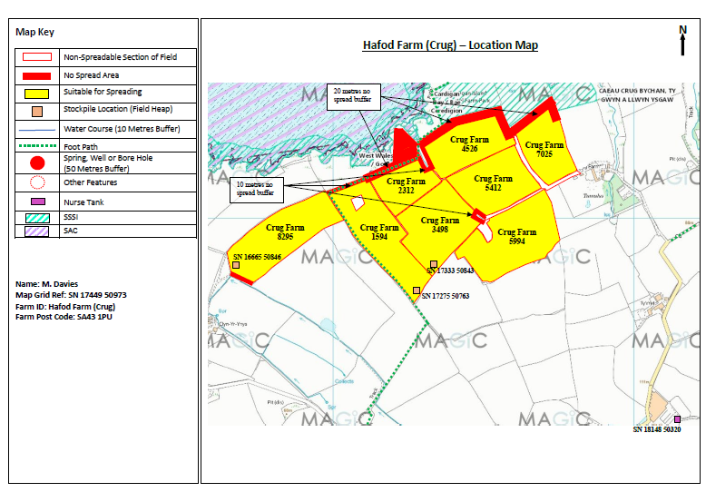

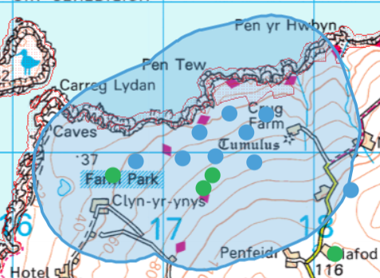
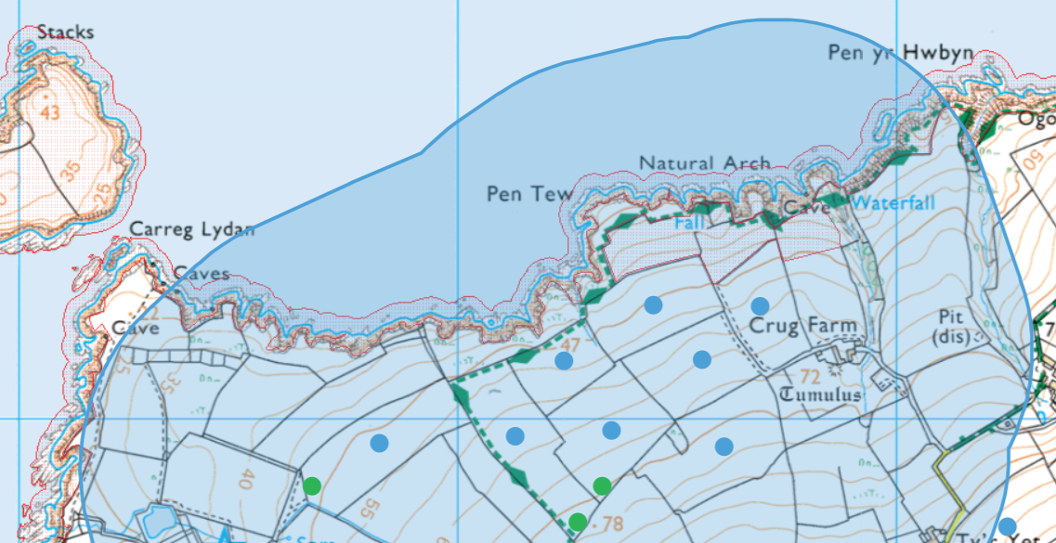
- Aberarth - Carreg Wylan SSSI
- Caeau Crug Bychan, Ty Gwyn a Llwyn Ysgaw SSSI

