PAN-023358 Mapping Report
SSSI, SAC, SPA and Ramsar map
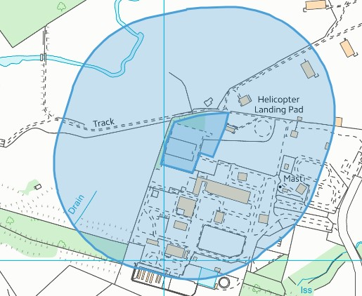
No problems to note, no sites within 200 meters.
Source protection zone 1, Springs, Wells, Issues or Boreholes
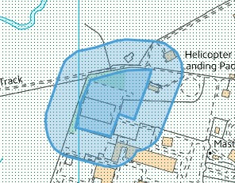
The site is within a SPZ2 but not a source protect zone 1. Springs, Wells, issues or boreholes within 50 meters of the site. No problems to note.

