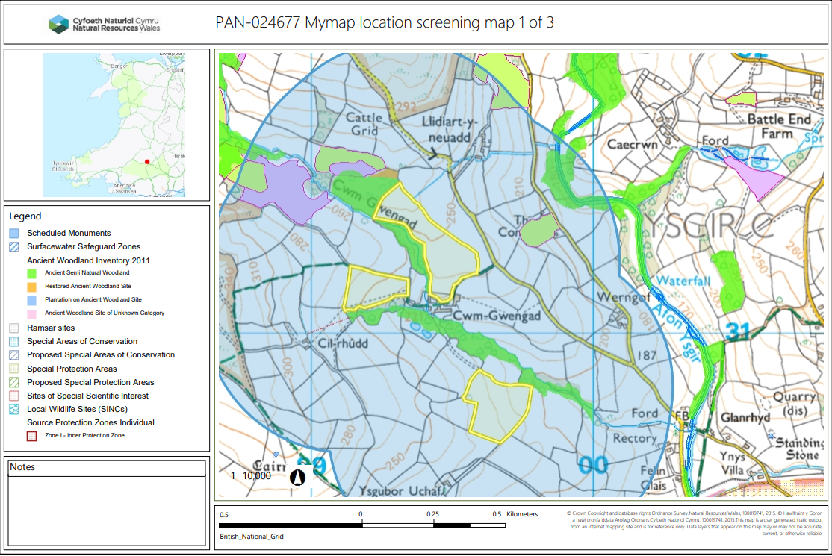
PAN-024677 My Map Report:

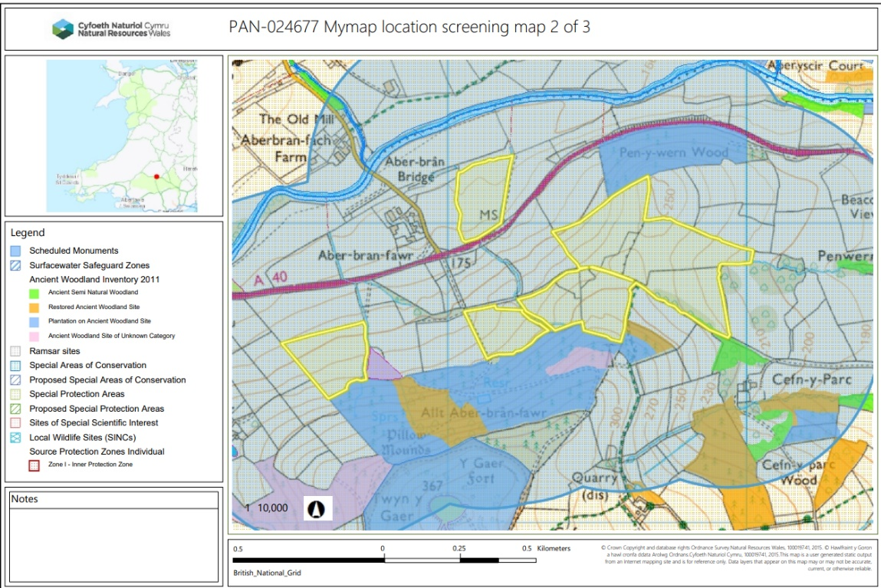

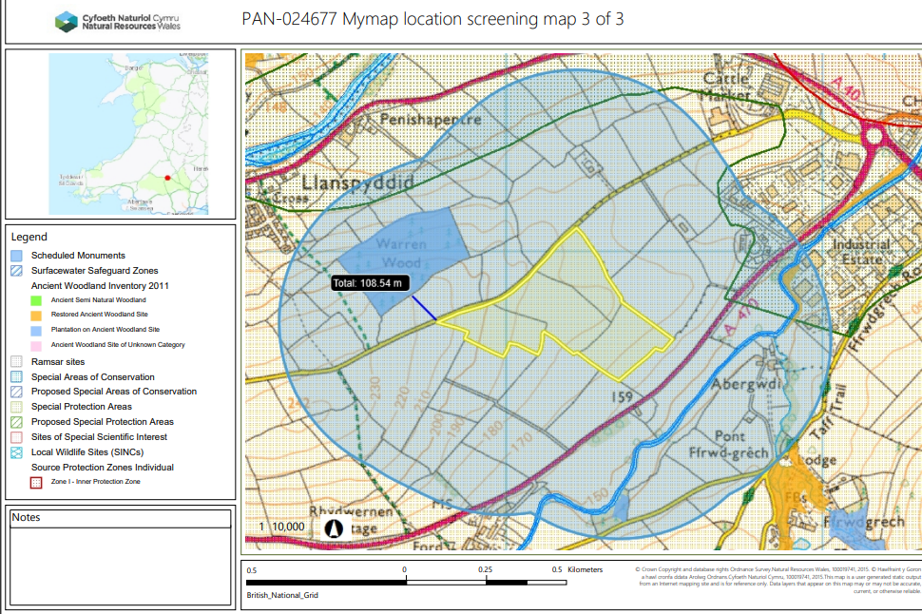

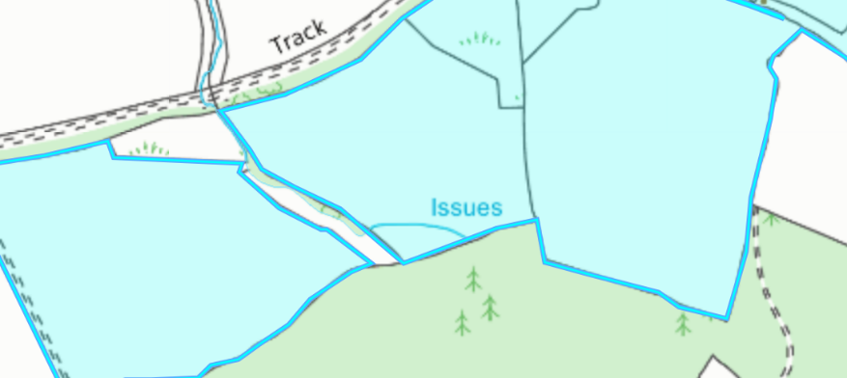
Detailed river network:
Field 1865 contains a water issue that has been correctly buffered by 10 meters when crossed reference to the submitted site specific risk assessment.

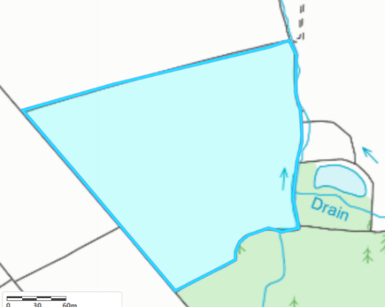
Field 6255 contains a water issue that has been correctly buffered by 10 meters when crossed reference to the submitted site specific risk assessment.

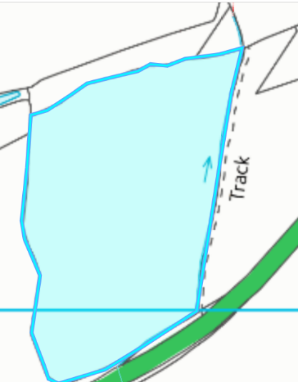
Field 1211 contains a water issue that has been correctly buffered by 10 meters when crossed reference to the submitted site specific risk assessment.

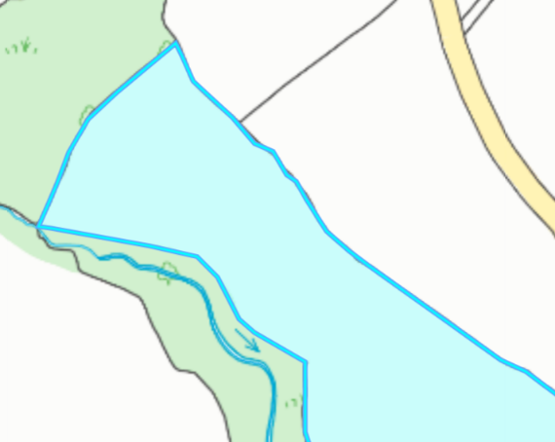
Field 4530 contains a water issue that has been correctly buffered by 10 meters when crossed reference to the submitted site specific risk assessment.

Groundwater protection zones (source)

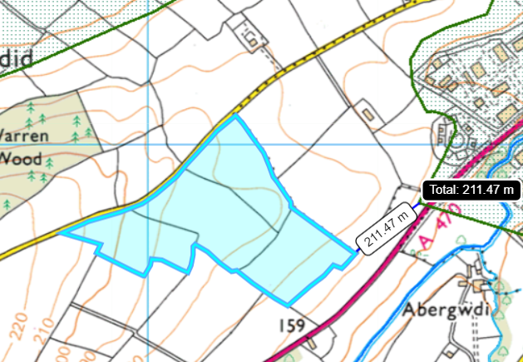
Field 3871 is located 211 metres from the Brecon source projection zone 2. No action needed due to no impact pathway.

Wells, springs or boreholes used for the supply of water for human consumption including from a private water supply or supplies
None in range.

Any springs wells or boreholes not used to supply water for domestic or food production purposes within 50m

None in range.
European designated sites- Natura 2000 (SPA, pSPA, SAC or cSAC) or Ramsar- or SSSI within 500m

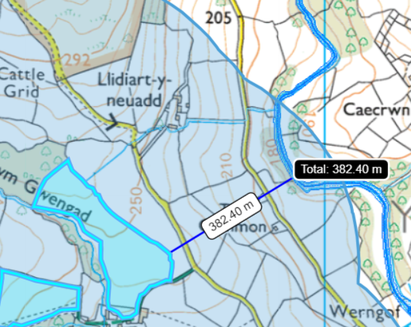
Fields 4530 is located 382 metres form the River Usk SAC and SSSI.

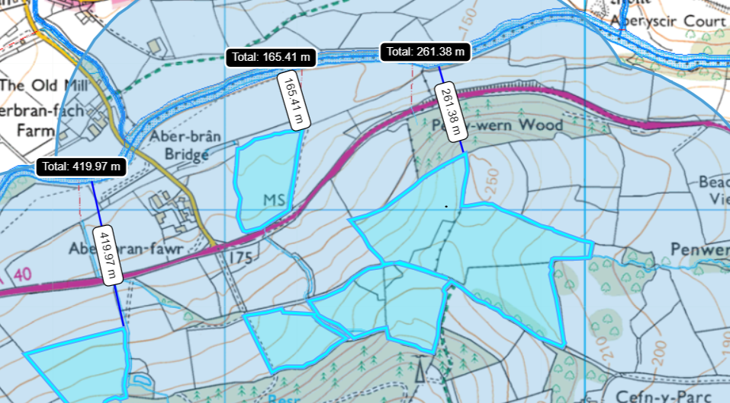
Fields 6255, 1211, and 2991 are located within 500 metres from the River Usk SAC & River Usk (Upper Usk) SSSI.

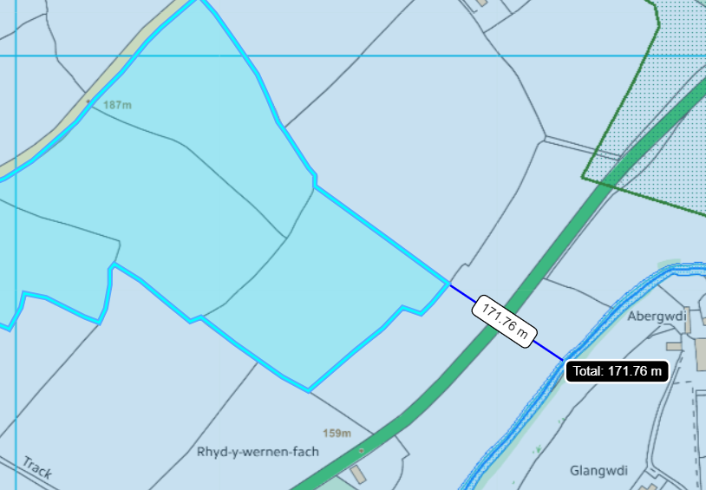
Field 3871 is located 172 metres from the River Usk SAC

Other protected sites:
- Protected Species-

- Protected Habitats- None in range.

- Scheduled Ancient Monument- None in range.

- Local Nature Reserve- None in range.

- National Nature Reserve- None in range.

- Ancient Woodlands-

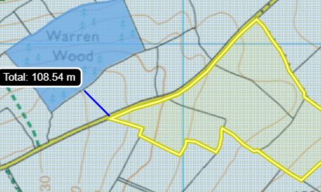
Field 9776 is located 172 metres from Warren woods. There is no direct impact pathway for the wastes to enter the ancient woodland. No action needed.

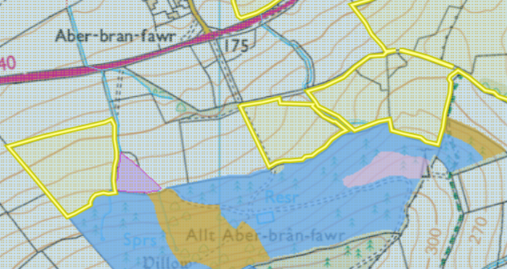

Fields 6255 , 1865, 3572 and 5372 border an ancient woodland site. A buffer zone needs to be implemented on the border of the sites to mitigate the risk of detriment to the ancient woodland as buffer zones are supposed to be implanted according to the submitted SSRA.

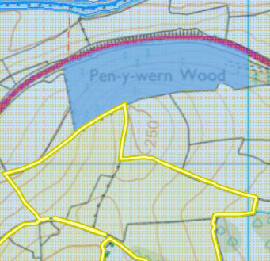

Field 5194 border an ancient woodland site. A buffer zone needs to be implemented on the border of the sites to mitigate the risk of detriment to the ancient woodland. SSRA. The ancient woodlands is displayed on the submitted site plan.

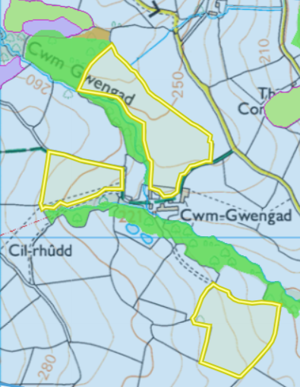

Fields 4530 and 9 acre border an ancient woodland. These fields do not have a no spread buffer zones in place as suggested by the submitted SSRA.

- Local Wildlife Sites (SINC)- None in range.

- National Park-
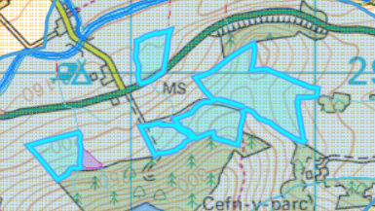

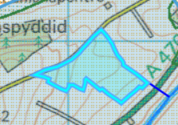

The Fields are located within the Brecon Beacons national park. This has been accounted for in the submitted SSRA.

- Groundwater Safeguard Zone- None in range.

- Hedges- Nothing of concern.

- Ditches- See slope map below.

- Local residents/ housing

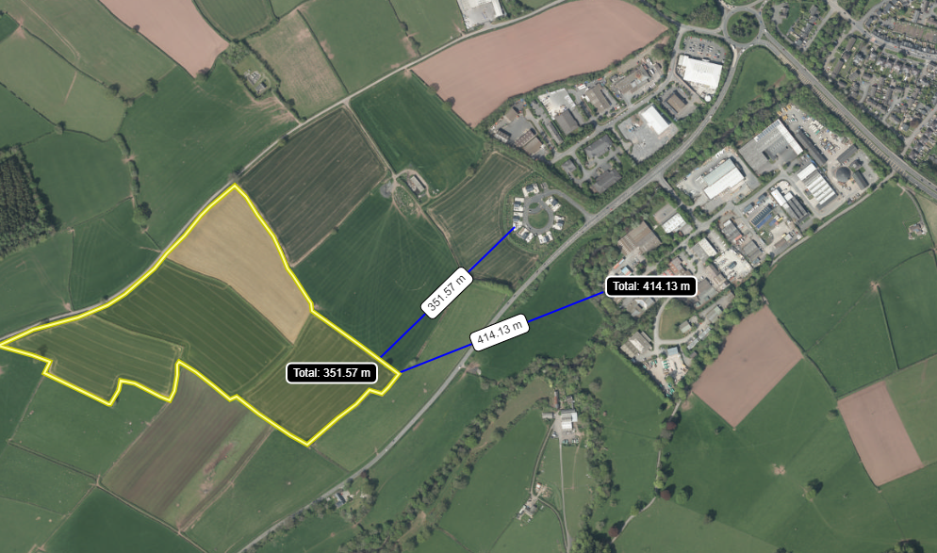

Field 3871 is located 350 metres from a residential area. As this deployment is spreading and storing food waste. An odour management plan should have been submitted as part of this application.

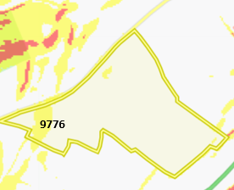
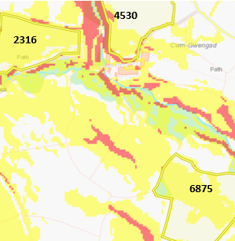
Slope Map
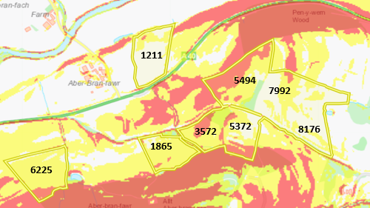
Fields 6255 1865, 3572, 5372, 7992, 5494 and 1211 have areas of land that are highly sloping at 12º +.
Fields 6225, 1865, 5372, 8176, 7992, 1211, 9776, 6875, 4530 and 2316 also contain areas of land moderately sloping at 7-12º .
The waste to be spread (EWC 02 03 04) is a solid meaning risk of surface runoff is minimal due to its solid nature. The submitted SSRA has taken into account slopes of the fields where the operator will take the following measures to minimize runoff:
- Abide by 10m no spread zones in place around field boundaries.
- Weather conditions are assessed prior to spreading to ensure, risk of run-off is low.
The applicant intents to spread the waste via rear discharge spreader which is an appropriate method for the waste type but as a consequence is less accurate at applying the waste to the soil. The application rate of the food waste is low at 15 t/ha to 16.5 t/ha. As the waste to be spread is at a lower application rate there is less chance of surface runoff when applying the wastes in suitable weather conditions. Therefore, for this waste the surface runoff risk has been determined as low as long as measures in the SSRA are adhered too.
It is not clear from the deployment application if fields 5494 and 3572 are being spread on as the site plan indicates they will receive the wastes, but the fields listed in the deployment do not mention these fields. This has been explained in the return email.

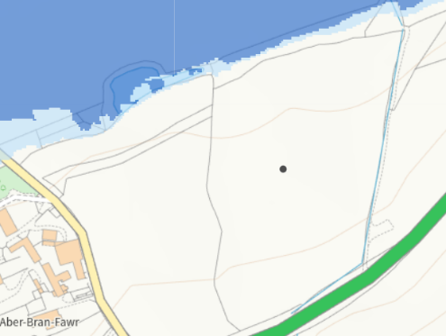
Flood risk
Fields 1211 brock field is located close to a flood plain from the River Usk. The flooding area does not encroach onto the spread field. No action needed.

