PAN-023892 MyMap Report

200 metres of a European Site or a SSSI
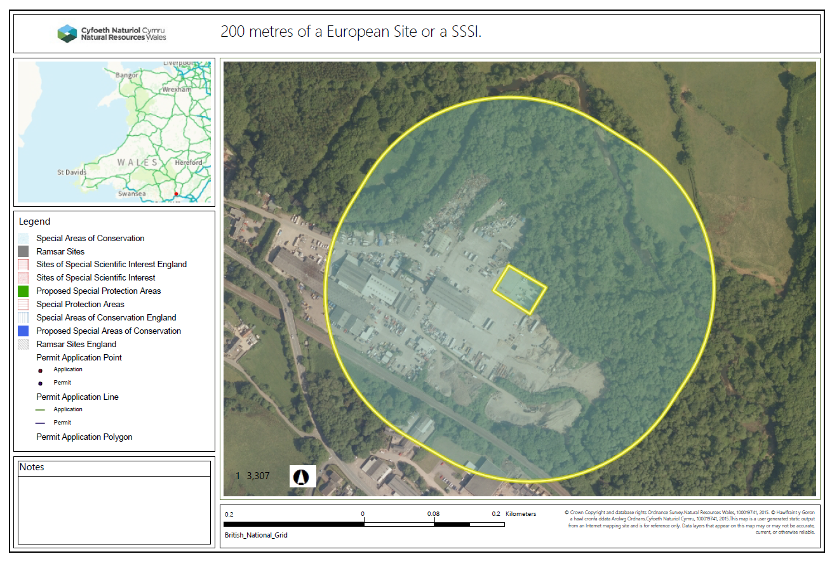

The activities shall not be carried out within 50 metres of any well, spring or borehole used for the supply of water for human consumption. This must include private water supplies.


