Biosecurity plan - White leg Shrimp (Litopenaeus vannamei)

Site name: | 360 Aquaculture – Metal Box
Authorisation number: | TBD by CEFAS
Address: | Metal Box, Milland Road Industrial Estate, Neath, SA11 1NJ

  - Biosecurity Manager
Name | Email | Phone
Leigh Biddiscombe (Production Manager) | leigh@360aquaculture.com | 07939548118

  - Useful Contacts
Name | Title | Telephone Number | Email
Richard Lloyd | Fish veterinarian | 07780 440 276 | richlloyduk@gmail.com
CEFAS | Fish Health Inspectorate | 01305 206 700 | fhi@cefas.co.uk
Novus Environmental Services Ltd | Waste disposal | 0330 221 1281 | Sonya.Elliott@novus-environmental.co.uk

  - Staff Training
The biosecurity manager will be responsible for training staff in:
- Aquatic animal husbandry practices that provide a low stress environment
- Identification of abnormal behaviour and external clinical signs of disease
- Disease reporting and notification procedures
- Staff responsibility in case the event of a disease outbreak
- Role of worker movements and actions in transmitting diseases to different areas within the farm (in this case shrimp farm and mussel farm)
- Biosecurity protocols for site visitors

All staff will have been trained on the above points for the species on site. Staff and management have used the CEFAS website, research papers and industry publications to educate themselves on the disease risks associated with shrimp farming. Finally, both managers of the facility have a good working relationship with the vet (Rich Lloyd) and have gained valuable information on fish health, welfare and disease recognition, which has been passed down to technicians.

Staff name | Date trained | Staff signature | Biosecurity manager signature

Any additional staff/ interns taken on will be adequately and promptly trained.

Identified biosecurity risks and limitation measures

Identified Risk | Probability | Impact | Risk limitation measure
Infectious agent transferred to system by movement of shrimp on to site | Medium/ low | High | Before introducing shrimp on to the farm the condition and provenance of the stocks will be discussed with the supplier. The supplier will be providing us with SPF shrimp and certification of brood stock health status. If the management team have any doubts, the supplier will not be used.
 |  |  | Batch of shrimp will not be accepted on to the site if they are showing any signs of infection and high unaccounted mortalities.
Protozoan and metazoan parasites to enter the farm | Low | High | Water from the mains will be run through a UV system, a sand filter and UV to ensure that harmful matters are neutralised. This will take place before it enters the nursery and on grow systems.
 |  |  | If staff have to work at our other site in Swansea dock (for building etc) then separate footwear must be worn along with overalls at the Swansea site.
 |  |  | Disinfection foot dips are to be placed on all entrances/ exits to the farm. Separate footwear will be allocated for work carried out outside the facility.
Shrimp husbandry | Low | High | Maintain awareness of diseases
 |  |  | Staff will be permitted to wash their hands, wear gloves and use disinfection footbaths (with designated footwear) before entering culture tank room.
 |  |  | Designated footwear and aprons for when staff are completing husbandry tasks
 |  |  | Routine checks to remove mortalities. Correct storage and disposal of mortalities to reduce the risk of spread of infection or disease (Novus Environmental – see useful contacts)
 |  |  | Feed will be only be handled while gloved and will be stored correctly to ensure it doesn’t get contaminated.
 |  |  | SOP’s established to ensure best husbandry practices are maintained
 |  |  | All equipment will be rinsed and disinfected after use and only equipment on drying racks will be used.
 |  |  | Daily and weekly cleaning rota to ensure good disease control and husbandry practice. This will be monitored by management. NB: our tanks will also be automatically cleaned daily via the use of a self-cleaning mechanism that will be in the form of brushes attached to our grading arm. This will circle the tank once a day and will accompany our cleaning regime. The nursery channel will be swept and siphoned twice a day by staff.
 |  |  | The equipment for our nursery and on grow systems will be kept separate and colour coded. Cross use of equipment will not be permitted.
 |  |  | Daily and a weekly, more in-depth, stock health inspection (closely monitoring for signs of disease i.e. high mortalities) and accurate records kept in logbook.
 |  |  | Discharge water will be contained, isolated from the systems and treated appropriately before being discharged in to Neath River.
System maintenance | Medium | High | Any work to be carried out on the system while shrimp are stocked is to be carried out using proper biosecurity protocols. Hands washed, gloves worn, foot baths used, waders worn etc.
 |  |  | Any extra kit that is to be needed after the production cycle has started will be thoroughly disinfected before being introduced to the system.
 |  |  | Any areas to the system that will require more detailed work to be carried out will be isolated and drained before work is to be carried out. Once the work is complete, the area will be cleaned and disinfected before it goes live again.
Farm traffic (personnel, visitors, contractors) | High | High | The farm already has limited access and only authorised personnel are permitted to enter the facility and then only staff will be permitted to enter the shrimp growing room.
 |  |  | Any contractors completing work on shrimp system (electrician) will need to follow biosecurity protocols and visitors log book.
 |  |  | Delivery drivers only permitted access to car park
 |  |  | No access for any general public or non 360 personnel

Monitoring the Plan

Stock health inspection | Trained by the biosecurity manager, staff will carry out daily and weekly health checks. Records of observations of kept the in logbook
Mortality levels | Mortalities recorded in work diary. Euthanised shrimp records will also be kept
Results of health inspections | Keep all documents from CEFAS, private consultant reports, supplier and also health and welfare checks completed by staff.
Visitors to the APB (Aquaculture Production Business) | Restrict access to farm facilities - no access except for farm staff and approved visitors
Shrimp movements on and off site | Record in CEFAS online fish movements
Shrimp movements within the site | Shrimp will be moved from the nursery system and in to the on grow tank which will be housed in the same room.
Disposal of waste | Dispose of waste and effluent water in accordance with the relevant local environmental health rules. Waste water will be treated at the discharge set up. Shrimp waste (morts) will be disposed of via Novus Environmental.
Water quality | Monitor and record significant changes. Keep water quality within optimum parameters
Keep all logbooks, record keeping up to date | This will aid the biosecurity manager in making informed decisions on the shrimp stock. Records will be inspected by management to ensure that accurate and detailed data is available.

Actions to Take in the Event of Clinical Disease

Record | Action to Take
Mortality or a sudden increase in mortality seen in batch of shellfish. Identification of a known problem. | Inform biosecurity manager and begin a more rigorous monitoring regime over the next 24-48hrs
Continuing unexplained mortality | Inform CEFAS and site veterinarian. Arrange for disease screening and if necessary, visit from vet.
Need to dispose of dead shrimp | Store shrimp in the designated moralities freezer and arrange a collection with Novus Environmental. Avoid long term storage of this material. See useful contacts for contact details.

Actions to mitigate escapees

The systems will be completely enclosed within one room in our facility. To ensure that the tank doesn’t split or crack we are using Balmoral Tanks which design and build tanks using BS EN 1993-4-2, which is Eurocode for design of tank structure. The bolted connections are designed to BS EN 1993-1-8. Actions/loading on tank is as per EN 1991-4 where primary loads applied to EN 1990 series. As an extra measure, a mesh screen will be placed over the holding tanks. Mesh will also be placed over all outflows and some kit within the filtration container and also the drain covers on the floor of the room.
Wastewater will be fully treated via our sewage treatment system and we are confident that if any escapees were to enter the sewage treatment they would be contained there. If, however, any shrimp were to make it out of the sewage treatment plant they would then be held within the holding tank, which is the last stop before the water is discharged in to the channel behind the Metal Box Pond. From the channel the water will enter Neath River.

System management plan

Optimal water quality parameters – for the system (within the facility)

Optimum WQ | Water Quality Parameter | Lower limit | Upper limit
29 - 31 | Temperature (⁰c) | <29 | >31
7.7 - 7.9 | pH | <7.5 | >8
250 - 300 | Orp (mv) | <200 | >500
15 | Salinity (ppt) | <10 | >15
5-7 | DO (mg/L) | <5 | >7
< 0.75 | Ammonia (mg/L) | Not required | >0.75
< 1 | Nitrite (mg/L) | Not required | >1
< 80 | Nitrate (mg/L) | <60 | >80
220 | Alkalinity (mg/L) | <200 | >250
0.2-0.5 | Phosphorus (mg/L) | Not required | >1
160 | Calcium (mg/L) | <160 | >170

Optimal water quality parameters – for discharge (after going through packaged sewage treatment plant):

Optimum WQ | Water Quality Parameter | Lower limit | Upper limit
5-7 | DO (mg/L) | <5 | >7
< 0.75 | Ammonia (mg/L) | Not required | >0.75
3 | BOD (mg/L) | Not required | >3

Cleaning – shrimp tanks

Our tanks will undergo automatic daily cleaning facilitated by our grading and harvesting arm, which will operate in both nursery and on grow tanks. Once daily, the arm will rotate around the tank, enabling passive grading of the shrimp. Brushes attached to the end of the grading arm, where it meets the tank wall, will ensure comprehensive 360° cleaning of the tank from the water surface to the tank floor. For this process, no additional water will be removed from the system. Debris/ dirt that is brushed off the walls will fall to the bottom of the tank and after an allocated time for settling has passed, we will turn on an air lift pump which will increase the flow of the tank for approx. 10 mins. This will allow the waste to gather at the centre of the tank where our automatic drain unit will remove the solids and waste from the holding tanks.
The automatic cleaning will also be accompanied by hands on cleaning as part of daily husbandry of the system. This will involve brushing any missed solids to the centre of the drain so it can be taken away. Our nursery channel will also require daily brushing as this part of the nursery system will not have the automatic cleaning mechanism. For the nursery channel, husbandry will take place two a day (like all other system husbandry) and this will involve sweeping all solids and uneaten feed to the drains where it is taken out of the holding tank. Again, this will also not remove anymore additional water.

Cleaning/ disinfection products

In the processes stated above, no chemicals or disinfection products will be. We will however be using Virkon Aquatic to clean all our equipment after each use. I.e. after sweeping the channel tank the brush will be dipped in a 1% solution of Virkon for 10 mins before being rinsed off with fresh water.
Virkon Aquatic is a specialised formulation of Virkon designed specifically for use in aquatic environments, including aquaculture facilities. It serves as a powerful disinfectant to control pathogens and diseases that can affect fish and other aquatic organisms.
All of our entry points in to the farm will also have a Virkon footbath which staff and visitors will be permitted to pass through in designated footwear.

Other chemicals used

- Sodium Bicarbonate
Buffering Agent: Sodium bicarbonate acts as a buffering agent, helping to stabilise pH levels in the water. It does this by releasing bicarbonate ions (HCO3-) into the water, which can neutralise acids, thus preventing rapid fluctuations in pH.
Alkalinity Regulation: Sodium bicarbonate also contributes to the total alkalinity of the water. Alkalinity is crucial for maintaining a stable environment for Whiteleg shrimp, as it provides resistance against pH changes caused by various factors, such as biological processes and waste accumulation.
- Hydrochloric Acid (HCl)
pH Adjuster: Hydrochloric acid is used to lower pH levels in the water when they rise above the desired range. In RAS systems, factors such as nitrification and organic matter decomposition can lead to the accumulation of bicarbonate ions, causing pH to drift upwards. Hydrochloric acid is added in controlled amounts to counteract this alkalinity and bring pH back to the optimal range for Whiteleg shrimp farming.
Alkalinity Reduction: Additionally, hydrochloric acid can help reduce alkalinity by converting bicarbonate ions (HCO3-) into carbon dioxide (CO2) and water (H2O), thereby decreasing the buffering capacity of the water. This process assists in fine-tuning water chemistry parameters, ensuring they remain within the ideal range for shrimp culture.
We will use sodium bicarbonate and hydrochloric acid in tandem to regulate pH levels in the systems. When pH rises above the desired range due to factors such as biological activity or nitrification, sodium bicarbonate's buffering capacity can become overwhelmed.
Hydrochloric acid is then added to lower pH levels by neutralising excess bicarbonate ions. By carefully adjusting the dosages of sodium bicarbonate and hydrochloric acid, we can maintain stable pH levels within the optimal range for Whiteleg shrimp health and growth.
While sodium bicarbonate helps to provide alkalinity and buffer pH, hydrochloric acid serves as a corrective agent to adjust pH levels as needed, ensuring a suitable environment for Whiteleg shrimp.

Monitoring and Maintenance:
Regular monitoring of the system's performance is crucial to ensure it meets required standards.
Routine maintenance, including inspections, lubrication of mechanical components, and checking aeration efficiency, is essential for optimal functioning.
Site overview

Locations of different activities | NGR
- Package sewage treatment plant | SS 74181 96357
- Enduramaxx holding tanks | SS 74181 96357
- Rising mains enters pond run off channel (“Effluent output point” on NRW discharge application) | SS 74051 96390
- Water quality testing point (same as 2) | SS 74181 96357
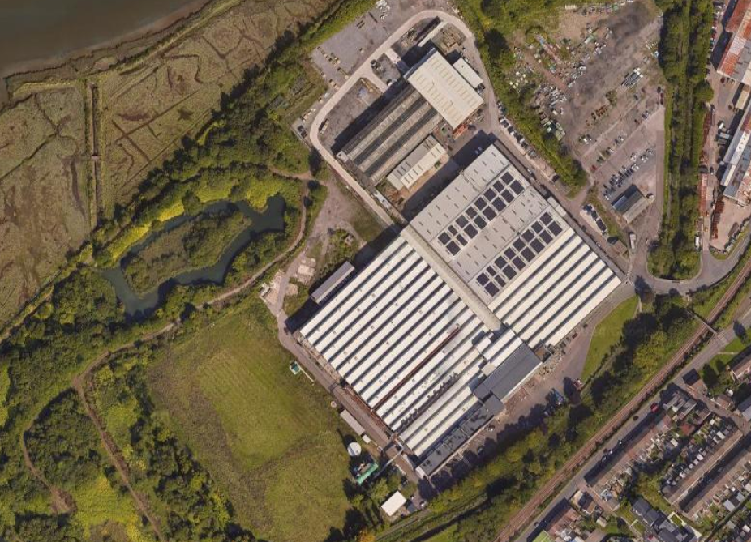
3
1, 2 & 4

Fig 1. One module
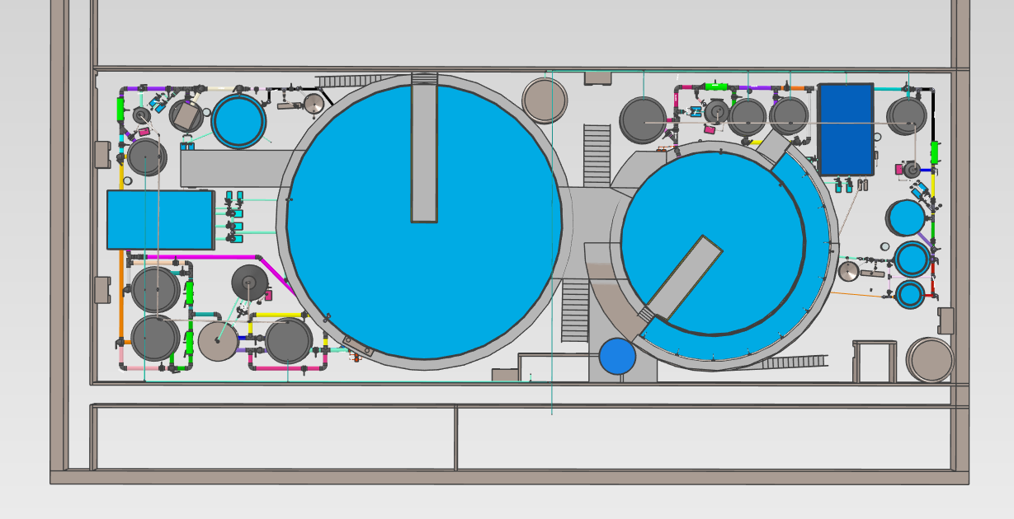
Fig 1. Showing one module. This is comprised of the nursery system on the right with the channel tank wrapped around the main nursery tank. On the left is the larger on grow system. These are two independent recirculating aquaculture systems. The smaller tanks and pipework around the systems are part of the filtration and allow for water movement to each part of the system.

Water discharge plan – Three Sixty Aquaculture, Metal Box

We will be exchanging water on a daily basis at our Neath site. When it leaves the facility, it will flow in to our packaged sewage treatment plant where any remaining solids will be removed from the water along with ammonia. It will then flow in to our Enduramaxx holding tanks, it will sit here until water reaches the float switch, at which point it will be pumped in to the run off channel from the Metal Box pond. It will then enter the Neath River.

Please see below for discharge diagrams

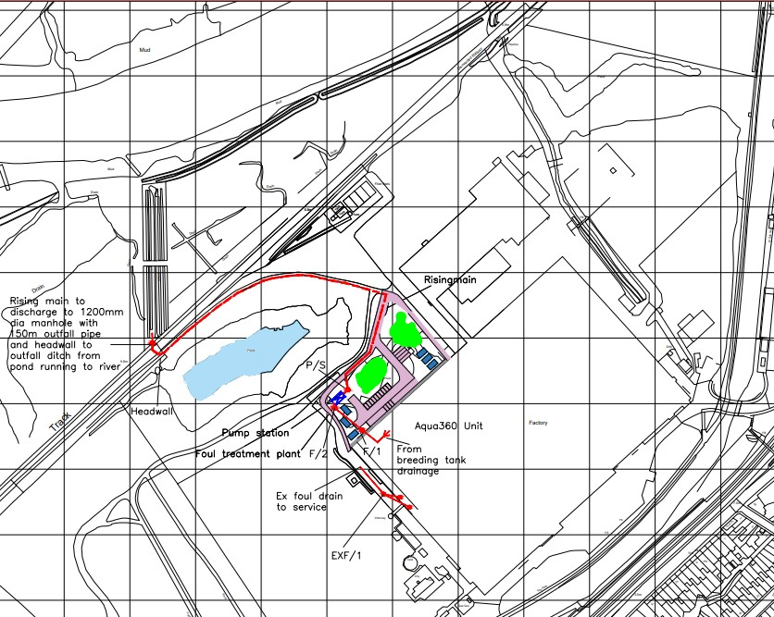

Over view of room showing location points of fire extinguishers

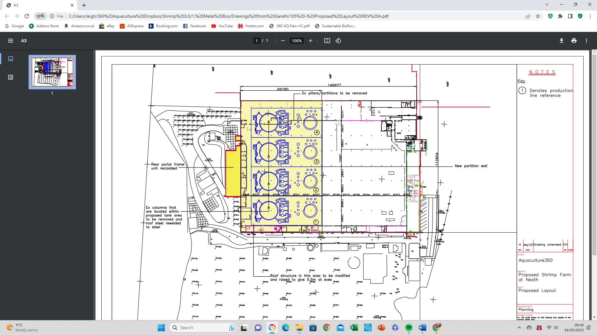
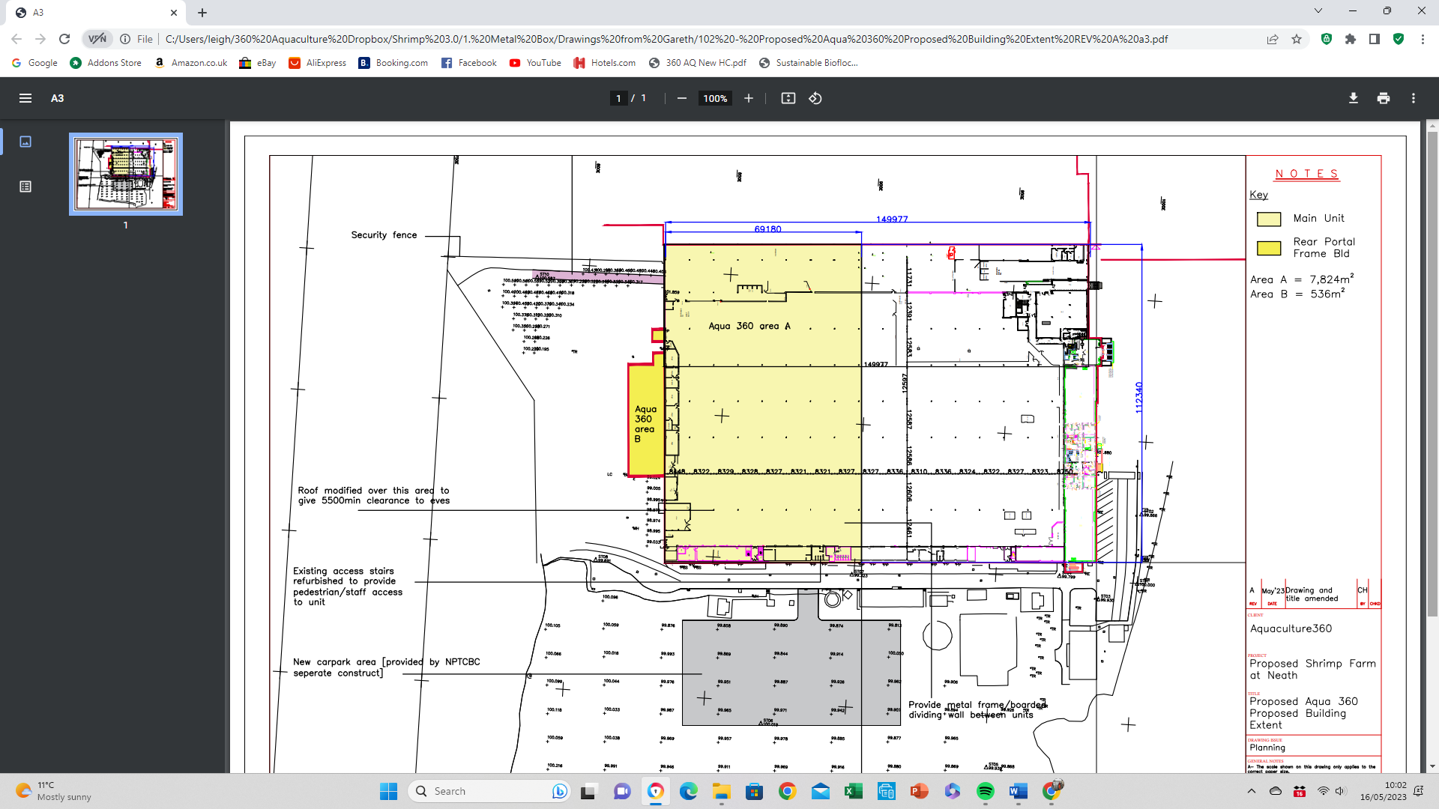

Site fire assembly points and boundry



