Permit
The Environmental Permitting (England & Wales) Regulations 2016

MJ Rubbish Removals Ltd

MJ Rubbish Removals Ltd
Star Trading Estate
Ponthir
Newport
NP18 1PQ

Permit number

EPR/DB3195CL

Permit
The Environmental Permitting (England and Wales) Regulations 2016
Permit number

EPR/DB3195CL

The Natural Resources Body for Wales (“Natural Resources Wales”) authorises, under regulation 13 of the Environmental Permitting (England and Wales) Regulations 2016

MJ Rubbish Removals Ltd (“the operator”),

whose registered office is

7 Derby Gove

Newport

Gwent

NP19 4QL

company registration number 08704713

to operate waste operations at

MJ Rubbish Removals Ltd

Star Trading Estate

Ponthir

Newport

NP18 1PQ

to the extent authorised by and subject to the conditions of this permit.

Under regulation 27(2) of the Regulations, standard rules SR2008 No01 are conditions of this permit.

Name | Date
Huw Davies | 12/04/2024

Authorised on behalf of Natural Resources Wales

Schedule 1 - Site plan

This is the plan referred to in the standard rules SR2008 No01

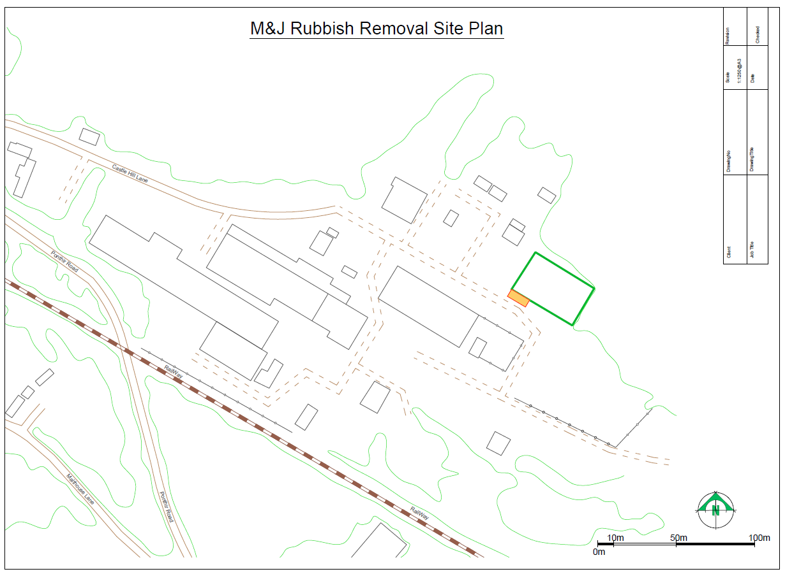

© Crown Copyright and database right 2024. Ordnance Survey licence number 100019741.

END OF PERMIT

