CRoW Appendix 4 (140_10_SD02)  CRoW Act 2000: Natural Resources Wales application for permission - Formal Notice |  | 
Natural Resources Wales Formal Notice.
Requirements of Section 28I of the Wildlife & Countryside Act 1981 as amended by the Countryside and Rights of Way Act (CRoW) 2000.
Duty in relation to granting any consent, licence or permit for activities likely to damage Sites of Special Scientific Interest (SSSI).
Guide to filling in this form for Natural Resources Wales staff:
To be completed by Permitting Officers for any applications for a permission which the Natural Resources Wales has considered under S28G duties to protect and enhance SSSIs. This applies to all proposed permissions within a SSSI, and to operations outside the SSSI boundary which are likely to damage its special features.
Refer to OI 140_10 ‘Applying the Countryside and Rights of Way (CRoW) Act 2000 to applications for permits with potential for impact on Sites of Special Scientific Interest (SSSI)’, including the flowchart in Appendix 2.
Pink italic text – drafting notes, to be deleted before completion/consultation.
Blue text – examples, to be replaced with permission-specific information.
Ensure you have completed all sections.
- Natural Resources Wales area/region/NPS hub: | Mid Wales
- Name of SSSI: | Upper River Usk SSSI (MONMOUTHSHIRE/POWYS)
- Type of permission: | Land spreading deployment under standard rules permit SR 2010 No4 Mobile plant for land spreading.
- Date for Natural Resources Wales permit determination: | 17/04/2024
- Predicted 28 day date for response from NRW conservation/ecology (under S28 I(4)): | n/a
- Natural Resources Wales reference no: | PAN-024676
- National grid reference: | Farm location: SO, 00951 27879  Fields:  1 1515 Bottom Newton SO 02130 28164  2 9408 Banky Newton SO 01931 28091  3 9995 5 Acres SO 01993 27946  4 7785 Top Newton SO 01768 27865  5 4984 Top Sheep SO 01465 27869  6 4470 Top Field SO 0165 27869  7 6971 Bog Field SO 00677 27708  8 2368 6 & half acres above lane SO 01224 27687  9 0865 Holly Bush SO 01076 27658  10 1079 Lane Field SO 01087 27787  11 9977 Above House Field SO 00988 27772  12 9466 Long Field SO 00939 27665  13 9060 Next to long field SO 00901 27604  14 8459 Little Field SO 00837 27594  15 7694 6 & half acres across the road SO 00782 27659  16 6856 Potato Field SO 00674 27566  17 5560 Cilwych SO 00549 27582  Storage:  1 SO 02282 28230
- Description of proposal: | A land spreading application to spread one waste stream (EWC 02 03 05 ) at Garngaled Farm, Brecon. Wastes are to be spread on grass fields. The application rate is 55 tonnes per ha, with a total tonnage to spread 2,164 tonnes.  The waste will be applied to the fields in two applications of 27.5 t/ha each.  The waste will be spread over 39.34 hectares of land within the listed fields at Garngaled Farm. The applicant intents to store 500 t of the waste in a slurry bag. The slurry bag complies with the storage requirements of the SR2010no4 and TGN 8.01 and the COAP regs 2021 from information acquired through request for information requests.  The wastes will be spread via a dribble bar which is an appropriate application method that places the wastes directly onto the soil which is more accurate than other surface spreading techniques.  Targeted periods of spreading on grass fields include 2 spring dressings/early summer at a low application rate of 27.5 T/ha each.  The land spreading activity will comply with the Code of Good Agricultural Practice guidelines (COGAP).  Documents related to this deployment can be found on the DMS.
- Is the proposed activity within (wholly or partially) the SSSI boundary? | 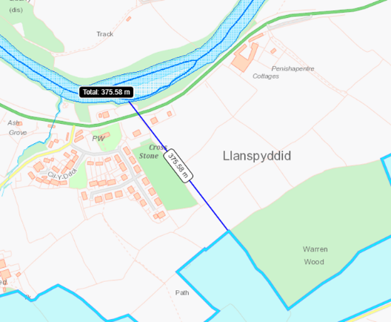  NO  The closest field (4984) is located 375 meters from the River Usk SSSI. Due to the distance the SSSI is from the proposed landspreading area there is no impact pathway as the distance from these two sites with act as a physical barrier preventing nutrients entering the SSSI.  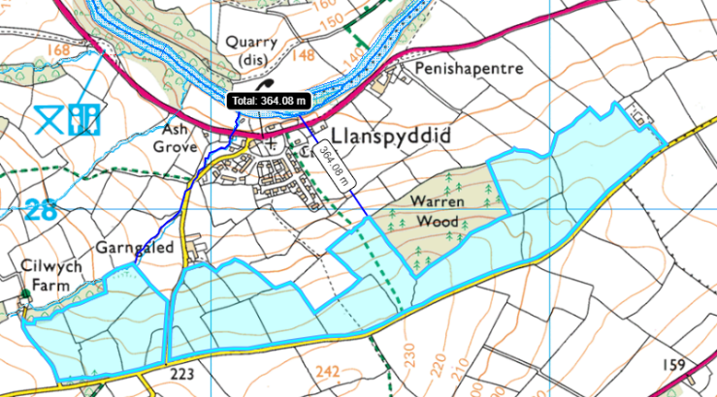  Field 6971 borders a watercourse that is hydrologically connected to the River Usk SAC & SSSI over a distance of 592 metres. There is an 20 meter no spread buffer zone in place in field 6971 to mitigate the risk of runoff into the water course.
- Has there been any pre-application discussion or correspondence with NRW conservation/ecology | NO
- What aspect(s) of the proposed permission may damage the features which are of special interest for the SSSI?

The following ‘Operations Requiring Consent’ (or other activities associated with the permission) that may cause damage) are relevant to the proposed permission.

5. Application of manure, fertilisers, and lime except to agriculturally improved permanent grass, forest, and all other unimproved riparian habitats.

7. Dumping, spreading, discharging or storage of any materials.

26. Use of vehicles, vessels, or craft likely to damage semi-natural habitats or disturb species of interest.

The following SSSI features and mechanisms of impact have been considered to assess the likelihood of damage:

Plants

- Water crowfoot
- Mosses and liverworts
- Welsh thread-moss (Bryum gemmiparum)
- Tiny pocket-moss (Fissidens exiguous)
- Spruce’s bristle-moss (Orthotricum sprucei)
- Aquatic lichen (Endocarpon adscendens)

Mammals

- Otter

Fish

- Atlantic salmon
- Twaite shad
- Sea lamprey
- Brook lamprey
- River lamprey
- Bullhead

Invertebrates

- Variety of invertebrates associated with exposed river sediments.

- Decision
:
i) The proposed permission is not likely to damage any of the flora, fauna or geological or physiological features which are of special interest.

- The closest field (4984) is located 375 meters from the River Usk SSSI. Due to the distance the SSSI is from the proposed landspreading area there is no impact pathway as the distance from these two sites with act as a physical barrier preventing nutrients entering the SSSI.

- 20m no spread buffer zones are in place in fields 5560 & 6971 which border a surface water stream. This no spread buffer zone is double the recommendation of the buffer zone stated in SR2010No4 and will effectively prevent nutrients entering the water course/ SSSI.

- The application rate of this waste stream (EWC 02 03 01) will be 55 Tonnes/ha spilt into two 27.5 tonnes/ ha applications. This low application rate reduces the risk of surface run off and/or leachate risk as the ground is highly unlikely to become over saturated allowing the soil to effectivity absorb the waste applied.

- The application method of this waste is appropriate by using a dribble bar which places the waste directly onto the soil/ more accurate.

- Areas of highly sloping land (12º+) have been removed from the deployment application to reduce the risk of surface runoff and/or leachate.

- The spreading of this waste will be undertaken in the spring when weather conditions are dry. This means the soil will have a lower water content allowing the wastes to be effectively absorbed by the soil and therefore mitigating the risk of surface runoff and/or leachate.

- All machinery to spread the waste is kept in mechanically sound condition, and calibrated.

- The land spreading activity will comply with the Code of Good Agricultural Practice guidelines (COGAP).

Natural Resources Wales is minded to: Issue the permission

- Name and job title of Natural Resources Wales officer: | Owen Clee  Permitting Officer
- Date form sent to NRW conservation/ecology | n/a
For Natural Resources Wales use only, once NRW conservation/ecology response received
- NRW conservation/ecology comment on assessment: | i) NRW conservation/ecology advise the operation can go ahead  ii) NRW conservation/ecology advise the operation can go ahead with conditions  iii) NRW conservation/ecology advise against permitting the operation  Please ensure that the NRW conservation/ecology response is attached to this Formal Notice.
- Name and job title of NRW conservation/ecology officer:
- Date of receipt of NRW conservation/ecology response:

