PAN-024676 My Map Report:
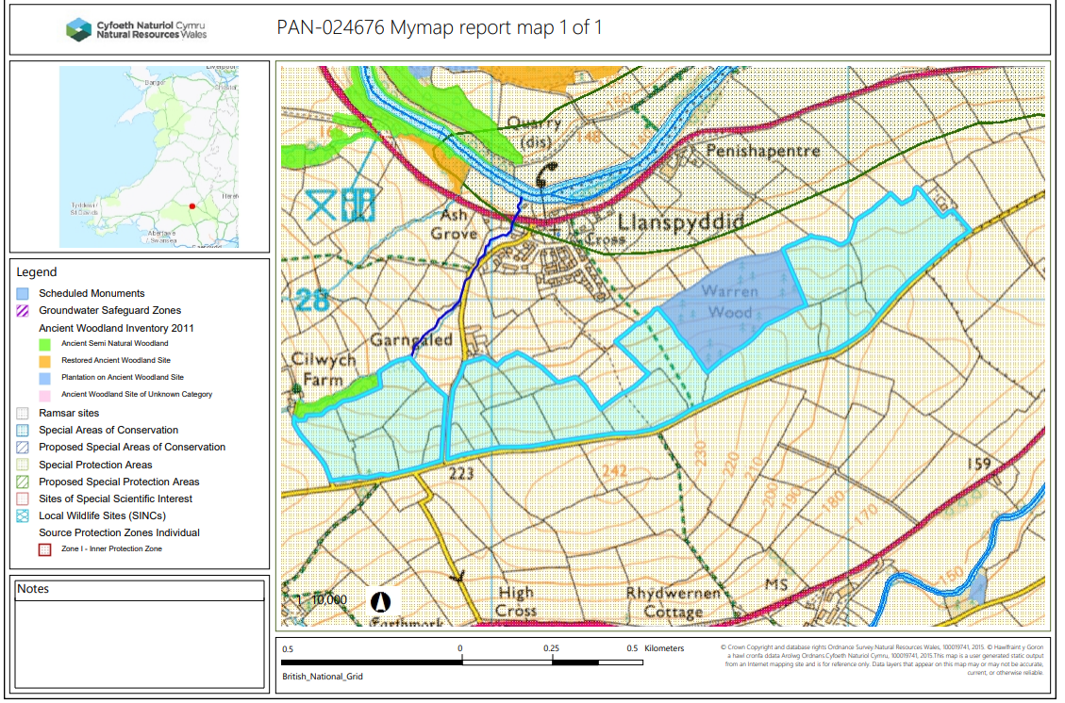

Detailed river network:
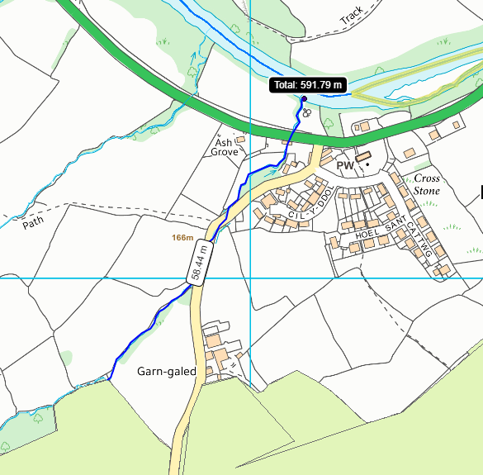

Field 6971 borders a watercourse that is hydrologically connected to the River Usk SAC & SSSI over a distance of 592 metres. There is an 20 metre no spread buffer zone in place in field 6971 to mitigate the risk of runoff into the water course. Which is double the requirement of SR2010no4.

Groundwater protection zones (source)

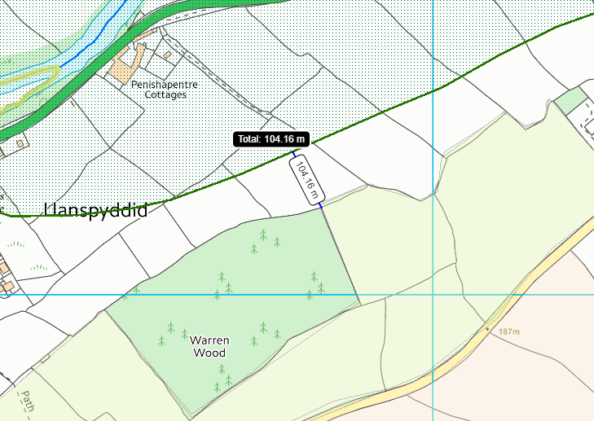
Field 9408 (closest field) is located 104 metres from a source protection zone 2. No action needed.

Wells, springs or boreholes used for the supply of water for human consumption including from a private water supply or supplies
None in range.

any springs wells or boreholes not used to supply water for domestic or food production purposes within 50m

None in range.

European designated sites- Natura 2000 (SPA, pSPA, SAC or cSAC) or Ramsar- or SSSI within 500m
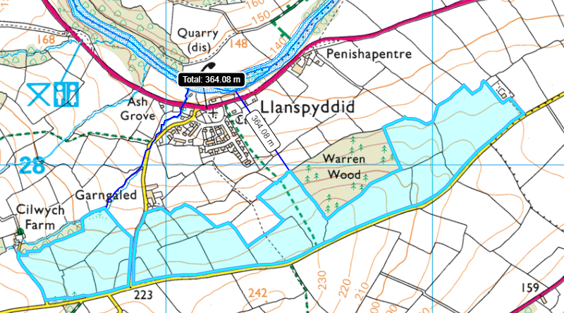
4989
6971
Field 4984 is the closest field located to the River Usk SAC and SSSI at a distance of 364 metres. (no impact pathway)
Field 6971 borders a watercourse that is hydrologically connected to the River Usk SAC & SSSI over a distance of 592 metres. There is an 20 meter no spread buffer zone in place in field 6971 (explained in the SSRA) to mitigate the risk of runoff into the water course. Which is double the requirement of SR2010no4.

Other protected sites:
- Protected Species- None in range.

- Protected Habitats- None in range.

- Scheduled Ancient Monument- None in range.

- Local Nature Reserve- None in range.

- National Nature Reserve- None in range.

- Ancient Woodlands-
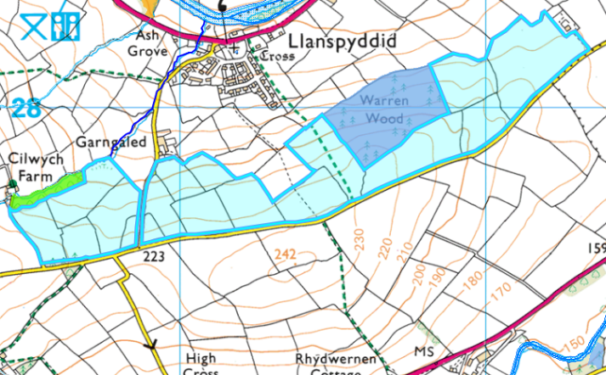
Fields 5560, 6971 border an Ancient Semi Natural Woodland (green). The applicant has updated the site plan in response to the request for information 1 to include a 10 metre no spread buffer zone.
Field 4984, 7785 & 9408 border an Plantation on Ancient Woodland Site. The applicant has updated the site plan in response to the request for information 1 to include a 10 metre no spread buffer zone.

- Local Wildlife Sites (SINC)- None in range.

- National Park-
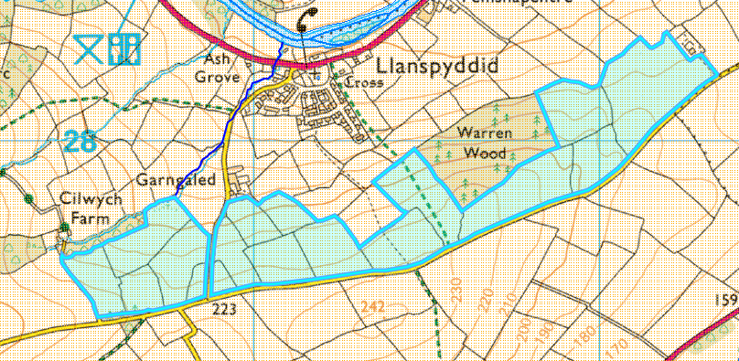

All the fields are located within the Brecon Beacons National park and have been addressed in the site specific risk assessment.

- Groundwater Safeguard Zone- None in range.

- Hedges- Nothing of concern.

- Ditches- See slope map.

Public rights of way-
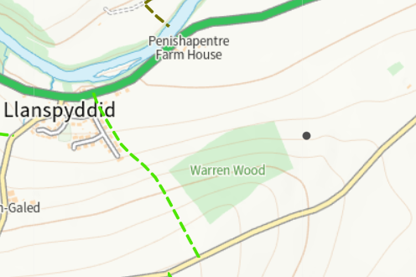

There is a public rights of way through field 4984. This has been displayed on the submitted site plan and has been designated as a no spread buffer zone.

Slope Map
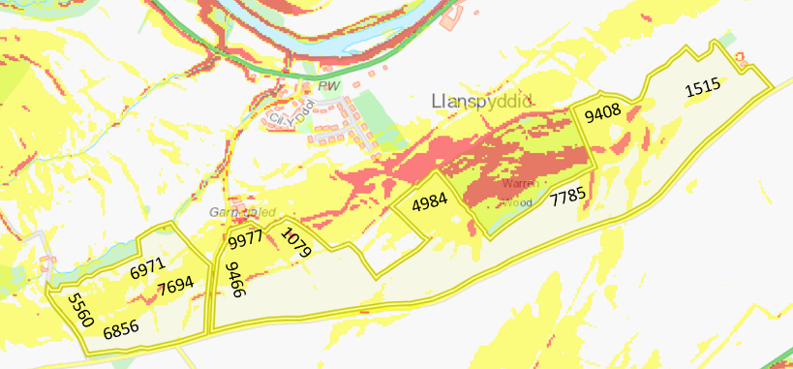
Fields 7694, 9466, 1079, 4984, 7785 and 9408 contain areas small areas of land that is highly sloping (12º+). The applicant has implemented no spread buffer zones in these areas to minimize the risk of surface runoff.
Fields 5560, 6856, 6971, 7694, 9977, 9466 1079, 4984 and 9408 contain areas of land moderately sloping at 7-12º . The applicant has implemented appropriate no spread buffer zones around water courses to minimize the risk of surface runoff into water courses.
A 20 meter no spread zone is in place in fields 6856 , 5560 & 6971 to minimize runoff into a water course hydrologically contented to the river Usk SAC and SSSI.
The application rate is split into two applications of 27.5 t/ha (55 t/ha total) which is a low application rate for the singular waste stream. This will the soil to effectively uptake the waste into the soil.
The waste is being applied to the soil via dribble bar which directly places the wastes onto the soil which is more accurate method of applying the wastes.

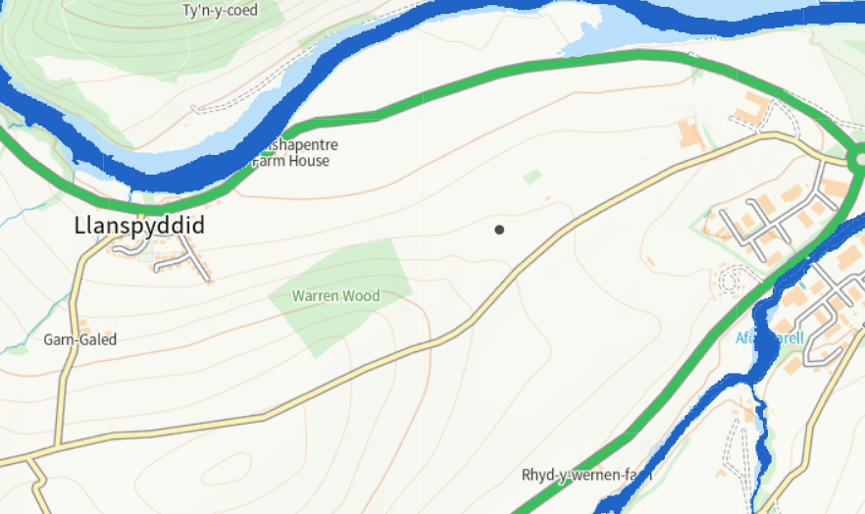
Flood risk

There is no flood risk from rives or sea from the fields listed in this deployment.

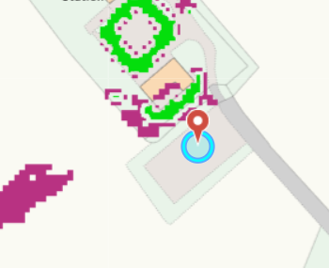
The location of the slurry bag is located on flat to gently sloping land.

