PAN-024707 MyMap report

removed 19/04/24 Monachty 1 & 2
groundwater source protection zones- none
any European designated sites- Natura 2000 (SPA, pSPA, SAC or cSAC) or Ramsar- or SSSI within 500m- none
any buildings or houses within 250m- shown
Within Groundwater Safeguard Zone- none
Scheduled Monument- none
Local Nature Reserve/National Nature Reserve- none
Local Wildlife Sites (SINC)- none

surface water courses/well/spring (or issue)/borehole
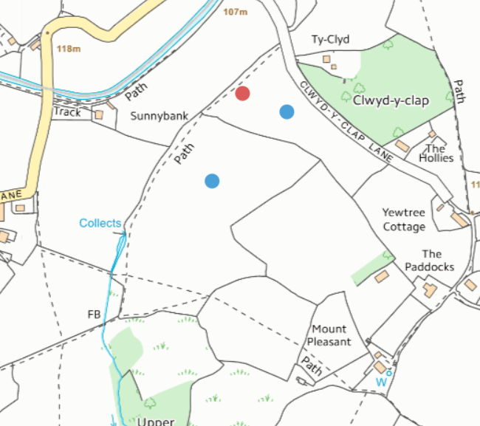
- No springs, wells or boreholes within distances
- Watercourse to the west of field 1- buffer in place

location of any public rights of way
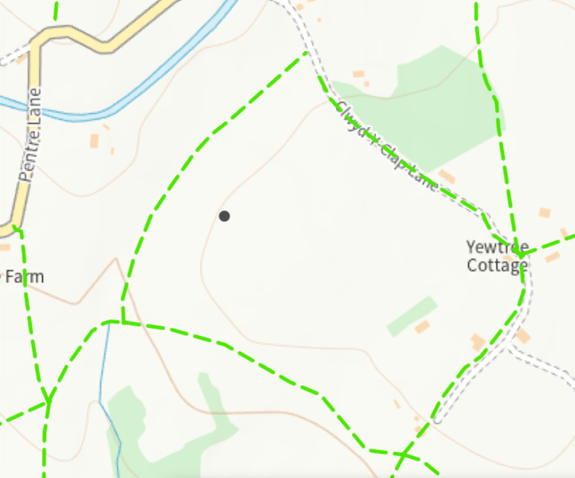
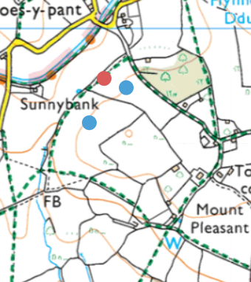
- Shown on plan and no spread

Protected Habitats/Section 7 species
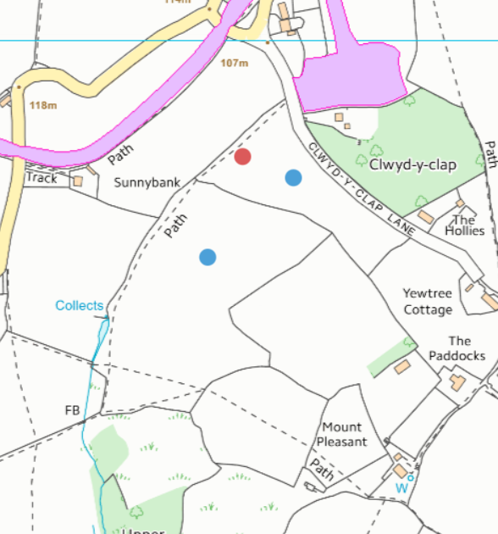
- None in fields
Ancient Woodlands
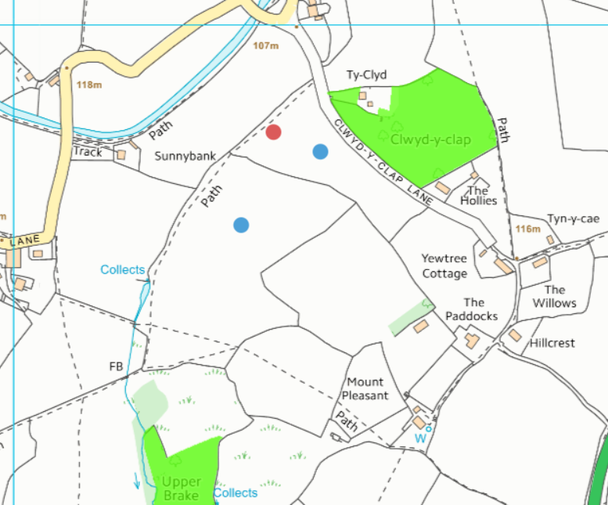
- Outside of spreading area
National Park
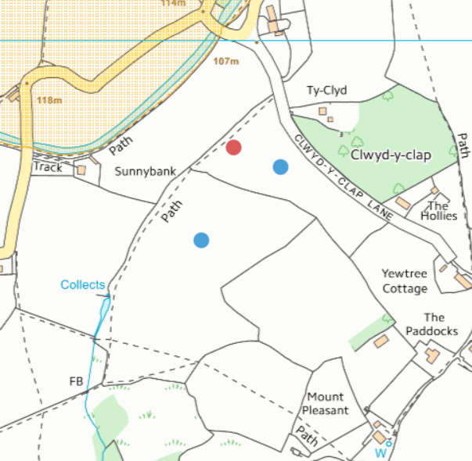
- Outside of spreading area

Flood risk
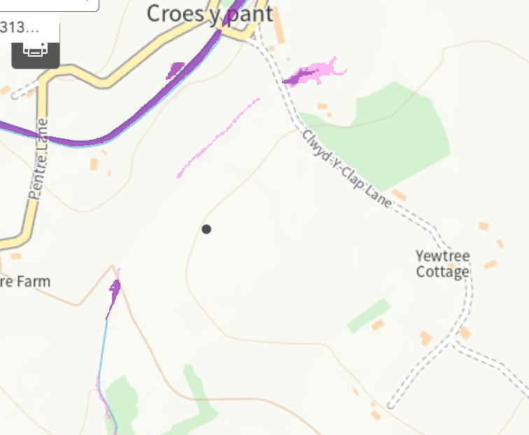
- No spread buffer in place
Field slope
Monachty 1 & 2
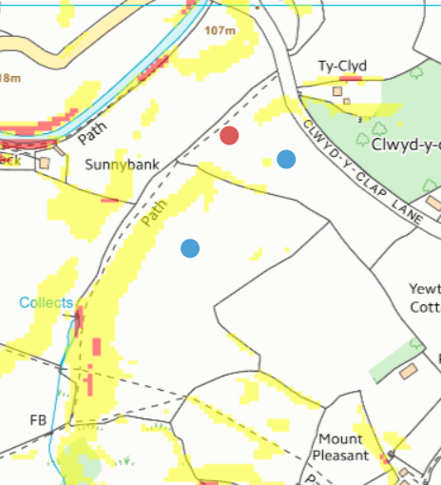

Coles 1-3
groundwater source protection zones- none
any European designated sites- Natura 2000 (SPA, pSPA, SAC or cSAC) or Ramsar- or SSSI within 500m- none
Within Groundwater Safeguard Zone- none
Scheduled Monument- none
Local Nature Reserve/National Nature Reserve- none
National Park- none

surface water courses/well/spring (or issue)/borehole
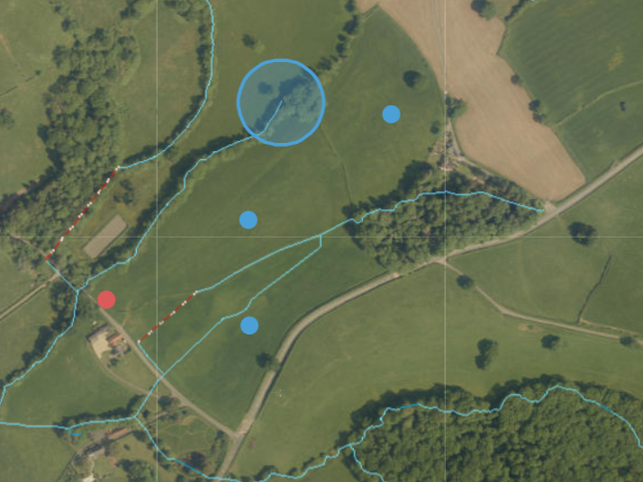
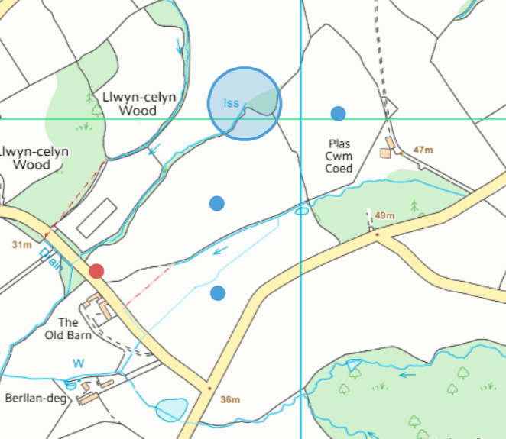
- Pond in field 1 buffered
- Most watercourse buffered except the one running through field 1
- Issue north of field 2 needs 50 meter buffer

location of any public rights of way
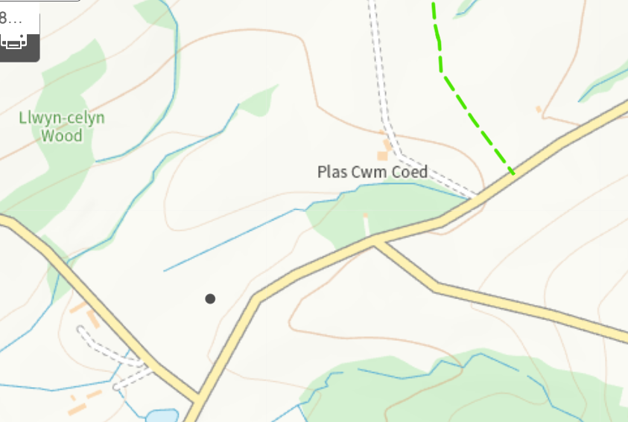
- None within or next to fields

Protected Habitats/Section 7 species
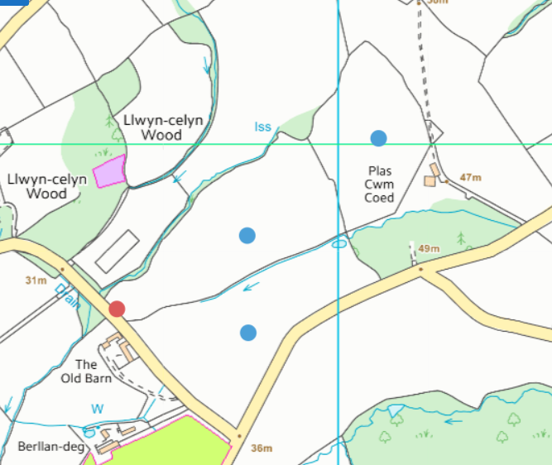
- None in fields

Ancient Woodlands
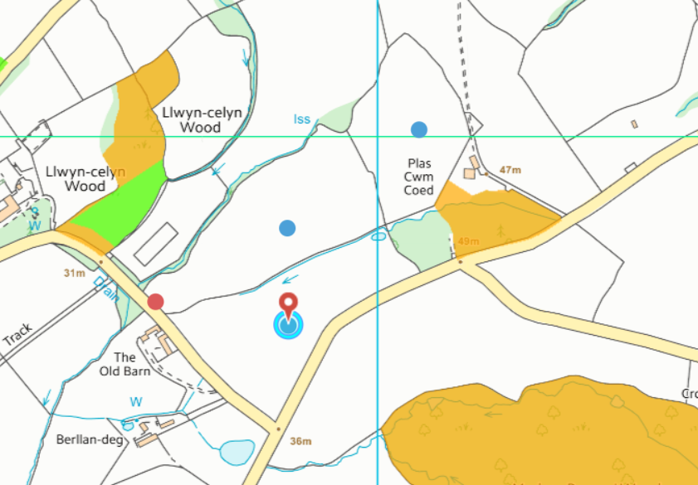
- AW to shown on spreading map
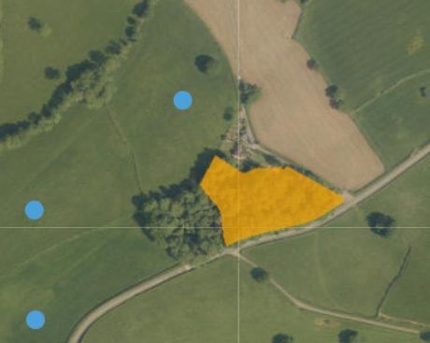
- Aerial photo shows that wooded area extends further than AW boundary and cannot be spread on

Local Wildlife Sites (SINC)
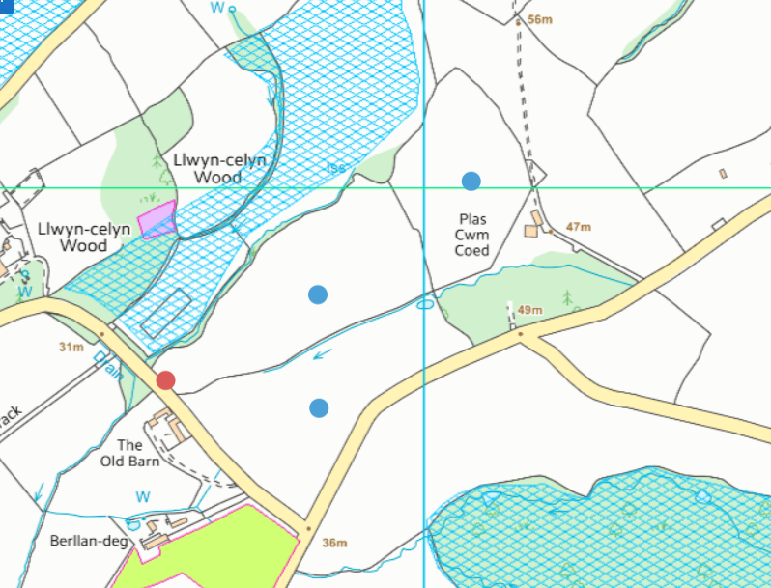
- North of fields but outside of spreading areas

Flood risk
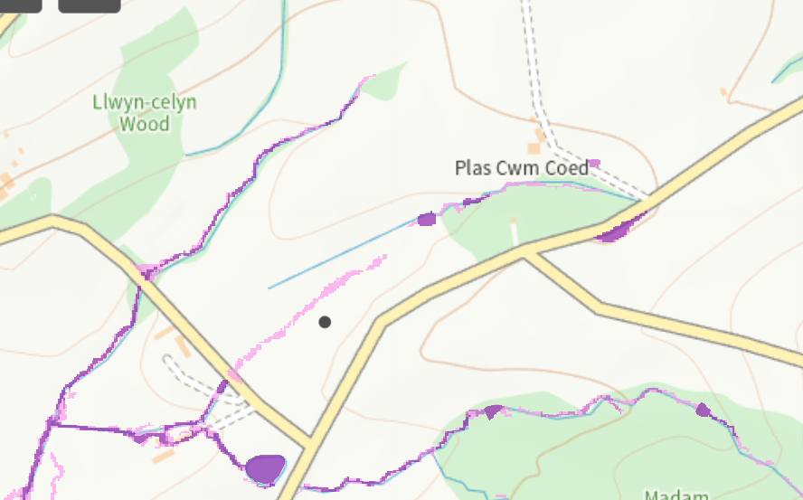
- Buffers in place on flood areas
Field slope
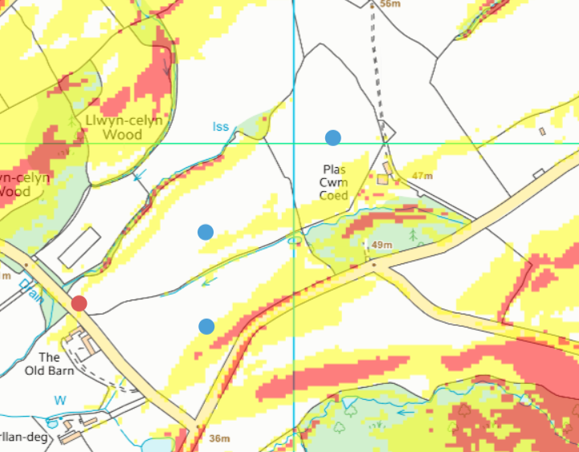

Parc 1-7
groundwater source protection zones- none
any European designated sites- Natura 2000 (SPA, pSPA, SAC or cSAC) or Ramsar- or SSSI within 500m- None
Within Groundwater Safeguard Zone- none
Scheduled Monument- none
Local Nature Reserve/National Nature Reserve- none
National Park- none

surface water courses/well/spring (or issue)/borehole
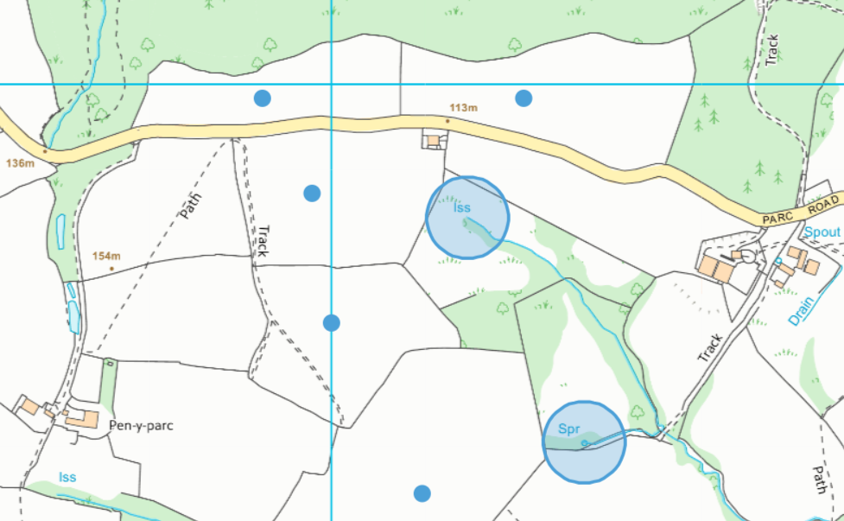
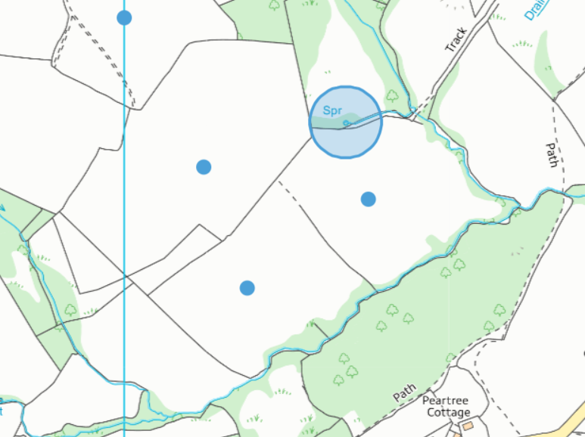
- Spring and issue both buffered
- Watercourses buffered

location of any public rights of way
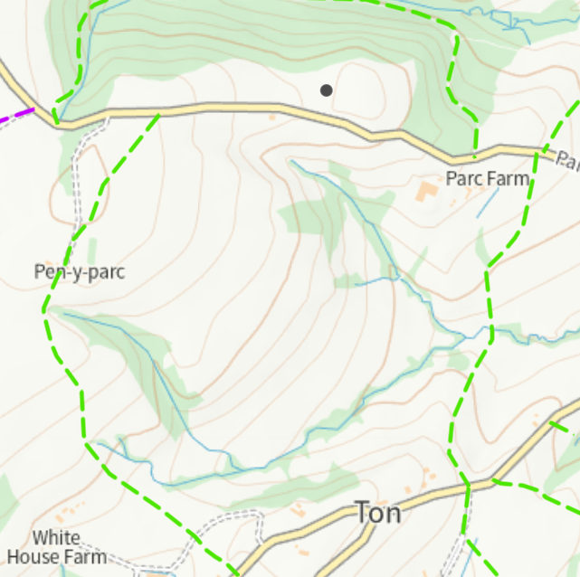
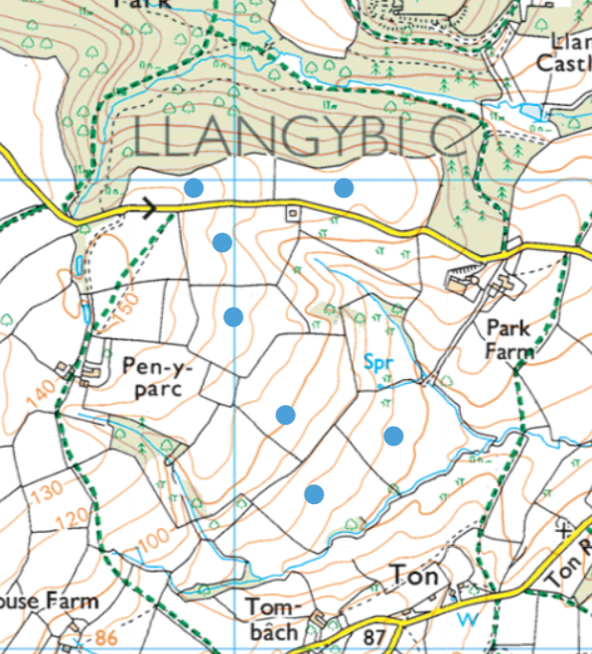
- None within or next to spreading fields
Protected Habitats/Section 7 species
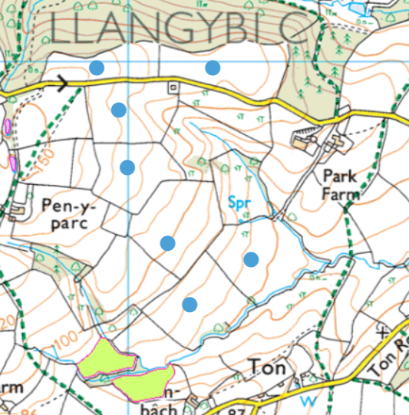
- none

Ancient Woodlands
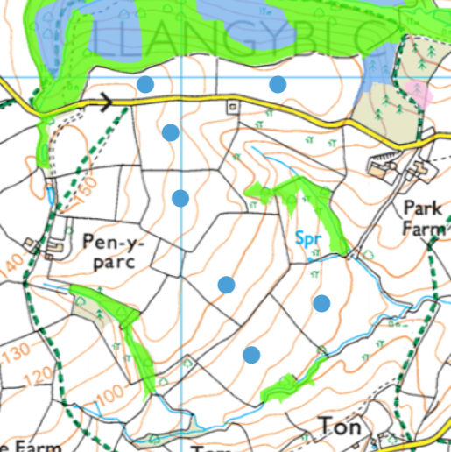
- not shown on maps

Local Wildlife Sites (SINC)
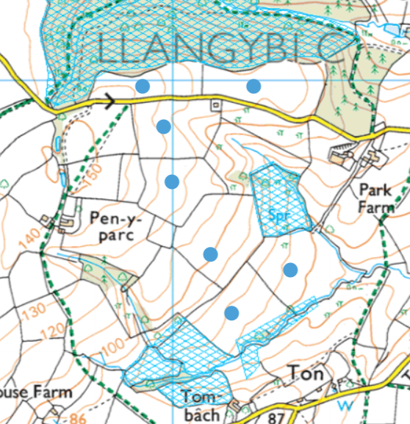
- not shown on maps
- overlap on field 7
- adjacent to fields 1, 2, 5, 6, 7
Flood risk
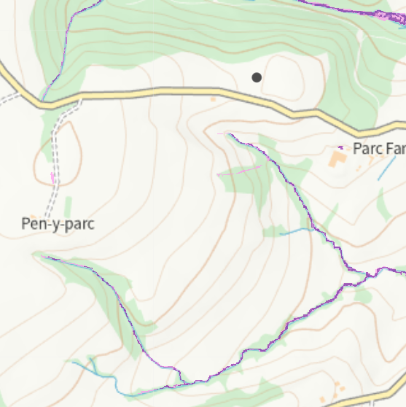

Field slope
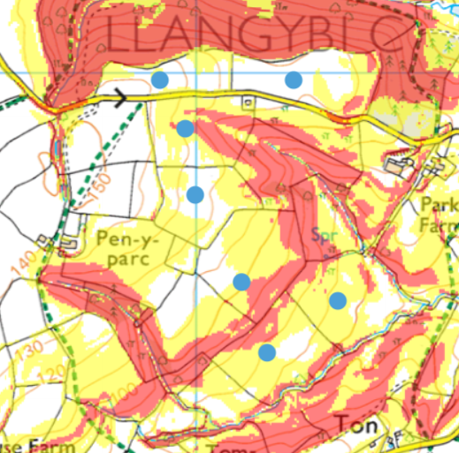
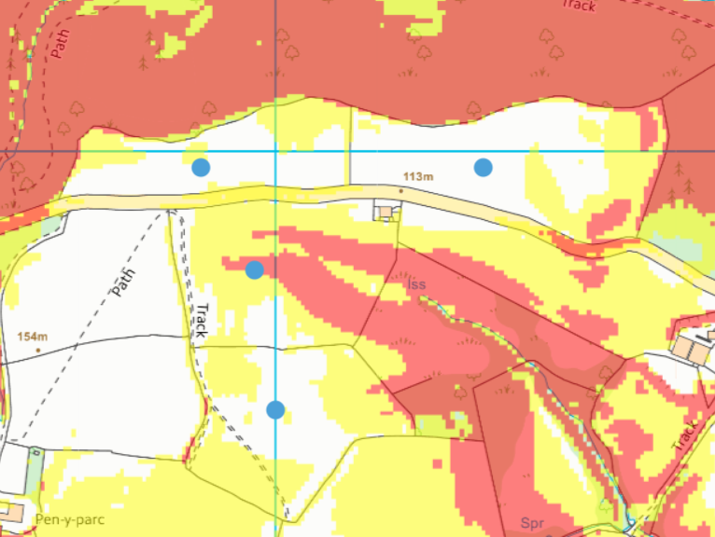
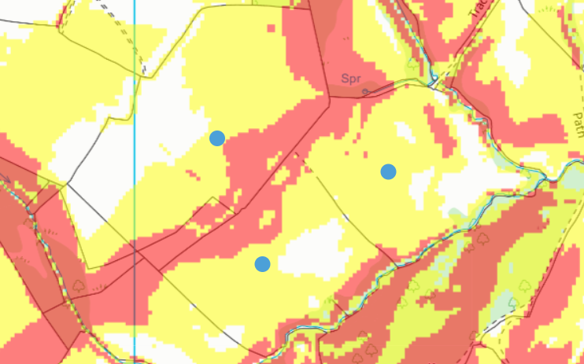

Parc 9 & 10
groundwater source protection zones- none
any European designated sites- Natura 2000 (SPA, pSPA, SAC or cSAC) or Ramsar- or SSSI within 500m
Within Groundwater Safeguard Zone- none
Protected Habitats/Section 7 species- none
Scheduled Monument- none
Local Nature Reserve/National Nature Reserve- none
National Park- none

surface water courses/well/spring (or issue)/borehole
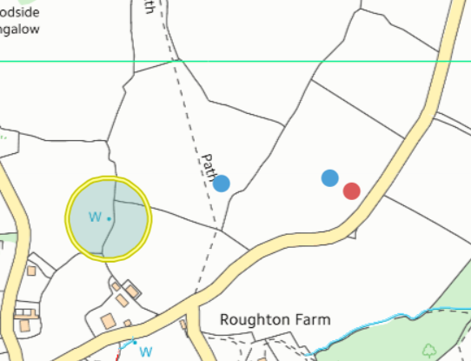
- no water courses
- well has buffer

location of any public rights of way
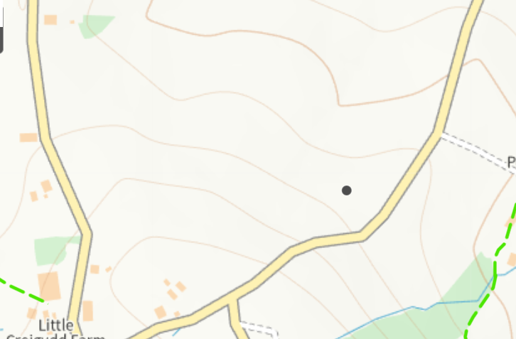
- none

Ancient Woodlands
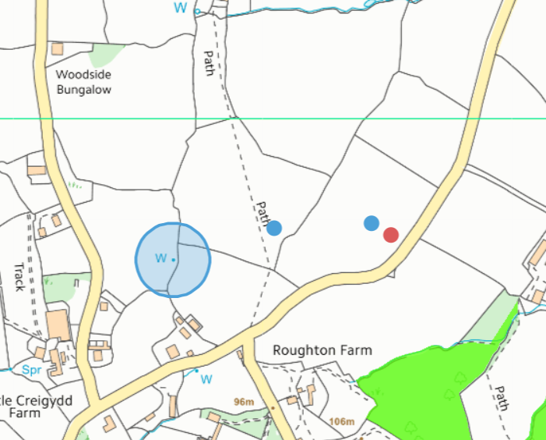
- none in permitted area or adjacent to boundaries

Local Wildlife Sites (SINC)
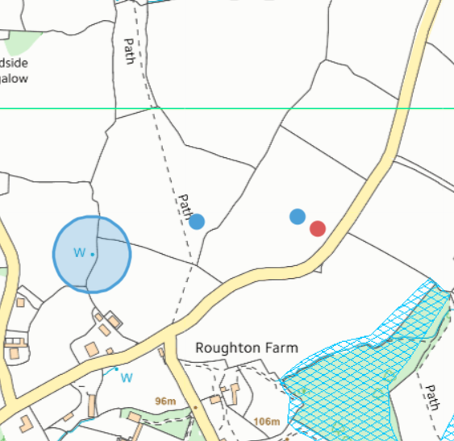
- none in permitted area or adjacent to boundaries

Flood risk
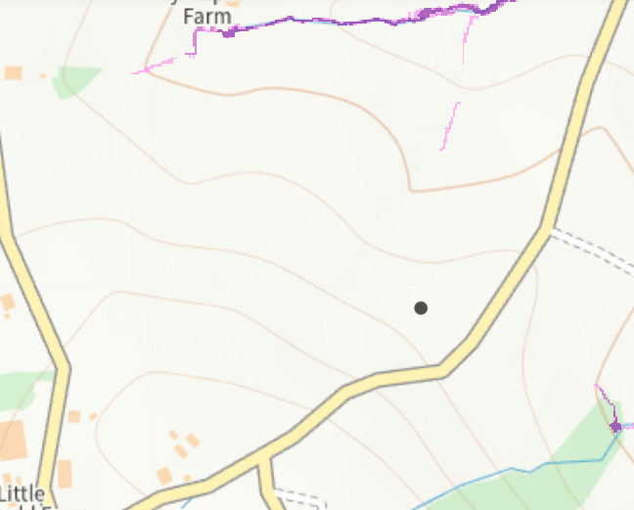
- none

Field slope


