Cardiff Coastal Defences - Saltmarsh Management Plan
Ground Investigation Works
Marine Licence (Activity 3)

April 2024
www.jbaconsulting.com

Prepared for:

Cardiff Council


Document Status
Issue date April 2024
Issued to Simon Dooley
Revision 02

Prepared by Hannah Webster BSc MSc
Ecologist
Reviewed by Jonathan Harrison BSc MSc MCIEEM
Senior Ecologist
Authorised by Anne-Marie Moon BSc MSc CEng MICE
Project Director
___________________________________________________________________
Carbon Footprint
The format of this report is optimised for reading digitally in pdf format. Paper consumption produces substantial carbon emissions and other environmental impacts through the extraction, production and transportation of paper. Printing also generates emissions and impacts from the manufacture of printers and inks and from the energy used to power a printer. Please consider the environment before printing.
___________________________________________________________________

Contract
JBA Project Manager Hannah Webster
Address Kings Chambers, 8 High Street, Newport NP20 1FQ
JBA Project Code 2024s0084
This report describes work commissioned by Cardiff Council. Jonathan Harrison and Hannah Webster of JBA Consulting carried out this work.
Purpose and Disclaimer
Jeremy Benn Associates Limited (“JBA”) has prepared this Report for the sole use of Cardiff Council and its appointed agents in accordance with the Agreement under which our services were performed.
JBA has no liability for any use that is made of this Report except to Cardiff Council for the purposes for which it was originally commissioned and prepared.
No other warranty, expressed or implied, is made as to the professional advice included in this Report or any other services provided by JBA. This Report cannot be relied upon by any other party without the prior and express written agreement of JBA.
Where assessments of works or costs identified in this Report are made, such assessments are based upon the information available at the time and where appropriate are subject to further investigations or information which may become available.
JBA disclaims any undertaking or obligation to advise any person of any change in any matter affecting the Report, which may come or be brought to JBA’s attention after the date of the Report.
Unless otherwise stated in this Report, the assessments made assume that the sites and facilities will continue to be used for their current purpose without significant changes.
Where field investigations are carried out, these have been restricted to a level of detail required to meet the stated objectives of the services. The results of any measurements taken may vary spatially or with time and further confirmatory measurements should be made after any significant delay in issuing this Report.
___________________________________________________________________
Copyright
© Jeremy Benn Associates Limited 2024
___________________________________________________________________

Contents
1 Introduction 1
1.1 Purpose of the Saltmarsh Management Plan 1
1.2 Aim of the Saltmarsh Management Plan 1
2 Summary of the Scope of Works 2
2.1 Site Location and Description 2
2.2 Scope of investigation 3
3 Pre-Construction Actions 5
4 Saltmarsh Management Plan 7
A Saltmarsh Maps i
A.1 Extent of Saltmarsh i
A.2 Saltmarsh extents April 2024 ii

List of Figures
Figure 2-1. Location of Rhymney River and its confluence into the Severn Estuary with key features. 2

List of Tables
Table 4-1. Saltmarsh Management Plan 6

Abréviations
CEMP Construction Environmental Management Plan
EIA Environmental Impact Assessment
SAC Special Area of Conservation
SMP Saltmarsh Management Plan
SSSI Site of Special Scientific Interest
NRW Natural Resources Wales

Introduction

Purpose of the Saltmarsh Management Plan
This Saltmarsh Management Plan (SMP) sets out the management approach, as agreed during consultation with Natural Resources Wales (NRW) for protection of the saltmarsh at the mouth of the Rhymney River and Severn Estuary to the east of Cardiff City Centre during the works to upgrade the flood defences at this location.
This version of the plan has been developed to protect the areas of saltmarsh during final ground investigation works prior to the main works taking place.
This management plan has been identified as essential mitigation within the Environmental Impact Assessment Report (EIA Report) and details other essential mitigation identified to avoid or minimise effects on the saltmarsh. Much of the proposed works and the surrounding saltmarsh habitat fall within the Severn Estuary Special Area of Conservation (SAC) and border the Gwent Levels Site of Special Scientific Interest (SSSI).

Aim of the Saltmarsh Management Plan
The aim of the Saltmarsh Management Plan in this phase of the works is to ensure that no works temporary or permanent take place within the saltmarsh and to protect the habitat from indirect impacts.
This will include pre- and post-construction monitoring and identify points at which intervention may be required. This plan is a live document which will be updated throughout the construction period. The plan will ensure that essential mitigation strategies required for safeguarding protected species and habitats are implemented as part of the contract.
This Management Plan will be included as an annex to the Construction Environmental Management Plan (CEMP) which will be developed by the Contractor prior to construction.

Summary of the Scope of Works

Site Location and Description
The proposed development comprises new fluvial and coastal flood defences along both banks of the River Rhymney on the outskirts of Cardiff from where the A4232 crosses the river down to the confluence between the river and the Severn Estuary. The defences will then extend along the Severn Estuary coastline, east and west from the River Rhymney. This area includes the DCWW Cardiff East WWTW and northwards along the eastern extent of the Lamby Way landfill site (see Figure 2-1).
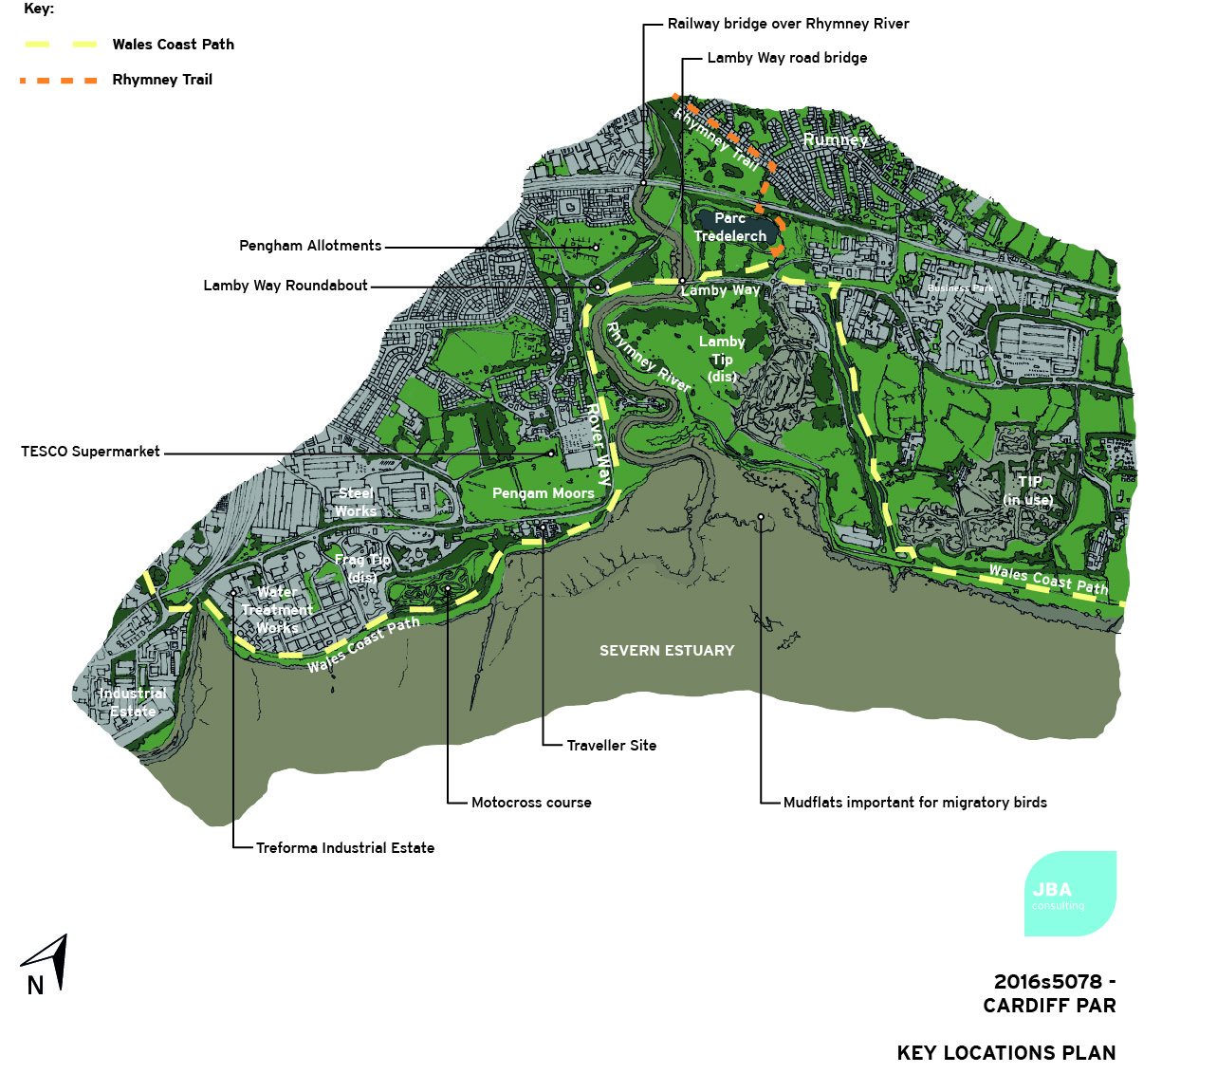
Figure 2-1. Location of Rhymney River and its confluence into the Severn Estuary with key features.

Scope of investigation
This plan addresses the ground investigation works along the coastal frontage within area 12 only, shown in figure 2-2..
The scope of the ground investigation comprises;
5 No. boreholes to be formed using a multipurpose drilling rig with rotary capability (e.g. Comacchio Rig or similar) and associated in-situ Standard Penetration Tests to a depth of 15m.
8 No. machine excavated trial pits to a depth of 3.5m.
Geotechnical and geochemical laboratory testing.
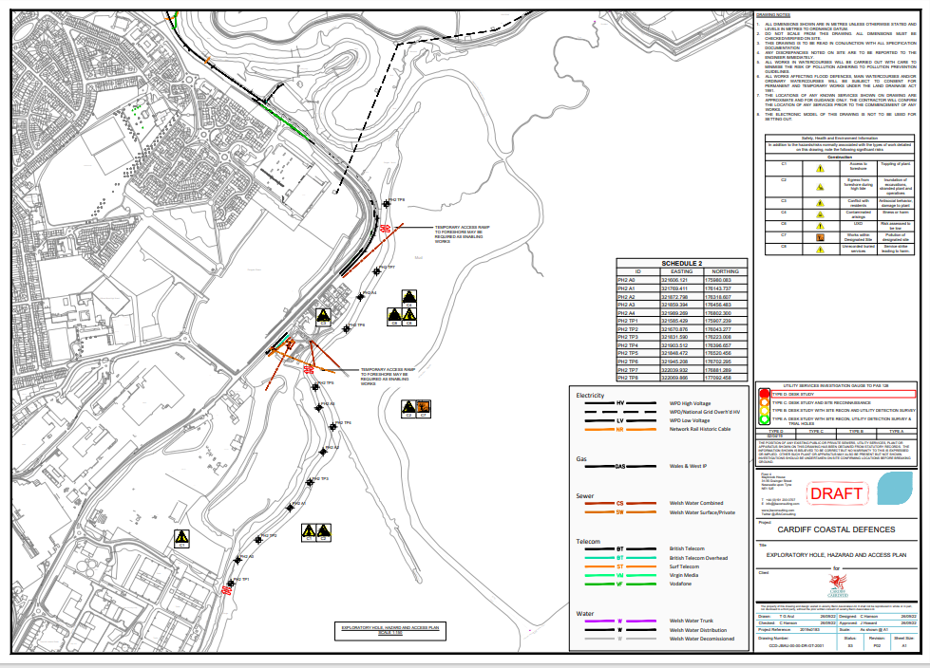
Figure 2-2. Location of proposed ground investigations

Pre-Construction Actions
The following conditions regarding the saltmarsh have been put in place during the planning process and the actions undertaken to date are detailed.
P1.1 - Confirm extents of valuable and sensitive saltmarsh habitat for future monitoring/ comparison. P1.2 - Conduct walkover survey to identify areas of erosion/accretion.
A site survey was undertaken on the 6th of November 2023 by Jonathan Harrison and Hannah Webster of JBA consulting and the current extent of the saltmarsh was determined. To more accurately map the western boundary of the saltmarsh Knights Brown took GPS points with the supervision of an ecologist in April 2024. This has ensured that these GI works will not require works within any saltmarsh habitat. The updated map is shown in Appendix A
P1.3 - Ensure mitigation of temporary works impacts is agreed. This should involve the production of a temporary works methods statement detailing mitigation measures for saltmarsh. This should also include details of the type of track matting to be used, the length of tracks required, and plant to be used on top of areas of saltmarsh.
These ground investigations will not require any works within the saltmarsh and as such tracking through the saltmarsh will not be required or permitted. The saltmarsh has been demarcated and the ECoW and the GI supervisor will be responsible for ensuring no works (temporary or permanent) take place within the marsh. It should be noted that it is likely that temporary tracks through the saltmarsh to facilitate the main works can be avoided and this is being developed.
P1.4 - Baseline invertebrate survey should be conducted to inform post-works monitoring – including Shrill Carder Bee.
A baseline invertebrate survey to include the Shrill Carder Bee will be completed in throughout the survey season (April - October). No construction works which could damage the saltmarsh will be permitted prior to this initial survey taking place. Until the survey is available the ECoW will be responsible for providing guidance on operations likely to damage the saltmarsh on case by case basis. Further surveys on the undisturbed saltmarsh will be undertaken between April and September.
P1.5 - A baseline rare plant species survey should be completed in the summer months prior to construction.
A baseline rare plant species survey will be completed in prior to any works being undertaken in the saltmarsh. No construction works likely to damage the saltmarsh will be permitted prior to this survey taking place.
P1.6 - Review the need for further mitigation measures in the Environmental Statement and habitat losses from temporary works should be revisited to identify further relevant actions.
A review of the Environmental Statement has been completed and no further mitigation measures have been identified.
It is intended that this document will be live throughout the construction period. It will be updated following the relevant baseline surveys and with further mitigation identified. Further enhancement measures will be included if opportunities are identified through the construction period.

Saltmarsh Management Plan
Table 4-1. Saltmarsh Management Plan
Ref. | Action | Responsibility | Ref to further information | Progress and further action | Sign off and date
Pre-Construction
P1.1 | Confirm extents of valuable and sensitive saltmarsh habitat for future monitoring/comparison. | Construction Contractor  ECoW | Environmental Statement | Completed  Updated 12/04/2024 | 6/11/23
P1.2 | Conduct walkover survey to identify areas of erosion/accretion. | Construction Contractor  ECoW | Environmental Statement  NVC Survey |  | 6/11/23
P1.3 | Ensure mitigation of temporary works impacts is agreed. This should involve the production of a temporary works methods statement detailing mitigation measures for saltmarsh. | Construction Contractor | Environmental Statement | No GI works will take place within the saltmarsh.  The saltmarsh has been demarcated and no temporary or permanent works will be permitted within the saltmarsh. | 27/02/24
P1.4 | Baseline invertebrate survey should be conducted to inform post-works monitoring – including Shrill Carder Bee. | Construction Contractor | Environmental Statement | Will be completed in between April and September 2024.
P1.5 | A baseline rare plant species survey should be completed in the summer months prior to construction. | Construction Contractor | Environmental Statement | Will be completed before any works likely to damage the saltmarsh are completed.

Ref. | Action | Responsibility | Ref to further information | Progress and further action | Sign off and date
During Construction
C1.1 | Presence of a suitably qualified Ecological Clerk of Works (ECoW) is required to ensure that all mitigation measures are implemented | Construction Contractor  ECoW | Environmental Statement | ECoW appointed by Cardiff Council
C1.2 | Best practice construction methods (CIRIA 2015) will be used including the use of appropriate pollution controls (i.e. Guidance for Pollution Prevention (GPPs)), such as construction drainage, a strict re-fuelling protocol and removal of all loose materials from the intertidal area | Construction Contractor | Environmental Statement
C1.3 | No works (temporary or permanent are permitted within the saltmarsh. | Construction Contractor | Environmental Statement

Ref. | Action | Responsibility | Ref to further information | Progress and further action | Sign off and date
Post Construction (Permanent Works)
PC1.1 | Surveys of the saltmarsh plant species composition will be important to inform the restoration of the saltmarsh and to demonstrate enhancement in the areas of saltmarsh that are retained. Monitoring of rare plant species should be undertaken to inform management practices.  This should take the form of a fixed-point quadrat survey to record abundance, as well as an updated NVC survey to record habitat type. | Contractor – survey subsequent two years after completion of works. | Environmental Statement
PC1.2 | Monitoring of saltmarsh post-construction to inform future management practices and enhancement opportunities.  Methods and frequency of monitoring to be agreed with NRW, and would likely include surveys of accretion/erosion, grazing pressure etc. | Construction Contractor | Environmental Statement
PC1.3 | Post-construction invertebrate survey to be completed in subsequent years post-construction to inform management practices. | Construction Contractor | Environmental Statement

Saltmarsh Maps

Extent of Saltmarsh
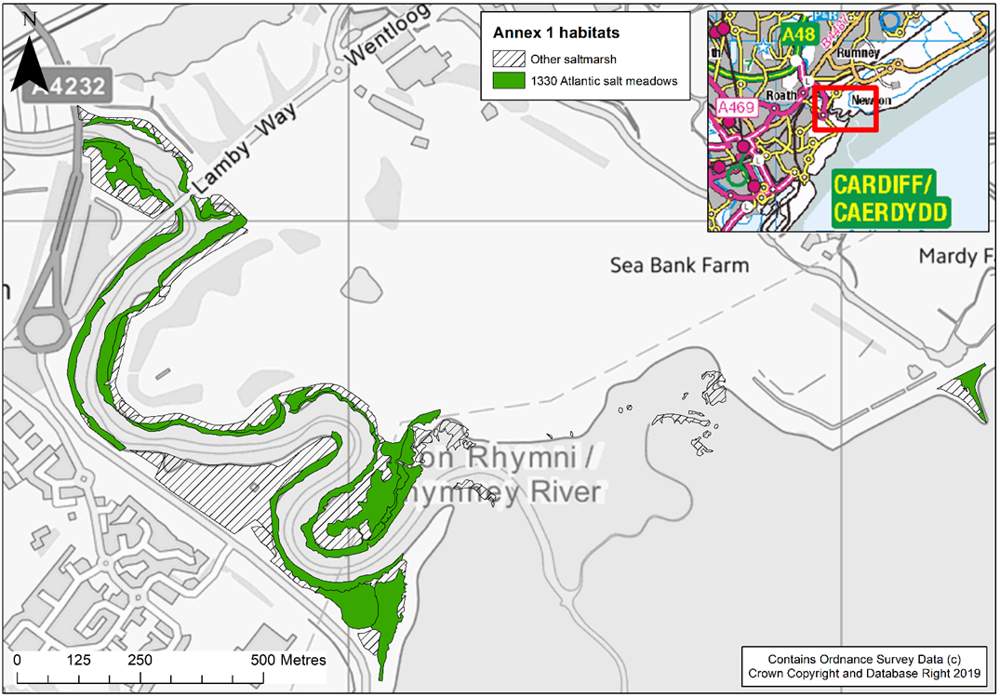

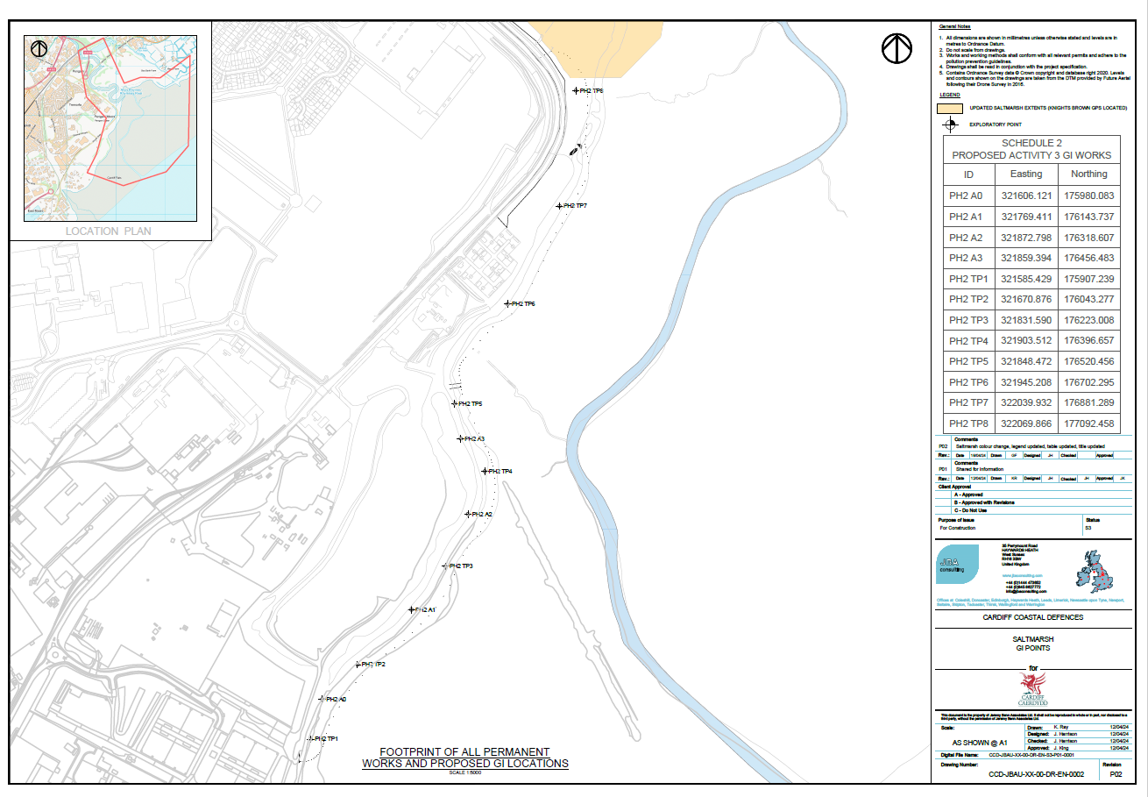

Offices at
Bristol
Coleshill
Doncaster
Dublin
Edinburgh
Exeter
Glasgow
Haywards Heath
Isle of Man
Leeds
Limerick
Newcastle upon Tyne
Newport
Peterborough
Portsmouth
Saltaire
Skipton
Tadcaster
Thirsk
Wallingford
Warrington

Registered Office
1 Broughton Park
Old Lane North
Broughton
SKIPTON
North Yorkshire
BD23 3FD
United Kingdom

+44(0)1756 799919
info@jbaconsulting.com

www.jbaconsulting.com
Follow us:

Jeremy Benn Associates Limited
Registered in England 3246693

JBA Group Ltd is certified to:
ISO 9001:2015
ISO 14001:2015
ISO 27001:2013
ISO 45001:2018

