PAN-024622 - My Map Report:
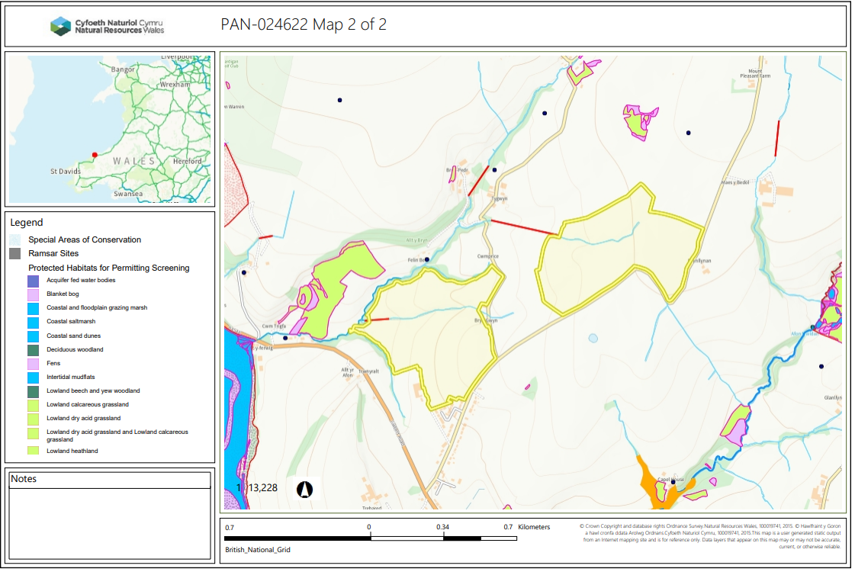

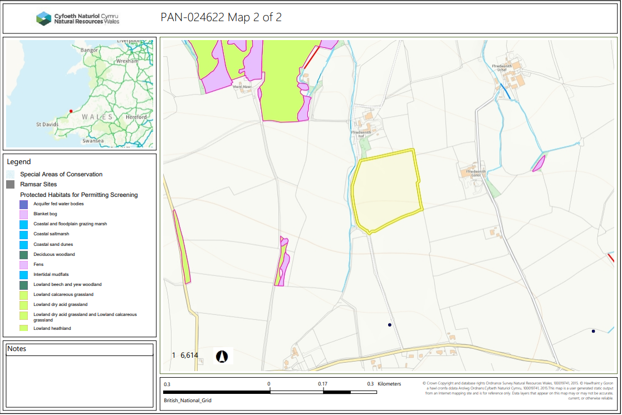

Detailed river network:
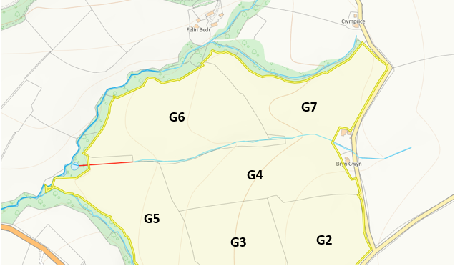
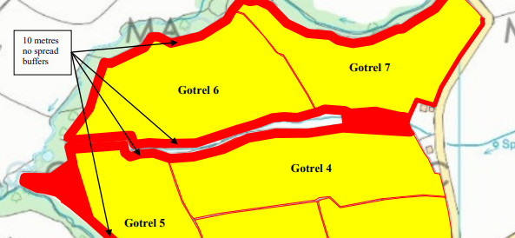
There are several modified attributions which run along the border and through the Gotrel farm fields. All the borders in which a modified attribution runs along have been appropriately buffered via a 10m no spread zone. The modified attribution through the centre of the fields Is also part of a large no spread zone, at least 10m either side, no action required.
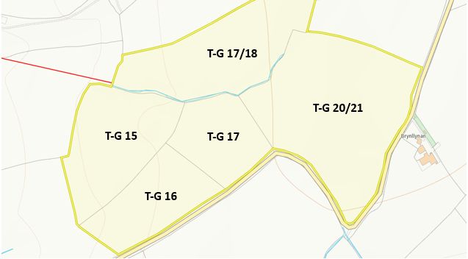
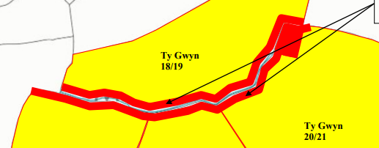
A modified attribution runs along the bottom border of T-G 17/18. This has been appropriately buffered with a 10m no spread buffer zone on either side of the attribution. The attribution and drain that are seen at the most southern point of T-G 20/21 have also been appropriately buffered with a 10 no spread buffer zone in along the section it borders. No action required.
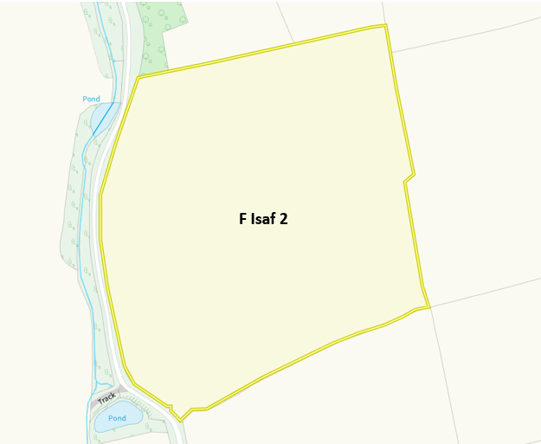
Several modified attributions run along the west border of field F Isaf 2. The section of field that runs adjacent to the water course has a 10m no spread buffer zone imposed. No action required.
Groundwater protection zones (source)
None in range
Wells, springs or boreholes used for the supply of water for human consumption including from a private water supply or supplies
None in range
any springs wells or boreholes not used to supply water for domestic or food production purposes within 50m

None in range
European designated sites- Natura 2000 (SPA, pSPA, SAC or cSAC) or Ramsar- or SSSI within 500m

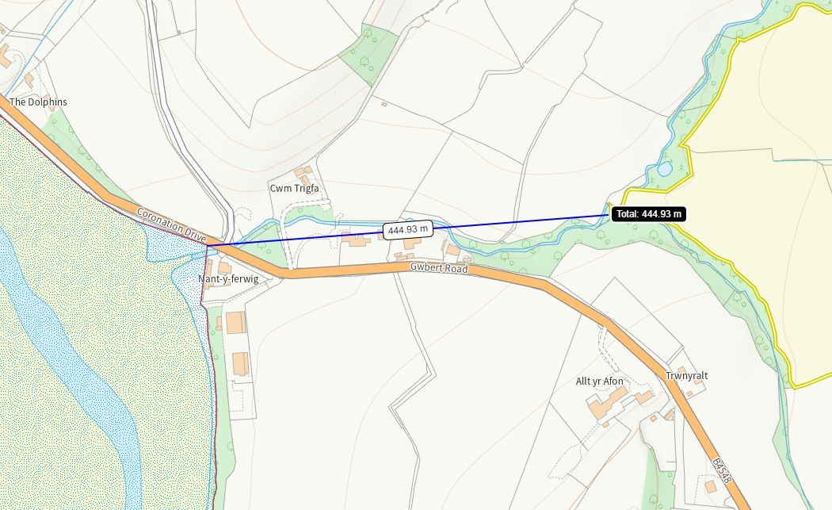

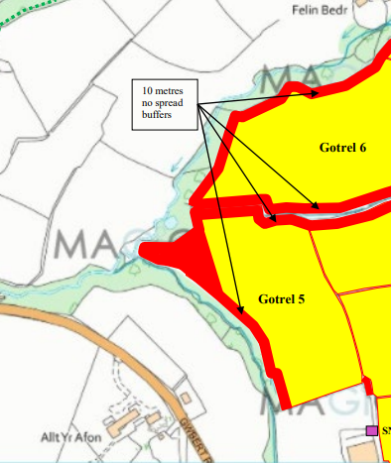
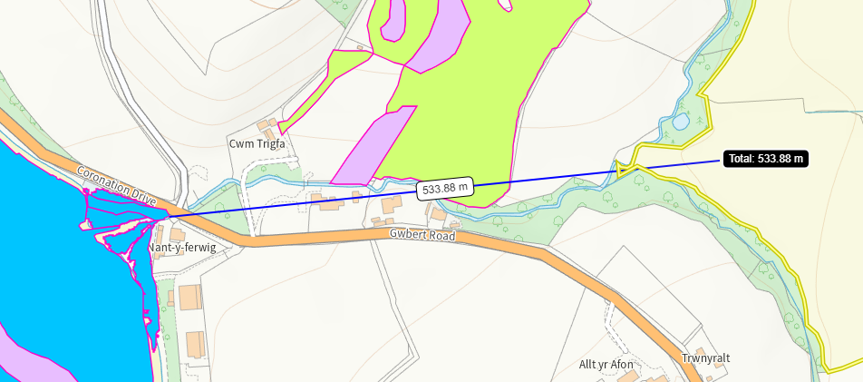
The Afon Teifi SAC/SSSI is 444m from the boundary of G5. However, due to the imposed no spread buffer zones in this corner and border of G5 it is over 500m form the spreading area and therefore, no action is required.
Other protected sites:
- Protected Species
None in range
- Protected Habitats
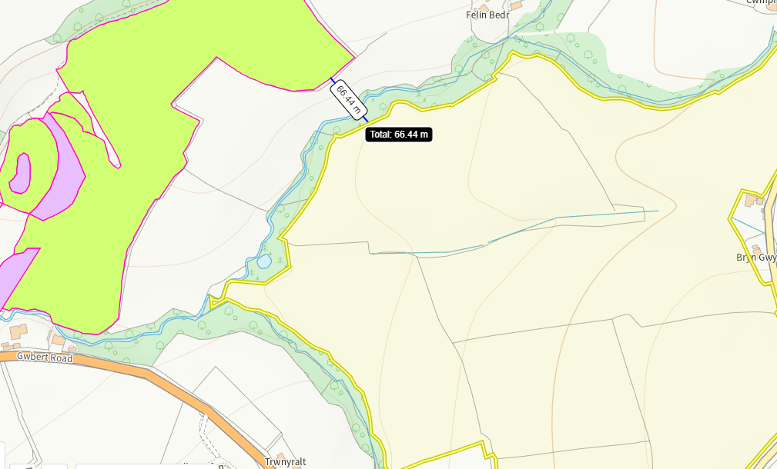
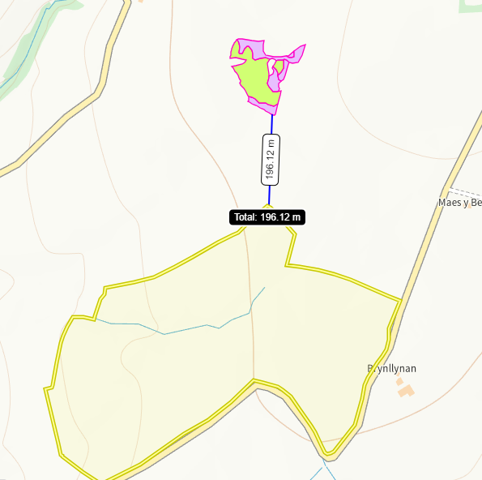
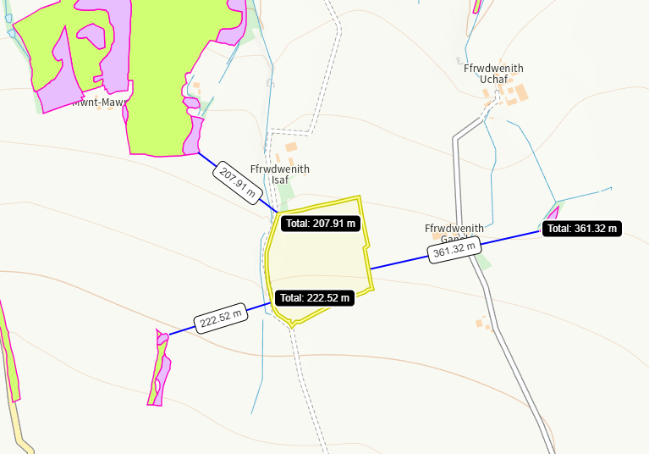
There are areas of Purple moor grass and rush pastures (purple) and Lowland dry acid grassland and Lowland calcareous grassland (green) located around all fields in this deployment. Due to the evident distance between them and the spreading areas, no impact pathway is perceived.

- Scheduled Ancient Monument
None in range
- Local Nature Reserve
None in range
- National Nature Reserve
None in range
- Ancient Woodlands
None in range
- Local Wildlife Sites (SINC)
None in range
- National Park-
None in range
- Groundwater Safeguard Zone-
None in range
- ANOBs
None in range
- Heritage coast
None in range
- World Heritage Sites
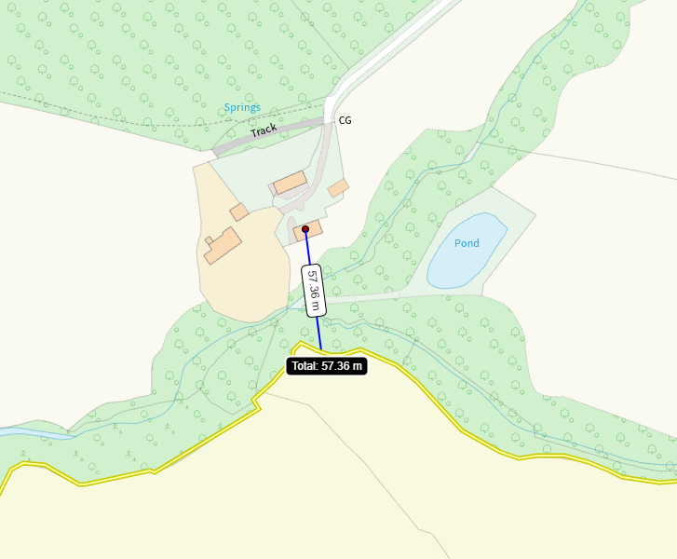
There is a post medival cornmill 57m from the spreading area. Due to the distance no impact pathway is perceived.

- Hedges, Ditches, Local residents, Housing, schools, Workplaces, Recreational facilities
Any in range appropriately mapped and considered

Slope map
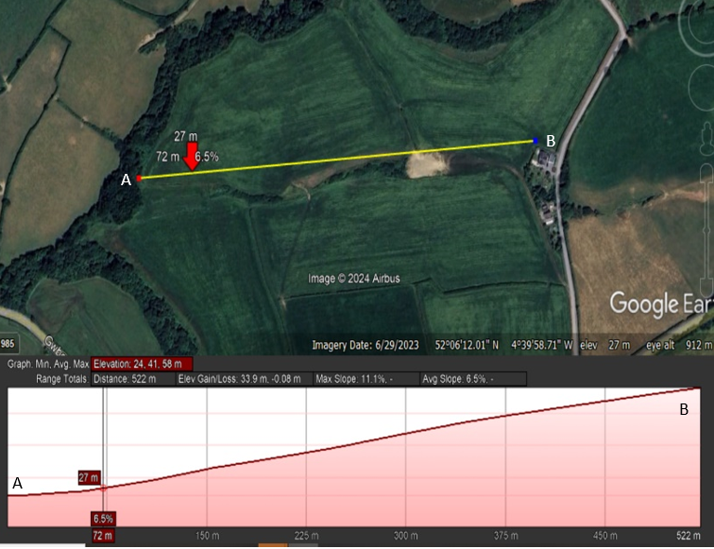
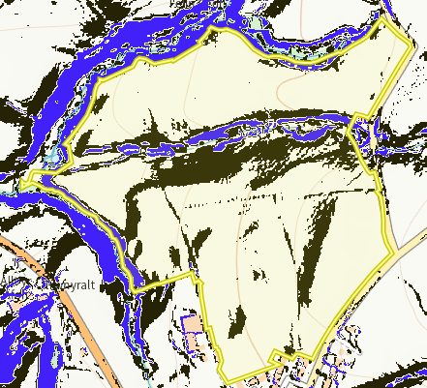
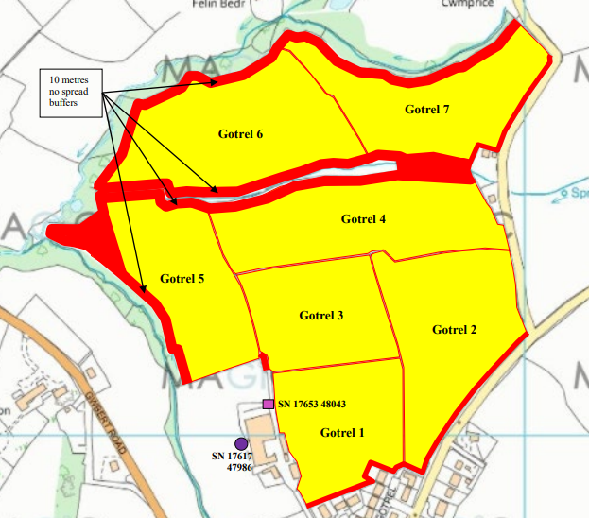
Field 4, 5, 6 and 7 all have areas of >12 degree slopes (blue). As shown in the spreading map the areas with the greatest slope have been buffered out to protect the water ways from potential run off. The elevation profile of the steepest slope also indicates run off would not be in the direction into the watercourse. All other areas of slope 7-12 degrees (black) are mainly contained within the fields and due to the waste type and application method, including each application not exceeding 50 t/ha, no runoff risk is perceived.

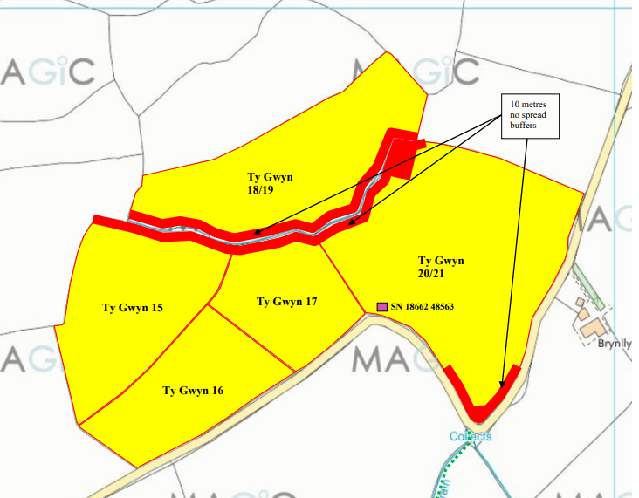
Field 18/19, 15 and 17 all have areas of >12 degree slopes (blue). As shown in the spreading map the areas with the greatest slope have been buffered out to protect the water ways from potential run off. The elevation profile of the steepest slope also indicates run off would not be in the direction into the watercourse. All other areas of slope 7-12 degrees (black) are mainly contained within the fields and due to the waste type and application method no runoff risk is perceived.

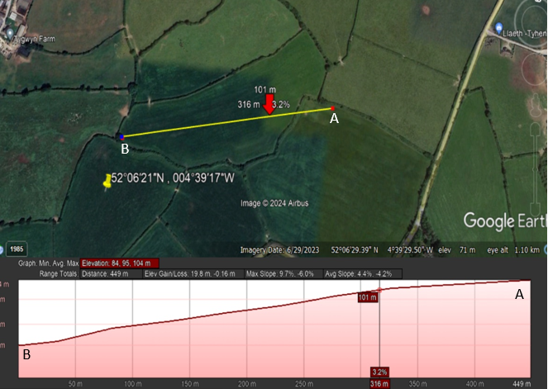
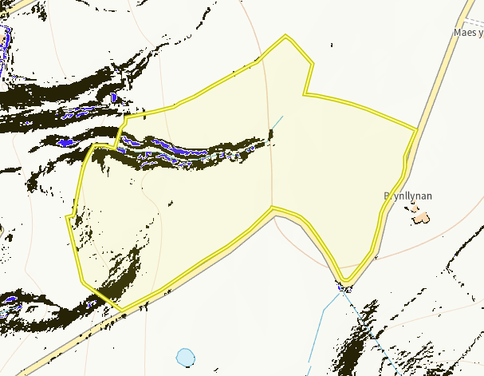

Flood risk
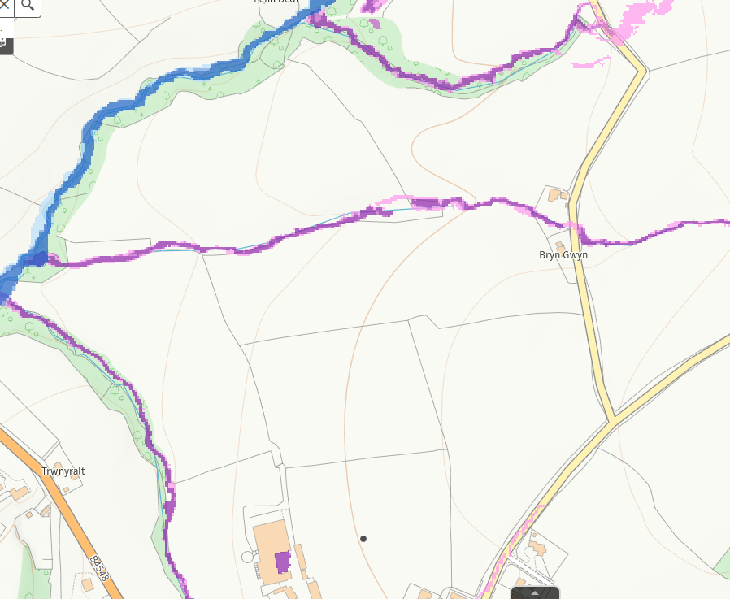
There is a medium to low flood risk from the water courses running both within field 4, 5, 6 and 7 as well as along the border of field 5. As shown in the spreading maps above all areas where a flood risk is present have a no spread buffer zone implemented. No action needed.
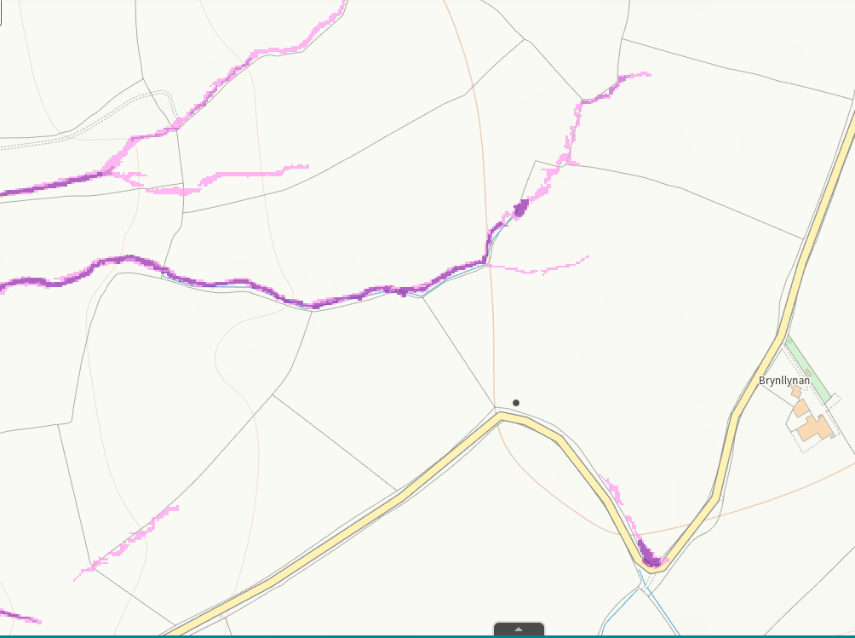
There is a medium to low flood risk from the water courses running both within field 18/19 and 20/21 as well as the top of field 16. As shown in the spreading maps above all areas where a flood risk is present have a no spread buffer zone implemented. No action needed. The small areas where a low risk is present are from surface water courses not shown on the maps, by following CGAP guidance with the weather, risk will be mitigated.

