Natural Resources Wales permitting decisions

Bespoke permit

We have decided to grant the permit for TAZ ROCK LTD operated by TAZROCK LTD.
The permit number is EPR/CB3791CX

We consider in reaching that decision we have taken into account all relevant considerations and legal requirements and that the permit will ensure that the appropriate level of environmental protection is provided.

Purpose of this document

This decision document:
- explains how the application has been determined
- provides a record of the decision-making process
- shows how all relevant factors have been taken into account
- justifies the specific conditions in the permit other than those in our generic permit template.

Unless the decision document specifies otherwise, we have accepted the applicant’s proposals.

Structure of this document

- Annex 1 the decision checklist
- Annex 2 the consultation and web publicising responses.
Annex 1: decision checklist
This document should be read in conjunction with the Duly Making checklist, the application and supporting information and permit/ notice.

.
Aspect considered |  |  | Justification / Detail | Criteria met
 |  |  | Justification / Detail | Yes
Consultation
Scope of consultation |  |  | The consultation requirements were identified and implemented. The decision was taken in accordance with RGN 6 High Profile Sites, our Public Participation Statement and our Working Together Agreements.
Responses to consultation and  web publicising |  |  | The web publicising & consultation responses (Annex 2) were taken into account in the decision.  The people who were consulted were:  - Glamorgan-Gwent Archaeological Trust  - Local Health Board, Cwm Taf  - Public Health Wales  - Planning authority, Rhondda Cynon Taff County Borough Council  - Environmental Health, Rhondda Cynon Taff County Borough Council  The decision was taken in accordance with our guidance.
Operator
Control of the facility |  |  | We are satisfied that the applicant (now the operator) is the person who will have control over the operation of the facility after the grant of the permit.  The decision was taken in accordance with EPR RGN 1 Understanding the meaning of operator.
Sustainable Management of Natural Resources (SMNR)
Considerations of SMNR - Compliance with our General Purpose |  | We are satisfied that this decision is compatible with our general purpose of pursuing the sustainable management of natural resources in relation to Wales and applying the principles of sustainable management of natural resources.” |  | ✓
Environment Wales Act 2016 – Biodiversity and resilience of ecosystems duty
Consideration of Section 6 |  | Section 6 of the Environment Wales Act 2016 requires that we seek to maintain and enhance biodiversity in the exercise of our functions, and in so doing promote the resilience of ecosystems, in a manner that is consistent with the proper exercise of our functions. NRW is satisfied that in this case, we have taken into account and had due regard to this duty in so far as it is consistent with the function of determining an application for an EPR permit. |  | ✓
The site
Extent of the site of the facility |  |  | The operator has provided a plan which we consider is satisfactory, showing the extent of the site of the facility.  A plan is included in the permit and the operator is required to carry on the permitted activities within the site boundary.
Site condition report |  |  | The operator has provided a description of the condition of the site.  We consider this description is satisfactory. The decision was taken in accordance with our guidance on site condition reports – guidance and templates (H5).
Biodiversity, Heritage, Landscape and Nature Conservation |  |  | The application is within the relevant distance criteria of a site of a protected species and habitat.  A full assessment of the application and its potential to affect Cors Bryn y Gaer SSSI, Woodland Park & Pontpren SSSI, Moel Penderyn SSSI & Blaen Cynon SAC has been carried out as part of the permitting process. We consider that the application will not affect the features of the sites. These assessments were carried via the Appendix 4 (SSSI) and HRA Form 1 (SAC) which are available on the public register. The HRA is further explained below.  There were no other designated sites within the relevant screening distances of the proposed waste operation.  Assessment of Likely Significant Effect:  In regard to the European designated site Blaen Cynon SAC the project has been screened for likelihood of significant effects and, taking account of the advice received from protected sites advisors, is considered not likely to have a significant effect on any Natura 2000/Ramsar site (As documented in section 3.2 of OGN 200 form 1, or section 5 if applicable)  .  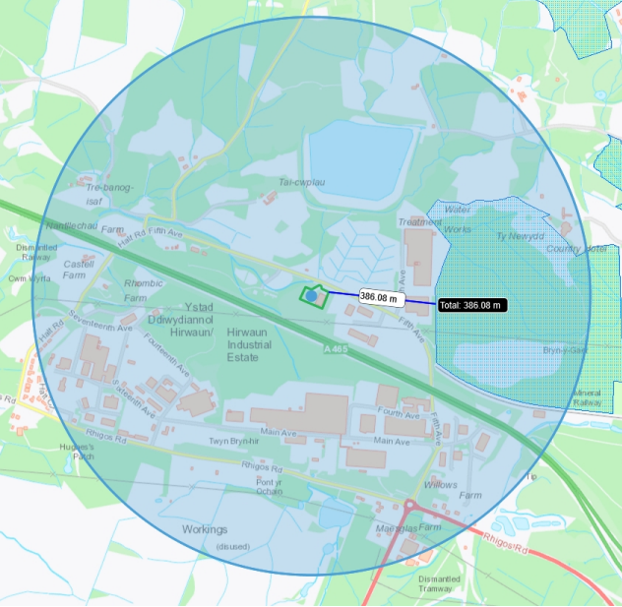  The proposed waste facility (solid green area on map below) is located 386m east of the closest section of the Blaen Cynon SAC.  HRA Overall conclusion:  In light of the conclusions of the likely significant effect screening , it has been ascertained that the project will not adversely affect the integrity of any Natura 2000/Ramsar site, as documented in section 4 of OGN 200 form 1, and section 5 is applicable.
Environmental risk |  |  | We have reviewed the operator's assessment of the environmental risk from the facility.  The operator’s risk assessment is satisfactory.
Operating techniques |  |  | We have reviewed the techniques used by the operator and compared these with the relevant guidance notes.  The operator has provided an emissions management plan which outlines a number of measures to ensure the site does not cause emissions in regard to dust. These measures have been assessed and considered suitable and in line with the guidance ‘How to comply with your environmental permit’.  The operator has provided an Environmental Management System which outlines a number of measures to ensure the site does not cause pollution during operation, including but not limited to waste acceptance, spillage and noise. These measures have been assessed and considered suitable and in line with our ‘How to comply with your environmental permit’, and ‘Technical Guidance Note WM3: Waste Classification’ and the Environment Agency ‘Noise and vibration management’ guidance which NRW have formally adopted.
Waste types |  |  | We have specified the permitted waste types, descriptions and quantities, which can be accepted at the regulated facility.  We are satisfied that the operator can accept these wastes for the following reason:  - The waste type (EWC) and quantities proposed are consistent with type of facility (A16) and processes being undertaken at the site.  - Pre acceptance criteria  We made these decisions with respect to the waste type in accordance with Technical Guidance WM3 Waste Classification and Assessment and ‘how to comply with my environmental permit’.
Pre-operational conditions |  |  | Based on the information in the application, we consider that we need to impose pre-operational conditions.  To build a post screening storage shed to store sorted aggregate before waste operations begin.
Incorporating the application |  |  | We have specified that the applicant must operate the permit in accordance with descriptions in the application, including all additional information received as part of the determination process.  These descriptions are specified in the Operating Techniques table in the permit.
Operator Competence
Environment management system |  |  | There is no known reason to consider that the operator will not have the management systems to enable it to comply with the permit conditions. The decision was taken in accordance with RGN 5 on Operator Competence.
Technical competence |  |  | Technical competency is required for activities permitted.  The operator has provided details of Gareth Danter-Hill as the Technical Competent Manager who is a member of an agreed scheme and holds the necessary continuing competence certificates.  Gareth Danter-Hill holds the following qualifications which demonstrate a higher level of competency then required for the specific activities applied for:  Primary Competency: WAMITAB Level 4 High Risk Operator Competence for Managing Physical and Chemical Treatment of Hazardous Waste  Continuing Competence:  - TSNH: Transfer, Non-hazardous waste, TMNH: Treatment – Non-hazardous Waste  - TSH: Transfer– Hazardous Waste, TMH: Treatment– Hazardous Waste  The operator satisfies the criteria in RGN 5 on Operator Competence.
Relevant  convictions |  |  | Our Enforcement Database has been checked to ensure that all relevant convictions have been declared.  No relevant convictions were found.  The operator satisfies the criteria in RGN 5 on Operator Competence.
Financial competence |  |  | There is no known reason to consider that the operator will not be financially able to comply with the permit conditions. The decision was taken in accordance with RGN 5 on Operator Competence.

Annex 2: Consultation, web publicising and newspaper advertising responses
Summary of responses to consultation, and the way in which we have taken these into account in the determination process. (Newspaper advertising is only carried out for certain application types, in line with our guidance.)

Response received from
Public Health Wales
Brief summary of issues raised
There were no grounds for objection based upon the public health considerations contained within the application. Provided the site is operated in line with current sector guidance and BAT.
Summary of actions taken or show how this has been covered
Best Available Techniques (BAT) do not apply to waste operations as BAT is a feature of the regulations that govern permitted installations. That being said during our determination process we have assessed the proposal to ensure that it meets appropriate measures and our guidance including but not limited to our How to comply with your environmental permit guidance.

This decision document outlines the assessments we undertook on this application.

