Permit
The Environmental Permitting (England & Wales) Regulations 2016

Clover Auto Parts Limited

Clover Auto Parts
Unit 8
Maelor Works
Wrexham
LL13 0UW

Permit number

EPR/DB3197ZX

Permit
The Environmental Permitting (England and Wales) Regulations 2016
Permit number

EPR/DB3197ZX

The Natural Resources Body for Wales (“Natural Resources Wales”) authorises, under regulation 13 of the Environmental Permitting (England and Wales) Regulations 2016

Clover Auto Parts Limited (“the operator”),

whose registered office is

27 Victoria Road

Formby

Liverpool

United Kingdom

L37 7AQ

company registration number 11249347

to operate waste operations at

Clover Auto Parts

Unit 8

Maelor Works

Wrexham

LL13 0UW

to the extent authorised by and subject to the conditions of this permit.

Under regulation 27(2) of the Regulations, standard rules SR2012No14 are conditions of this permit.

Name | Date
Huw Davies | 07/05/2024

Authorised on behalf of Natural Resources Wales

Schedule 1 - Site plan

This is the plan referred to in the standard rules SR2012No14
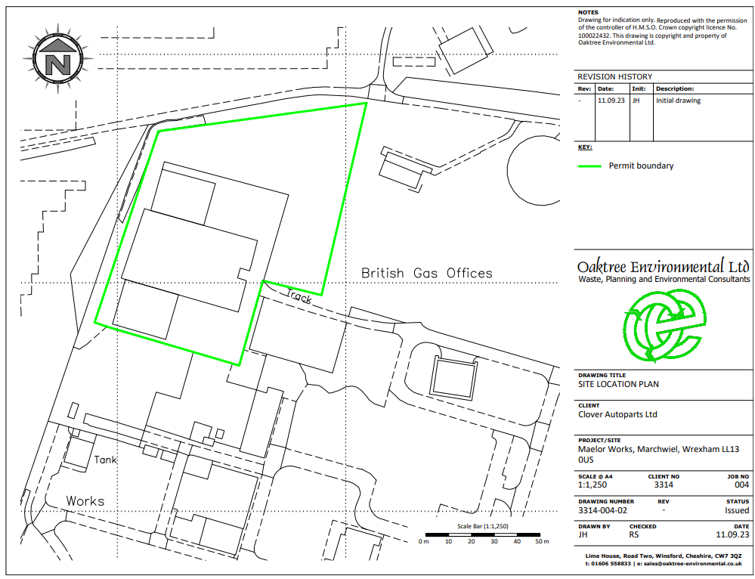

END OF PERMIT

