PAN-024951 MyMap report
Application map
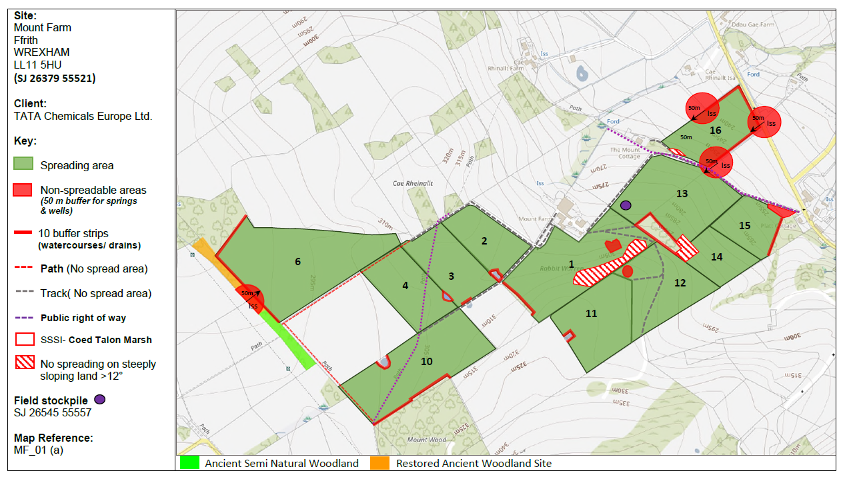
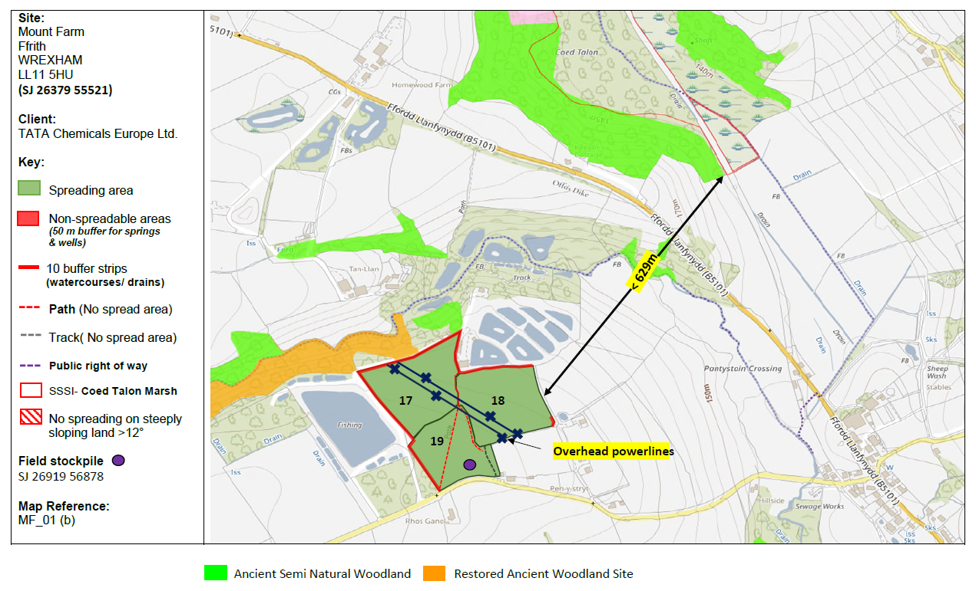

surface water courses
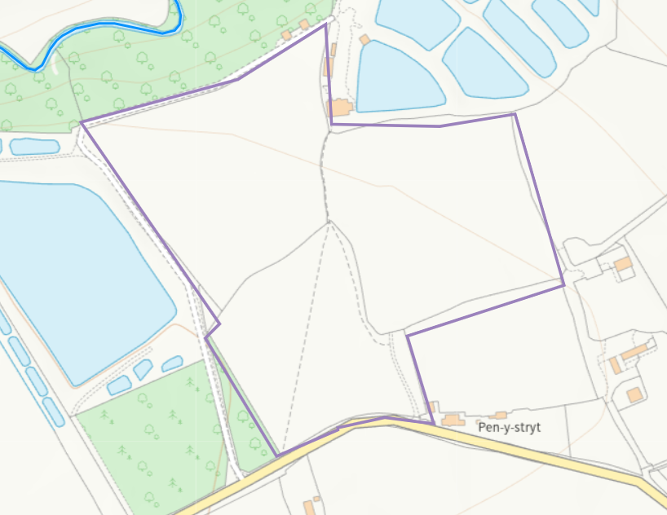
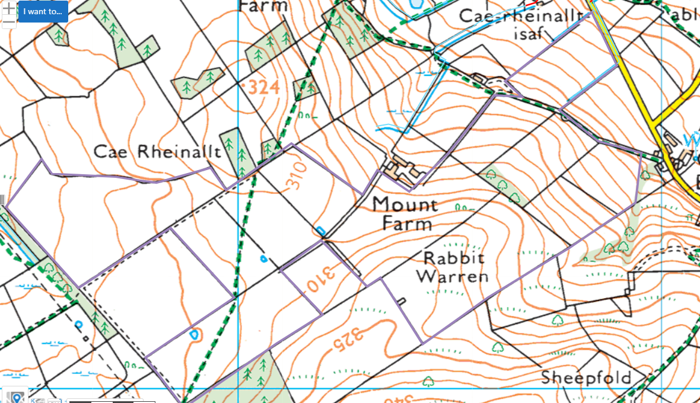

well, spring (or issue) or borehole
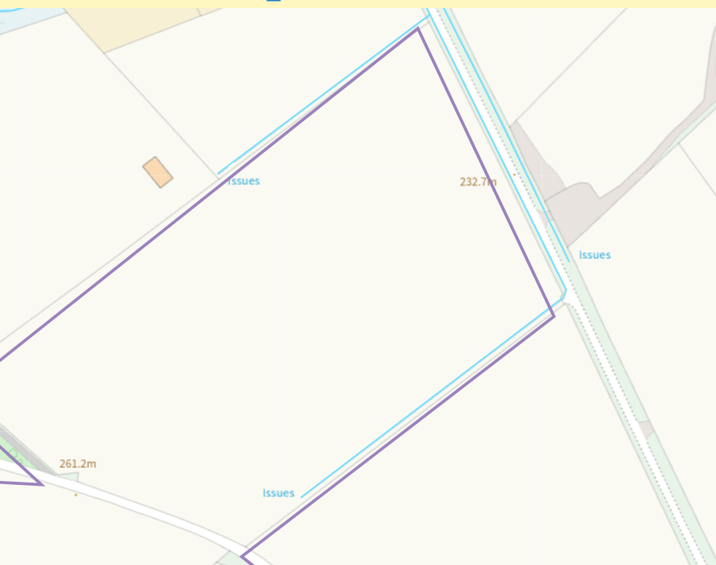
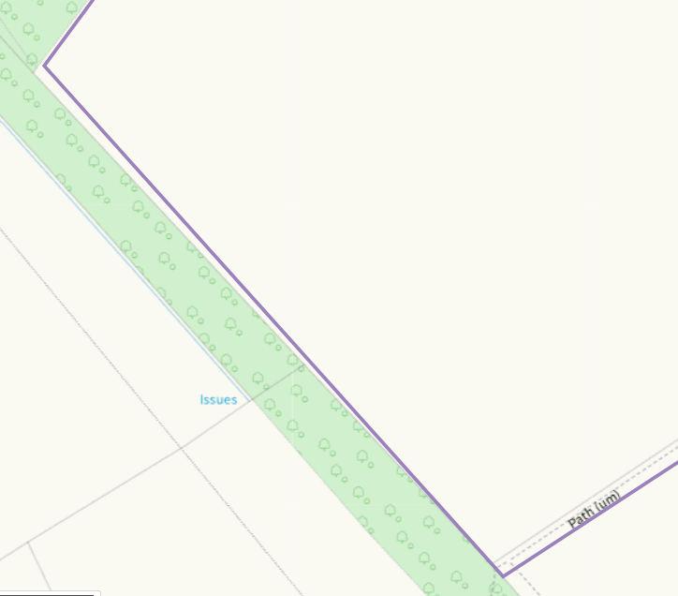

European designated sites- Natura 2000 (SPA, pSPA, SAC or cSAC) or Ramsar- or SSSI within 500m
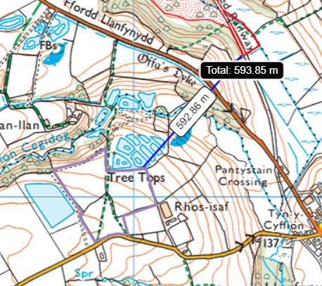

location of any public rights of way
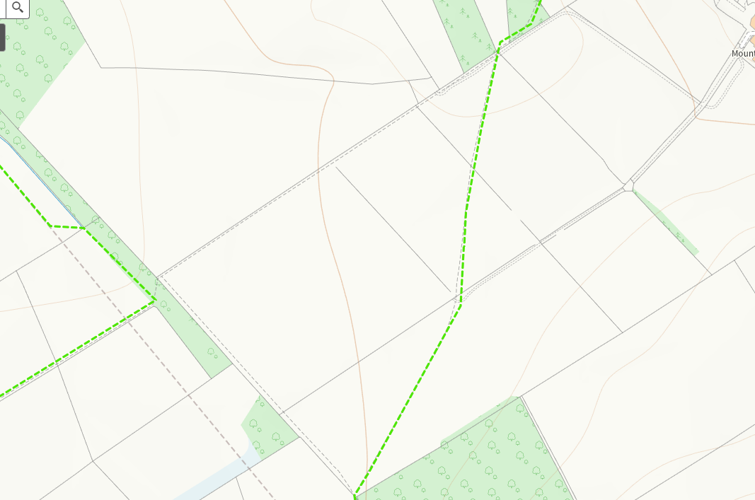
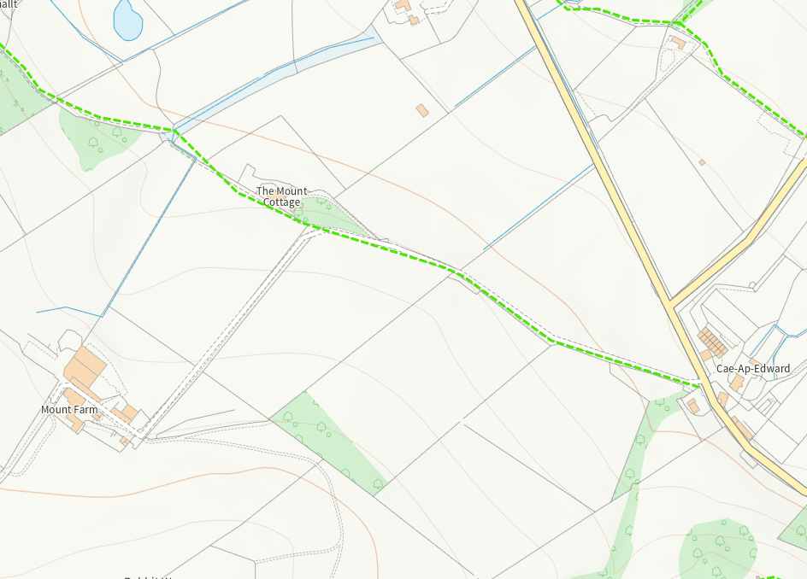
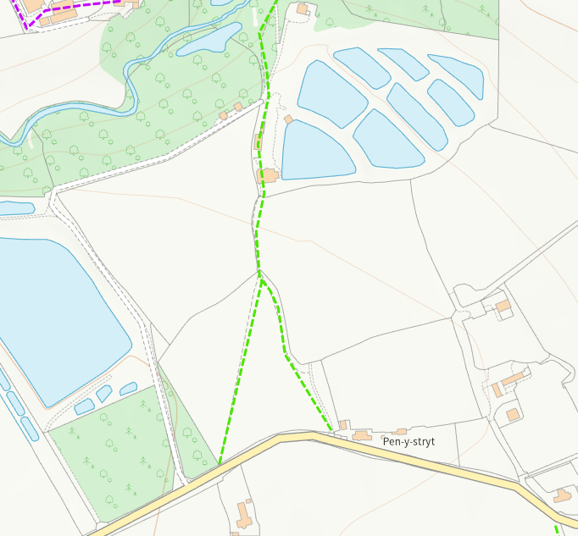

Protected Habitats
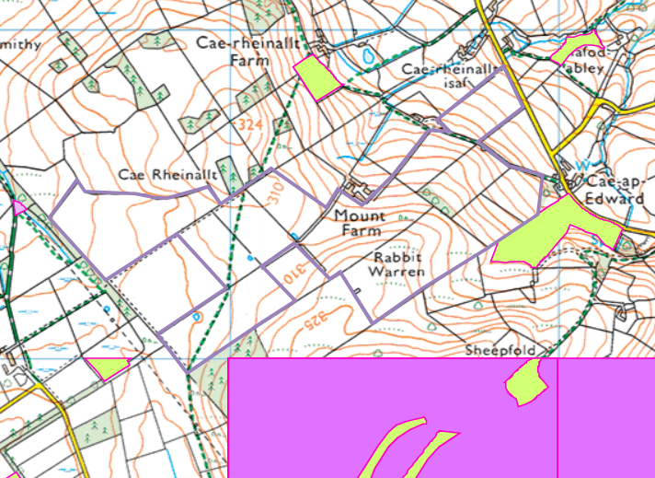
- Lowland dry acid grassland and Lowland calcareous grassland (alongside fields 14/15)
- Threatened Bryophyte (pink square to the south of the fields)

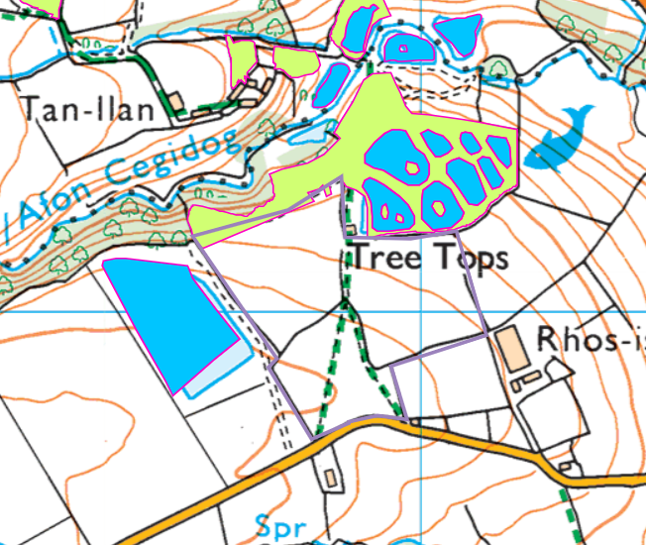
- Reedbeds (blue)
- Lowland dry acid grassland and Lowland calcareous grassland (green)

Ancient Woodlands (green and orange), Local Wildlife Sites (SINC) (blue)
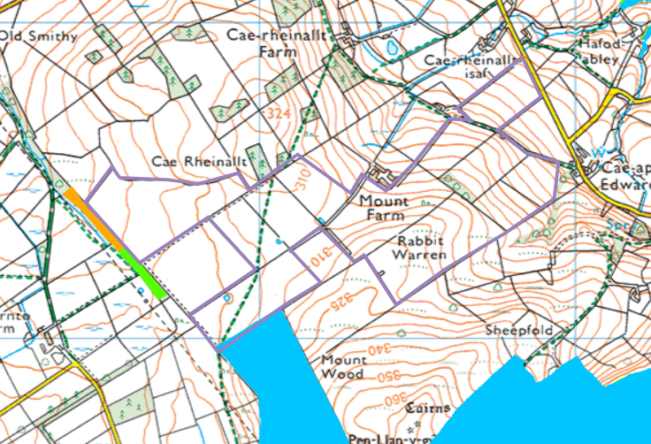
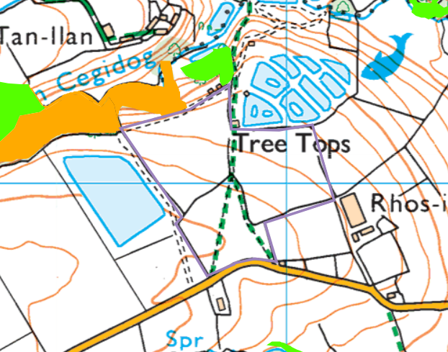
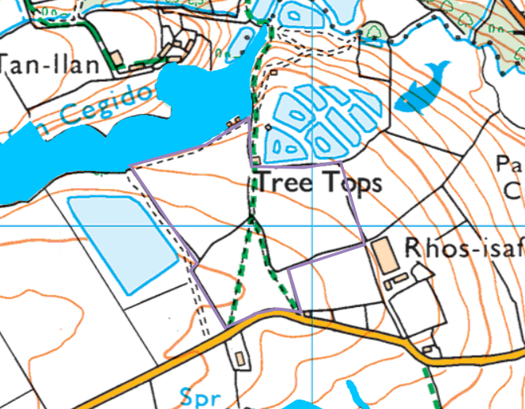

Flood risk
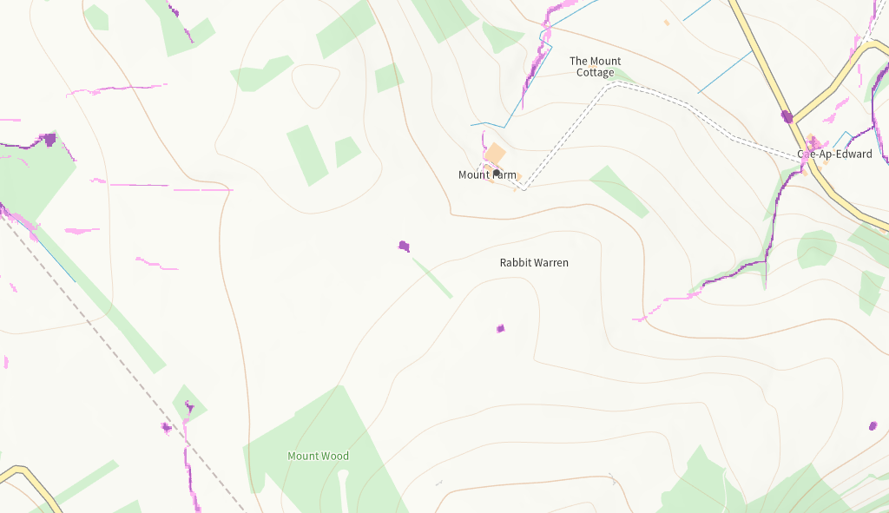
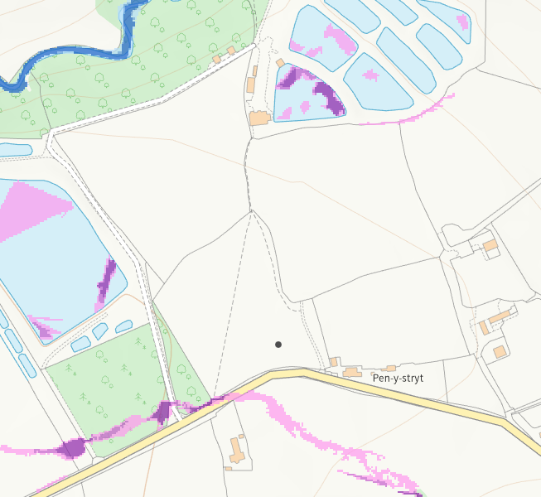

Slope
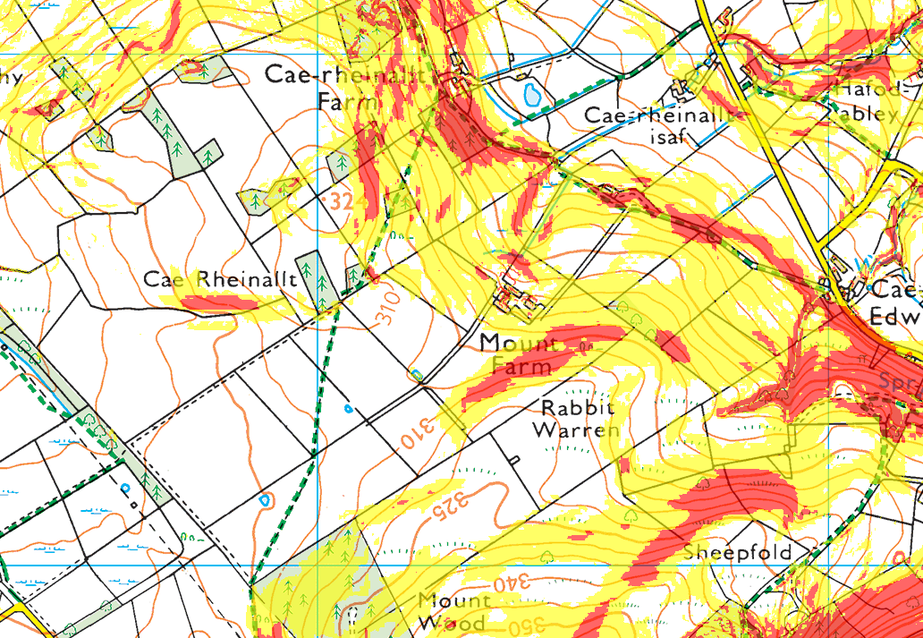
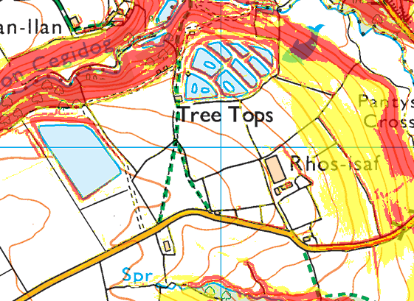
0-7 degrees (transparent)- parts of 1/6/12/13/14/15/16, all of 2/3/4/10/11/17/18/19, Storage field heap- field 19. Storage field heap at SJ 25194 56027
7 -12 degrees (yellow)- parts of 1/6/12/13/14/15/16, Storage field heap- field 13
12 degrees plus (red)- parts of 1 (no spread areas, however these do not match- RFI), 13/14/15


