PAN-025239 MyMap Report
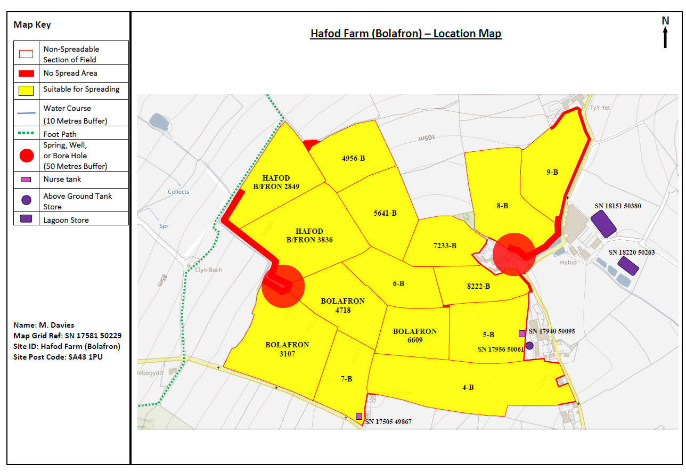

European designated sites- Natura 2000 (SPA, pSPA, SAC or cSAC) or Ramsar- or SSSI within 500m- None
groundwater source protection zones- none
Within Groundwater Safeguard Zone- none
Protected Habitats/ Section 7 species - none
Local Nature Reserve- none
National Nature Reserve- none
Ancient Woodlands- none
Local Wildlife Sites (SINC) - none
National Park- none

surface water courses
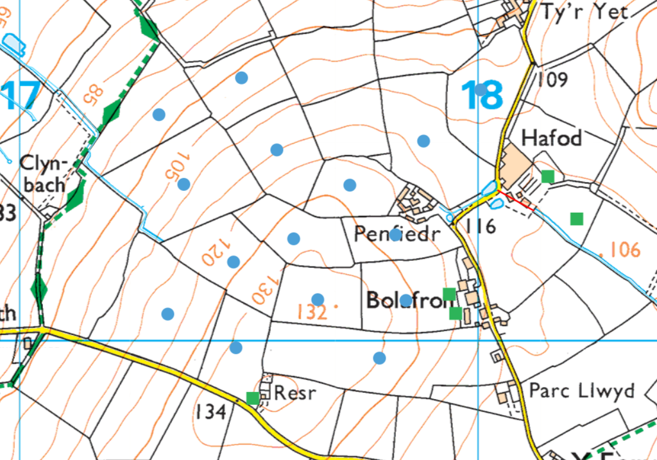
well, spring (or issue) or borehole
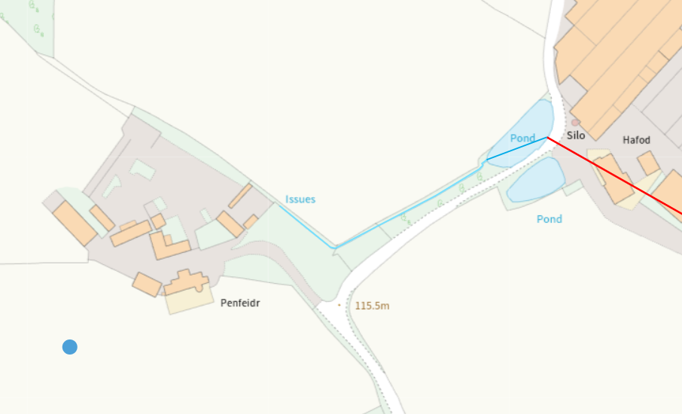
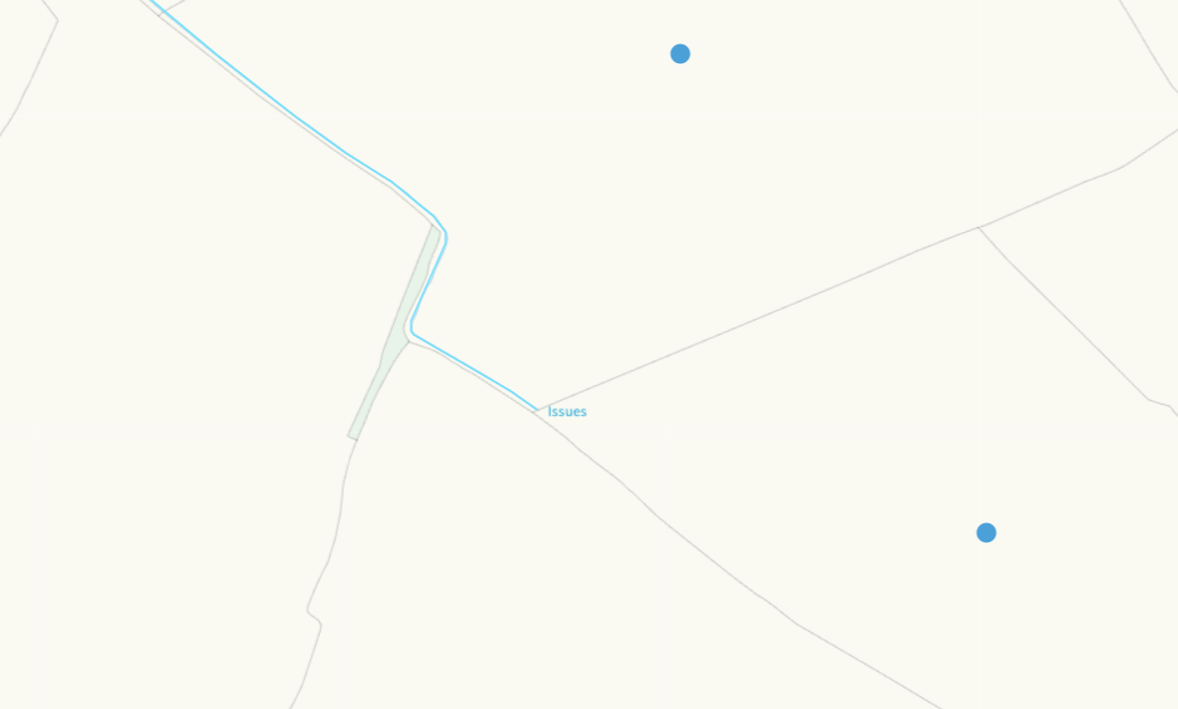

location of any public rights of way
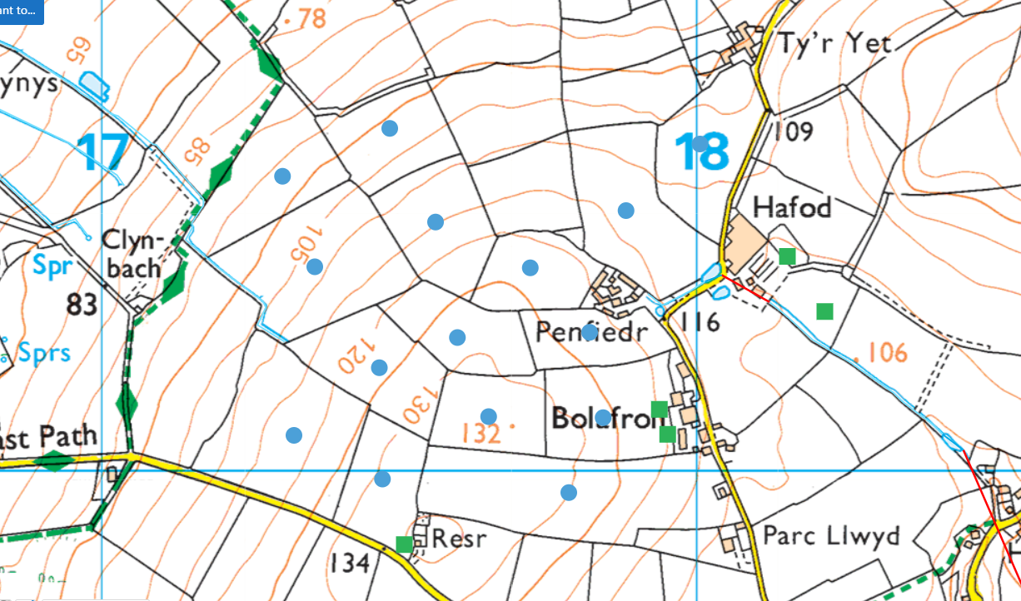
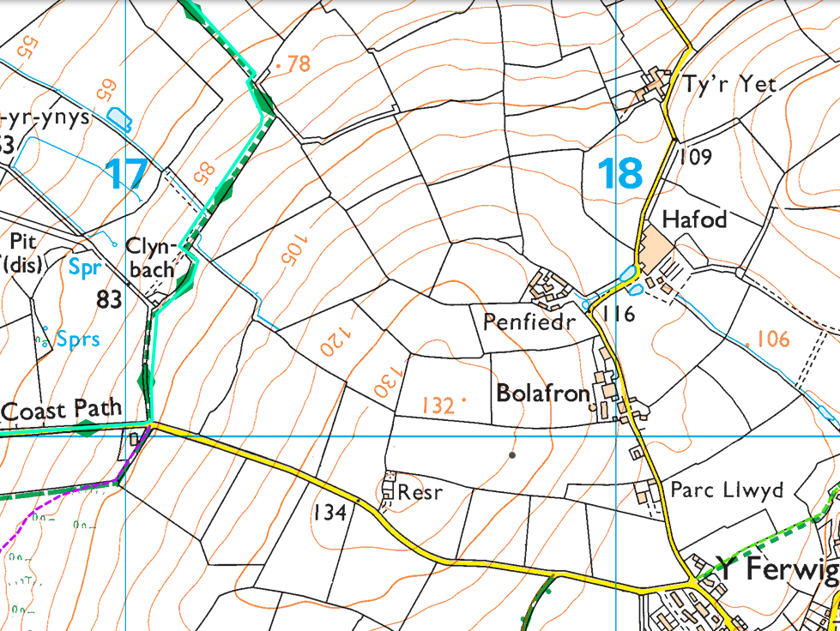
Scheduled Monument
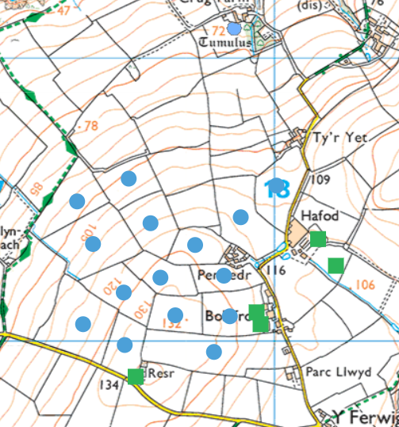

Flood risk
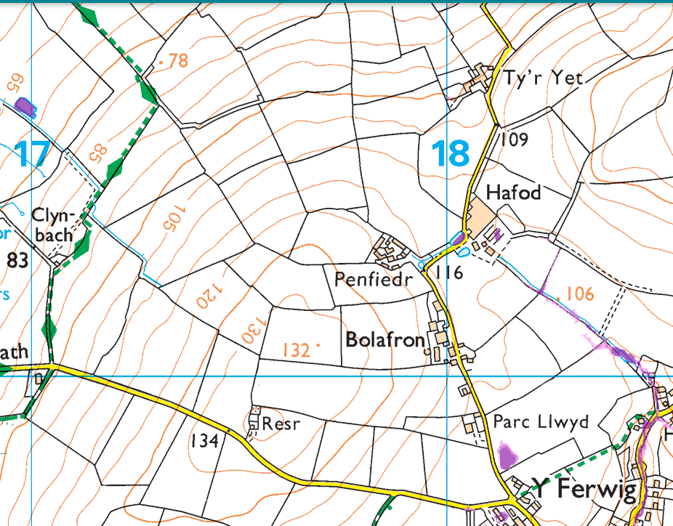
Slope


