PAN-024920 My Map Report:
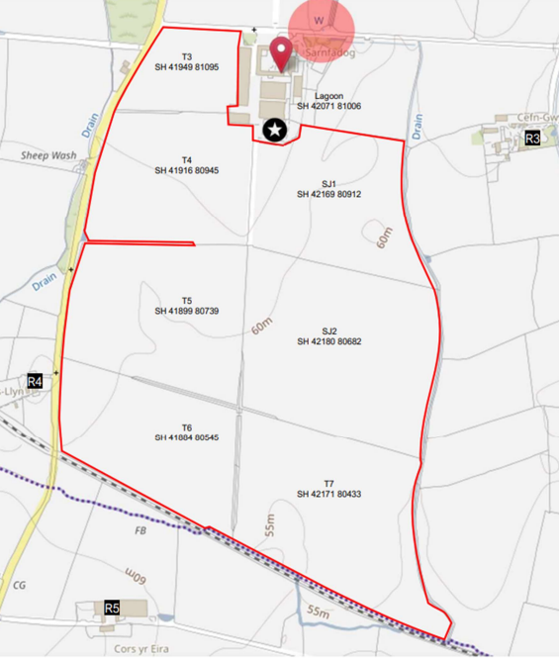
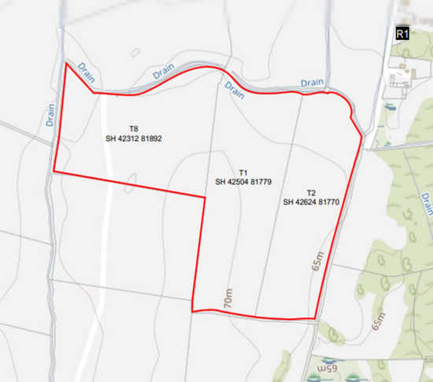
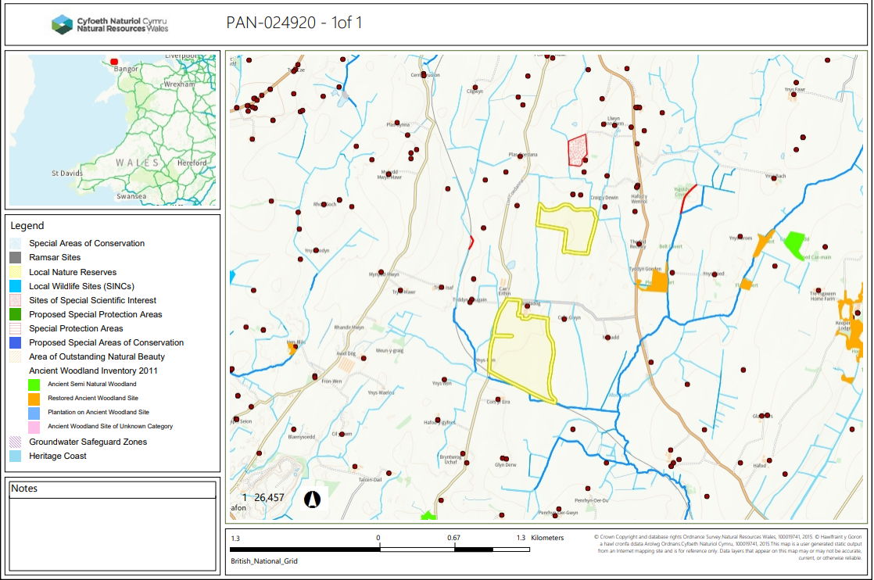

Detailed river network:
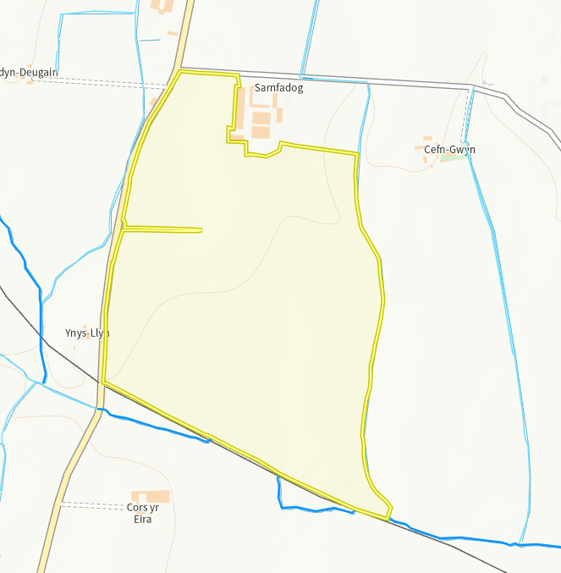
Several modified attributions run parrel to the field boundaries. There is one on both the east and west border as well as the south. None of the attributions cross into the proposed spreading areas and there is a minimum of 10m no spread buffer zone around the whole of the field perimeter to mitigate any runoff.

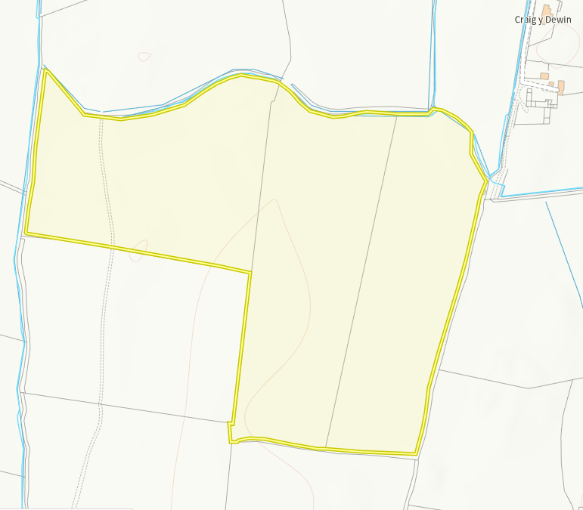
There are two drains running along the top of all fields as well as down the west side of field T8. In addition, there are a number of modified attributions all of which stem from the north of field T2. None of the attributions or drains cross into the proposed spreading areas and there is a minimum of 10m no spread buffer zone around the whole of the field perimeter to mitigate any runoff.

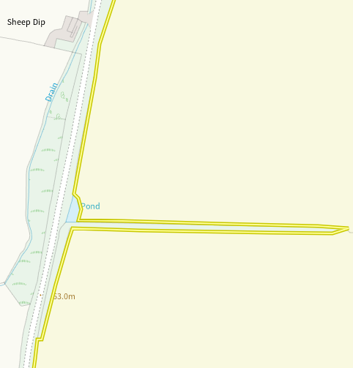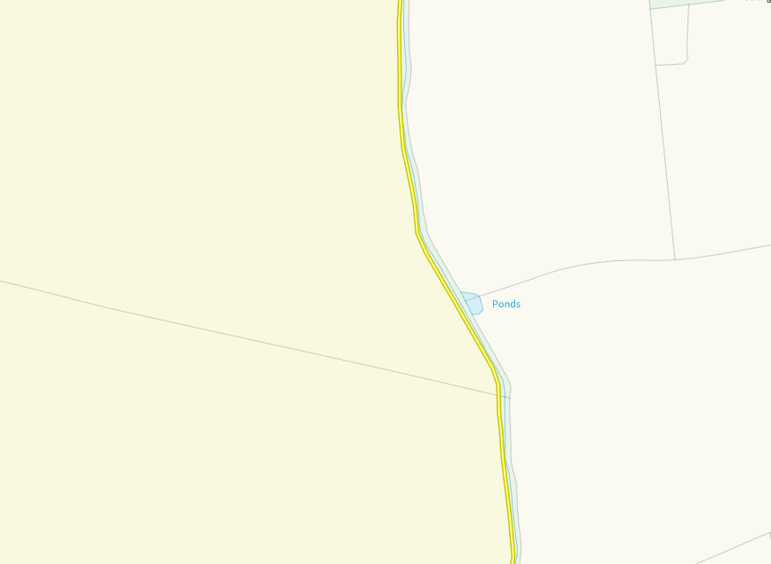
There are two ponds around the spreading area. Both are visible on the map and due to the minimum 10m no spread buffer zones implemented around the boundary of all fields there is no run off risk present.

Groundwater protection zones (source)
None in range
Wells, springs or boreholes used for the supply of water for human consumption including from a private water supply or supplies
None in range
any springs wells or boreholes not used to supply water for domestic or food production purposes within 50m

None in range

European designated sites- Natura 2000 (SPA, pSPA, SAC or cSAC) or Ramsar- or SSSI within 500m

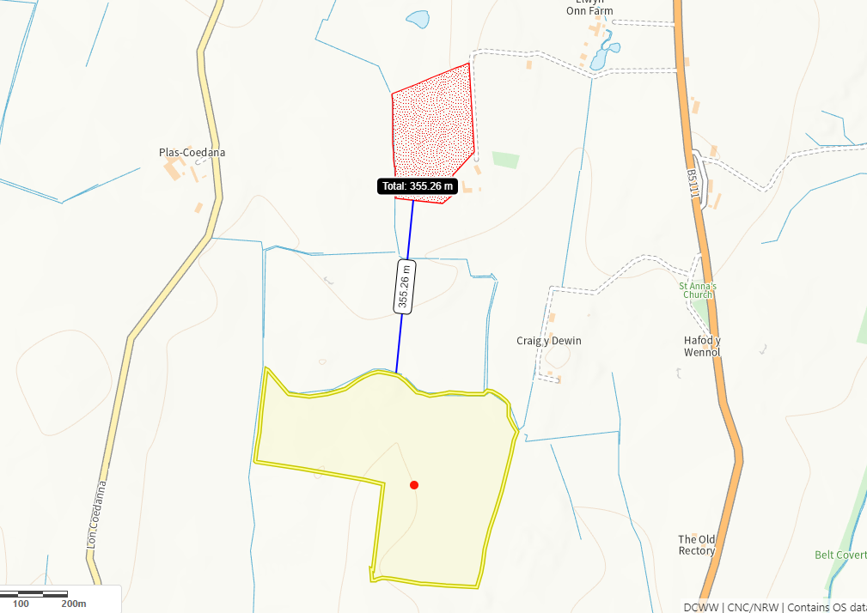
Maen Gwyn SSSI is 355m from the T1, T2 and T8. Due to the distance of this site form the spreading area and the additional minimum 10m no spread buffer implemented on all fields borders, no impact pathway is perceived.
Other protected sites:
- Protected Species-
None in range
- Protected Habitats-
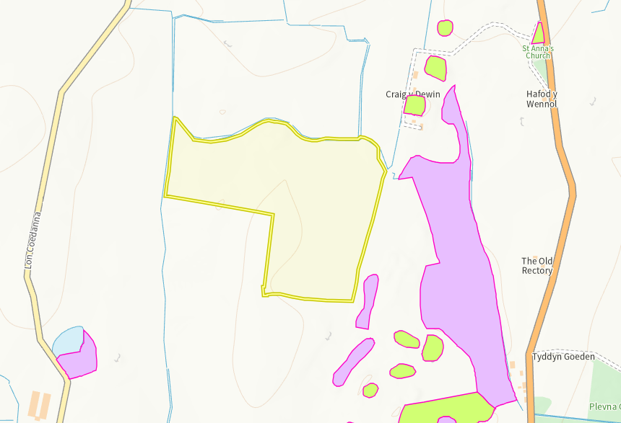
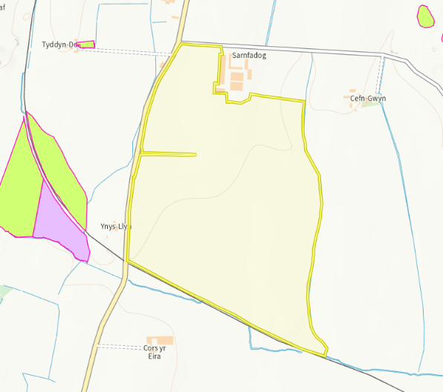

There is areas of Purple moor grass and rush pastures (purple) and Lowland dry acid grassland and Lowland calcareous grassland (green) in close proximity to both T2 and T5 and T6. None of the protected habitats cross into the spreading area and due to the distance from the spreading area, no impact pathways are perceived.

- Scheduled Ancient Monument-
None in range
- Local Nature Reserve
None in range
- National Nature Reserve-
None in range
- Ancient Woodlands-
None in range
- Local Wildlife Sites (SINC)-
None in range
- National Park-
- None in range
- Nitrate Vulnerable Zone (NVZ)-
- None in range
- Groundwater Safeguard Zone-
- None in range
- ANOBs
- None in range
- Heritage coast
- None in range
- World Heritage Sites
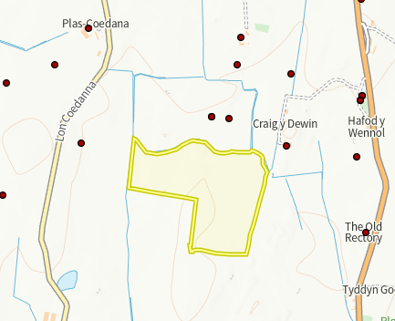
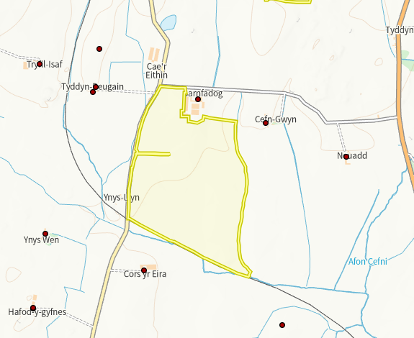

There is several post medieval and medieval, churches, farms and sites surrounding both fields. None of the sites are in the spreading area. No action required.

- Hedges, Ditches
All appropriately mapped
- Local residents
All appropriately mapped and identified as sensitive receptors.
- Housing, schools, Workplaces, Recreational facilities
None in range

Slope Map
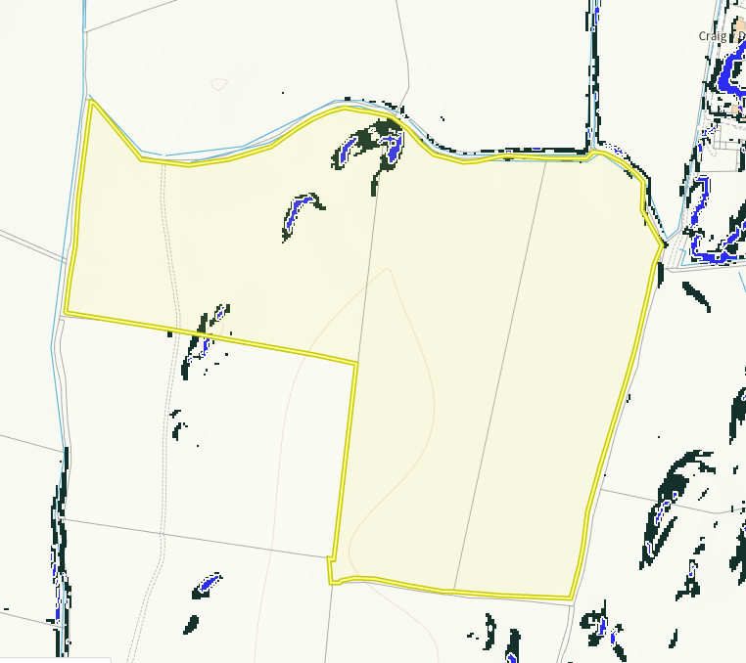
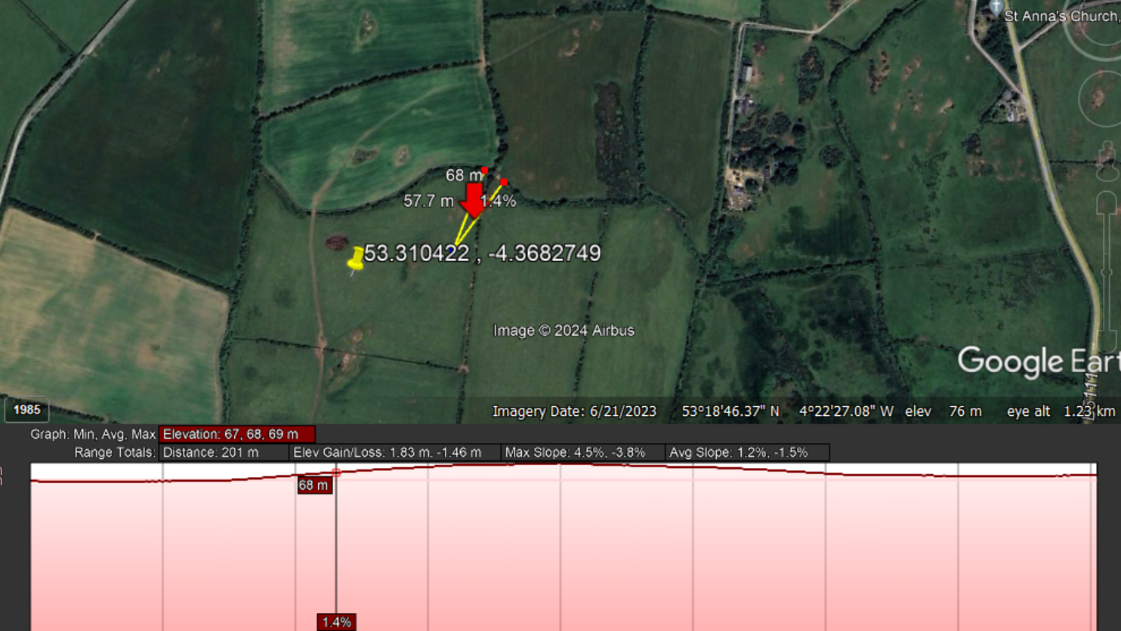

There are areas of 12 degrees plus slope in fields T8 and slightly at the top of T1 shown in blue, with areas of 7-12 degrees shown in black predominantly in field T8. Due to the 10m no spread buffer zone implemented at the border of all fields and lack of any sensitive receptors directly adjacent, no action required.
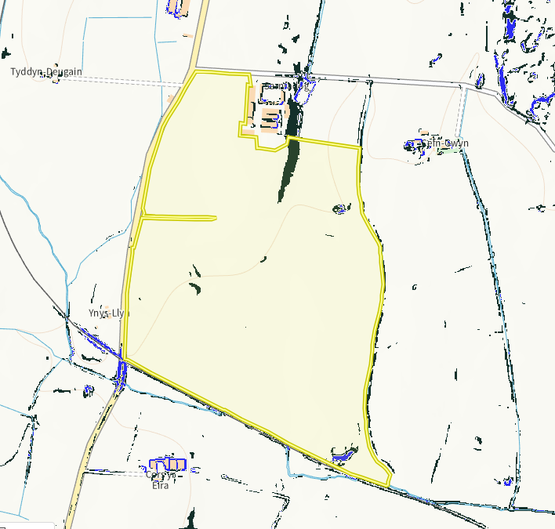
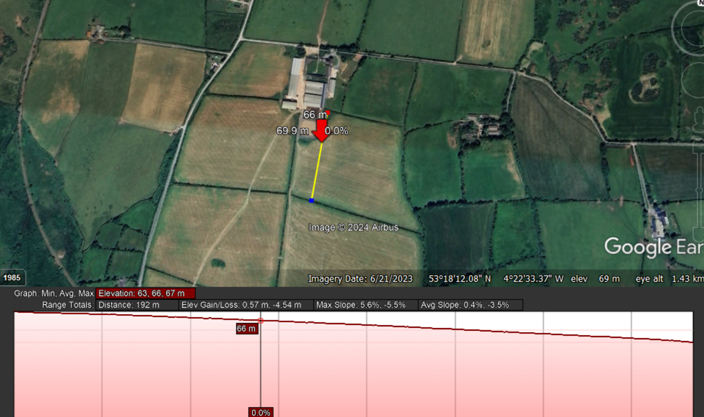
There are areas of 12 degrees plus slope at the bottom of T7 and SJ1 shown in blue, with areas of 7-12 degrees shown in black predominantly in field SJ1, T7 and T5. Due to the sloping being mainly contained in the fields, the area of sloping in SJ1 sloping into the field and the 10m no spread buffer zones on field boundaries. No action required.

Flood risk
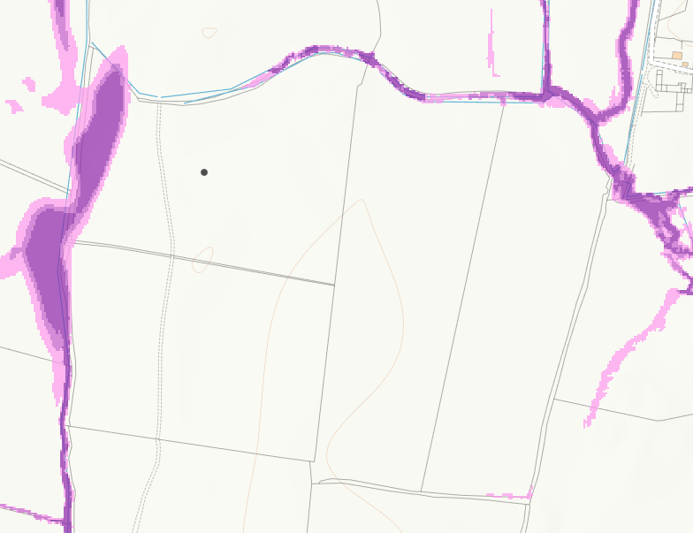
There are areas of high (dark purple) and medium (light purple) flood risk from surface water and small watercourses in some of the spreading area of T8 and along the top border of T1 and T2. There are 10m no spread buffer zones on the border of the fields and the ABS states spreading operations will not be carried out in heavy rain or when heavy rain is forecast, which would mitigate any flooding risk.

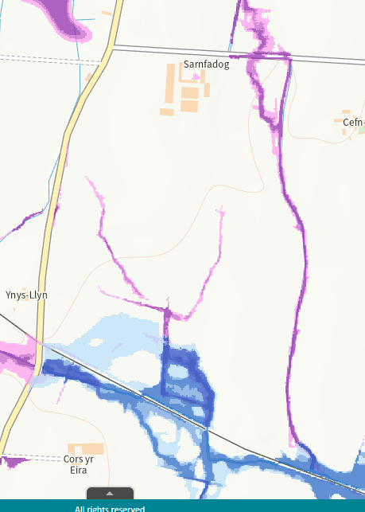
There are areas of high (dark blue), medium (lighther blue) and low (lightest blue) flood risk from surface water and small watercourses in large sections of T6 and T7. There is also some flood risk again high (dark purple) and medium (light purple) seen at the top of SJ1 and T5 and SJ2. There are 10m no spread buffer zones on the border of the fields and the ABS states spreading operations will not be carried out in heavy rain or when heavy rain is forecast, which would mitigate any flooding risk.

