APPLICATION FOR A MARINE LICENCE FOR MARINE WORKS

Marine Works include, but are not limited to, coast defences, beneficial uses of dredged materials, subsea cables, pontoons, jetties, land reclamation, grab samples and outfall pipes under the Marine and Coastal Access Act 2009

Please read the notes carefully before completing the form.
- The Marine Licensing Team (MLT) administers Part 4 of the Marine and Coastal Access Act 2009 on behalf of the Licensing Authority, the Welsh Ministers.

- The completed application form must be accompanied by a location plan and, where appropriate, descriptive drawing(s) and any supporting environmental assessments. One completed hard copy of the application and supporting documents will always be required. Additional copies are required for consultation purposes.

  - For application and supporting documents less than 10MB we can accept an additional copy via email.
  - For applications larger than 10MB 16 additional copies in CD/DVD format will be required
  - When applications and supporting documents are hard copy only 16 copies will be required.

- Please submit applications to the Permit Receipt Centre via the details at the top of this form

- Please submit marine licence applications, including this form and all supporting documents, at least 4 months before the licence is required.

Some projects may raise matters that require a significantly longer time for consideration. These are most likely to be:

  - Projects that fall within The Marine Works (Environmental Impact Assessment) Regulations 2007 – as amended requiring an Environmental Statement
  - Large scale projects with substantial volumes of material being deposited or excavated
  - Works requiring an Appropriate Assessment to be conducted under The Conservation of Habitats and Species Regulations 2017.

- Information should be provided about the anticipated duration of the entire project in respect of works below/seaward of Mean High Water Spring (MHWS). Where appropriate, planned phasing of the work for which consent is sought must be detailed. For projects lasting more than one calendar year, planned phasing details must be given for each 12 month period.

A licence fee is payable in respect of an application. Details of fees can be found on our web pages.

Please note applications will not be processed without the correct relevant fee or invoicing details.

- Payments can be made via Cheque, BACS or credit/debit card.
- Cheques should be crossed and made payable to Natural Resources Wales.
- For BACS payments ensure you provide the reference number (not remittance number)
- For credit/debit card payments please complete the CC1 form and submit with the application. The CC1 form can be found on our web pages

Further information on payment methods can be found on our web pages

- All activities need to comply with the Water Framework Directive (WFD). The framework and guidance can be found on the Natural Resources Wales website, http://naturalresources.wales. The results of your WFD assessment must be attached to your marine licence application.

- Please answer all questions. If any information is not available at the time of application please indicate in the relevant section, giving reasoning in a covering letter. Outstanding details must be submitted as soon as possible. Any delay in forwarding details is likely to result in delays in determining your application.
Your application may not be considered complete and therefore not processed until key information has been submitted. Your application may be returned if you fail to submit outstanding information within given timescales.

- Please note any licence may have conditions that must be discharged before works can commence. This will take additional time.
- If you have any queries with regards to completing this application please contact the MLT: marinelicensing@naturalresourceswales.gov.uk

How your application will be processed by the MLT:

- Submit all application to the Permit Receipt Centre via the details at the top of this form.

- Checked and acknowledged by the MLT within 21 days of receipt of application and payment
- If the application is complete and no further information is needed at this time, your application will be placed in a work queue to be assigned a permitting officer

- If the application is not complete, further information will be request and need to be provided before the application can be considered as complete
- Our 4 months service level for determining non-EIA applications will begin from the date the completed application is received (Please note some projects may take significantly longer than 4 months to determine due to their nature)

- EIA projects may take significantly longer due to their scale and complexity. Therefore we encourage early engagement with the MLT
- Your application and supporting documents will be sent to for an initial consultation period of 28 days (42 days for EIA projects)
- For the majority of projects, a public notice must be advertised. Public consultation will be 28 days (49 days for EIA projects).
For EIA projects a second public notice will be required. The MLT will advise on how this should be done.
- Responses to consultation will be considered and additional information requested at this time, if necessary.
- A decision on your Marine Licence Application will be made

All information submitted may be referred to within a licence, therefore all works must be in accordance with this information, unless otherwise agreed with NRW acting on behalf of the Licensing Authority during the determination process.

It is the responsibility of the applicant to obtain any other consents/authorisations that may be required.

Application Form Structure
- Project Description and Cost
- Applicant Details
- Details of Agent, Contractor, Vehicles and/or Vessels used to carry out works
- Environmental Impact Assessment (EIA)
- Licensable Period
- Project Description
- Methods Statement
- Materials of Project
- Beach Replenishment, Land Reclamation or Salt Marsh Feeding
- Temporary Works
- Dredge and Disposal of Dredge Material
- Protected Sites
- Other Consents
- Statutory Powers
- Public Register
- Application Fee
- Declaration

Check List
Please ensure that you have included all the necessary information before you submit you application. If any of the below are not completed in the application form, the application is likely to be considered incomplete and may be returned to you

Item | Yes (√)
The applicant is a legal entity? | y
The declaration is signed by the applicant? | y
Is the application fee correct? | y
Are the grid references/coordinates correct? | y
Do the coordinates match map locations? | y
Have all the relevant supporting documents been submitted? | y
Has a clear methodology been provided in the application form? | y
Has Protected sites information been included? | y
Has a Water Framework Directive (WFD) assessment been submitted?
Are all the continuation sheets for application questions appended with correct corresponding numbers? | n/a

Should you have any queries regarding you application please contact the MLT via marinelicensing@naturalresourceswales.gov.uk
- Project Description and Cost

1 (a). Project Name
Pre-Consents Geotechnical Surveys in the Celtic Sea

1(b). Please provide a brief description of the proposed project, including location
The Crown Estate (COMPANY) wishes to lease areas in the Celtic Sea for offshore windfarms, to support the transition to renewable energy. The COMPANY will commission geotechnical surveys during the leasing round to provide baseline data to developers early in the development cycle. The purpose of doing the surveys pre-consent is to reduce the uncertainty, and hence risk for developers, and to expedite the Final Investment Decision and Commercial Operations Date of the wind farm.

Geotechnical surveys will be undertaken in two Project Development Areas (PDAs) in Welsh waters (Figure 1).

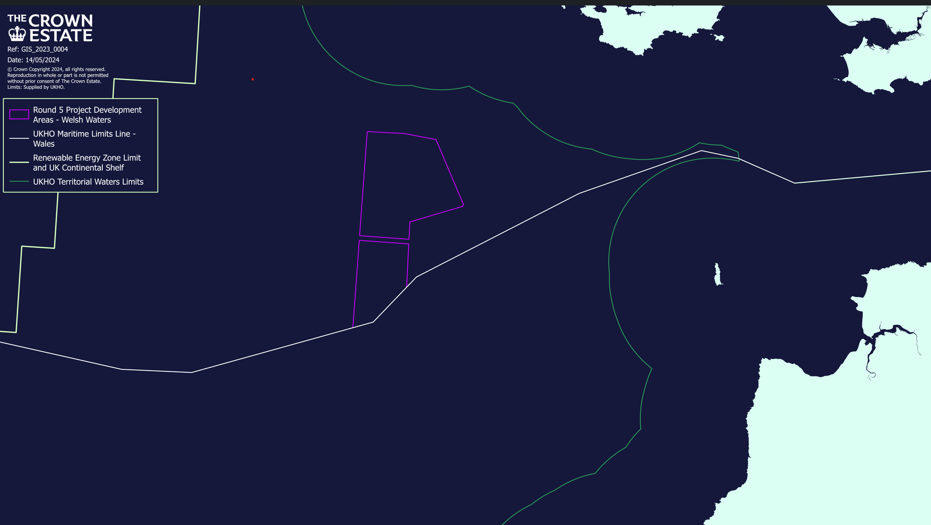

1(c). Please provide an estimated gross cost of the project (Inc. materials and labour) for works that fall below/seaward of Mean High Water Springs (MHWS)

Redacted

Applicant Details

To whom the licence will be issued. This must be a legal entity such as an individual, registered company/ charity or public body.
Rachel Holmes
Title Dr Full Name

Company or Trading
Name
The Crown Estate UK Limited
05952425

Company Registration
Number (if applicable)

Name of Contact or
individual (if different)
Marine Consents Manager
Position in Company

154 Cowley Road, Oxford, Oxfordshire
OX4 1UE

Address inc. postcode
(provide registered
Company address if
applicable)

Telephone Number
+44 7825 783467

rachel.holmes@thecrownestate.co.uk

Email Address
- Details of Agent, Contractor, Vehicles and/or Vessels used to carry out works

3(a). Agent Details

This is who we will correspond with unless otherwise informed. If no agent we will contact the applicant.

Title Full Name

Company or Trading
Name

Company Registration
Number (if applicable)

Name of Contact or
individual (if different)

Position in Company

Address
(Inc. postcode)

Telephone Number

Email Address

3(b). Does the Applicant wish to be included in all correspondence? Yes ☒ No ☐

3(c). Contractor Details

In order for contractors to benefit from the licence permission, details must be provided.

Any details not provided with application must be confirmed before operations commence.

Contractor Company or Trading Name | Address
Fugro GB Limited | Fugro House, Hithercroft Road, Wallingford, OX10 9RB

3(d). Will the works require the use of vessels? Yes ☒ No ☐

3(d) (i).Vessel Details (if applicable and available)

In order for contractors to benefit from the licence permission, details must be provided.

Any details not provided with application must be confirmed before operations commence.

Operator | Name of Vessel | Type of Vessel | Vessel Registration Number | Country of Registration
Solstad Offshore | Normand Mermaid | Subsea Survey/Supply Vessel | IMO 9249348 | Norway

3(e). Will the works require the use of vehicle? Yes ☐ No ☒

3(e) (i). Vehicle Details (if applicable and available) to be used below MHWS

In order for contractors to benefit from the licence permission, details must be provided.

Any details not provided with application must be confirmed before operations commence.

Operator | Type/Description of Vehicle

3(f). If the contractor or vessels or vehicles are not known at the application stage, when do you expect to provide these details?

These details will need to be confirmed prior to the licence and operations commencement

- Environmental Impact Assessment (EIA)
Certain projects, due to their scale, location and/or nature, may require an EIA under the Environmental Impact Assessment Directive (Directive 85/337/EEC – as amended). If a project qualifies under EIA, an Environmental Statement (ES) must be prepared and submitted with the application.
Projects that fall within Annex I of the Directive automatically require an EIA. Projects that fall within Annex II of the Directive are assessed on a case-by-case basis for the requirement for an EIA to be undertaken.

4(a). Do you consider the works to be under the Environmental Impact Assessment Directive (Directive 85/337/EEC – as amended)? Yes ☐ No ☒

4(a) (i) If Yes, which Annex does the proposal fall under? Annex I☐ Annex II☐

4(a) (ii) Which number(s) within the Annex does the proposal relate to?

4(b). Have you applied for a screening or scoping opinion from the MLT under the Marine Works (Environmental Impact Assessment) Regulations 2007 (as amended)? Yes ☐ No ☒

4(b) (i). If Yes, please provide the reference number

4(c). Has an Environmental Impact Assessment been undertaken? Yes ☐ No ☒

4(c)(i).If Yes, has an Environmental Statement been submitted to support this Marine Licence application? Yes ☐ No ☐

4(d). If an Environmental Impact Assessment has been undertaken, but an ES has not been submitted, please provide an explanation

Please continue on a separate sheet if necessary. Please tick if you have done this ☐

- Licensable Period

Determination of applications will be based on the works taking place during these dates. Please ensure you have included an adequate contingency period. If works are not completed by the Requested Licence Expiry Date you may be required to submit a new application. Including a contingency period within your original application does not impact on Licence Fee
30th September 2024
1st July 2024

Start Date Requested Licence Expiry Date

Please ensure you submit your application for a Marine Licence at least 4 months prior to the intended start date. Some projects, such as EIA projects, will take significantly longer to determine.
- Project Description

6(a). Please give a description of the proposed project.
This should include the purpose of the project, estimated timescales of construction and operation, and broken down by the phases of works, if applicable.
Details should include, but not be limited to, dimensions of project, quantity of material being deposited and removed.

The purpose of the geotechnical campaign is to provide an overview of the ground conditions near surface and at depth across the site.

Start Date: 1st July 2024 End Date: Estimated 19th August 2024
Hard stop: 30th September 2024.

The vibrocore footprint is 2.4 m x 2.8 m and the approximate volume of each sample is 0.5334m3 (depending on penetration & due to soil conditions). Each vibrocore will take around 1.5 hrs.

The cone penetration test (CPT) instrument footprint is 3x3m. Each CPT will take 2hrs. Each thermal test will take 1.5 hrs. Up to 80 locations are to be sampled/tested using geotechnical methods.

There is no direct interaction with any Marine Protected Area. The Project Development Areas are over 200m from any MCZ.

Please continue on a separate sheet if necessary. Please tick if you have done this ☐

6(b). Please detail the location of the proposed construction project.
This should be either Ordnance Survey National Grid Reference (i.e. AB 12345 67890) or Latitude and Longitude in decimal degrees to 4 decimal places (i.e. Lat 52.1234 Long 4.1234), defining the extent of the project. Please specify which coordinate system has been used.

The PDAs lie within Welsh waters, whose coordinates are provided in Table 1, with latitude and Longitude in decimal degrees to 4 decimal places.
OBJECTID * | PDA | Longitude | Latitude
1 | 1 | -5.6176 | 51.2320
2 | 1 | -5.6176 | 51.2221
3 | 1 | -5.7692 | 51.2242
4 | 1 | -5.7688 | 51.2341
5 | 1 | -5.7681 | 51.2548
6 | 1 | -5.7622 | 51.4254
7 | 1 | -5.6486 | 51.4254
8 | 1 | -5.5497 | 51.4167
9 | 1 | -5.5495 | 51.4167
10 | 1 | -5.5493 | 51.4164
11 | 1 | -5.5493 | 51.4164
12 | 1 | -5.5474 | 51.4139
13 | 1 | -5.5474 | 51.4138
14 | 1 | -5.5399 | 51.4039
15 | 1 | -5.5398 | 51.4038
16 | 1 | -5.5213 | 51.3795
17 | 1 | -5.5203 | 51.3781
18 | 1 | -5.5188 | 51.3761
19 | 1 | -5.4612 | 51.3010
20 | 1 | -5.4611 | 51.3010
21 | 1 | -5.4584 | 51.2974
22 | 1 | -5.4571 | 51.2957
23 | 1 | -5.4569 | 51.2955
24 | 1 | -5.4558 | 51.2940
25 | 1 | -5.4581 | 51.2905
26 | 1 | -5.6176 | 51.2555
27 | 1 | -5.6176 | 51.2398
28 | 1 | -5.6176 | 51.2320

Please continue on a separate sheet if necessary. Please tick if you have done this ☒

6(c). The following must be provided with the completed application form:

- a suitably scaled extract of an Ordnance Survey Map or Admiralty Chart with location of project, complete with North Arrow and Scale See Figure 2
- construction plans and sectional drawings showing those proposed works below/seaward of MHWS, which should give details of the materials to be used (for beach replenishment the quantity, particle size and source of material to be deposited and deposit location is also required). Not applicable

- a descriptive schematic drawing and suitably scaled location plan which show the full extent of the project clearly in relation to the surrounding area and features. Not applicable

Please list below all supporting documents that have been submitted with this application, including suitable documents/maps/drawing titles and reference numbers

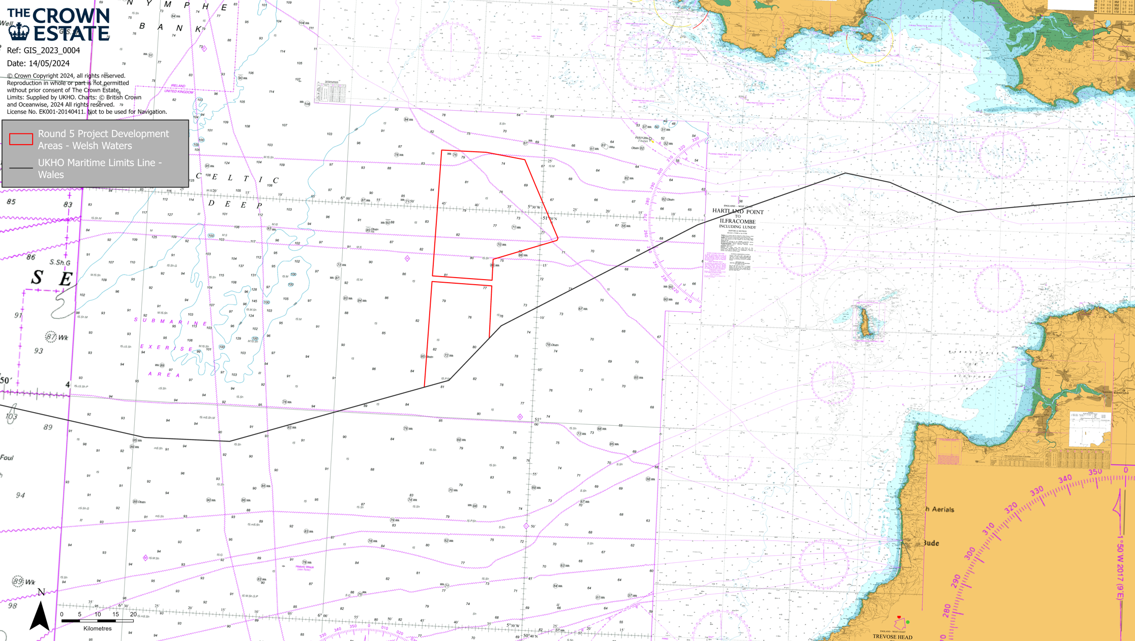

Figure 2 Admiralty chart with location of PDAs

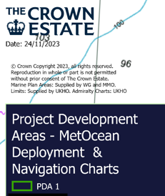

Please continue on a separate sheet if necessary. Please tick if you have done this ☐

The applicant should note that these drawings/plans may be copied to others as part of the MLT's consultation procedures. If they are subject to copyright, it is the responsibility of the applicant to obtain the necessary approvals to reproduce the documents and to submit up to 16 copies with the application.

- Methods Statement

7(a). Please provide a detailed method statement for the works
This must include methods for all works including temporary structures or deposits such as jetties, cofferdams, moorings or landing stages to be constructed seaward of MHWS

See attached documents

Method Statements:

Fugro: High Performance Corer (HPC) Launch and Recovery onboard MV Normand Mermaid Procedure | EUAF-FNLM-NMM-PR-004 | Issue 05

Fugro: SEACALF® MKV Launch and Recovery Procedure onboard Normand Mermaid Procedure | EUAF-FNLM-NMM-PR-003 | Issue 05

Equipment Specifications:

Fugro: Seacalf® mkiv – continuous drive
Fugro: High performance corer

Please continue on a separate sheet if necessary. Please tick if you have done this ☒

7(b). Do you intend to undertake activities that could generate underwater noise?

This include piling, use of explosives, geophysical, acoustic deterrent devices and multibean echosounders. Yes ☐ No ☒

7(b) (i). If Yes, what type(s) of activities will be undertaken?

7(b) (ii). If Yes, approximately how many days will the activity be undertaken for?

If Yes, you will be required to complete an additional form that will be provided.

7(c). Please state the measures to be taken to:
- Minimise risk to the marine environment
Negligible environmental impacts are anticipated. The activities to be undertaken are small scale and temporary and will result in very localised impacts. There is anticipated to be negligible impacts to mobile species including fish, marine mammals and birds.

- Prevent undue interference to others

The surveys are temporary and small scale and no undue interference to others is anticipated.

- Maintain navigational safety, including marking and lighting of works

The survey vessel will be stationary during the deployment and will display appropriate lights and/or day marks. A Fisheries Liaison Officer will be onboard. The survey vessel will adhere to the IMO convention on the international regulations for prevention of a collision at sea at all times. Given the relatively short sampling time required, the sampling activity is not expected to impact or pose any specific risk to the safety of navigation.
The Crown Estate have engaged with British, Belgian and French fishing fleets who have all been briefed on the planned survey activities and timelines. With the support of onshore Fishing Industry Representatives from the Cornish Fish Producers Organisation and offshore Fisheries Liaison Officers present onboard each survey vessel, survey locations will be promulgated to all fishing vessels known to operate within the PDA’s.
Prior to undertaking any survey work, the survey vessel will undertake reconnaissance of a survey location for the presence of fishing equipment with the support of the onboard FLO. Should fishing gear be present at the survey location, the vessel will move to an alternative site until arrangements can be made for the fishing gear to be moved.
FLO’s will actively engage with any vessels engaged in fishing activity while the survey work is underway.

Please continue on a separate sheet if necessary. Please tick if you have done this ☐

- Materials of Project

8(a). Description of materials to be deposited seaward of MHWS (Please tick all that apply)
Timber ☐ Iron/Steel ☐ Concrete ☐ Biocides/other chemicals ☐
Silt ☐ Stone/Rock ☐ Gravel ☐ Plastic/Synthetics ☐
Sand ☐ Other ☐

If other, please provide a description of materials.
Not applicable

8(b). Delivery method of materials to site
If sea delivery, please include details of vessels to be used with a chart of proposed route and transhipment area. If vehicle delivery, please provide the proposed access route.

Please continue on a separate sheet if necessary. Please tick if you have done this ☐

8(c). Will the works involve removals seaward of MHWS? Yes ☒ No ☐

8(c) (i). Description of materials to be removed seaward of MHWS (Please tick all that apply)
Timber ☐ Iron/Steel ☐ Concrete ☐ Biocides/other chemicals ☐
Silt ☐ Stone/Rock ☐ Gravel ☐ Plastic/Synthetics ☐
Sand ☐ Other ☒

8(c) (ii). Description of objects/materials to be removed seaward of MHWS
Including quantities to be removed.
Small samples of sediment will be removed for testing the volume of each sample is c.0.5334m3 and up to 80 samples will be taken.

- Beach Replenishment, Land Reclamation or Salt Marsh Feeding
For works involving any of the above, please provide the following information

9(a). Is the material to be deposited like for like to existing material? Yes ☐ No ☒

9(a)(i) If No for Beach Replenishment please provide justification why?
Not applicable

9(b). Description of material to be deposited
Please provide the grading specification of materials to be used, if using a range of grain sizes please state the percentage by weight passing. If unsure, please refer to the Wentworth Scale

Please continue on a separate sheet if necessary. Please tick if you have done this ☐

9(c). Source of the material to be deposited
Including dredged or land based stating the origin of material

9(d). Has the material been chemically analysed? Yes ☐ No ☐
If material has been analysed, we may request this information to determine the application

9(d) (i) If Yes, is the analysis data been included with the application? Yes ☐ No ☐

Temporary Works

10(a). Will there be any temporary deposits below MHWS? Yes ☐ No ☒
This includes construction materials, removed objects/material, jetties or cofferdams
If Yes, please continue with section 10

10(b). Please provide the location of temporary deposits
Please include a map/chart displaying the location of temporary deposits, if necessary.

10(c). Description of temporary deposits

Please continue on a separate sheet if necessary. Please tick if you have done this ☐

- Dredge and Disposal of Dredge Material
If you are undertaking Dredge and Disposal activities please also complete the Dredge and Disposal application form and submit together.

11(a). Do you intend to apply for a marine licence to dispose of dredged material to sea as part of the works in this application? Yes ☐ No ☒

- Protected Sites

Licensing Authorities have a duty to ensure that projects will not have significant adverse environmental impact, particularly on any designated European Site of Conservation Importance - Special Areas of Conservation (SAC) and Special Protection Areas (SPA), listed under the Habitats Directive (Council Directive 92/42/EEC on the conservation of natural habitats and of wild fauna and flora). In addition, it is Government Policy that Wetlands of International Importance (Ramsar sites) are also considered as European Sites. There is a duty to take reasonable steps to further the conservation and enhancement of nationally designated sites (Sites of Special Scientific Interest (SSSIs).

12(a). Have you had pre-application correspondence with NRW, its legacy bodies or Natural England? Yes ☐ No ☒

12(a)(i). If Yes, please provide copies of correspondence with application and state which team(s) you have contacted?

12(b). Are any part of the works located within or likely to affect a designated conservation site? (SAC, SPA, SSSI or Ramsar) Yes ☐ No ☒

12(b)(i). If Yes, which designated site(s) may be affected?

12(c). Please provide a description of all mitigation measures proposed to avoid any impact on designated conservation sites.
No specific mitigation is proposed in relation to designated sites.

Please continue on a separate sheet if necessary. Please tick if you have done this ☐

12(d). If the works are not located within or likely to affect a designated conservation site, please indicated the approximate distance to the nearest designated conservation site.
It is our view that the operations proposed will not have a likely significant effect on any SPA/SAC or Ramsar site. This conclusion is based on the type or equipment being deployed, the very small scale of impact (footprint) and distance to the nearest MPAs.

The nearest SAC is the West Wales Marine site which is over 21km away & the Bristol Channel Approaches SAC is over 23km away.
The nearest SPA is the Skomer, Skokholm and the Seas off Pembrokeshire SPA which is over 9km away.
The above sites are designated for highly mobile species.

Please note that if the proposed works are in or within 2km of a European Site of Conservation Importance you will have to provide suitable mitigation measure to avoid any impact on designated conservation sites.

- Other Consents

Please detail all consents that you have applied for or received for these works

Type of Consent | Applied for | To be applied for | Reference Number | Date of Issue and Expiry

Planning Permission under Town and County Planning Act 1990 – From Local Planning Authority (LPA)

Name and Address of LPA for location of works

Land Owners Consent such as The Crown Estate Consent

Port Authority or Local Harbour permissions

Other NRW consents such as Flood Defence or SSSI assent

Details of NRW consent

Other consents such as Transport and Works Act Order, Section 36 Electricity Act, grant/loan sanction

Details of other consents

- Statutory Powers

14(a).Does the applicant have statutory powers to consent any aspect of the project?
E.g. coast protection authority, dredging powers, statutory undertakers Yes ☐ No ☒

14(a)(i).If Yes, please give details and state the relevant legislation that gives these powers

- Public Register

Under The Marine Licensing (Register of Licensing Information)(Wales) Regulations 2011 and the Environmental Impact Assessment Directive (Directive 85/337/EEC – as amended) , all information contained within or provided in support of this application will be placed on the Public Register unless NRW approve of the applicant’s reasons for withholding all or part.

15. Is there any information contained within or provided in support of this application that you consider should NOT be included on the Public Register on the grounds that its disclosure:

15(a). Would be contrary to the interest of National Security? Yes ☐ No ☒

15(b). Would prejudice to an unreasonable degree you, or some other person’s commercial interest of those of a third party? Yes ☒ No ☐

If Yes to either (a) or (b), please provide full justification as to why all or part of the information you have provided should be withheld

The costs of the project are commercially sensitive and should not be disclosed.

Please continue on a separate sheet if necessary. Please tick if you have done this ☐

- Application Fee

16(a). What are the corresponding fee band for this application? Band 2 ☐ Band 3 ☒

16(b) Band 2 Only

Projects are charged at a fixed fee of £1920. The application will not be processed until the correct fee has been provided.

Please provide the method of payment

Method | Yes (√) | Reference Number
Cheque
BACS (not remittance no.)
World Pay (phone or CC1)
By Phone

Please attach CC1 Form with application. Can be found on our web pages

16(c) Band 3 Application only

Band 3 applications are charged at on hourly rate of £120 and are invoiced in arrears. Please complete the details below which will be required for invoicing.

Customer Name
The Crown Estate

Isabelle Hastie
FAO

Purchase order number

1 St James’s Market
St James’s
London
SW1Y 4AH

Address for invoice

Telephone Number
0207 851 5337

Isabelle.hastie@thecrownestate.co.uk

Email Address

- Declaration

I declare that to the best of my knowledge and belief that the information given in this application form and supporting documentation is true.

WARNING: It is an offence under the Marine and Coastal Access Act 2009, under which this application is made, to fail to disclose information or to provide false or misleading information and can invalidate any licence granted.

Signature 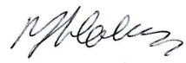 Date 14/05/2024

Name (in capitals) R.J. Holmes

Position in Company Marine Consents Manager

Applications cannot be processed unless signed by the Applicant (not agent), the applicant must have appropriate level of authority within the company.

Applications will not be processed unless signed

