This template is intended to be used in conjunction with a Band 1 Marine Licence application. Please complete each section below following the guidance provided (max 500 words per section). For any queries relating to this template please contact: marinelicensing@cyfoethnaturiolcymru.gov.uk

Summary
Please provide a brief summary of the application including location of the works (coordinates - lat/long, decimal degrees). For activities that cover a large area please provide coordinates of the approximate extent of works.

As part of the Clean Seas Environmental Monitoring Programme we have fixed survey stations in the area we are sampling in 2024 which are routinely sampled every two years. We will collect 0.1m cube of sediment at up to 50 random chosen stations using a day grab (see below map), which will be analysed in the laboratory for contaminants to ensure the UK government adheres with European Commission regulations. The results of this monitoring programme will be part of OSPAR reporting. Therefore, we have added all possible stations in the below station list. The density of grab samples will not exceed 50 samples within any one hectare. The survey will take place between the 15th and the 25th July on board the RV CEFAS Endeavour.

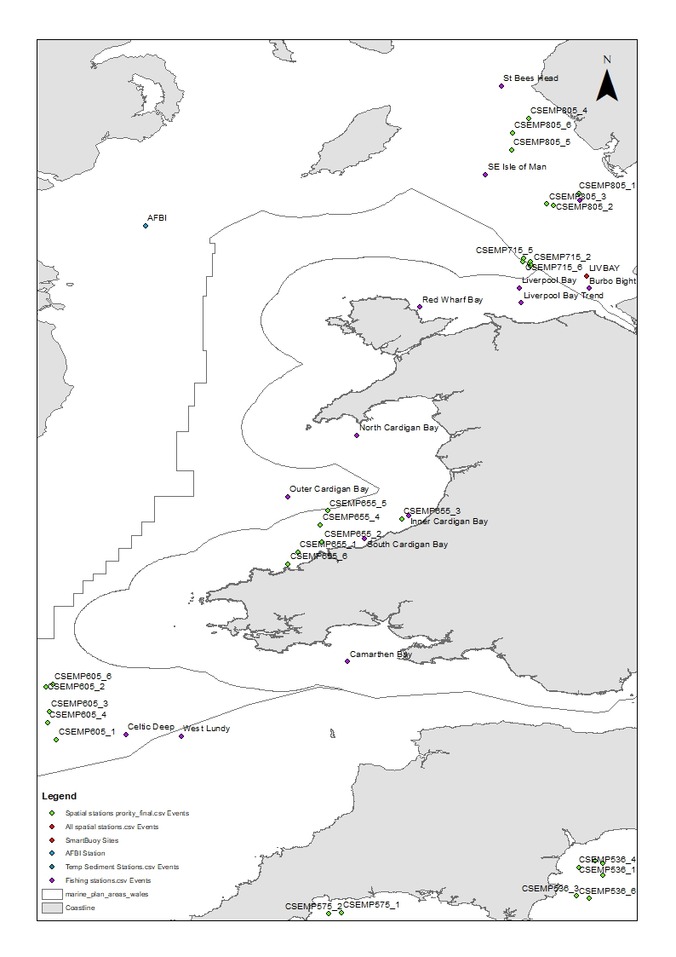

Scope of works
Please provide a full description of all proposed works including:
- Sequence of works (mobilisation, marine works, site remediation (if required))
- Estimated timing of works (duration, working hours, day/night, plus contingency)
- Plant, machinery or vessel required
- Estimated quantities (removals, deposits, construction materials)

The RV CEFAS Endeavour will sail from Portland Port between the 15th June to 25th July 2023. We will be work 24hrs operations in two 12 hrs shift patterns. The work will be carried out on the RV CEFAS Endeavour, we will deploy a day grab (see image below) from the starboard side gantry. At each site a small volume sediment (< 0.1 m3, max two replicates per site) will be removed for sediment. polycyclic aromatic hydrocarbons (PAHs), trace metal contaminants, sediment particle size analysis (PSA), marine plastics and benthic fauna. Work being undertaken to evaluate sediment contamination levels and benthic community abundance at a number of locations around the Welsh coastline. This work is being undertaken as part of Defra’s Clean Seas Environmental Monitoring Programme (CSEMP) for the purposes of OSPAR reporting. Each deployment is likely to take between 15 minutes to an hour dependant on the ground conditions. We can confirm that the total sample volume across all samples is no more than 4 cubic metres. We will only collect the minimum sediment requirements to not disturb the seabed more than absolutely necessary to carry out the research work for the UK government, no effects are anticipated from the works carried out.

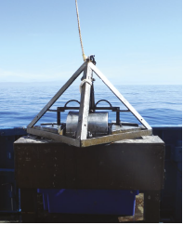
Day Grab for sediment collection

Access and working areas
Please provide details of access to the site and working areas. This should include:
- Attached map of the access/egress route and working areas (annotated aerial image and/or OS map) – N/A
- Predicted plant/vehicle movements -N/A
- Storage areas for plant, equipment and materials (if required) N/A
- Risks to navigation

As part of Defra’s Clean Seas Environmental Monitoring Programme (CSEMP), CEND1224 will be using a Benthic grab for sediment sampling for the purposes of OSPAR reporting. We can confirm that our proposed works will not pose a risk to others.

Environmental mitigation
Please list appropriate mitigation measures to minimise impacts on the marine environment these may include:
- Pollution prevention and control procedure (guidance available at: http://www.netregs.org.uk/media/1304/gpp-5-works-and-maintenance-in-or-near-water.pdf)
- Spill response kits
- Minimise plant traffic
- Designated access and egress routes
- Storage of materials (fuel, chemicals, construction waste)
- Biosecurity (guidance available at http://www.snh.gov.uk/docs/A1294630.pdf)

Note: To assist you, the following mitigation statements will be used as conditions within the licence. By signing this method statement you will be agreeing to adhere to these restrictions. If you are unable to do this, the application will not qualify as Band 1.

- All equipment, temporary structures, access tracks, waste and/or debris associated with the works will be removed on completion of the works.

- Bunding, storage facilities and spill kits will be employed to contain and prevent the release of fuel, oils and chemicals associated with the plant, refuelling and construction equipment into the marine environment.

- Plant, vehicles and machinery will not be refuelled on the foreshore.

- Coatings and treatments will be suitable for use in the marine environment and are used in accordance with best environmental practice.

- All equipment, materials, machinery and PPE used will be in a clean condition prior to their arrival on site, and upon removal from site, to minimise risk of introducing non-native species into the marine environment.

- In the event of removal of any sensitive species or habitat designated by NRW under Schedule 7 of the Environment (Wales) Act 2016, no further removals will occur at that location or within 20m of that location.

Please list your bespoke mitigations here:

Additional Information
Please list any additional information that may help with the application:
- Consents/permissions required
- List of plans or drawings attached to method statement
- Emergency procedures
- Contact details

We will seek the following permissions in support of this Scientific Survey:

- An Exemption from the MMO under the following rules:
- Article 17 Scientific Instruments etc.
In many cases a licence will not be required to deposit scientific instruments or associated equipment in connection with any scientific experiment or survey at sea (or to subsequently remove it).
and
- Article 17A Samples for Testing and Analysis
A licence may not be required for a removal activity taking a sample for testing or analysis where the sample is less than 1m3.

- Southern, Cornwall and North Western IFCA Authorities.
- The Crown Estates SSL (Seabed Survey Licence).
- Welsh Government

The work will be carried out within the following MPAs listed below, however no effects are anticipated from the works carried out. West Wales Marine/Gorllewin Cymru Forol SAC, Northern Cardigan Bay/Gogledd Bae Ceredigion, Pen Llyn a r Sarnau/Lleyn Peninsula and the Sarnau, Liverpool Bay/ Bae Lerpwl. We will only collect the minimum sediment requirements to not disturb the seabed more than absolutely necessary to carry out the research work for the UK government.

- Customer details

Signature: Freya Goodsir

Full name: Freya Goodsir

Organisation name (where appropriate): CEFAS

Contact e mail: Freya.goodsir@cefas.gov.uk

Contact phone number: 01502524420

