Request for changes to licence DEML2248 ‘Seagrass Ocean Rescue’
- Originator: Stijn den Haan & Dr. Richard Unsworth
- Changes requested by: Stijn den Haan
- Licence holder: Dr. Richard Unsworth, Project Seagrass
- Contact Details:
  - Stijn: Stijn.denhaan@swansea.ac.uk, 07888829291
  - Richard: Richard@projectseagrass.org
Request
To amend methods described in DEML2248 with the following:
- Use our boat Gwenhidw to tow a sled over the seabed that injects seagrass seeds through a peristaltic pump into the sediment. Details are explained below.
- Use our boat Gwenhidw to tow a sled over the seabed that opens a shallow furrow of a few centimetres depth, in which we deploy biodegradable bags with seeds and/or seed balls with seagrass seeds. Details are explained below.
Background
The Seagrass Ocean Rescue North Wales project aims to plant seagrass over an area of 10 hectares across North Wales, for which we obtained marine licence DEML2248. Since the start of our licence in November 2022, we have conducted field-based manual (hand-held) scientific planting trials at Carreg y Defaid (Y Gamlas) and Pen-y-Chain 1 in February and April 2023 by planting 200,000 seagrass. Moreover, we have conducted experiments in controlled aquariums at Swansea University. Our field-based results show that seed injection techniques – built on decades of research in the United States (Traber, Granger, and Nixon 2003; Orth et al. 2008; Marion and Orth 2010) and more recently in The Netherlands (Govers et al. 2022; Gräfnings et al. 2023) – are very effective seagrass planting techniques in addition to planting biodegradable bags. Furthermore, through our aquarium-based research we are developing a promising technique to plant seagrass seeds with the use of seed balls (based on previous work, including Xu et al. 2022); these have shown success in the aquarium-based and small-scale field-based trials. Hence, through this amendment, we would like to make it possible to use these techniques at scale and thereby increase our effectiveness in restoring seagrass meadows in North Wales.
Detailed request: sled for seed injection
We obtained this sled from the University of Rhode Island; this sled has been thoroughly tested, used, and its method has been published (Orth et al. 2008; Traber, Granger, and Nixon 2003) to inject a mixture of gelatin and seagrass seeds into the seabed and successfully restore seagrass meadows in the United States. When it is towed, the sled opens shallow furrows (the depth can be adjusted based on local sediment conditions), into which the abovementioned mixture is injected through a peristaltic pump operated from the boat, and the furrow is closed again afterwards. The sled is 1 metre in width. The planting depth is a few centimetres and can be adjusted based on local sediment conditions.

Our aim with this sled, or an adapted version with the same functionality, is to:
- Use it within the boundaries of the marine licence areas described in DEML2248;
- Tow it with our boat Gwenhidw;
- Use a mixture of Zostera marina seeds, inert clay powder, gelatin powder, and/or water to inject into the seabed; the volume of this mixture that would be injected is c. 300-400 mL / m² along with c. 300-350 Zostera marina seeds.
- While our aim is to plant seagrass over an area of 10 hectares, we will not spread seagrass seeds homogeneously across 10 hectares. Instead, we will concentrate our seeds in high-density plots, using mechanised and manual planting methods, to establish dense seagrass patches as density is important to survival success (Van Katwijk et al. 2016; Maxwell et al. 2017; Dalby et al. 2023). Therefore, when injecting seagrass seeds with the abovementioned mixture, the amount of deposited material (excl. water) per hectare equates to c. 750 kg.

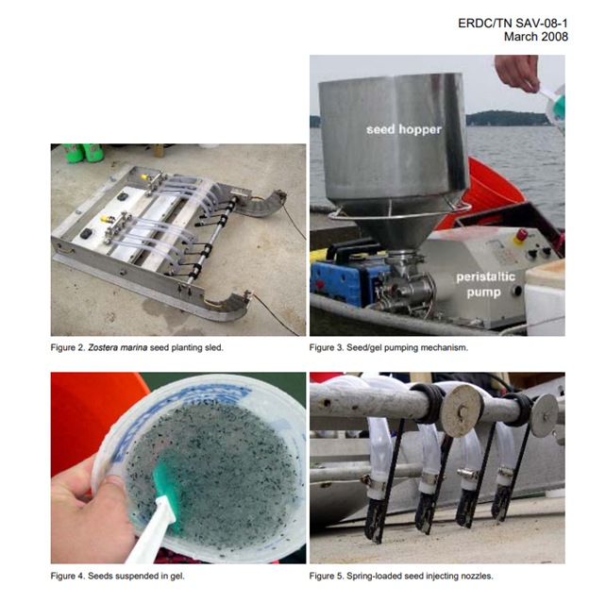
Figure 1 Pictures of the sled for seagrass seed injection; pictures adapted from Orth et al. 2008.

Detailed request: sled to plant seed balls and bags
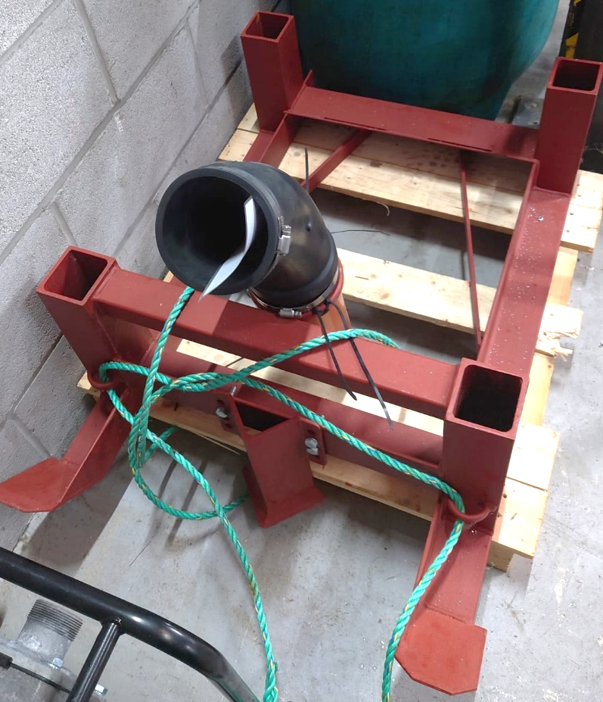
This prototype sled was constructed by Sam Rees at Swansea University. When it is towed by a boat, it opens a furrow in which biodegradable bags with seagrass seeds and/or seedballs with seagrass seeds can be deposited, after which the sled automatically closes the furrow again. The sled has one moving part which is a lever to increase or decrease the depth at which the furrow is created (thereby adjusting for local sediment conditions). This sled has been trialled in the Swansea Bay with bags filled with only sediment thus far, which demonstrated its proper functioning.
Figure 2 The sled (red in colour) to plant seed balls and bags. Note that it is located on a pallet for storage only. Through the black flexible coupling, bags and/or seed balls would be fed to the sled for burial.

Our aim with this sled, or an adapted version with the same functionality, is to:
- Use it within the boundaries of the marine licence areas described in DEML2248;
- Tow it to create a furrow and plant:
  - Biodegradable bags containing seagrass seed and c. 80 mL sand, the bag being roughly 13 cm x 7.5 cm in size. Planting density is c. 8 bags per m².
  - Seed balls consisting of inert clay powder, loam powder, silt powder, limestone powder, carrageenan powder (polysaccharides of red algae), and/or water. The seed balls are c. 2 cm in diameter. Planting density is c. 100-400 balls per m², depending on the number of seeds present in each ball, which is c. 0.25-1 kg dry powder per m². Clay is the dominant ingredient.
  - After planting abovementioned items, the furrow is automatically closed again as the sled moves over the seabed.

Stakeholder Engagement
We will inform relevant stakeholders of the Seagrass Ocean Rescue North Wales project via Alison Palmer-Hargrave (Pen Llyn a’r Sarnau SAC Officer), Nia Jones (Living Seas Manager at the North Wales Wildlife Trust), and Flo Taylor (Stakeholder Engagement Officer at Project Seagrass).

References
Dalby, Oliver, Rhys A. Coleman, Yi Mei Tan, Geordie Jennings, Perran L. M. Cook, Emma L. Jackson, Peter I. Macreadie, and Craig D. H. Sherman. 2023. “Understanding the Seagrass‐sediment‐light Feedback to Guide Restoration Planning: A Case Study Using Zostera Muelleri.” Restoration Ecology 31 (8): e14044. https://doi.org/10.1111/rec.14044.
Govers, Laura L., Jannes H. T. Heusinkveld, Max L. E. Gräfnings, Quirin Smeele, and Tjisse van der Heide. 2022. “Adaptive Intertidal Seed-Based Seagrass Restoration in the Dutch Wadden Sea.” Edited by Maura (Gee) Geraldine Chapman. PLOS ONE 17 (2): e0262845. https://doi.org/10.1371/journal.pone.0262845.
Gräfnings, Max L. E., Jannes H. T. Heusinkveld, Dieuwke J. J. Hoeijmakers, Quirin Smeele, Henk Wiersema, Maarten Zwarts, Tjisse van der Heide, and Laura L. Govers. 2023. “Optimizing Seed Injection as a Seagrass Restoration Method.” Restoration Ecology 31 (3): e13851. https://doi.org/10.1111/rec.13851.
Marion, Scott R., and Robert J. Orth. 2010. “Innovative Techniques for Large-Scale Seagrass Restoration Using Zostera Marina (Eelgrass) Seeds.” Restoration Ecology 18 (4): 514–26. https://doi.org/10.1111/j.1526-100X.2010.00692.x.
Maxwell, Paul S., Johan S. Eklöf, Marieke M. Van Katwijk, Katherine R. O’Brien, Maricela De La Torre‐Castro, Christoffer Boström, Tjeerd J. Bouma, et al. 2017. “The Fundamental Role of Ecological Feedback Mechanisms for the Adaptive Management of Seagrass Ecosystems – a Review.” Biological Reviews 92 (3): 1521–38. https://doi.org/10.1111/brv.12294.
Orth, Robert, Scott Marion, Steven Granger, and Michael Traber. 2008. “Restoring Eelgrass (Zostera Marina) from Seed: A Comparison of Planting Methods for Large-Scale Projects:” Fort Belvoir, VA: Defense Technical Information Center. https://doi.org/10.21236/ADA478894.
Traber, Michael, Steven Granger, and S Nixon. 2003. “Mechanical Seeder Provides Alternative Method for Restoring Eelgrass Habitat (Rhode Island).” Ecological Restoration 21: 213–14.
Van Katwijk, Marieke M., Anitra Thorhaug, Núria Marbà, Robert J. Orth, Carlos M. Duarte, Gary A. Kendrick, Inge H. J. Althuizen, et al. 2016. “Global Analysis of Seagrass Restoration: The Importance of Large‐scale Planting.” Edited by Henrik Österblom. Journal of Applied Ecology 53 (2): 567–78. https://doi.org/10.1111/1365-2664.12562.
Xu, Shaochun, Yi Zhou, Yongliang Qiao, Shidong Yue, Xiaomei Zhang, Yu Zhang, Mingjie Liu, Yunling Zhang, and Zhenhai Zhang. 2022. “Seagrass Restoration Using Seed Ball Burial in Northern China.” Restoration Ecology, April. https://doi.org/10.1111/rec.13691.

