PAN-025082 My Map Report:
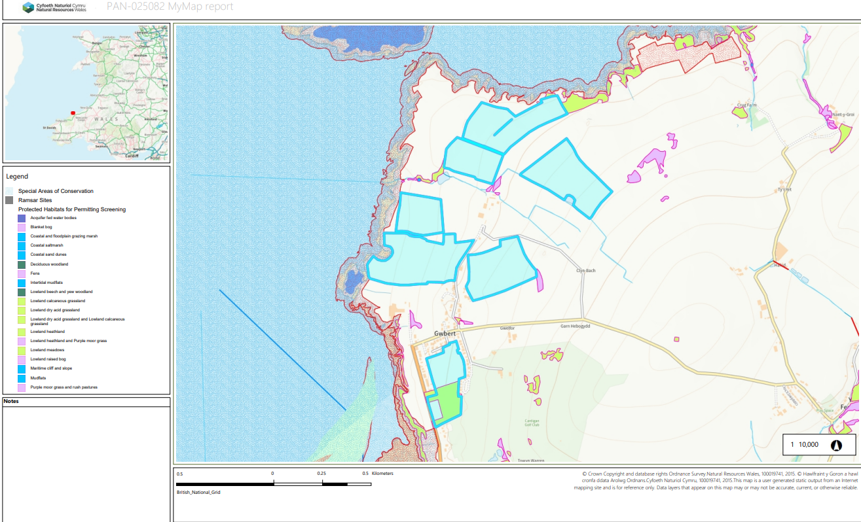
CY 9155
4885
Dun 2
3370
5928
2056
0834

Detailed river network:
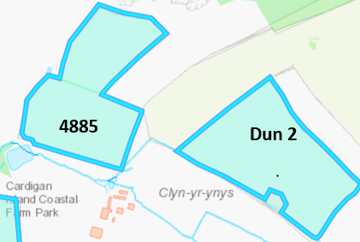
Fields 4885 & Dun 2 are located next to a water issue. There is a 10 meter no spread buffer zone in place along the boundary of the fields and the water issues to prevent nutrients entering the water. No action needed.
There is also a pond located in Dun 2 which has been buffered by 10 meters to prevent nutrients entering the water. No action needed.

Groundwater protection zones (source)
None in range.

Wells, springs or boreholes used for the supply of water for human consumption including from a private water supply or supplies
Fields 4885 is located within 50 metres 2 springs. The applicant has implemented a no spread buffer zone in this area, so the distance is 50 meters. No action needed.

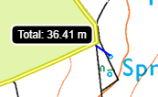
4885

any springs wells or boreholes not used to supply water for domestic or food production purposes within 50m

None in range.

European designated sites- Natura 2000 (SPA, pSPA, SAC or cSAC) or Ramsar- or SSSI within 500m

The fields in this deployment are located within 500 metres of the following SSSIs:
- Aberarth - Carreg Wylan SSSI (closest field 0834 borders the SSSI).
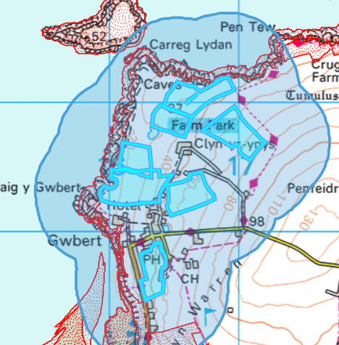
- Afon Teifi SSSI Caeau Crug Bychan
0834
- Ty Gwyn a Llwyn Ysgaw SSSI (closest field is located 450 metres).

The fields in this deployment are located within 500 metres of the following SACs:
- Cardigan Bay / Bae Ceredigion (closest field 0834 borders the SAC).
- West Wales Marine / Gorllewin Cymru Forol (closest field 0834 borders the SAC).
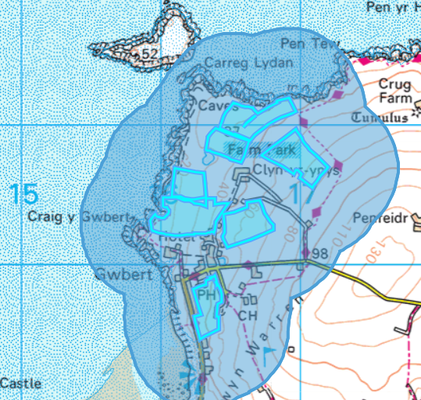
0834

Other protected sites:
- Protected Species-
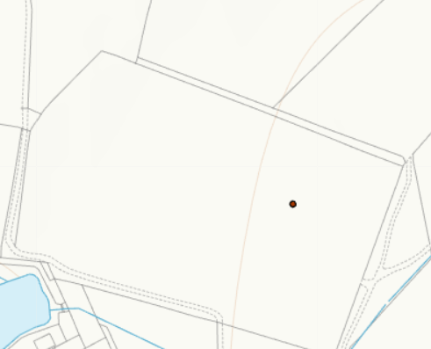
4885

Fields 4885 contains a protected species Linaria cannabina (bird). The landspreading activity will not affect this protected species due to waste being applied to the fields only and not hedgerows etc. No action needed.

- Protected Habitats-
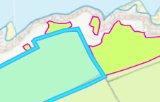
CY9155
Fields 4885 contains a protected species Linaria cannabina (bird). The landspreading activity will not affect this protected species due to waste being applied to the fields only and not hedgerows etc. No action needed.

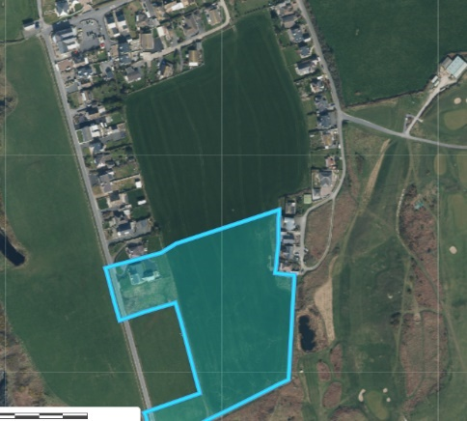
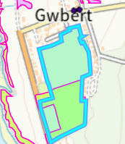
3370

3370
Field 3370 contains a protected habitat: Lowland dry acid grassland and Lowland calcareous grassland. Aerial imagery and the submitted EIA evidence shows this area of land is agriculturally improved and is not acid grassland. As a result, no action is needed.

- Scheduled Ancient Monument- None in range

- Local Nature Reserve- None in range.

- National Nature Reserve- None in range.

- Ancient Woodlands- None in range.

- Local Wildlife Sites (SINC)- None in range.

- National Park- None in range.

- Groundwater Safeguard Zone- None in range.

- Hedges- nothing of concern.

- Ditches- see slope map below.

- Local residents, Housing, schools, Workplaces, Recreational facilities

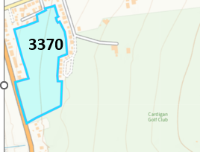
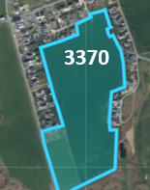
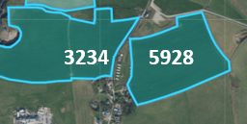

Fields 3234, 5928 and 3370 are located close to residential properties and field 3370 borders a golf club. The applicant has considered these areas in the submitted odour management plan due to spreading of odorous wastes EWC 02 05 02. The submitted OMP has been assessed and complies with the H4 odour guidance.

5928

3234

3370

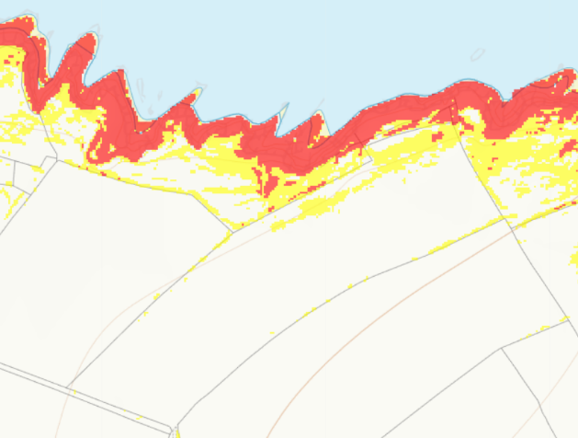
Slope Map
CY 9155

Field CYY 9155 is located on some moderately sloping land (7-12º). The applicant has implemented no spread buffer zone in these areas to minimize the risk of surface runoff. No action needed.

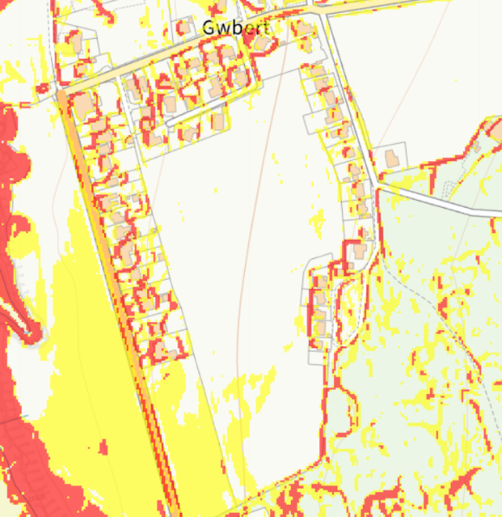
Field 3370 contains minimal areas of moderately sloping land(7-12º). Due to the minimal areas of moderately sloping land. The applicant is also using the appropriate application methods applying via dribble bar for non-stackable wastes and rear discharge spreader for stackable wastes. The applicant is also reducing the risk of surface runoff by applying a maximum of 50t /ha at one time. This allows the soil to effectively uptake the nutrients. Due to these reasons. The surface runoff risk has been determined as low. No action needed.

3370

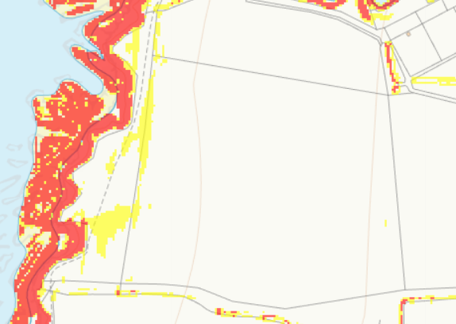
2056

Field 2056 contains minimal areas of moderately sloping land(7-12º). The applicant has implemented no spread buffer zone in these areas to minimize the risk of surface runoff. No action needed.

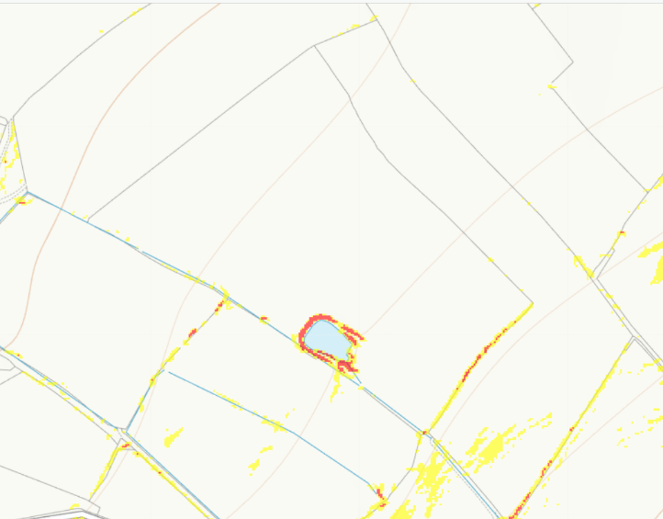
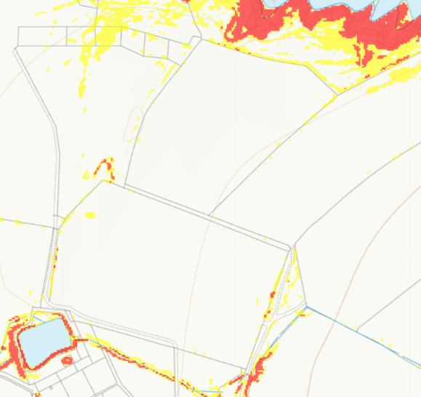
Dun 2
4855

Field 4855 is located on flat to gently sloping land no action needed.

Field Dun 2 contains minimal highly sloping land 12º+ around a pond. The applicant has implemented no spread buffer zone in these areas to minimize the risk of surface runoff. No action needed.

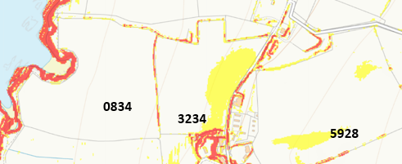
Fields 0834 is located on flat to gently sloping land. West of the field contains highly sloping land which has been buffered by 20 metres to minimize the risk of surface runoff. No action needed.
Field 3234 contains some moderately sloping land. The applicant is using the appropriate application methods applying via dribble bar for non-stackable wastes and rear discharge spreader for stackable wastes. The applicant is also reducing the risk of surface runoff by applying a maximum of 50t /ha at one time. This allows the soil to effectively uptake the nutrients. Due to these reasons. The surface runoff risk has been determined as low. No action needed.
The rfi will request the highly sloping land is removed from the deployment.
Field 5928 contains some moderately sloping land as these areas are contained within the field the risk of surface runoff is low. No action needed.

