CRoW Appendix 4 (140_10_SD02)  CRoW Act 2000: Natural Resources Wales application for permission - Formal Notice |  | 
Natural Resources Wales Formal Notice.
Requirements of Section 28I of the Wildlife & Countryside Act 1981 as amended by the Countryside and Rights of Way Act (CRoW) 2000.
Duty in relation to granting any consent, licence or permit for activities likely to damage Sites of Special Scientific Interest (SSSI).
Guide to filling in this form for Natural Resources Wales staff:
To be completed by Permitting Officers for any applications for a permission which the Natural Resources Wales has considered under S28G duties to protect and enhance SSSIs. This applies to all proposed permissions within a SSSI, and to operations outside the SSSI boundary which are likely to damage its special features.
Refer to OI 140_10 ‘Applying the Countryside and Rights of Way (CRoW) Act 2000 to applications for permits with potential for impact on Sites of Special Scientific Interest (SSSI)’, including the flowchart in Appendix 2.
Pink italic text – drafting notes, to be deleted before completion/consultation.
Blue text – examples, to be replaced with permission-specific information.
Ensure you have completed all sections.
- Natural Resources Wales area/region/NPS hub: | Mid Wales
- Name of SSSI: | Aberarth - Carreg Wylan SSSI, Afon Teifi SSSI and Caeau Crug Bychan, Ty Gwyn a Llwyn Ysgaw SSSI.
- Type of permission: | Land spreading deployment under standard rules permit SR 2010 No4 Mobile plant for land spreading.
- Date for Natural Resources Wales permit determination: | 21/05/2024
- Predicted 28 day date for response from NRW conservation/ecology (under S28 I(4)): | n/a
- Natural Resources Wales reference no: | PAN-025082
- National grid reference: | Farm location: SN 18094 50342  Fields:  Hafod CYY 5505 SN 16551 51051  Hafod CYY 4885 SN 16480 50858  H CYY Daries 2056 SN 16203 50569  H CYY Tawyn 0834 SN 16088 50345  H CYY Tawyn 5928 SN 16598 50289  H CYY Tawyn 3370 SN 16338 49708  Hafod CYY Dun 2 SN 16983 50759  Hafod CYY 9155 SN 16726 51038  Clyn yr Ynys 2062 SN 17208 50624  H CYY Tawyn 3234 SN 16327 50327  Storage:  SN 17052 50301  SN 17956 50061  SN 17089 50586  SN 17120 50561
- Description of proposal: | A land spreading application to spread 10 waste streams (EWC 02 05 02, 02 07 02 and 19 09 02 ) at Hafod Farm, Cardigan. Wastes are to be spread on 10 fields which contain grass, maize and wheat. The application rate of the wastes ranges from 26-250 tonnes per ha, with a total tonnage to spread a maximum of 9430 tonnes.  The waste will be spread over 49.4 hectares of land within the listed fields at Hafod Farm. The waste spread under this deployment consist of stackable wastes ( 2 EWC 19 09 02 wastes) and the rest non-stackable liquids and sludges. The non stackable wastes are intended to be spread by dribble bar. The dribble bar applicator are effective in limiting odour generation & nutrient losses. The stackable wastes are intended to be spread via rear discharge spreader.  The liquid wastes are delivered by HGV road tankers which are discharged into a temporary field nurse tank (‘holding  tank’), or above ground storage tank prior to spreading. The wastes aren’t mixed and are spread on separate fields. Each  liquid waste is spread from a nurse tank onto the deployed fields at the required timings as stated above.  Liquid waste may be stored in an above ground storage tank (permastore) for future application when conditions are suitable and there is requirement. Should the ground or weather conditions mean it’s unsuitable for spreading then. Temporary storage of liquid waste in nurse tanks may be required. The nurse tanks do not have secondary containment, but are impermeable purpose built AW Trailers alloy nurse tanks  featuring internal bracing, an anti-corrosive interior coating, designated fill and empty valves that can be shut by gate valves. These valves can be locked off in the event of temporary overnight temporary storage if the tank contains liquid to ensure secure temporary storage.  All liquid storage will be completely empty before use and no other Wastes, slurry etc are to be mixed with any individual  waste listed under this deployment whilst in storage.  For liquid wastes the maximum application rate for each field will be split into multiple applications where it’s over 50t/ha. Each individual application will not exceed 50t/ha in any one application to a field.  The stackable water clarification sludge cake is delivered to the spreading fields and stockpiled in temporary field heaps  prior to spreading.  Targeted periods of spreading on spring wheat and maize fields include Spring to Summer 2024 (April to June).  Targeted periods of spreading on grass fields include spring 2024, immediately after silage cuts – spring, summer, early autumn 2024, (April – September 2024).  EWC 19 09 02 sludges which contain iron will only be spread on fields with a soil pH of 5.5 or above.  EWC 19 09 02 sludges which contain aluminium-based coagulants  will only be spread on fields with a soil pH of 6.0 or above.  .  The land spreading activity will comply with the Code of Good Agricultural Practice guidelines (COGAP).  Documents related to this deployment can be found on the DMS.
- Is the proposed activity within (wholly or partially) the SSSI boundary? | NO  The table below outlines the no spread buffer zones in the fields closest to the SSSIs and the distance the fields are from the SSSIs  Due to field 3370 being located 140 meters away from the Afon Teifi where no impact pathway was identified this SSSI was not considered further in this Appendix 4 assessment.  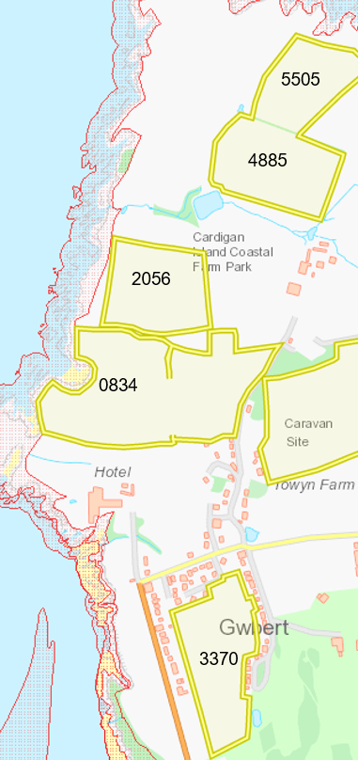  Aberarth  Carreg Wylan  SSSI  Field 9155 is located 450 metres from the Caeau Crug Bychan, Ty Gwyn a Llwyn Ysgaw SSSI. Due to distance the spreading field is from the SSSI no impact pathway could be identified and was not considered further in this Appendix 4 assessment.  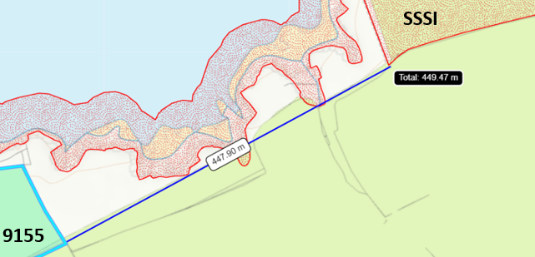
  Field | Distance from Aberarth Carreg Wylan SSSI and (buffer zone in place). | Distance from Afon Teifi SSSI and (buffer zone in place).
  0834 | Borders SSSI (20m) | Over 500 meters
  2056 | 8m (20m) | Over 500 meters
  5505 | 19 (20m) | Over 500 meters
  3370 | 61m (0m) | 140m (0m)
  9155 | 22m (20m) | Over 500 meters
- Has there been any pre-application discussion or correspondence with NRW conservation/ecology | NO
- What aspect(s) of the proposed permission may damage the features which are of special interest for the SSSI?
The following ‘Operations Requiring Consent’ (or other activities associated with the permission) that may cause damage) are relevant to the proposed permission.

Aberarth-Carreg Wylan

- Dumping, spreading or discharging of any materials.
- Application of manure, slurry, silage liquor, fertilisers and lime.
- Use of vehicles or craft in a manner likely to damage the flora, fauna or features for which the site is of special interest.

The following SSSI features and mechanisms of impact have been considered to assess the likelihood of damage:

Aberarth-Carreg Wylan

This site is of special interest for its geological, geomorphological and biological features. The cliffs, support an array of marine and coastal wildlife including:

Mammals

- Bottlenose dolphin
- Atlantic grey seal

Invertebrate

- Honeycomb worm

Birds

- Chough
- Kittiwake
- Lesser black-backed gull.

Plants

- Rock sea lavender
- Common gromwell
- Smooth cat’s ear

Habitats

- Wild thyme grasslands
- Coastal heathlands
- Sand dunes
- Bracken and woodlands
- Dense scrubs
- Acid grasslands
- Marshy grasslands

Geological

- Caledonian structures exposed in the sea cliffs and foreshore.
- Pleistocene / Quaternary sedimentary profiles.
- Overhangs and caves
- Maritime cliff crevice and ledge

- Decision
i) The proposed permission is not likely to damage any of the flora, fauna or geological or physiological features which are of special interest.

- Fields closest to the Aberarth-Carreg Wylan SSSI (2056, 0834 and 5505) contain a 20 meter no spread buffer zone to prevent nutrients entering the SSSIs.

- The fields closest to the two SSSIs (2056, 0834 and 5505) are on flat to gently sloping land meaning the risk of runoff/leachate is low as the waste will be incorporated into the soil effectively.

- To mitigate the pollution risk to watercourses/SSSIs the waste materials will not be applied at a rate greater than 50 t/ha in a single application.

- Non stackable wastes will be spread via dribble bar applicator which are efficient methods to prevent odour transmission & nutrient losses. Stackable wastes (water treatment cake) will be spread via rear discharge spreader which is an appropriate method for the physical form of the waste.

- Wastes will be spread at appropriate times when the crop will benefit from the nutrients provided i.e., spring/summer.

- The wastes will be applied following the Code of Good Agricultural Practice.

- Regular servicing of all machinery is conducted and spreading equipment is annually calibrated. To prevent waste being held in faulty machinery replacement spreading equipment will be available.

- Spreading machinery will travel over the field in a direction which will most easily allow the machinery to turn within the boundaries of the field. Any spreading equipment will be turned off and/or lifted out of the soil prior to turning at the end of each run.

- Machinery turns will be routed to avoid rutting and wheel slip. The turns will not be executed on any buffer strips.

- There will be sufficient trained staff available to ensure that the operation continues throughout operational hours.

- Weather conditions will be monitored prior to spreading with wind speed and direction.

- Spillages: all spillages will be reported immediately to NRW.

Natural Resources Wales is minded to: Issue the permission

- Name and job title of Natural Resources Wales officer: | Owen Clee  Permitting Officer
- Date form sent to NRW conservation/ecology | n/a
For Natural Resources Wales use only, once NRW conservation/ecology response received
- NRW conservation/ecology comment on assessment: | Please delete as appropriate:  i) NRW conservation/ecology advise the operation can go ahead  ii) NRW conservation/ecology advise the operation can go ahead with conditions  iii) NRW conservation/ecology advise against permitting the operation  Please ensure that the NRW conservation/ecology response is attached to this Formal Notice.
- Name and job title of NRW conservation/ecology officer:
- Date of receipt of NRW conservation/ecology response:

