PAN-024856 My Map Report:
Application map
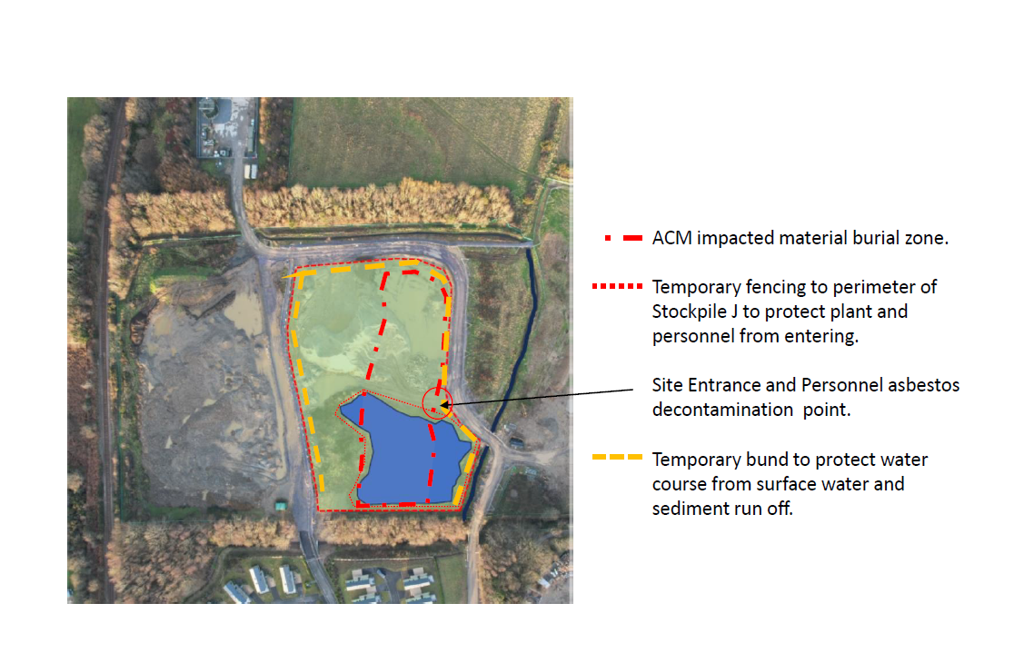
Detailed river network:
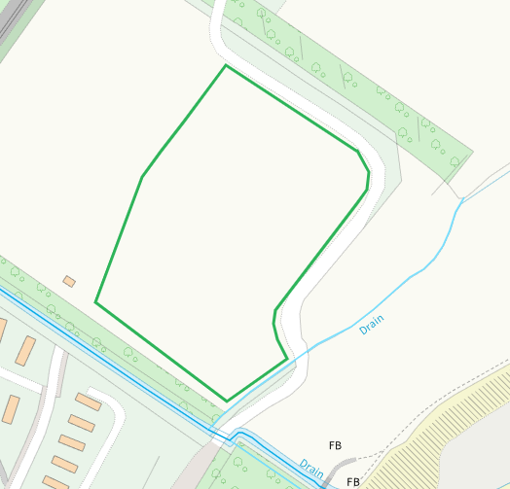
European designated sites- Natura 2000 (SPA, pSPA, SAC or cSAC) or Ramsar- or SSSI within 1000m
SAC - Lleyn Peninsula and the Sarnau
SSSI - Glanllynnau a Glannau Pen-ychain i Gricieth
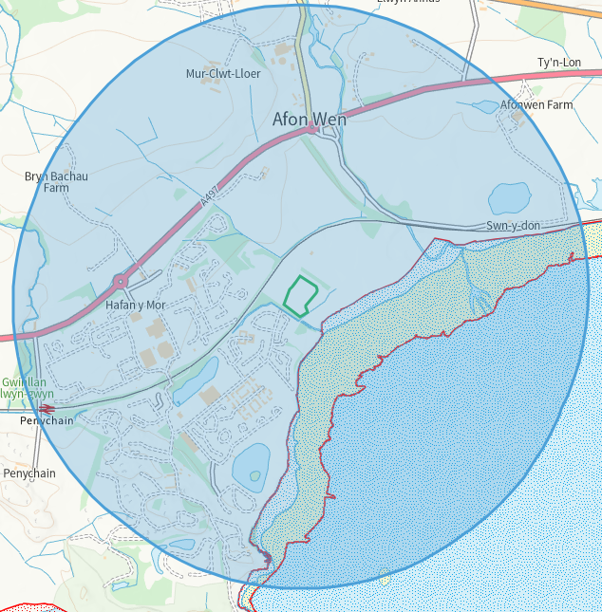
Local Wildlife Sites
1. Byntirion
2. Llynnoedd Afonwen
3. Pen y Bryn
4. By Butlins
5. Pont Llwyn-gwyn
6. Lon Drwsdeugoed
7. Butlins 2
8. Porth Fechan coastal grassland
9. Butlins 3
10. Butlins 1
11. Afon Wen

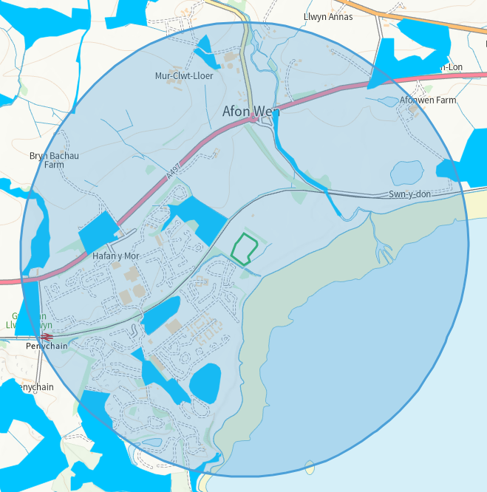

Ancient Woodland
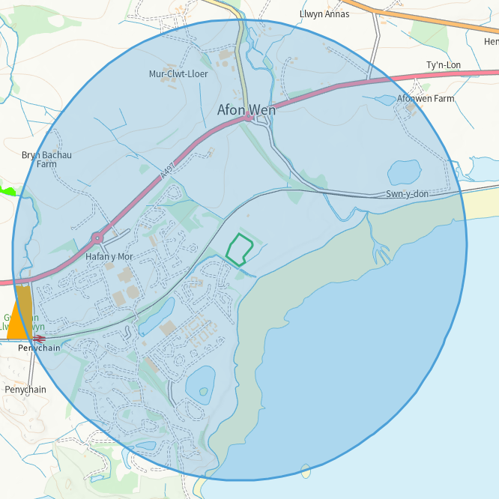
Flood Risk


