PAN-025174 - My Map Report:
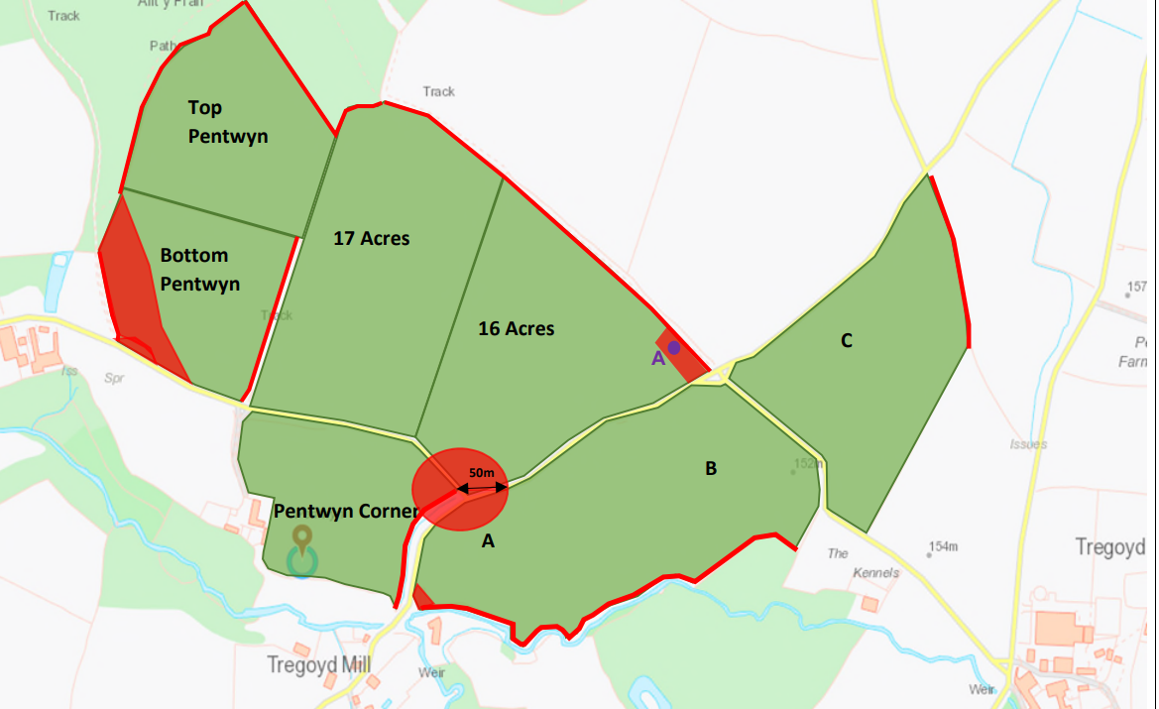
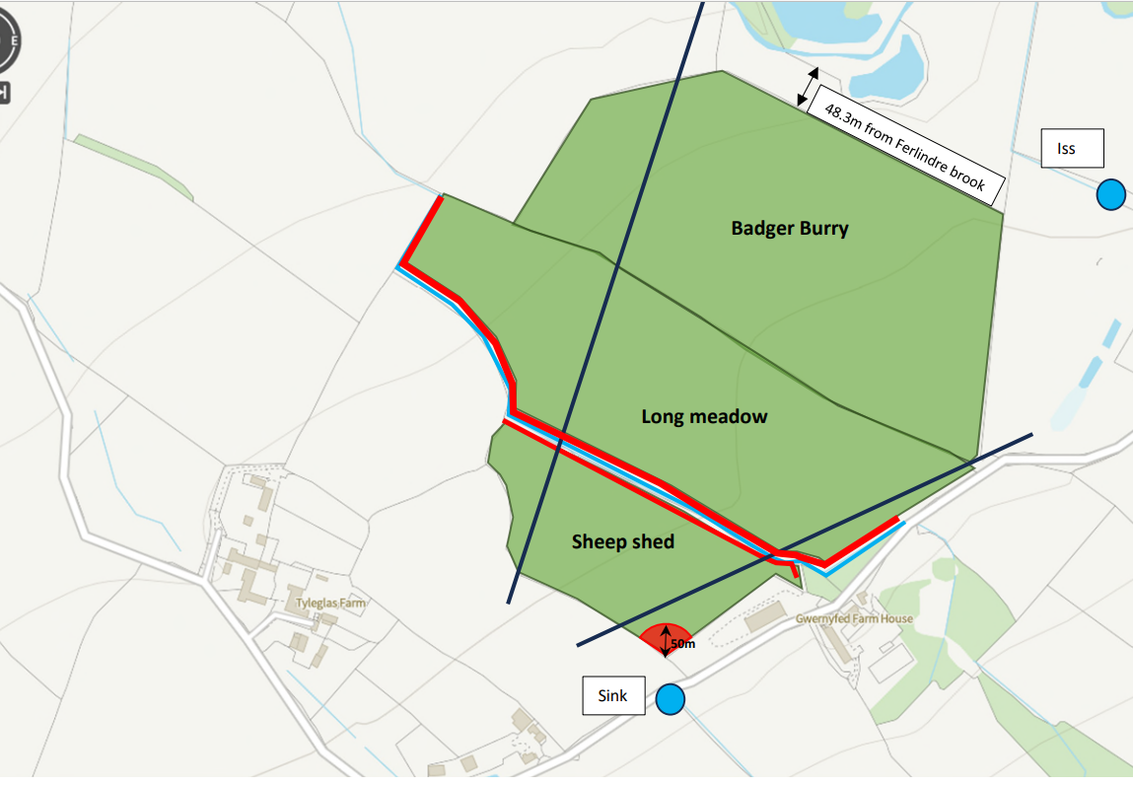
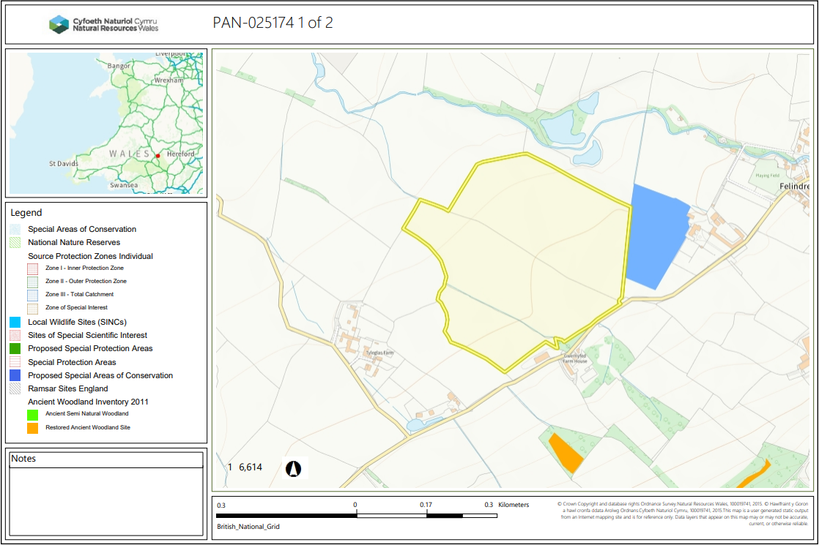
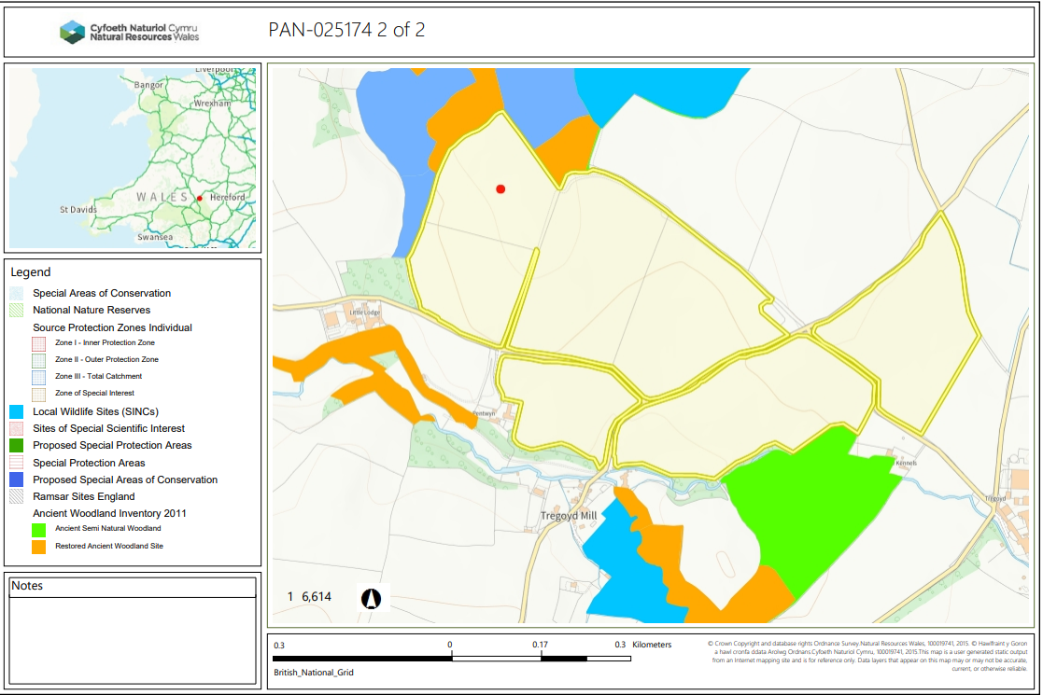

Detailed river network:
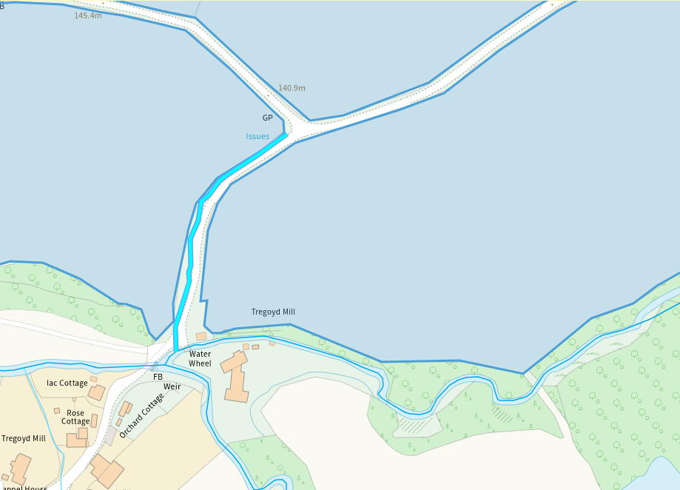
Several modified attributions are at the south end of fields A, B and Pentwyn corner. In addition, there is an issue at the top corner of Pentwyn Corner. All of these have been appropriately buffered, no action required.
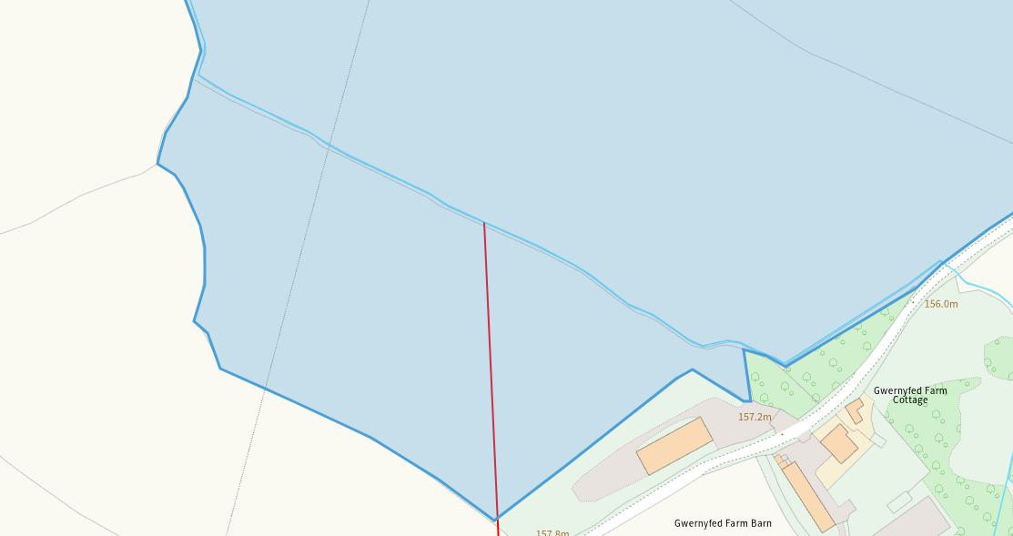
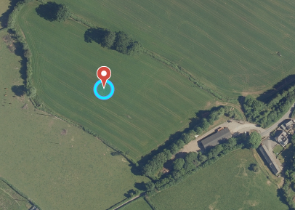
A modified attribution runs parallel between long meadow and sheep shed. There is appropriate gaps and no spread buffer zones implemented. The red line indicates a modified attribution running through sheep shed, however, ariel images show there is no watercourse present. No action required.
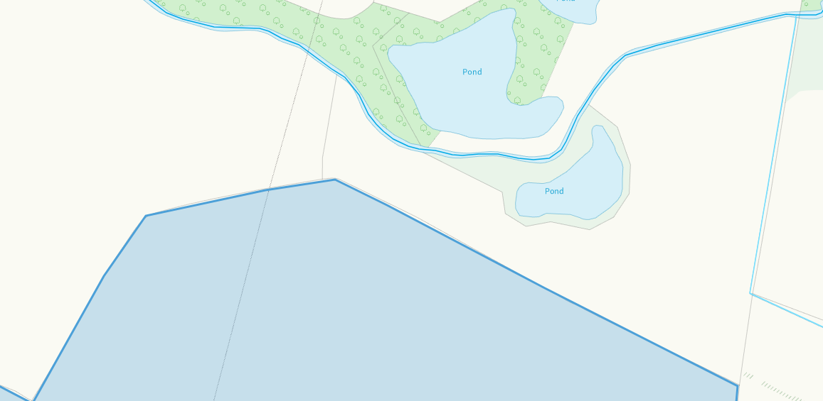
Badger brook is 36m from the Felindre brook. This has been correctly identified in submitted maps and due to the distance between the brook and spreading area, no action required.

Groundwater protection zones (source) – None in range
Wells, springs or boreholes used for the supply of water for human consumption including from a private water supply or supplies – None in range
any springs wells or boreholes not used to supply water for domestic or food production purposes within 50m – None in range

European designated sites- Natura 2000 (SPA, pSPA, SAC or cSAC) or Ramsar- or SSSI within 500m – None in range

Other protected sites:
- Protected Species- None in range
- Protected Habitats-
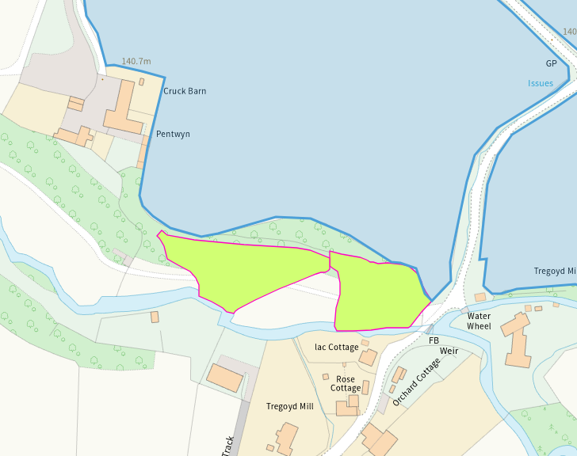
A section of Lowland dry acid grassland and Lowland calcareous grassland borders pentwyn corner. This does not cross into the spreading area and as such no action required.
- Scheduled Ancient Monument-
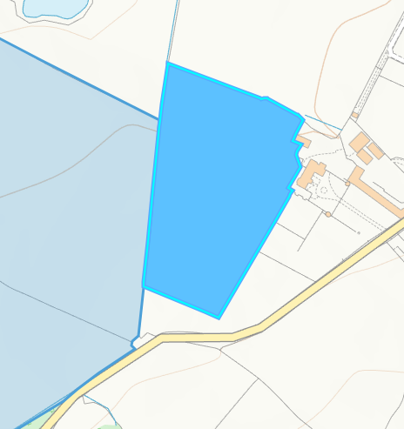

Garden works at old gwernyfed, a post medieval ancient monument sits on the border of badger burry, although this is not within the spreading area there is not buffer implemented on this border and it has not been identified in spreading maps.

- Local Nature Reserve- None in range
- National Nature Reserve- None in range

- Ancient Woodlands-
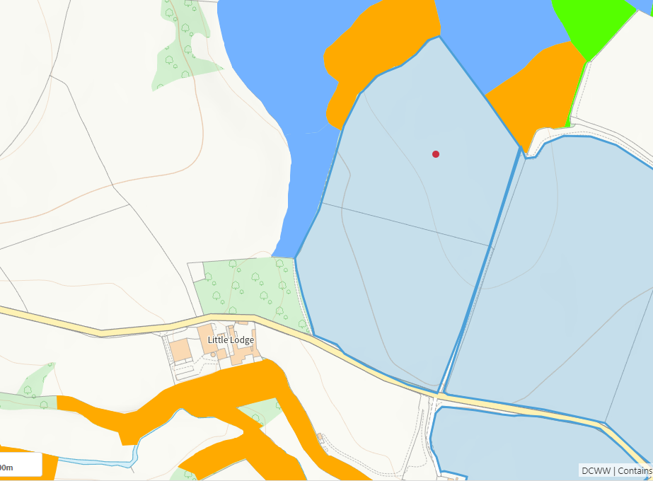

There is areas of ancient semi natural woodland (green), restored ancient woodland (orange) and plantation on ancient woodland (blue) bordering bottom and top Pentwyn. All of the above are appropriately identified on submitted maps and 10m no spread buffers implemented on those borders adjacent.
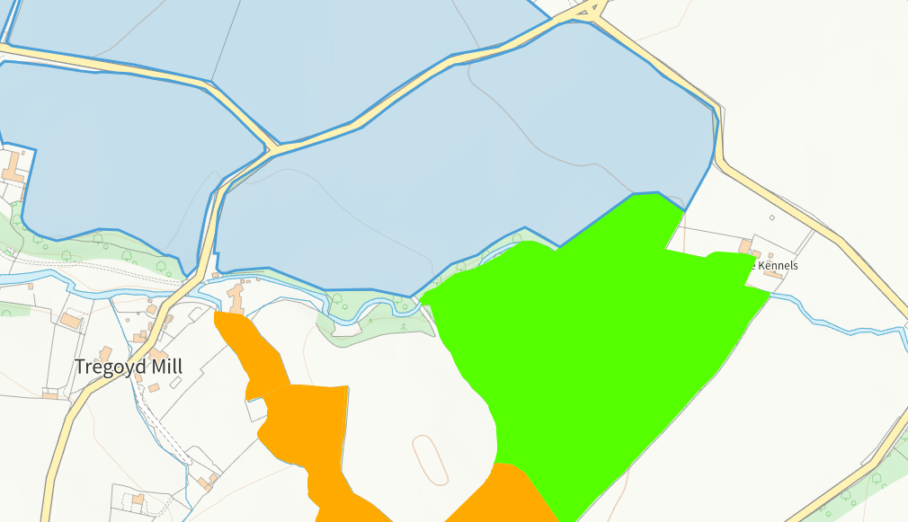

There is areas of ancient semi natural woodland (green) bordering field A and B. It has been appropriately identified on submitted maps and 10m no spread buffers implemented on those borders adjacent.

- Local Wildlife Sites (SINC)- All appropriately identified on submitted maps.

- National Park- Brecon Beacons national park borders long meadow field. This jhas been identified on submitted maps and due to a road being between the park and spreading area. No pathway perceived.

- Groundwater Safeguard Zone- None in range
- ANOBs – None in range
- Heritage coast – None in range

- World Heritage Sites
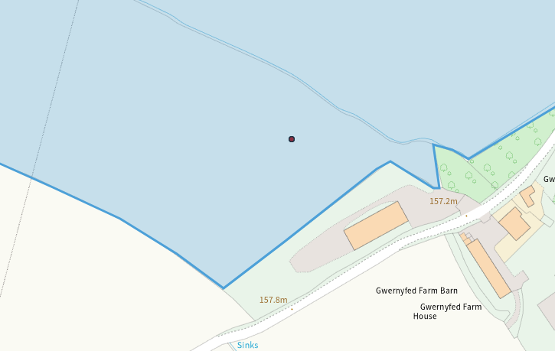
A post medieval garden feature, Tyle glas barrow is within sheep shed field. It has not been identified or buffered.
- Hedges- No cause for concern
- Ditches- No cause for concern
- Local residents, Housing, schools, Workplaces, Recreational facilities – Sensitive receptors identified in the submitted maps and ABS

Public footpaths

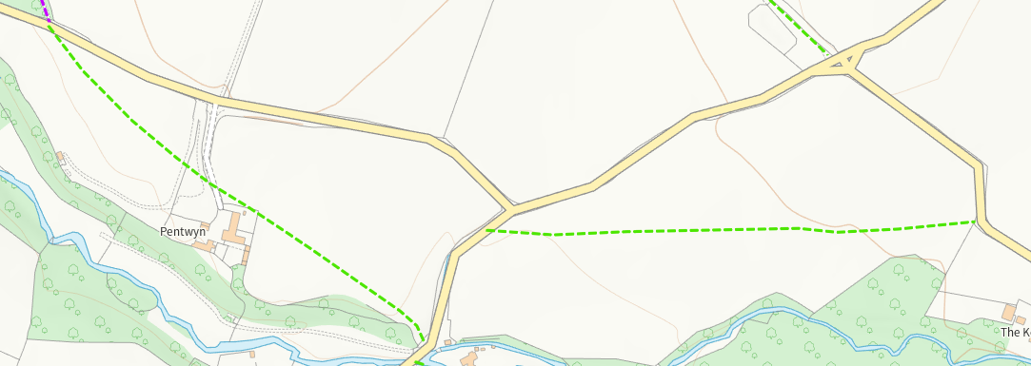
There is a footpath through pentwyn corner and fields A and B, neither have been identified or buffer appropriately.

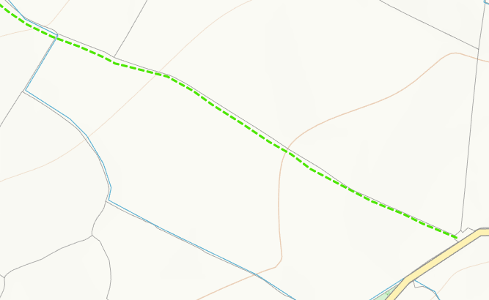
A footpath runs along the border of Long meadow, this has not been identified or appropriately buffered.

Slope Map
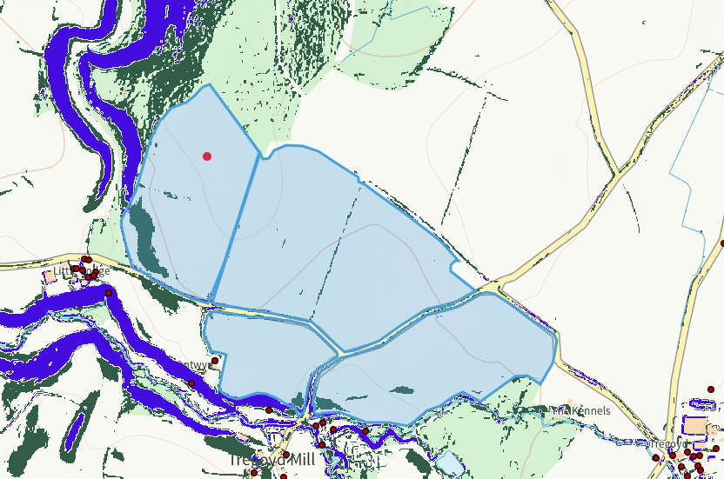

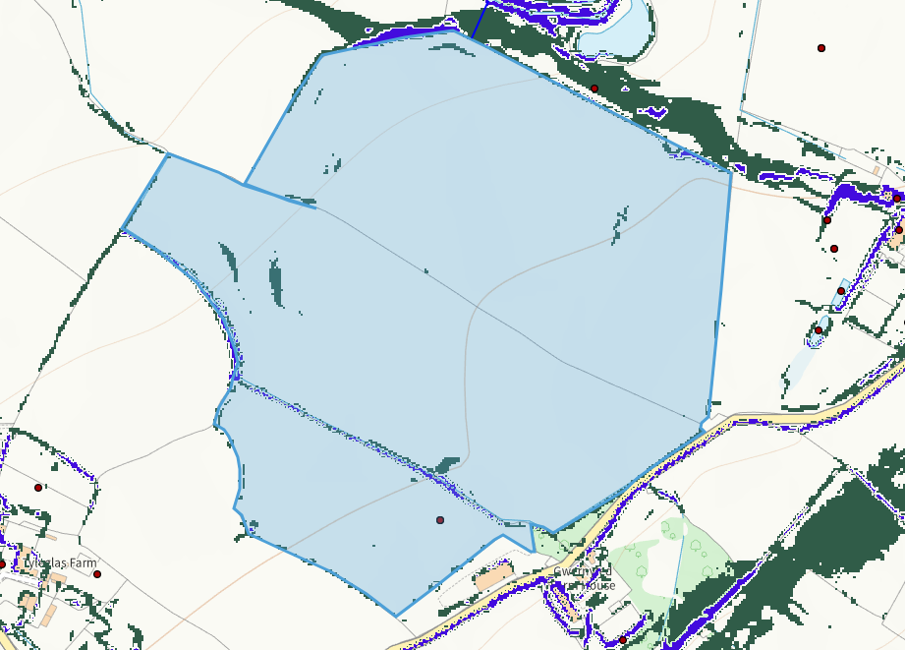
Sloping assessment in relevant Decision document.
Flood Risk
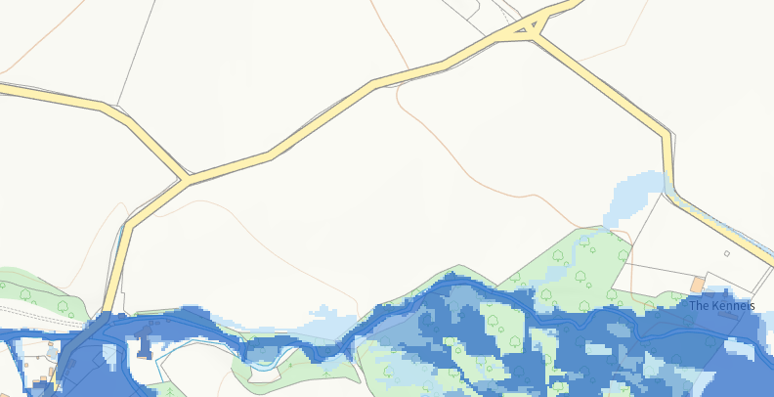
Field A and B are the only fields with an area of flood risk in them, which is a low risk from rivers. They state in the ABS waste will only be applied when weather conditions are suitable and due to the low risk, no action required.

