PAN-023987 MyMap report

Application plan- AB3091ZZ SYCHTYN NP23R-3 Plan
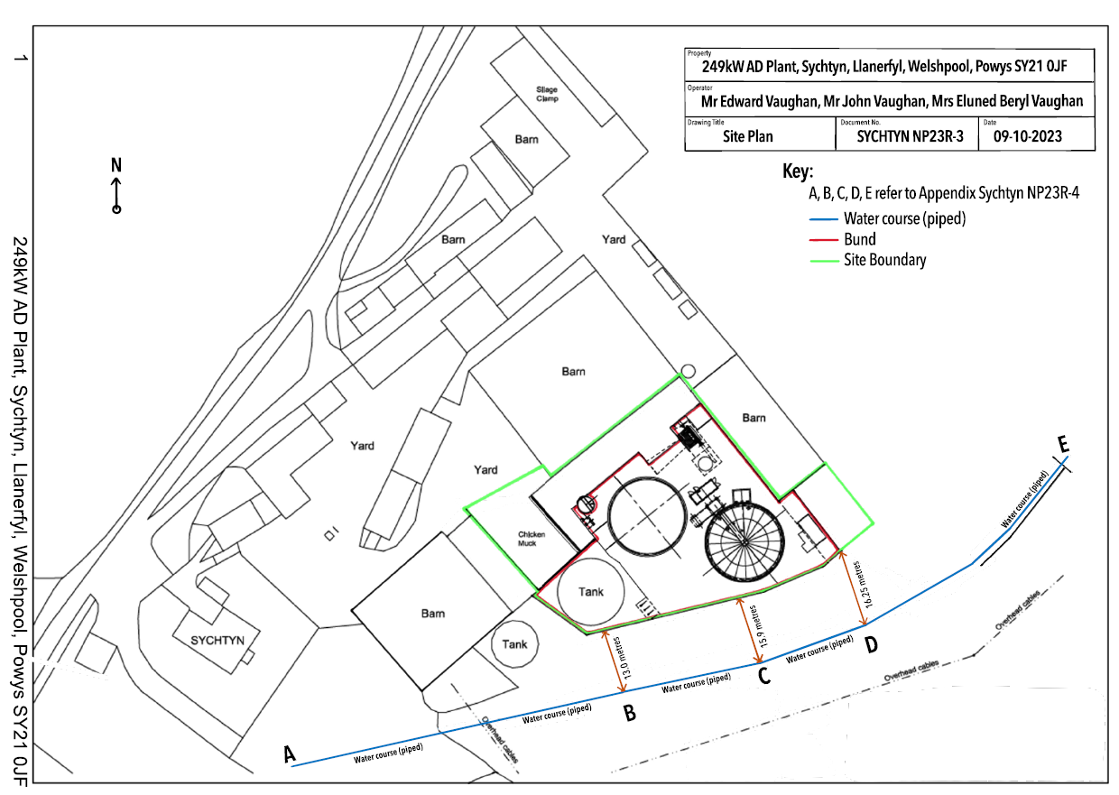
2.2.2 The permitted activities must not be carried out within (a) 10 metres of any watercourse;
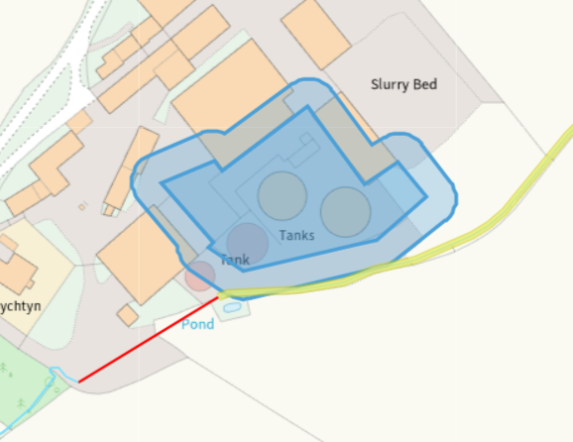
While our mapping system is showing that the southern boundary of the site is within 10 meters of the watercourse, this watercourse is no longer a surface watercourse. Document AB3091ZZ SYCHTYN NP23R4 Appendix shows the distance from the site boundary to the subsurface water course, which is in excess of 10 metres

2.2.2 The permitted activities must not be carried out within (b) a groundwater source protection zone 1, or if a source protection zone has not been defined then within 50 metres of any well, spring or borehole used for the supply of water for human consumption. This must include private water supplies.
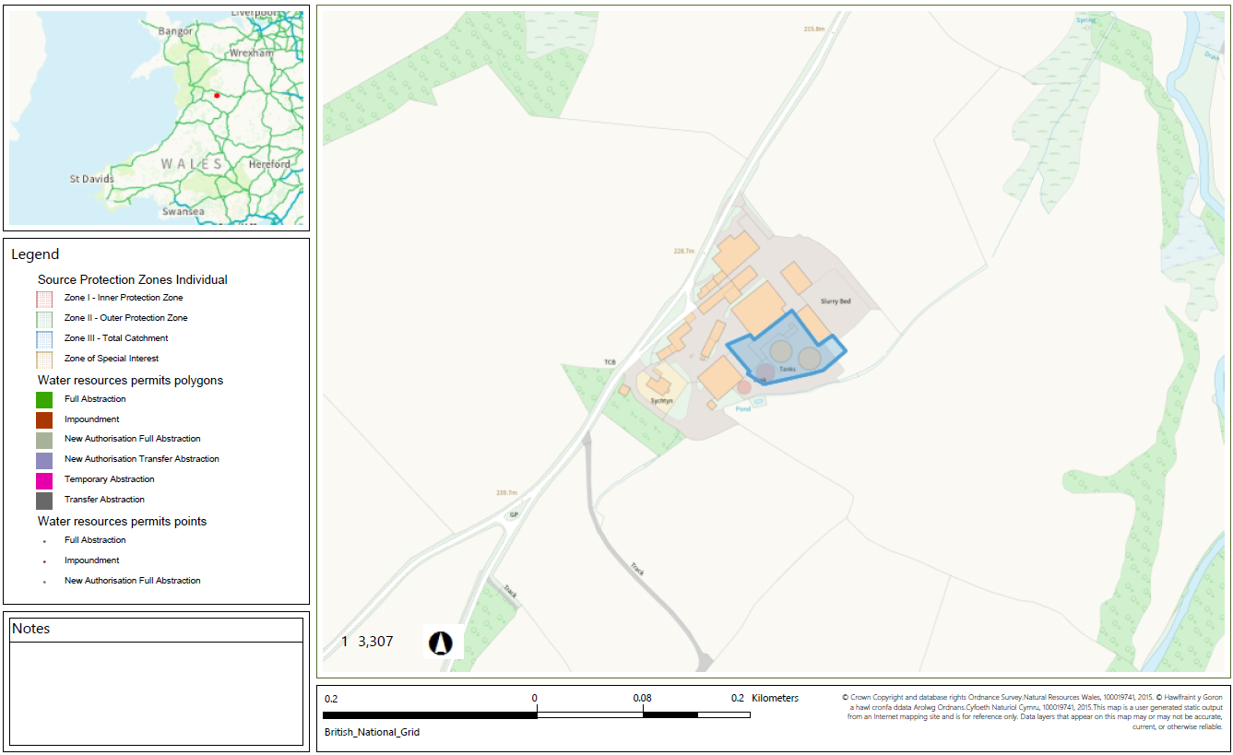
- none
2.2.2 The permitted activities must not be carried out within (c) a specified Air Quality Management Area;
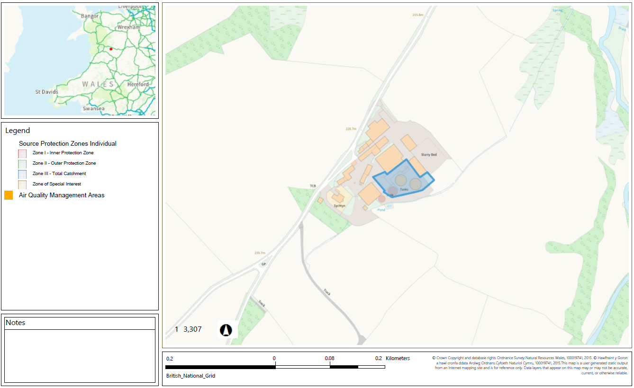
- none
2.2.3 The gas engine stack must be a minimum of 3 metres in height and must not be located within (a) 200 metres of a European Site or a Site of Special Scientific Interest (excluding any site designated solely for geological features);
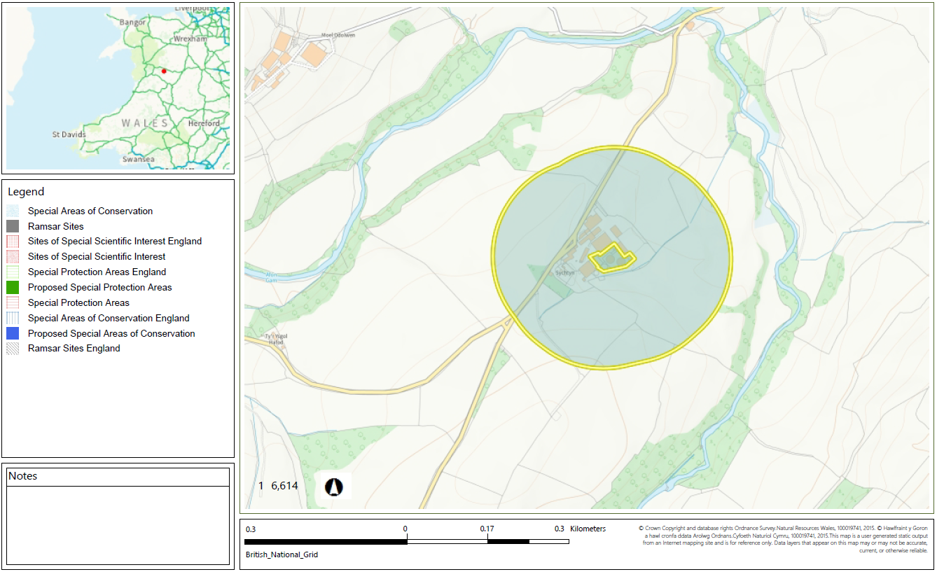
- none
2.2.3 The gas engine stack must be a minimum of 3 metres in height and must not be located within (b) 200 metres from the nearest sensitive receptor in cases where the stack does not have an “effective” stack height of 3 metres or more, or the stack is less than 7 metres in height."
“nearest sensitive receptor” means the nearest place to the permitted activities where people are likely to be for prolonged periods. This term would therefore apply to dwellings and associated gardens (including farmhouses) and to many types of workplaces. We would not normally regard a place where people are likely to be present for less than 6 hours at one time as being a sensitive receptor. The term does not apply to the operators of the permitted facility, their staff when they are at work or to visitors to the facility, as their health is covered by Health and Safety at Work legislation.
As per original application- 23/11/2015- the effective stack height is more than 3 metres/ the stack height more than 7 metres

